Summary of Exam 7 Home Monitors
Continuous Glucose Monitor | How long is it worn? Up to 14 days  Date of Removal _________________  Instructions for wearing it: Don’t submerge the monitor underwater. It’s ok to shower with it on. Avoid sleeping on the side with the monitor. If it falls off before 8 days of wear give us a call.  How to return it: Remove monitor (rip it off like a bandaide). Place the monitor in the bag with the glucose sensor sticker. Use the mailer provided by MESA and return it to the post office or a return mail box.
Hip Activity Monitor | How long is it worn? 8 days  Date of Removal _________________  Instructions for wearing it: Keep the monitor dry. Remove it when you sleep or nap. Put it back on as soon as you wake. Wear with black knob facing the sky.  How to return it: Return red monitor and belt or clip in the same envelope as the wrist monitor and the daily diary. Use the mailer provided by MESA and return it to the post office or a return mail box.
Wrist Sleep Monitor  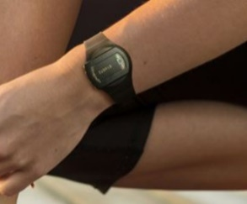 | How long is it worn? 8 days  Date of Removal _________________  Instructions for wearing it: The watch is waterproof and can be worn continuously for 8 days, even when you are asleep. Press the invisible button when you wake up in the morning and when you are trying to fall asleep at night.  How to return it: Return wrist monitor in the same envelope as the red hip monitor and the daily diary. Use the mailer provided by MESA and return it to the post office or a return mail box.
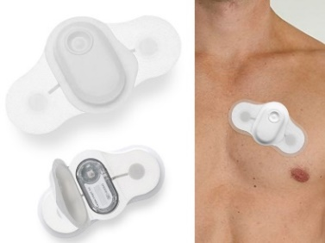  Heart Patch Monitor | How long is it worn? 8 days  Date of Removal _________________  Instructions for wearing it: Wear the patch for 8 days without removing it. Don’t submerge it underwater. It’s ok to shower with it on but keep it out of the direct stream of water. Press the button when you experience stress. Don’t forget to answer the daily phone calls.  How to return it: Remove monitor and use adhesive removal wipe. Fold wings into middle to make it not sticky. Place inside white pouch and then use the mailer provided by MESA and return it to the post office or a return mail box.
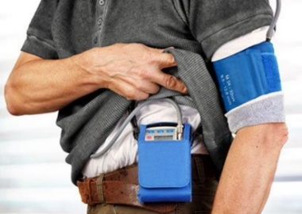  24-hour Blood Pressure Monitor | How long is it worn? 24 hours  Date and time of Removal _________________  Instructions for wearing it: Stay still when the monitor takes your blood pressure. If you need to stop a reading press the circle button. Keep the monitor dry. Remove the cuff when you shower. Turn device off by press and hold circle button until it asks if you want to turn it off. Uncover and loosen cuff. Slide off and remove sleeve. To put back on, slide cuff over sleeve ensuring arrow points to inside of arm and tubing is coming out of the top. Tighten and turn back on by pressing circle button. Re-cover with sleeve.  How to return it: Use the container/box provided by MESA and return via courier.
If you have questions about the monitors, call [study contact] at [phone number]

