MESA-MIND Neurological Exam Outline
What are we testing?
- Cranial nerves
- Motor strength, tone, and bulk
- Reflexes
- Coordination
- Sensory function
- Posture, gait, balance

- Extraocular Movements (EOM, CN’s: III, IV, VI)
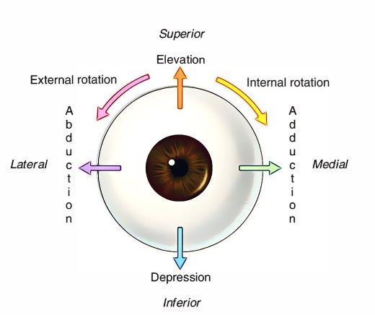
  - Look for abnormal saccades:
    - Sitting ~3 feet away from participant.
    - Finger one 18-24 inches away from participant.
    - At eye level with participant.
    - Ask participant to move her eyes and follow the examiner’s finger into all cardinal positions of gaze

- Visual Field (CN: II)
  - Ask participant to look forward at the examiner’s face / nose
  - Have participant cover one eye at a time
  - If you can’t see it = they can’t
  - If you can see it and they can’t = something wrong
  - Have her to look in all 4 corners of visual field
  - Have participant count examiner’s fingers presented singly in both right and left visual fields
  - (optional) test visual neglect to double simultaneous stimulation

- Coordination: Upper Body
  - Finger-nose-finger
  - Have her touch your finger, then touch her nose
  - Then repeat moving your finger around

- Tongue Protrusion & Atrophy (CN: XII)
  - Ask the participant to stick out her tongue as far as possible then wiggle it around.
    - Look for tongue coming straight out (no “tongue deviation”)

- Facial Movement (CN: VII)
  - Ask participant to wrinkle forehead then smile big
    - Look for a droop on one side
    - Look for facial droop - may be subtle
    - Paralysis of forehead (loss of wrinkles) indicative of Bell’s palsy rather than stroke due to a supranuclear lesion.
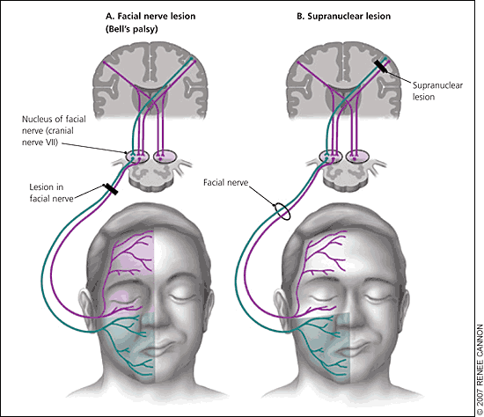

- Facial: Motor/Sensory (CN: V)
  - Sensory – Tactile Extinction
    - Instruct participant to close her eyes and ask her to identify light touch applied to areas V1, V2, and V3 on both sides of his/her face.
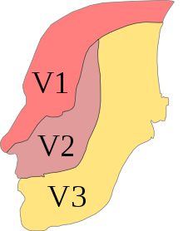

- Apraxia
  - Disorder in which the individual has difficulty with the motor planning to perform tasks or movements when asked, provided that the request or command is understood and the individual is willing to perform the task.
e.g. “use a hammer”, “use scissors”

- Motor: Muscle Strength (Upper Body, CN: XI)
  - Have participant turn head and provide resistance.
  - Have participant raise shoulders same time (look for symmetrical movement)
  - Have participant exert force against examiner’s resistance pushing down on her shoulders
  - Other Upper Body Muscles
- Arm abduction
  - “chicken wing” arms (try to push arms down as she works against you)
- Elbow flexion/extension
- Wrist flexion/extension
- Finger flexion/extension

- Tremor (Postural & Resting)
  - Hands right out in front of her
    - Wait long enough to see if there is a postural tremor (~10 seconds)
    - If you can make tremor stop by supporting hands, might just be nervous
    - Look for resting tremor throughout the examination

- Coordination: Rapid Movements
  - Instruct participant do the following:
    - Quickly move fingers
    - Quickly pronate/supinate forearms
    - Quickly make a fist and open fingers bilaterally

- Motor: Muscle Strength (Lower Body)
  - Lower body strength/rigidity:
    - Tell her to provide resistance when you either pull or push
    - Look for ankle swelling while look at lower body
  - Lower body flexion/extension (see images):
- Hip flexion
- Knee flexion/extension
- Ankle flexion/extension
- Toe flexion/extension

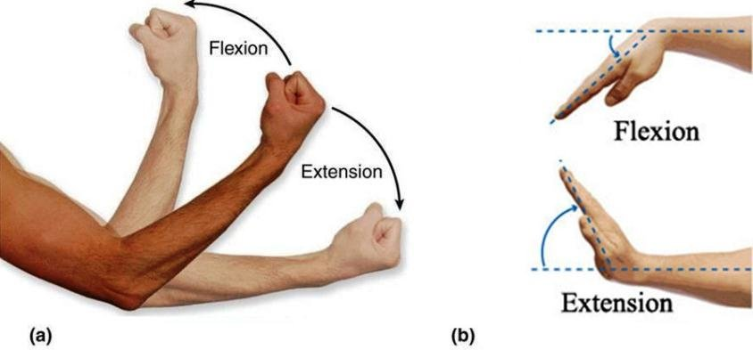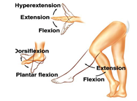
- Rigidity
  - Ask the participant to completely relax and roll joints (e.g. wrist and ankle)
  - If there is rigidity, have her tap on leg while you rotate wrist (loosens rigidity)
  - Make notes of unilateral versus bilateral rigidity

- Reflexes
  - DTR’s at ankle, knee, & elbow using reflex hammer

- Coordination: Lower Body
  - Instruct participant to move her heels up and down (in a stomping motion) as quickly as possible.

- Postural Reflex (Optional Pull test) https://www.youtube.com/watch?v=Jhmt3t1BS6M

What else to be looking for:
- Muscle wasting
- Fasciculation
  - Muscle twitches may also be due to trauma and injury or may be symptoms of anxiety or depression. ... Some people who lack certain minerals, such as magnesium or calcium, may also develop muscle twitches. Fasciculation’s may also be linked to other routine factors such as: strenuous exercise.
- Chorea
  - Causes involuntary, unpredictable body movements
  - Can range from minor movements, such as fidgeting, to severe uncontrolled movements of the arms and legs. It can also interfere with speech, swallowing, posture, and gait.
- Myoclonus
  - Refers to a quick, involuntary muscle jerk. Hiccups are a form of myoclonus, as are the sudden jerks, or "sleep starts," you may feel just before falling asleep. These forms of myoclonus occur in healthy people and rarely present a problem.
Types of Tremors:
- Resting
  - Occurs when muscle in relaxed and may be a sign of PD (“pillrolling” tremor)
- Action
  - Occurs with voluntary movements.
- Postural
  - Occurs when a person maintains a position against gravity such as holding the arms outstretched.
- Kinetic
  - Associated with any voluntary movement such as moving the wrists up and down or closing and opening the eyes.
- Intention
  - Produced with purposeful movement towards a target, such as lifting a finger to touch the nose.
  - Typically the tremor will worsen as they get closer to the target.
- Task specific
  - Only appears when performing highly-skilled, goal-oriented tasks such as handwriting or speaking.
- Isometric
  - Occurs during voluntary muscle contraction that is not accompanied by any movement such as holding a heavy book or a dumbbell in the same position.

Additional Notes:
- Parkinson’s disease = typically asymmetric tremors and rigidity
- Parkinsonism = symmetric tremors (typically)
- Parkinson's disease slow movement
  - Slowed movement that affects both fine and gross motor control.
- Bradykinesia refers to slowness of movement.
  - Tasks requiring fine motor control (buttoning a shirt or using utensils, for example) are particularly slow for someone with bradykinesia from Parkinson's disease, and reaction times are much slower, as well.

