Consent to join the
Multi-Ethnic Study of Atherosclerosis (MESA)
Exam 7 In-person PILOT

Person in charge of this study at [Field Center] (Principal Investigator):
[PI Name]

Study Coordinator and Contact Person:
[Research Team Contact Name and Phone Number]

The sponsor of this study: The National Heart, Lung, and Blood Institute (NHLBI) and the National Institute of Aging (NIA) from the National Institutes of Health (NIH)

This form tells about the 7th exam for the Multi-Ethnic Study of Atherosclerosis (MESA) PILOT STUDY. This is a research study. It is not medical care. Joining this pilot study is voluntary. You can choose to join or not. No matter what you decide, it will not affect your clinical care.

Review this form carefully. It tells all about the pilot study so you can decide if you want to join. We will give you a copy of it to keep. If you have questions, please ask us.

Here are some key points about the pilot:
- If you join, we will ask you to:
  - Give blood, urine and other samples and have some tests
  - Answer questions about your health and lifestyle
  - Have some other imaging tests, if you agree
  - Wear small monitors on your body at home, if you agree

- You will be helping researchers make discoveries. This may help people with health problems in the future. Also, we will give you the results of some of your medical tests. This may or may not help your doctors take better care of you.
To learn more, please read the rest of this form.

What is the MESA Exam 7 Pilot Study?
MESA is an ongoing research study that started in 2000 at six sites, including this one. It has a large exam (Exam 7) starting soon. We would like to pilot this exam to make sure it is easy and works smoothly.

Why are you asking me to join the Pilot Study?
You have volunteered for it and responded to a flyer, or heard about it by other means.

What will you ask me to do?

We will ask you to come to the MESA Clinic for the exam and imaging tests and to complete some of the exam parts at home. We will send study staff to your home, if you would like. You can say yes or no to any part and still be part of Pilot.

We will gather samples from you. This will take about 25 minutes.
    - We will ask you for a urine sample. We will give you instructions for how to do this.
    - We will ask you for a blood sample. We will take about 5 tablespoons of blood. We will take blood from your arm using a needle.
    - We will ask you for a hair sample. We will pluck about 10 hairs from your head.
    - We will swab the inside of the lower part of your nose with a soft brush.

We will ask you to complete some questionnaires and tests.
- Questionnaires. We will ask you to complete some questionnaires. Some of the questions ask about sensitive topics like drug or alcohol use. You can also choose to answer the questions at home over the phone or on a secure website. The questionnaires will take about 1 hour.
      - We will ask what medicines you are taking.
      - We will ask you about your health, lifestyle, and your home and neighborhood environment.

- Measurements. We will measure your height, weight, hips, waist, and neck. This will take about 10 minutes.
- Vitals. We will measure your blood pressure, temperature, pulse, and the amount of oxygen in your blood. If you usually use supplemental oxygen, you will remove it for this test. This will take about 10 minutes.
- Arterial Stiffness. We will measure the stiffness of your arteries using a blood pressure cuff on your arms and legs to record pulse waves in your arteries. This will take about 20 minutes.
- Physical Exam and Short Physical Performance Battery. We will test your balance and how fast you walk. We will look for symptoms of neurological problems. This will take about 30 minutes.
- Spirometry. We will ask you to breathe into a tube as hard and fast as you can. We might ask you to do this again after inhaling a medicine that opens up the airways in your lungs. This will take about 15 to 20 minutes.

3. We will ask you to do some other tests.

Cognitive Function Testing. We will ask you to answer some questions that will test your memory and thinking. You can choose to do this in-person or at home with a video visit. The audio of this test will be recorded for quality purposes unless you refuse to have it recorded. This testing will take about 1 hour. We will also ask you to refer us to speak with someone who lives with you or knows you well. We will ask them about how you are functioning at home. We will not share any of your results with them.

Computed Tomography (CT) of the Lungs. We will take pictures of your lungs using a CT scanner, which is like an X-ray. This will take about 20 minutes.
Brain Magnetic Resonance Imaging (MRI). If you are eligible and it’s safe for you, we will take pictures of your brain using MRI. You will lay very still on a table inside the machine. There is no injection or contrast dye involved with MRI. It will take about one hour.
[Brain Amyloid by Positron Emission Tomography (PET) Imaging (Wake Forest, Hopkins, Columbia only). If you complete a brain MRI, you may be asked to complete a brain PET scan. The PET scan uses a small amount of a radioactive substance, called a “tracer,” to measure the amount of amyloid protein in the brain, a marker of brain aging and Alzheimer’s disease. A small catheter (plastic tubing with a needle on the end) will be inserted into a vein in your arm and a small amount of tracer will be injected into the vein of your arm. We will measure your blood pressure, heart rate, temperature and body weight prior to the tracer injection. Your blood pressure will also be measured after the injection, and again once the scan is complete. Approximately 40 minutes later you will be positioned in the PET scanner and will undergo imaging of your brain first with low dose CT and then with PET for a total of 30 minutes. During your time in the PET scanner you must hold your head as still as possible. The amyloid PET visit will take a total of 90-120 minutes to complete. You will receive a follow-up phone call 24-72 hours later to ask how you are feeling after the PET scan.]

We will ask you to wear monitors on your body for several days at home.
Activity/Sleep, and Heart Monitors. We will ask you to wear watch-size monitors on your waist, wrist and chest for 8 days and nights. The monitors will measure how much you move and your heart rhythm. You can take the waist and wrist monitors off to bathe. The chest monitor can stay on for bathing and showering but you shouldn’t put it under water. You will fill out a questionnaire, usually over the phone, about your sleep and eating and stress each day, which takes about 20 minutes.
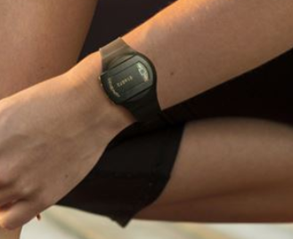
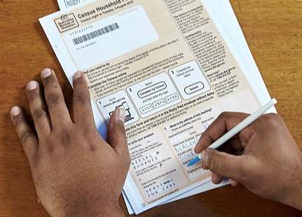
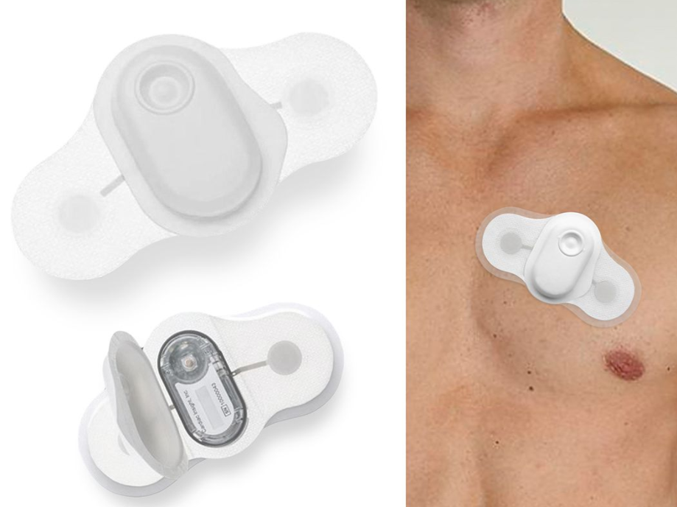

Glucose Monitor. We will ask you to wear a quarter-sized monitor on the back of your arm for up to 14 days. The monitor will measure levels of sugars in your blood. You will wear it nonstop and can bathe or shower with it on. You will fill out a daily form to record your sleep and eating times
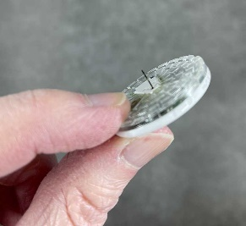

Overnight Sleep Monitor. We will put sensors on your head, neck, chest, and finger for one night of sleep. Study staff can come to your home to set up the equipment and pick it up after monitoring or you can have the equipment sent to your home with instructions.

24-Hour Blood Pressure Monitoring. We will ask you to wear a light blood pressure cuff and carry a small box on your waist for 24 hours. You will take it off to bathe. You will fill out a form to record your sleep and eating times. This blood pressure measures your blood pressure every 30 minutes over one day and night.
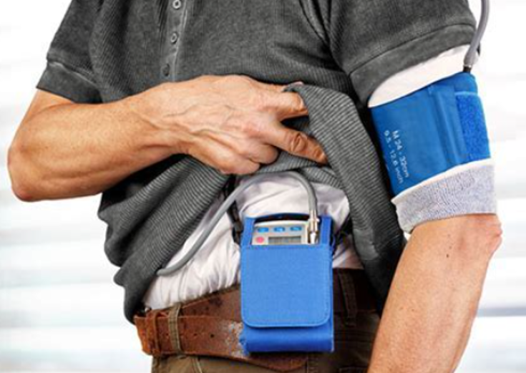

What will you do with my samples?
The samples being collected for the pilot will not be stored or, in most cases, tested. If a test is run, results will be destroyed.

Are there any risks to joining MESA Exam 7?
Yes, there are risks to joining MESA Exam 7. Review these risks carefully. Ask any questions you have.
Risk from giving blood and other samples: The most common risks of giving the blood and hair samples are brief pain and, for blood, bruising. The nasal brushing may cause brief discomfort and, occasionally, a nosebleed. Some people may feel dizzy or faint. There is also a very small risk of infection.
Risk from Spirometry. This test might make you cough or feel dizzy. The medicine to open your lung airways can make you feel shaky and make your heart beat faster.
Risk from Cognitive Assessment. These exercises may be challenging and could make you feel frustrated, bored, or tired.
Risk from Short Physical Performance Battery. This test could make you feel short of breath or feel faint.
Risk from Lung CT: This research study includes exposure to radiation that is for research purposes only. Therefore, your total radiation exposure is more than what is required for your medical care alone. This extra radiation exposure is necessary to obtain the research information desired. The amount of additional radiation that you may receive in this study is small. The cancer risk from this additional radiation is estimated to be less than 0.13%. At these low levels, scientists are uncertain as to the actual risk and there may be no risk at all. You will be asked to hold your breath during the scan.
Risk from Brain MRI. The MRI used for this test is loud. You will be given earplugs or earphones to wear. There is no radiation involved. You might feel anxious in the MRI if you do not like small spaces. The MRI machine uses a strong magnet that will attract other metals. You cannot have an MRI if you have a pacemaker, an implanted defibrillator, or other implanted electronic or metallic devices, shrapnel, or metal that is attracted to a magnet. You will be able to speak directly to the MRI technologist at all times, and the scan will be stopped at any time upon your request.
[Risk from Brain Amyloid PET. You could have brief pain or bruising from the needle used to put a dye in your blood for this test. In rare cases, the needle can cause bleeding, swelling, or a blood clot. The small amount of dye put in your arm might cause a rare reaction to the dye such as tingling or brief discomfort. While the machine’s opening is larger than the MRI, you might feel anxious if you do not like small spaces. You will be asked to hold your breath during the CT that is part of this procedure.
PET/CT imaging involves exposure to small amounts of radiation. You will receive radiation from a “low dose” CT scan which is used to help align your head position with the PET Scan. The total dose of radiation from each combined PET/CT scan will be considered to be comparable to other everyday risks.]
Risk from Activity and Sleep Monitors. The hip and wrist activity monitors could be uncomfortable. They could also irritate your skin.
Risk from Heart Rhythm Recorder. The monitor could be uncomfortable. The stickers that hold the monitors to your skin could irritate your skin. You cannot swim or go underwater when wearing the monitor.
Risk from Glucose Monitor. The most common risks of the monitor are brief pain and a low risk of bruising and infection. The sticker that holds the monitor to your skin could irritate your skin.
Risk from Overnight Sleep Study. The sleep monitors can be uncomfortable. You might have a hard time sleeping with the monitors. The stickers that hold the monitors to your skin could irritate your skin.
Risk from 24-hour Blood Pressure Monitor. The 24-hour blood pressure monitor can be uncomfortable. The blood pressure cuff will cause pressure when it inflates on your arm. It could disturb your sleep and make your skin turn red for a short time. Very rarely, the pressure could damage a nerve in your arm.
Risk to your privacy: Participating may be a risk to your privacy. If there is a data breach, someone could see or use your record without permission. There is a chance they could figure out who you are. It could impact your employment, insurance, or family relationships.. Your privacy is very important to us. We will take great care to protect it. We believe the risk to your privacy is low, but it is not zero.

Also, MESA has a Certificate of Confidentiality. This is another way to protect your privacy. It will help us fight most legal demands to give out information that could identify you. This means researchers can refuse to give out information that identifies you except if:

- there is a law that requires disclosure, such as to report child abuse and neglect, or harm to self or others;
- you give permission to disclose your information, including as described in this consent form; or
- it is used for other scientific research allowed by federal law.

Incidental Findings: Several of the tests that you are having as part of this research study are similar to, but not the same as, clinical tests that your doctor might order. The results of our tests will be reviewed by a qualified person and read to an appropriate clinical standard. Research studies are not a replacement regular clinical care you get from your health care provider
There is a possibility that, while reviewing your research tests, we may find something that we did not expect to see in this study. If this finding might be significant to your immediate health we will report this to you. This is what is called an “incidental finding.”
We will let you know if we see such an incidental finding. Depending on the type of incidental finding, we may contact you by mail or by phone. In the case of a potential serious emergency, we will make every effort to contact you in a timely manner.
A qualified member of the research team will talk to you if there is an incidental finding. You do not have an option to decline information about an incidental finding.
If you want, we will give information about this incidental finding to your health care provider, or we will refer you to an appropriate health care provider for further evaluation.
- An incidental finding may cause you to feel anxious.
- Since an incidental finding might be part of your medical record, you could face greater difficulty in getting health or life insurance.
- The costs for any care that will be needed to diagnose or treat an incidental finding would not be paid for by MESA. These costs would be your responsibility.

Will you ever give out my name or other information that identifies me?
There are a few times when we might need to give out your name or other information that identifies you.
  - We will give out information about you to protect your health or the health of others.
  - If we learn or suspect that you are being abused.
  - If we learn or suspect you are abusing, neglecting, or have abandoned someone who depends on you for care, like a child or dependent adult.
  - If we learn that you plan to harm yourself or someone else.
  - If we learn that you have a disease that is a risk to public health, like measles.
  - If we learn that you have a condition that is urgent.
- We will give out any data that the people who oversee U.S. research laws and regulations need to make sure we are following the law. This may include information that identifies you. The people who oversee research are from:
  - The Office for Human Research Protections
  - The U.S. Food and Drug Administration
  - The National Institutes of Health (NIH)
  - Other sites involved in this study, including the University of Washington Data Coordinating Center.
  - University of Washington Institutional Review Board (a committee that oversees the conduct for research involving human participants) and the University of Washington Human Research Protection Office. The Institutional Review Board has reviewed and approved this study.

Are there any benefits?
The pilot study is not medical treatment. It is a research study. If you join, you will be helping researchers organize MESA Exam 7. This may help people with health problems in the future.
We will give you some of the results from the pilot study. If you want, we will also give your healthcare team results from your exam. This may or may not help your doctors take better care of you.

Does it cost anything to participate?
You do not have to pay any money to participate. That said, if you have injuries because of participating, you will be treated for the injury. If you have to take extra time off work, you may lose wages.

Will I be paid?
The tests performed are paid for by the National Institutes of Health. You will be reimbursed for some of your travel expenses related to coming to the clinic.
If your results suggest that you need more medical treatment, you will be referred to your health care provider. If you don't have one, we will help you find a provider. We do not cover the cost of follow-up care related to the study tests. If you need follow-up care, it must be covered by you or your insurance company. We will not pay for additional medical tests.

If you are selected to complete additional exam procedures, you will be compensated for your time [this may vary by local Field Center]:

Exam 7 main components | $75
Cognitive Assessment | $75
Lung CT | $75
Brain MRI | $75
Amyloid PET imaging | $100
Activity/Sleep and Heart Monitors | $150
Glucose Monitor | $50
Overnight Sleep Monitor | $85
24-Hour Blood Pressure Monitor | $50
Total (all components) | $735

[To receive payment, you might be asked to provide your social security number, name, and address at some sites and if over $600 per year. When payments are reported to the IRS we do not let them know what the payment is for. We only tell them that you have been paid. If you do not wish to provide this information you can still take part in this study, but you will not be paid.]

What if I get hurt?
[If you get hurt because of participating in the pilot, we will pay for your care.
Insert local institutionally required language for study-related injuries in a greater than minimal risk study].
For further information contact [PI or Study Coordinator Name and Phone Number].

Do I have to join?
Joining the pilot study is voluntary. You can choose to join or not. No matter what you decide, now or in the future, it will not affect your care. You will not lose any benefits or rights. You will not be penalized.

Can I be taken out of the pilot study?
Yes, the study team can take you out of the study. They could remove you if they think it is necessary for your safety. The team will tell you if they remove you.

What if I have questions?
We encourage you to ask questions. If you have any questions, please contact: [name(s), phone number(s)].

If you have questions, concerns or complaints or would like to talk to someone outside of the study about your rights as a research participant or about your experience, contact the University of Washington Human Research Protection Office
(206) 543-0098, collect call option (206) 221-5940 or email hsdinfo@uw.edu

[SITE SPECIFIC PARTICIPANT REPORTING INFORMATION CAN BE INSERTED HERE]

A description of this clinical trial will be available on http://www.clinicaltrials.gov, as required by U.S. Law. This Web site will not include information that can identify you. At most, the Web site will include a summary of the results. You can search this Web site at any time.

This form is not a contract. You are not waiving any legal rights by agreeing to.

Remember:
- You have the right to as much time as you need to decide if you want to join Nobody is allowed to pressure you.
- You have the right to understand all of the information in this form.
- You have the right to ask questions and get answers you can understand.

If you decide to join,
- You have the responsibility to participate as best you can.
- You have the responsibility to tell us if you want to stop participating.
- You have the responsibility to follow directions as best you can.
- You have the responsibility to tell us accurate and complete information.
- You have the responsibility to tell us right away if you are having any problems related to the study.

Informed consent:

I have read this consent form. This research study has been explained to me and all of my questions have been answered. I choose to take part in pilot study.

Consent for Sharing of Information with Health Care Provider:
I agree that we may share findings important to my health from tests and examinations with my health care provider.
- Yes, I agree to allow MESA to share my results with my healthcare provider.
- No, I do not agree to allow MESA to share my results with my healthcare provider.

Consent to Cognitive Assessments and Share Results with Participant.
I agree to participate in MESA cognitive assessments which include audio recording for quality purposes, I understand that I will be paid $75 if I complete this. I permit MESA to send me a letter describing the results when the study is complete. If there are concerns about impairments, I would like another letter that I can share with my health care provider. MESA will not send this information directly to my health care provider.

- Yes, I will participate in cognitive assessments.
- No, I will not participate in cognitive assessments.

- Yes, audiotapes of my cognitive assessments can be kept to use for future studies.
- No, audiotapes of my cognitive assessment cannot be kept. Please destroy my audio recordings once records are complete.

- Yes, tell me the results of my cognitive assessments
- No, do not tell me the results of my cognitive testing.

Consent for Lung CT scan
I agree to participate in the Lung CT scan. I understand that the results of my lung CT will be shared with me and if I agree, with my health care provider. I understand that I will be paid $75 if I complete this.

- Yes, I consent to participate in the Lung CT.
- No, I do not wish to participate in the Lung CT.

Consent for Brain MRI scan
I agree to participate in the brain MRI scan. I understand that urgent results of my brain MRI will be shared with me and if I agree, with my health care provider. I understand that I will be paid $75 if I complete this.

- Yes, I consent to participate in the Brain MRI.
- No, I do not wish to participate in the Brain MRI.

[Consent for Amyloid PET scan
I agree to participate in the Amyloid PET scan. I understand that the results of my amyloid PET will be not shared with me and that I will be paid $100 if I complete this.

- Yes, I consent to participate in the Amyloid PET.
- No, I do not wish to participate in the Amyloid PET.]

Consent for Activity and Sleep Monitors, Heart Monitor Patch, Diary, and Daily Questionnaire
I consent to participate in the activity/sleep monitor, heart monitor, daily diary, and daily stress questionnaire. I understand that the results of my monitors will be shared with me and if I agree, with my health care provider. I understand that I will be paid $150 if I complete this.

- Yes, I consent to participate in the activity and heart monitor patch, daily diary, and daily stress questionnaire.
- No, I do not wish to participate in the activity and heart monitor patch, daily diary, and daily stress questionnaire.
Consent for Glucose Monitor
I agree to participate in the glucose monitoring and daily diary. I understand that the results of my glucose monitor will be shared with me and if I agree, with my health care provider. I understand that I will be paid $50 if I complete this.

- Yes, I consent to participate in the glucose monitoring and daily diary.
- No, I do not wish to participate in the glucose monitoring and daily diary.

Consent for Home Sleep Study
I agree to participate in the home sleep study and daily diary. I understand that the results of my sleep study will be shared with me and if I agree, with my health care provider. I understand that I will be paid $85 if I complete this.

- Yes, I consent to participate in the home sleep study and daily diary.
- No, I do not wish to participate in the home sleep study and daily diary.

Consent for 24-hour Blood Pressure Monitor
I agree to participate in the 24-hour blood pressure monitor and daily diary. I understand that the results of my blood pressure monitor will be shared with me and if I agree, with my health care provider. I understand that I will be paid $50 if I complete this.

- Yes, I consent to participate in the blood pressure monitor and daily diary.
- No, I do not wish to participate in the blood pressure monitor and daily diary.

Do not sign this form if today’s date is after EXPIRATION DATE: [XX/XX/XXXX].

(Signature of Participant) (Date)

(Participant's name – printed)

Statement of Person Who Obtained Consent

I reviewed this form with the person who has signed above. They have told me that they understand the risks and benefits of taking part in the study. They have told me they understand what is involved with taking part in the study. I do not have concerns that they lack capacity to consent. I have made sure that all of their questions have been answered.

(Signature of Person who Obtained Consent) (Date)

(Name of Person who Obtained Consent - printed)

Contacts and Questions:
[Insert as needed at each Field Center]

[Audio Recording of Interviews
As part of this research, if you agree, an audio recording will be made of the cognitive function test interviews. The audio recording is to assure accuracy and quality of the research tester’s assessment. The audio recordings will be stored at the coordinating center should they be needed for future MESA research studies. Any audio recordings will not be used for advertising or non-study related purposes.

You should know that:
- You may request the recording be stopped at any time.
- You can also withdraw your consent to use the audio recording before it is used.
- You should also understand that you will not be able to inspect, review, or approve the audiotape before it is used in this study.
- If you agree to allow the recording and then change your mind, you may request that the recording be destroyed. If the recording has had all identifiers removed, we may not be able to do this.
These recordings will be used for the purposes of this research and will not be used for any other reason.
Please indicate your decision below by checking the appropriate statement:

______I agree to allow the Principal Investigator and [FIELD CENTER] study team members to make and use audio recordings of me (or the participant I represent) for the purpose of this study.

______I agree that audiotapes of me (or the participant I represent) can be kept for use in future studies if they are kept secure and any future study will be reviewed by an Institutional Review Board. I understand that I will not be able to inspect, review, or approve their future use.

______I do not agree to allow the Principal Investigator and [FIELD CENTER] study team members to make and use audio recordings of me (or the participant I represent) for the purpose of this study.]

