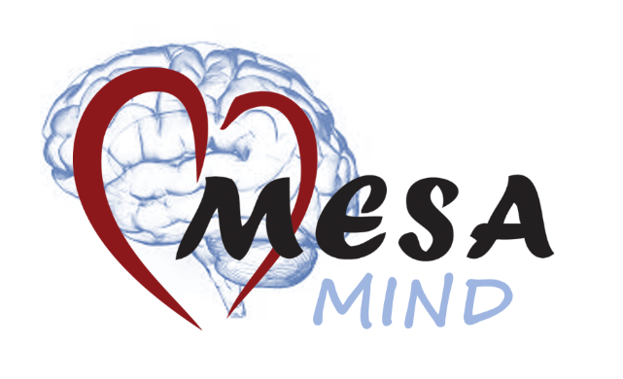
[DATE] Participant ID#

ADDRESS

Dear Mr./Ms. XXX,
Thank you for your recent participation in the Multi-Ethnic Study of Atherosclerosis (MESA). As part of the study, you had a brain MRI performed on [DATE]. As we have discussed with you, your brain MRI shows findings that may have clinical significance. [if site=JHU, We are sending you a copy of the radiologist’s interpretation of your brain MRI.] If you requested it, a copy of this letter is being sent to your doctor. You should discuss the brain MRI results with your doctor if you have not already done so.
Once again, we greatly appreciate your participation in MESA. If you have any questions, please call <Clinic Coordinator> at <clinic phone>.
Sincerely,
<Site PI name>
Principal Investigator

[cc: add doctor’s name here if copy sent]
[Date] Participant IDNO:
ADDRESS

Dear Dr. XXX,

Your patient, XXX (Date of Birth: XXX), is a participant in the Multi-Ethnic Study of Atherosclerosis (MESA). They volunteered for a research brain MRI on <insert date>, and requested that the findings be forwarded to you. Enclosed is a copy of the letter sent to NAME. XXX. [if site=UMN or NWU, “The brain MRI showed xxxxx”] [if site <> UMN or NWU, “The brain MRI findings are described on the attached report”]. Your patient may contact you to discuss these findings. Please note that these tests were performed as part of a research study to answer certain research questions. They are therefore limited in scope and may not be equivalent to tests done as a part of routine medical care.
If you have any questions, please call <study coordinator> at <clinic phone number>.

Sincerely,

<PI Name at Clinic Site>
Principal Investigator

