**MESA Exam 6 Upper Airway MRI Variable Guide,** version 1.0, 6/13/2021

**MESA Ancillary study #253, Atrial Fibrillation Study**

**PI: Susan R. Heckbert, MD, PhD, University of Washington**

**Documentation created by Brendan Keenan, Robin Nance, Richard Schwab, Andrew Wiemken**

Please acknowledge the MESA Atrial Fibrillation Ancillary Study funding in all publications that use the Upper Airway MRI data: R01 HL127659.

This data set contains one record per ancillary study participant who contributed upper airway anatomy data. The upper airway data were read from a brain MRI that took place a median of 17 months after their MESA exam 6 visit. A total of 1062 participants had brain MRIs. Upper airway measurements could not be made on the scans of 62 participants, and they are not included, leaving 1000 participants in this Upper Airway MRI data set.

Following the table of variables below are figures and documentation that show details about each variable. The column “Reference Figure” in the table of variables indicates which figure shows details, and a “c” suffix in this column indicates that the variable is calculated as a combination of two or more other variables. A list of abbreviations is provided on page 2 of this Variable Guide.

Certain variables may be of key interest to researchers, and these include soft tissue measures:

RP airway volume

RG airway volume

Epiglottis volume

Soft palate volume

Tongue volume

Pterygoid muscle volume

Fat pads volume

RP lateral walls volume

RG lateral walls volume

Tongue fat volume

And craniofacial measures:

SNA angle

SNB angle

ANB angle

Saddle angle

Upper facial height

Lower facial height

RPOG-C3 length

Hyoid/RPOG length

Hyoid/C3 length

Hyoid/S length

ACB/horizontal angle

Mandible divergence

Nasopharyngeal box area

Oropharyngeal box area

RP intermandibular volume

RG intermandibular volume

|  |  |
| --- | --- |
| **Abbreviations** | **Description** |
| RP | retropalatal - appearing on same slices as soft palate |
| RG | retroglossal - appearing on same slices as tongue |
| S | sella turcica |
| N | nasion |
| A | A point - subspinale |
| B | B point - supramentale |
| BA | basion |
| ANS | anterior nasal spine |
| PNS | posterior nasal spine |
| ME | menton |
| RPOG | retropogonion |
| C3 | most antero-inferior point of C3 |
| UFH | upper facial height |
| LFH | lower facial height |
| AFH | anterior facial height - UFH+LFH |
| IMV | area contained within mandible |
| IMVE | area contained within mandible, extended posteriorly to spine |
| LW | lateral wall |
| ACB | Anterior cranial base |

**Data Set Variables**

| **Variable** | **Variable Label** | **Units** | **Notes** | **Reference Figure** |
| --- | --- | --- | --- | --- |
| idno | Participant ID | --- | MESA ID |  |
| brainmri_tt6c | MRI: Time from baseline to brain MRI | days | Time from MESA baseline visit to upper airway and brain MRI |  |
| uamri_mandvol6 | MRI: MANDIBLE VOL. (CUBIC MM) | cubic mm | volume of mandible | 6 |
| uamri_rpawvol6 | MRI: RP AIRWAY VOL. (CUBIC MM) | cubic mm | volume of airway appearing on same slices as soft palate (retropalatal) | 1 |
| uamri_rgawvol6 | MRI: RG AIRWAY VOL. (CUBIC MM) | cubic mm | volume of airway appearing on all other slices (retroglossal) | 1 |
| uamri_epigvol6 | MRI: EPIGLOTTIS VOL. (CUBIC MM) | cubic mm | epiglottis within RoI - almost always only partially segmented | 2 |
| uamri_spvol6 | MRI: SOFT PALATE VOL. (CUBIC MM) | cubic mm | volume of soft palate | 2 |
| uamri_gtongvol6 | MRI: TONGUE (GENIOGLOSSUS) VOL. (CUBIC MM) | cubic mm | volume of genioglossus+intrinsic muscles (main body of tongue) | 2 |
| uamri_otongvol6 | MRI: OTHER TONGUE MUSCLES VOL. (CUBIC MM) | cubic mm | volume of all extrinsic muscles except genioglossus combined | 2 |
| uamri_ptervol6 | MRI: PTERYGOID MUSCLE VOL. (CUBIC MM) | cubic mm | volume of medial pterygoids | 2 |
| uamri_fpadvol6 | MRI: FAT PADS VOL. (CUBIC MM) | cubic mm | volume of parapharyngeal fat pads appearing in RoI | 2 |
| uamri_rplwvol6 | MRI: RP LATERAL WALLS VOL. (CUBIC MM) | cubic mm | volume of lateral pharyngeal walls appearing on same slices as soft palate | 2 |
| uamri_rglwvol6 | MRI: RG LATERAL WALLS VOL. (CUBIC MM) | cubic mm | volume of lateral pharyngeal walls on all other slices | 2 |
| uamri_tfatvol6 | MRI: TONGUE FAT VOL. (CUBIC MM) | cubic mm | volume of fat within genioglossus and intrinsic muscles | 11 |
| uamri_spfatvol6 | MRI: SOFT PALATE FAT VOL. (CUBIC MM) | cubic mm | volume of fat within soft palate |  |
| uamri_sna6 | MRI: SNA (DEGREES) | degrees | angle between landmarks | 3 |
| uamri_snb6 | MRI: SNB (DEGREES) | degrees | angle between landmarks | 3 |
| uamri_anb6c | MRI: ANB (DEGREES) | degrees | angle between landmarks - functionally this is SNA-SNB | 3c |
| uamri_skclass6c | MRI: SKELETAL CLASS (1,2,3) | --- | categorical indicator of retrognathia, based on value of ANB. 1=normal, 2=retrognathia, 3=prognathia | 3c |
| uamri_sadlang6 | MRI: SADDLE ANGLE (N-S-BA) (DEGREES) | degrees | angle between landmarks | 3 |
| uamri_ufh6 | MRI: UPPER FACIAL HEIGHT (N-ANS) (MM) | mm | distance between landmarks | 4 |
| uamri_lfh6 | MRI: LOWER FACIAL HEIGHT (ANS-ME) (MM) | mm | distance between landmarks | 4 |
| uamri_afh6c | MRI: ANT. FACIAL HEIGHT (UFH+LFH) (MM) | mm | UFH+LFH | 4c |
| uamri_ufhafh6c | MRI: UFH/AFH | --- | ratio of UFH/AFH | 4c |
| uamri_rpogc36 | MRI: RPOG-C3 (MM) | mm | distance between landmarks | 5 |
| uamri_hyoidrpog6 | MRI: HYOID BONE-RPOG (MM) | mm | distance between landmarks | 5 |
| uamri_hyoidc36 | MRI: HYOID BONE-C3 (MM) | mm | distance between landmarks | 5 |
| uamri_hyoidsel6 | MRI: HYOID BONE-S (MM) | mm | distance between landmarks | 5 |
| uamri_pnsaaa6 | MRI: PNS-ANTERIOR ARCH ATLAS (MM) | mm | distance between landmarks | 4 |
| uamri_pphor6 | MRI: PALATAL PLANE-HORIZONTAL (DEGREES) | degrees | angle between landmarks | 10 |
| uamri_acbhor6 | MRI: ACB-HORIZONTAL (DEGREES) | degrees | angle between landmarks | 3 |
| uamri_anspnssel6c | MRI: ANS-PNS-SELLA-NASION (DEGREES) | degrees | difference between PP/Horiz and ACB/Horiz | c |
| uamri_mandlencor6 | MRI: MAND LENGTH CORPUS (MM) | mm | gonion to menton | 6 |
| uamri_mandlenram6 | MRI: MAND LENGTH RAMUS (MM) | mm | gonion to condyle | 6 |
| uamri_mandlen6c | MRI: TOTAL MAND LENGTH (MM) | mm | sum of corpus and ramus length | 6c |
| uamri_manddiv6 | MRI: MAND DIVERGENCE (DEGREES) | degrees | gonion-menton-gonion | 6 |
| uamri_mandwcan6 | MRI: MAND WIDTH CANINE (MM) | mm | width between landmarks | 6 |
| uamri_mandw1pm6 | MRI: MAND WIDTH 1ST PREMOLAR (MM) | mm | width between landmarks | 6 |
| uamri_mandw2pm6 | MRI: MAND WIDTH 2ND PREMOLAR (MM) | mm | width between landmarks | 6 |
| uamri_mandw1m6 | MRI: MAND WIDTH 1ST MOLAR (MM) | mm | width between landmarks | 6 |
| uamri_mandw2m6 | MRI: MAND WIDTH 2ND MOLAR (MM) | mm | width between landmarks | 6 |
| uamri_mandwigon6 | MRI: MAND WIDTH INNER GONION (MM) | mm | width between landmarks | 6 |
| uamri_manddepth6 | MRI: MAND DEPTH (MM) | mm | axial depth of mandible from incisors to gonion line | 6 |
| uamri_mandwcond6 | MRI: MAND WIDTH CONDYLE (MM) | mm | width between landmarks | 6 |
| uamri_maxdiv6 | MRI: MAX DIVERGENCE (DEGREES) | degrees | tuberosity-incisors-tuberosity | 7 |
| uamri_maxwcan6 | MRI: MAX WIDTH CANINE (MM) | mm | width between landmarks | 7 |
| uamri_maxw1pm6 | MRI: MAX WIDTH 1ST PREMOLAR (MM) | mm | width between landmarks | 7 |
| uamri_maxw2pm6 | MRI: MAX WIDTH 2ND PREMOLAR (MM) | mm | width between landmarks | 7 |
| uamri_maxw1m6 | MRI: MAX WIDTH 1ST MOLAR (MM) | mm | width between landmarks | 7 |
| uamri_maxw2m6 | MRI: MAX WIDTH 2ND MOLAR (MM) | mm | width between landmarks | 7 |
| uamri_maxwtub6 | MRI: MAX WIDTH TUBEROSITY (MM) | mm | width between landmarks | 7 |
| uamri_maxdepth6 | MRI: MAX UNIT DEPTH (MM) | mm | width between landmarks | 7 |
| uamri_mandisurf6 | MRI: MAND INNER SURFACE (SQUARE MM) | square mm | maximum single-slice axial surface area within mandible | 6 |
| uamri_nasobox6 | MRI: NASOPHARYNGEAL BOX (SQUARE MM) | square mm | triangle between Nasion-ANS-Basion | 8 |
| uamri_orobox6 | MRI: OROPHARYNGEAL BOX (SQUARE MM) | square mm | quadrilateral between Nasion-Basion-C3-Menton | 8 |
| uamri_nasoorobox6c | MRI: NASO-OROPHARYNGEAL BOX (SQUARE MM) | square mm | sum of naso+oro boxes | 8c |
| uamri_rpimv6 | MRI: RP IMV (INCL. AIRWAY) (CUBIC MM) | cubic mm | area contained within mandible, retropalatal slices | 9 |
| uamri_rgimv6 | MRI: RG IMV (INCL. AIRWAY) (CUBIC MM) | cubic mm | area contained within mandible, retroglossal slices | 9 |
| uamri_rpimve6 | MRI: RP IMV-E (INCL. AIRWAY) (CUBIC MM) | cubic mm | area contained within mandible, extended to spine, retropalatal | 9 |
| uamri_rgimve6 | MRI: RG IMV-E (INCL. AIRWAY) (CUBIC MM) | cubic mm | area contained within mandible, extended to spine, retroglossal | 9 |
| uamri_imv6c | MRI: IMV (INCL. AIRWAY) (CUBIC MM) | cubic mm | RP+RG IMV | 9c |
| uamri_imve6c | MRI: IMV-E (INCL. AIRWAY) (CUBIC MM) | cubic mm | RP+RG IMVE | 9c |
| uamri_rpawminarea6 | MRI: MIN AREA IN RP AIRWAY (SQUARE MM) | square mm | minimum axial cross-sectional area in retropalatal airway | 1 |
| uamri_rpawminap6 | MRI: RP MIN AP DIST. (MM) | mm | anterior-posterior dimension of minimum area slice, retropalatal airway | 1 |
| uamri_rpawminlat6 | MRI: RP MIN LATERAL DIST. (MM) | mm | lateral dimension of minimum area slice, retropalatal airway | 1 |
| uamri_rgawminarea6 | MRI: MIN AREA IN RG AIRWAY (SQUARE MM) | square mm | minimum axial cross-sectional area in retroglossal airway | 1 |
| uamri_rgawminap6 | MRI: RG MIN AP DIST. (MM) | mm | anterior-posterior dimension of minimum area slice, retroglossal airway | 1 |
| uamri_rgawminlat6 | MRI: RG MIN LATERAL DIST. (MM) | mm | lateral dimension of minimum area slice, retroglossal airway | 1 |
| uamri_rpslices6 | MRI: # OF RP SLICES | --- | integer of slice count in retropalatal region |  |
| uamri_rgslices6 | MRI: # OF RG SLICES | --- | integer of slice count in retroglossal region |  |
| uamri_ttongvol6c | MRI: TOTAL TONGUE VOL. (CUBIC MM) | cubic mm | other tongue+tongue combined | 2c |
| uamri_lwvol6c | MRI: TOTAL LW VOL. (CUBIC MM) | cubic mm | RP+RG lateral walls | 2c |
| uamri_tstvol6c | MRI: TOTAL SOFT TISSUE VOL. (CUBIC MM) | cubic mm | all soft tissue combined | 2c |
| uamri_tfatpct6c | MRI: TONGUE FAT PERCENTAGE (PERCENT) | percent | tongue fat volume/tongue volume | c |
| uamri_spfatpct6c | MRI: SOFT PALATE FAT PERCENTAGE (PERCENT) | percent | soft palate fat volume/soft palate volume | c |
| uamri_awvol6c | MRI: TOTAL AIRWAY VOLUME (CUBIC MM) | cubic mm | UAMRI_RPAWVOL6 + UAMRI_RGAWVOL6 | c |
| uamri_awcsa6c | MRI: AIRWAY CROSS-SECTIONAL AREA (SQUARE MM) | square mm | (UAMRI_AWVOL6C / (UAMRI_RPSLICES6 + UAMRI_RGSLICES6))/3 | c |
| uamri_awlen6c | MRI: TOTAL AIRWAY LENGTH (MM) | mm | (UAMRI_RPSLICES6 + UAMRI_RGSLICES6)*3 | c |
| uamri_rpawcsa6c | MRI: RP AIRWAY CROSS-SECTIONAL AREA (SQUARE MM) | square mm | (UAMRI_RPAWVOL6 / UAMRI_RPSLICES6)/3 | c |
| uamri_rgawcsa6c | MRI: RG AIRWAY CROSS-SECTIONAL AREA (SQUARE MM) | square mm | (UAMRI_RGAWVOL6 / UAMRI_RGSLICES6)/3 | c |
| uamri_notes6 | MRI: NOTES | --- | notes |  |

Reference Figures.

Figure 1.

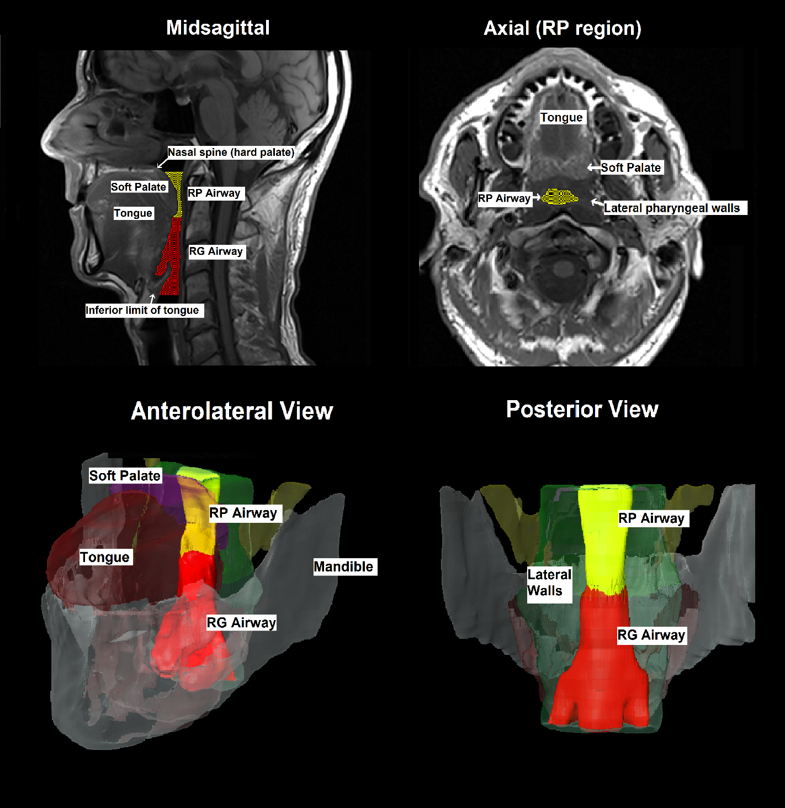

3 mm axial and 5mm sagittal magnetic resonance images (MRI; T1-weighted, spin echo images) and 3D reconstructions derived from axial MRI, showing methods of volumetric measurement of airway. Airway is separated into retropalatal (RP, defined as at the axial level of the soft palate) and retroglossal (RG, defined as inferior to RP and posterior to the tongue) regions. Volume is measured slice-by-slice on axial scans using Amira image analysis software. Sagittal scan is included to picture full airway and regions and 3D reconstruction is included to show anatomical context.

Figure 2.

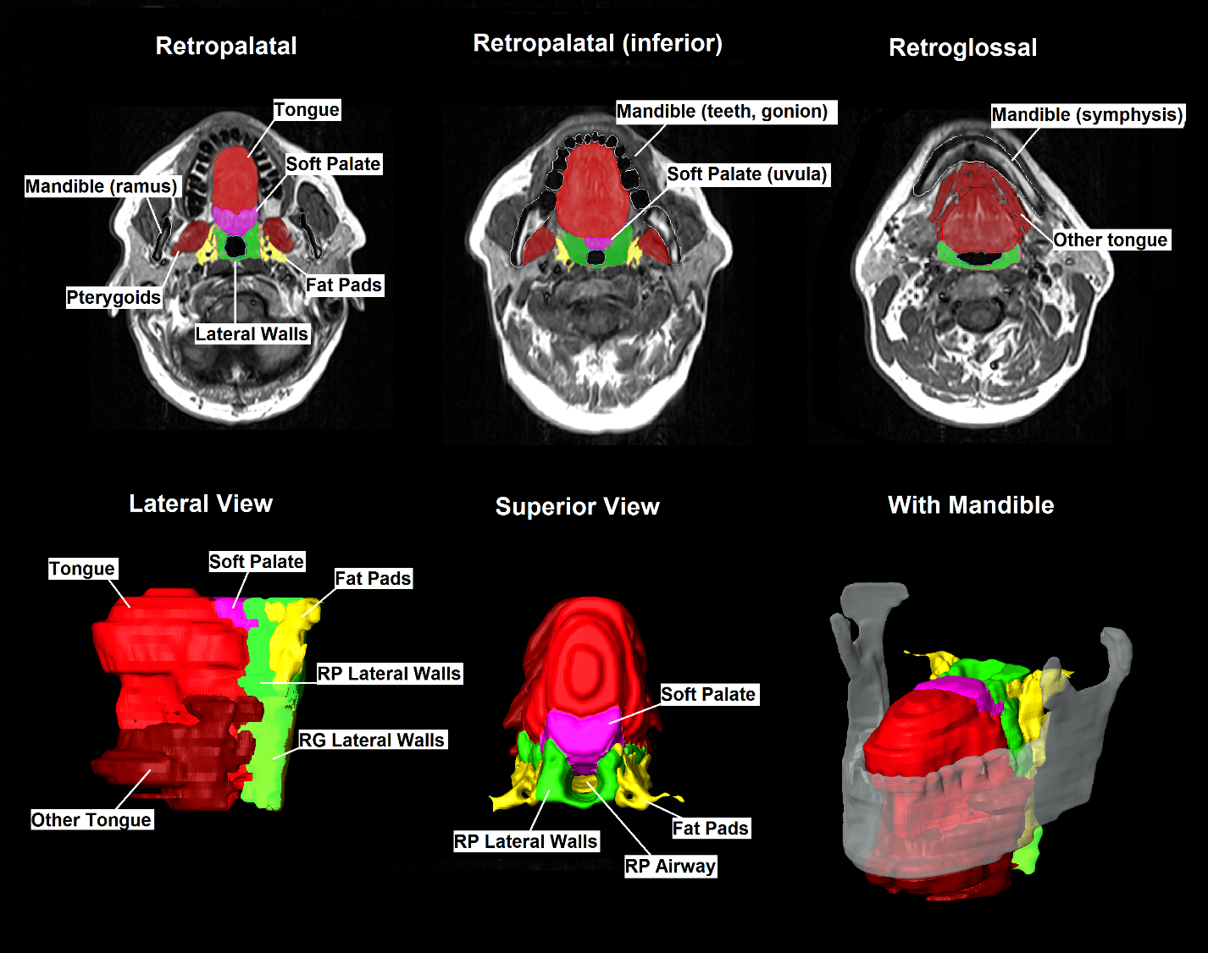

Axial 3mm MRI slices (T1, spin echo) and three-dimensional reconstructions of upper airway soft tissue structure. Soft tissue structures measured are: tongue {genioglossus muscle}, soft palate, lateral parapharyngeal walls (separated into retropalatal {RP} and retroglossal {RG} regions), parapharyngeal fat pads, pterygoid muscles, epiglottis, and other tongue muscles (hyoglossus, styloglossus, mylohyoid, geniohyoid, digastric). Volumetric measurements are acquired slice-by-slice on axial MR images using Amira software. 3D reconstructions are rendered from axial analysis volumes, and are included to show anatomical context.

Figure 3.

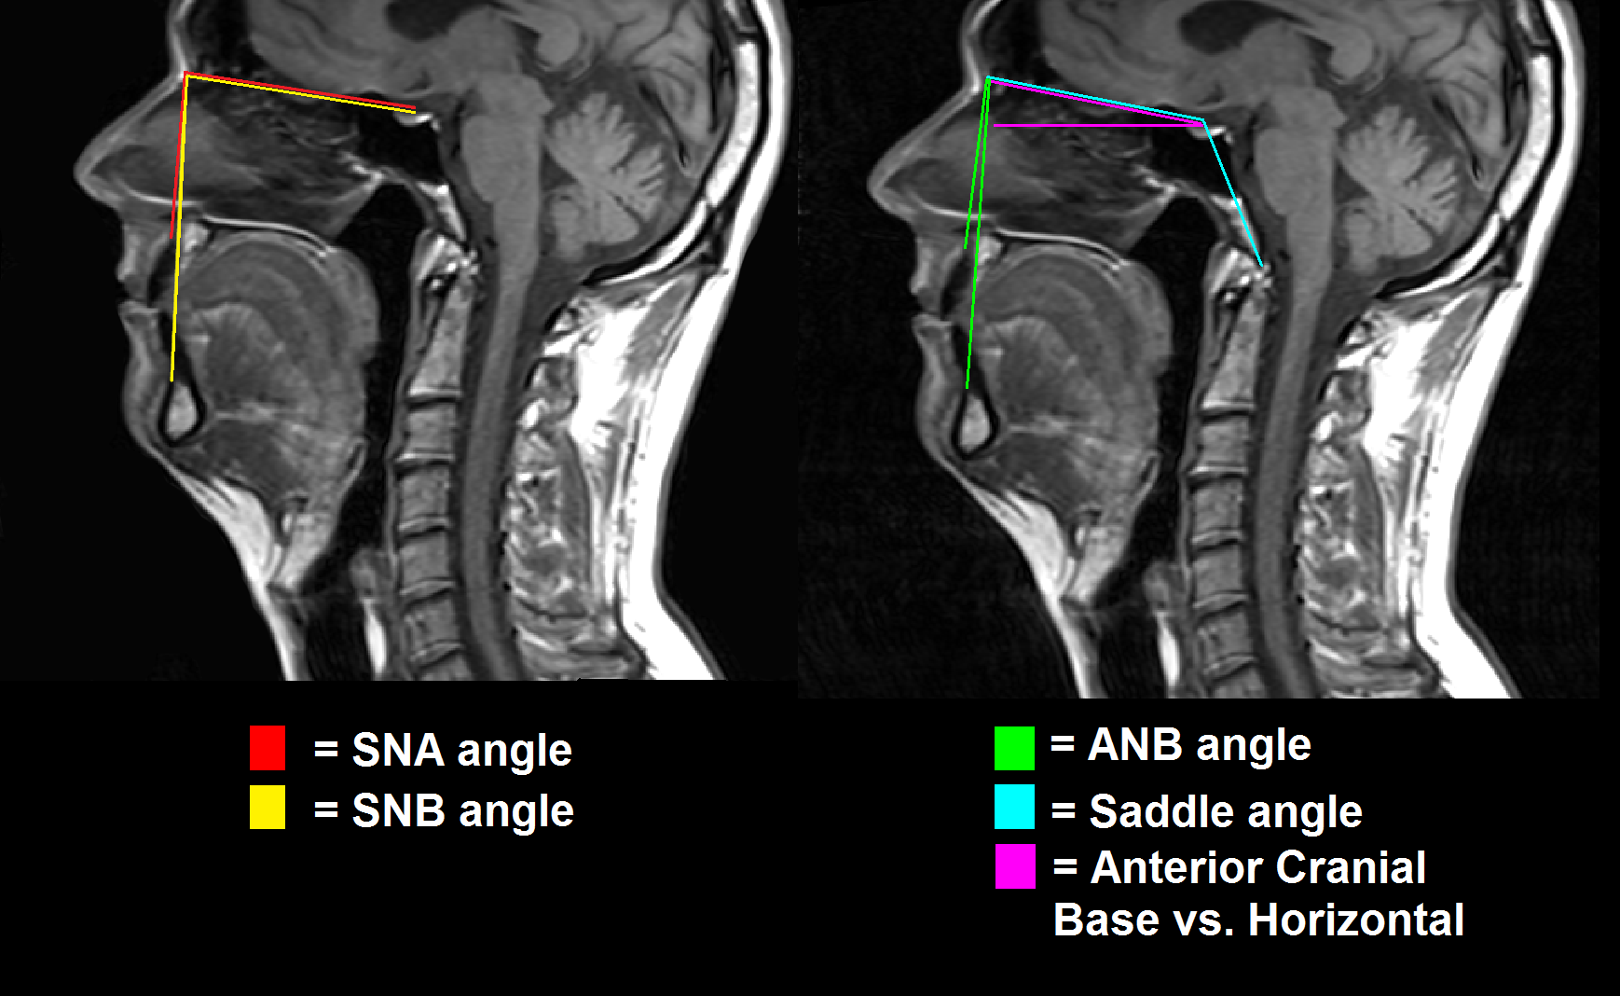

Midsagittal 5mm magnetic resonance images (T1, spin echo) showing craniofacial angle measurements. Craniofacial points are: nasion (N), the most anterior aspect of the frontonasal suture; sella (S), the most anterior–inferior point of the sella turcica; supramentale (B), the deepest point on the curvature of the facial surface of the mandibular symphysis; subspinale (A), the deepest point on the curvature of the facial surface of the maxilla (premaxilla); and basion, midpoint on the anterior margin of the foramen magnum. The angles measured were: the sella–nasion–subspinale (SNA) angle (red lines); the sella–nasion–supramentale (SNB) angle (yellow lines); ANB (subspinale-nasion-supramentale) angle, i.e. the difference between the SNA and SNB angles (green lines); anterior cranial base (sella to nasion) vs. horizontal plane (magenta lines); and nasion-sella-basion (saddle angle, cyan lines). Analysis is performed on the mid-sagittal MRI slice.

Figure 4.

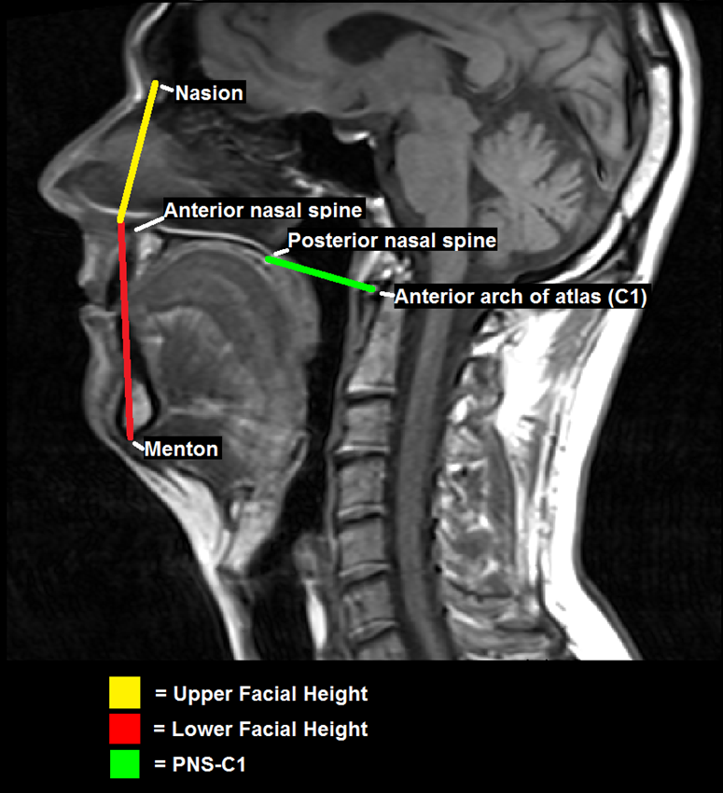

Midsagittal 5mm magnetic resonance images (T1, spin echo) showing facial height measurements. Craniofacial points are: nasion, the most anterior aspect of the frontonasal suture; menton, the most inferior point of the mandibular symphysis; the most anterior point of the nasal spine; the most posterior point of the nasal spine; and the centroid of the anterior arch of the atlas, a feature of first cervical vertebra (C1). Upper facial height (UFH, yellow lines) is defined as the straight line distance between the nasion and anterior nasal spine. Lower facial height (LFH, red lines) is the distance between anterior nasal spine and menton. Anterior facial height (not pictured) is the exact sum of upper and lower heights, and a ratio (unpictured) is taken of UFH/AFH. A final measurement is taken comprising a line between the posterior nasal spine and C1. Analysis is performed on the mid-sagittal MRI slice.

Figure 5.

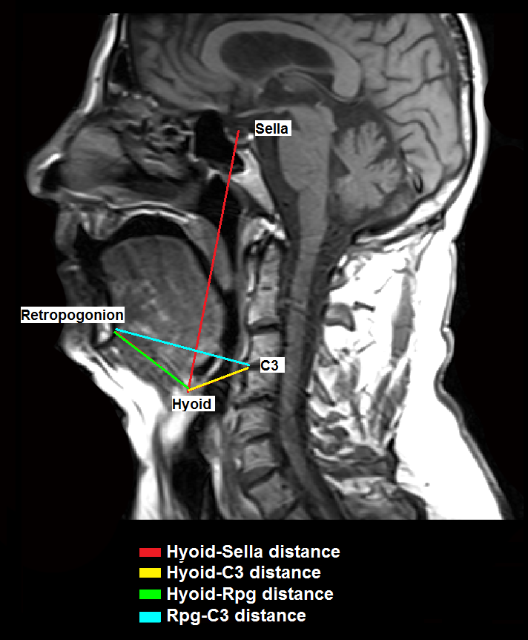

Midsagittal 5mm magnetic resonance images (T1, spin echo) showing hyoid measurements. Craniofacial points are: sella, the most anterior–inferior point of the sella turcica; hyoid, centroid of the visible cross-section of the hyoid bone; C3, the most anterior-inferior point of the third cervical vertebra; and Retropogonion (Rpg), the most posterior point of the inner surface of the mandibular symphysis. The four measurements are measured as straight line distances between respective craniofacial points. Analysis is performed on the mid-sagittal MRI slice.

Figure 6.

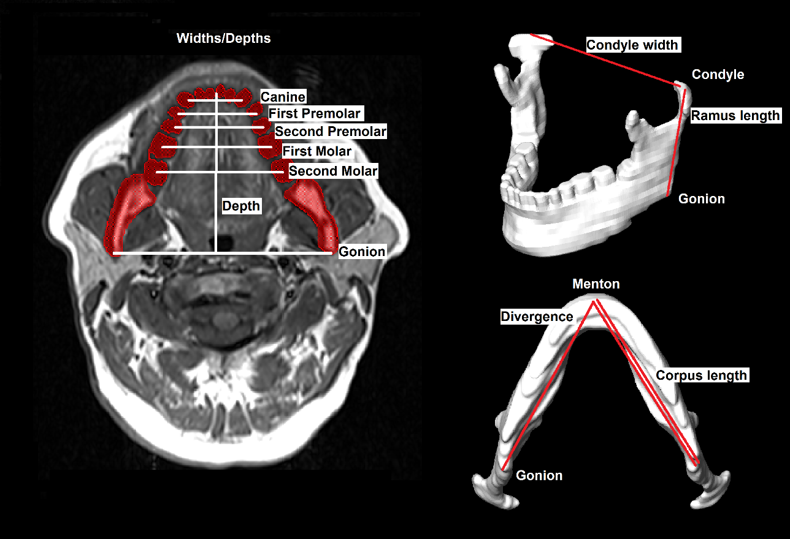

Axial MRI (3mm, T1, spin echo) slice and three-dimensional reconstruction of mandible. Craniofacial points are: gonion, located at the lowest, posterior, and lateral point on the mandibular angle; menton, the most inferior point on the mandibular symphysis; condyle, the most superior point on the mandibular ramus; canines, the centroids of the mandibular canines; premolars, the centroids of the first and second premolars; molars, the centroids of the first and second molars; and the most anterior point of the mandible on the occlusal plane (generally between the mandibular central incisors). Corpus length is measured from menton to gonion. Ramus length is measured from gonion to condyle. Divergence is measured as an angle with its apex at the menton and lines extending directly to each gonion. Mandibular widths are measured between the canines, first and second premolars, first and second molars, gonions and condyles. Mandibular depth is measured from the most anterior point of the mandible on the occlusal plane to the line marking gonion width, perpendicular to that line. Lengths, widths, and divergence are measured from the surface of a three-dimensional reconstruction of the mandible derived from axial MRI; widths are shown here on axial MRI for clarity.

Figure 7.

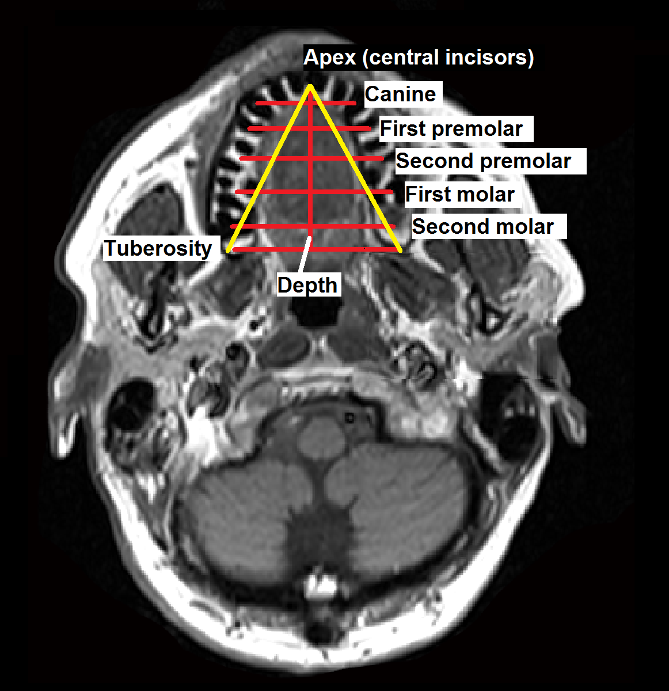

Axial 3mm magnetic resonance images (T1, spin echo) showing maxilla measurements. Craniofacial points include: tuberosity, the most posterior point of the maxillary tuberosity; canines, the centroids of the maxillary canines; premolars, the centroid of the first and second premolars; molars, the centroids of the first and second molars; and the point between the roots of the central maxillary incisors. Maxillary widths are measured between teeth and tuberosities. Divergence is measured as an angle with its apex between the roots of the central maxillary incisors and lines extending to each tuberosity. Maxillary depth is measured from the roots of the central maxillary incisors to the tuberosity width, perpendicular to that line. Analysis is performed on the axial MRI slice showing the clearest, most pronounced image of the maxillary roots.

Figure 8.

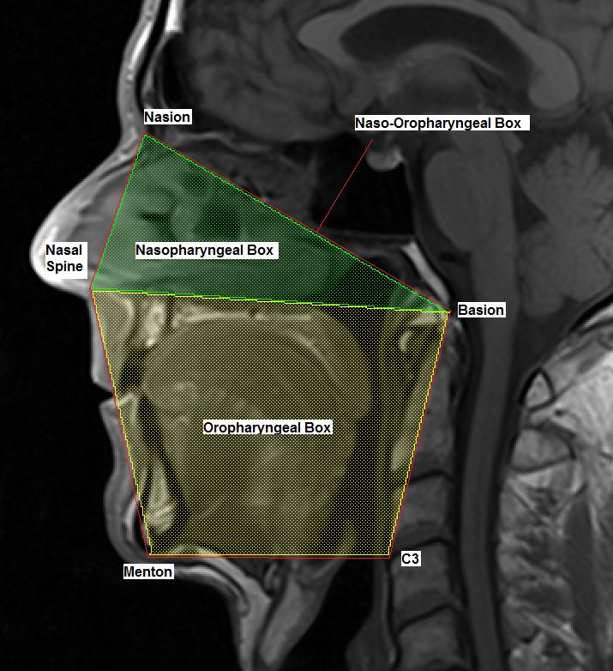

Midsagittal 5mm magnetic resonance image (T1, spin echo) showing method of measuring nasopharyngeal and oropharyngeal boxes. Craniofacial points are: Basion, midpoint on the anterior margin of the foramen magnum; Nasion, the most anterior aspect of the frontonasal suture; Nasal spine at most anterior point; Menton, the most inferior point on the mandibular symphysis; C3, the most anterior-inferior point of the third cervical vertebra. The Nasopharyngeal box is defined by the nasal spine, nasion, and basion. The Oropharyngeal box is defined by the nasal spine, basion, C3, and menton. Naso-Oropharyngeal box is an exact sum of the two. Analysis is performed on the mid-sagittal MRI slice.

Figure 9.

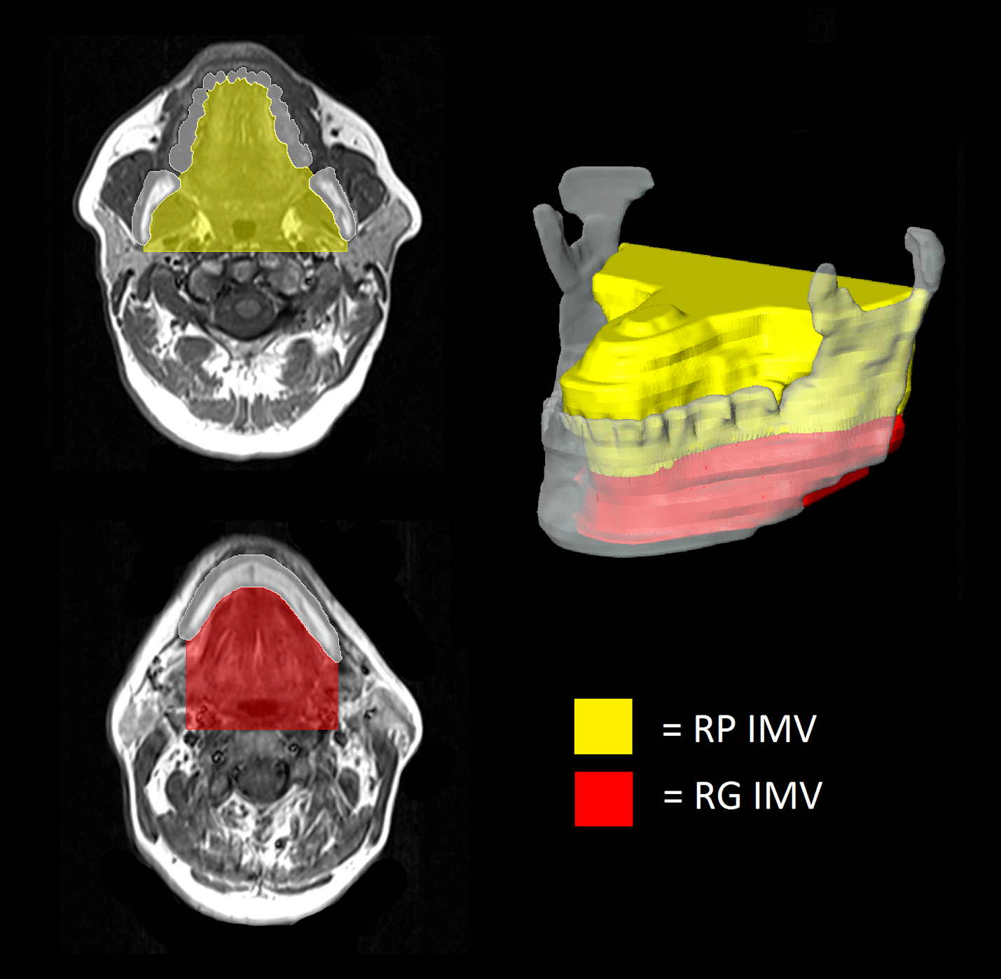

Axial MRI (3mm, T1, Spin-echo) and 3D reconstruction showing intramandibular volume (IMV), separated into retropalatal (RP) and retroglossal (RG) regions. The IMV is defined as any space bordered laterally by two sections of the mandible; this space is extended backward rectangularly to the anterior border of the cervical spine, while maintaining its lateral dimensions, and includes all portions of the soft palate and tongue regardless of their appearance within this defined space. Analysis of IMV is performed slice-by-slice on axial MRI. A 3D reconstruction is included to demonstrate context within the mandible.

Figure 10.

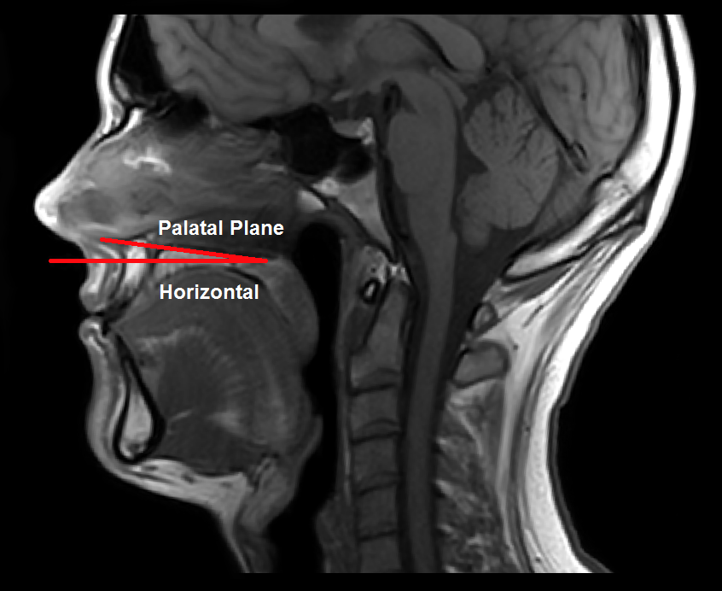

PALATAL PLANE-HORIZONTAL ANGLE

Figure 11.

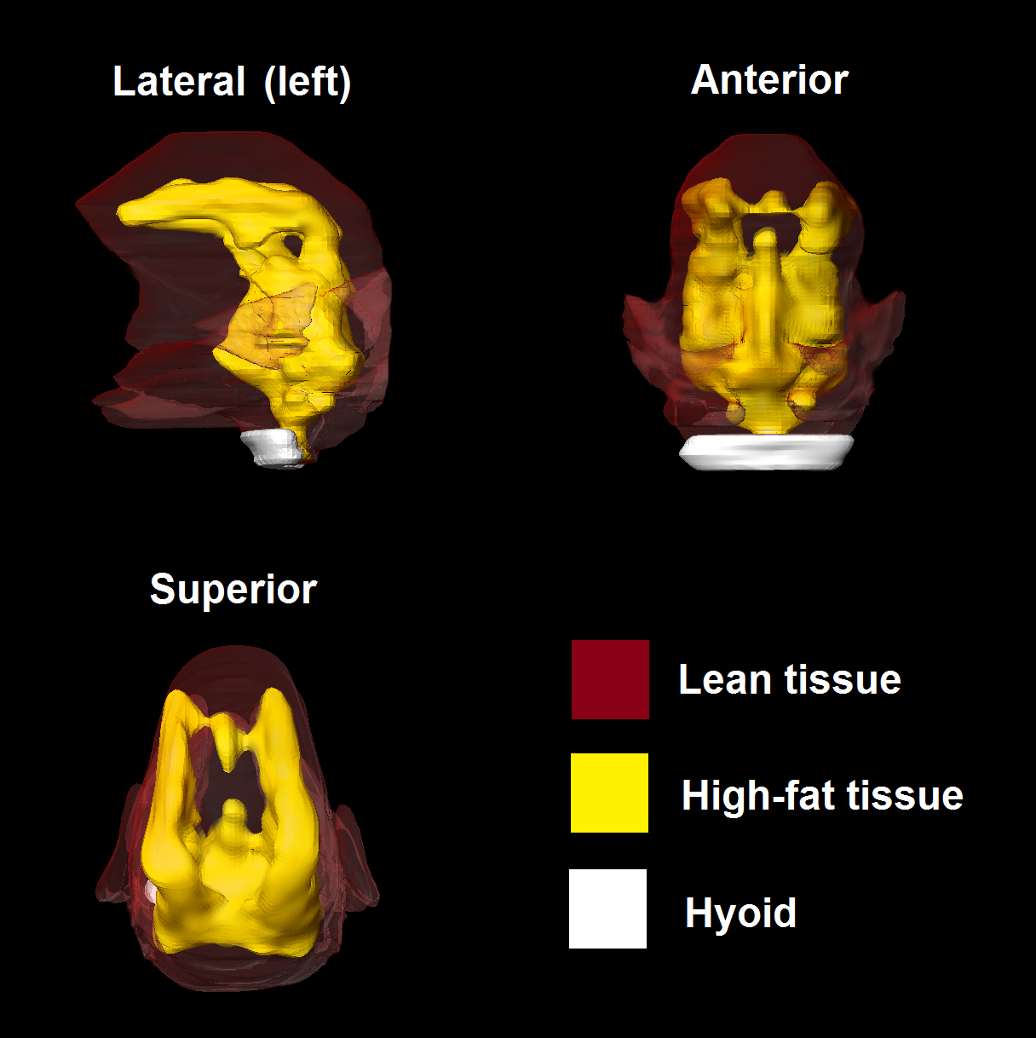

Tongue fat