MESA Exam 5 Ancillary Study 113 Sleep Questionnaire Data Set Variable Guide

Data Set name : | MESAe5_SleepQ_20140617
Principal Investigator : | Susan Redline
Contact Information : | sredline1@rics.bwh.harvard.edu

Order | Variable | Variable Description | Value Labels
1 | idno | PARTICIPANT ID NUMBER
2 | bedtmwkday5c | BEDTIME WEEKDAY (24 HOUR FORMAT) | Please note: Hour : Minute (HH:MM) date format may not have been preserved for STATA program users. Please contact CC for further guidance.
3 | waketmwkday5c | WAKETIME WEEKDAY (24 HOUR FORMAT)
4 | wkdaysleepdur5c | SLEEP DURATION WEEKDAY (HOURS:MINUTES)
5 | wkdaysleepdur5t | SLEEP DURATION WEEKDAY (HOURS)
6 | bedtmwkend5c | BEDTIME WEEKEND (24 HOUR FORMAT) | Please note: Hour : Minute (HH:MM) date format may not have been preserved for STATA program users. Please contact CC for further guidance.
7 | waketmwkend5c | WAKETIME WEEKEND (24 HOUR FORMAT)
8 | wkendsleepdur5c | SLEEP DURATION WEEKEND (HOURS:MINUTES)
9 | wkendsleepdur5t | SLEEP DURATION WEEKEND (HOURS)
10 | nap5 | USUAL WEEK: NUMBER OF NAPS (5 MINUTES OR MORE) | 0: NONE  1: ONE OR MORE TIMES
11 | trbleslpng5 | PAST 4 WEEKS: TROUBLE FALLING ASLEEP | 1: NO, NOT IN THE PAST 4 WEEKS  2: YES, LESS THAN ONCE A WEEK  3: YES, 1 OR 2 TIMES A WEEK  4: YES, 3 OR 4 TIMES A WEEK  5: YES, 5 OR MORE TIMES A WEEK
12 | wakeup5 | PAST 4 WEEKS: WAKE UP SEVERAL TIMES A NIGHT | 1: NO, NOT IN THE PAST 4 WEEKS  2: YES, LESS THAN ONCE A WEEK  3: YES, 1 OR 2 TIMES A WEEK  4: YES, 3 OR 4 TIMES A WEEK  5: YES, 5 OR MORE TIMES A WEEK
13 | wakeearly5 | PAST 4 WEEKS: WAKE UP EARLIER THAN PLANNED | 1: NO, NOT IN THE PAST 4 WEEKS  2: YES, LESS THAN ONCE A WEEK  3: YES, 1 OR 2 TIMES A WEEK  4: YES, 3 OR 4 TIMES A WEEK  5: YES, 5 OR MORE TIMES A WEEK
14 | bcksleep5 | PAST 4 WEEKS: TROUBLE GETTING BACK TO SLEEP AFTER YOU WAKING TOO EARLY | 1: NO, NOT IN THE PAST 4 WEEKS  2: YES, LESS THAN ONCE A WEEK  3: YES, 1 OR 2 TIMES A WEEK  4: YES, 3 OR 4 TIMES A WEEK  5: YES, 5 OR MORE TIMES A WEEK
15 | slpngpills5 | PAST 4 WEEKS: TAKE SLEEPING PILLS TO HELP SLEEP | 1: NO, NOT IN THE PAST 4 WEEKS  2: YES, LESS THAN ONCE A WEEK  3: YES, 1 OR 2 TIMES A WEEK  4: YES, 3 OR 4 TIMES A WEEK  5: YES, 5 OR MORE TIMES A WEEK
16 | irritable5 | PAST 4 WEEKS: HAVE SLEEP DIFFICULTIES CAUSING IRRITABILITY | 1: NO, NOT IN THE PAST 4 WEEKS  2: YES, LESS THAN ONCE A WEEK  3: YES, 1 OR 2 TIMES A WEEK  4: YES, 3 OR 4 TIMES A WEEK  5: YES, 5 OR MORE TIMES A WEEK
17 | sleepy5 | PAST 4 WEEKS: FEEL OVERLY SLEEPY DURING DAY | 1: NO, NOT IN THE PAST 4 WEEKS  2: YES, LESS THAN ONCE A WEEK  3: YES, 1 OR 2 TIMES A WEEK  4: YES, 3 OR 4 TIMES A WEEK  5: YES, 5 OR MORE TIMES A WEEK
18 | typicalslp5 | PAST 4 WEEKS: OVERALL TYPICAL NIGHT SLEEP | 0: VERY SOUND OR RESTFUL  1: SOUND AND RESTFUL  2: AVERAGE QUALITY  3: RESTLESS  4: VERY RESTLESS
19 | readng5 | CHANCE OF DOZING / FALL ASLEEP WHILE: SITTING AND READING | 1: NO CHANCE  2: SLIGHT CHANCE  3: MODERATE CHANCE  4: HIGH CHANCE
20 | tv5 | CHANCE OF DOZING / FALL ASLEEP WHILE: WATCHING TV | 1: NO CHANCE  2: SLIGHT CHANCE  3: MODERATE CHANCE  4: HIGH CHANCE
21 | sittng5 | CHANCE OF DOZING / FALL ASLEEP WHILE: SITTING INACTIVE IN PUBLIC | 1: NO CHANCE  2: SLIGHT CHANCE  3: MODERATE CHANCE  4: HIGH CHANCE
22 | riding5 | CHANCE OF DOZING / FALL ASLEEP WHILE: RIDING AS PASSENGER IN CAR | 1: NO CHANCE  2: SLIGHT CHANCE  3: MODERATE CHANCE  4: HIGH CHANCE
23 | lyngdwn5 | CHANCE OF DOZING / FALL ASLEEP WHILE: LYING DOWN TO REST IN AFTERNOON | 1: NO CHANCE  2: SLIGHT CHANCE  3: MODERATE CHANCE  4: HIGH CHANCE
24 | talkng5 | CHANCE OF DOZING / FALL ASLEEP WHILE: SITTING AND TALKING TO SOMEONE | 1: NO CHANCE  2: SLIGHT CHANCE  3: MODERATE CHANCE  4: HIGH CHANCE
25 | quietly5 | CHANCE OF DOZING / FALL ASLEEP WHILE: SITTING QUIETLY AFTER LUNCH (NO ALCOHOL) | 1: NO CHANCE  2: SLIGHT CHANCE  3: MODERATE CHANCE  4: HIGH CHANCE
26 | car5 | CHANCE OF DOZING / FALL ASLEEP WHILE: IN CAR STOPPED IN TRAFFIC | 1: NO CHANCE  2: SLIGHT CHANCE  3: MODERATE CHANCE  4: HIGH CHANCE
27 | dinner5 | CHANCE OF DOZING / FALL ASLEEP WHILE: AT DINNER TABLE | 1: NO CHANCE  2: SLIGHT CHANCE  3: MODERATE CHANCE  4: HIGH CHANCE
28 | driving5 | CHANCE OF DOZING / FALL ASLEEP WHILE: WHILE DRIVING | 1: NO CHANCE  2: SLIGHT CHANCE  3: MODERATE CHANCE  4: HIGH CHANCE
29 | snored5 | PAST 4 WEEKS: SNORED | 1: NEVER  2: RARELY (1-2 NIGHTS A WEEK)  3: SOMETIMES (3-5 NIGHTS A WEEK)  4: ALWAYS OR ALMOST ALWAYS (6-7 NIGHTS A WEEK)  9: DON'T KNOW
30 | stpbrthng5 | PAST 4 WEEKS: STOP BREATHING DURING SLEEP | 1: NEVER  2: RARELY (1-2 NIGHTS A WEEK)  3: SOMETIMES (3-5 NIGHTS A WEEK)  4: ALWAYS OR ALMOST ALWAYS (6-7 NIGHTS A WEEK)  9: DON'T KNOW
31 | legsdscmfrt5 | EXPERIENCE DESIRE TO MOVE LEGS BECAUSE OF DISCOMFORT / DISAGREEABLE SENSATIONS IN LEGS | 0: NO  1: YES  9: DO NOT KNOW
32 | rubbnglgs5 | FEEL NEED TO MOVE TO RELIEVE DISCOMFORT BY WALKING OR RUB LEGS | 0: NO  1: YES  9: DO NOT KNOW
33 | wrserest5 | SYMPTOMS WORSE WHEN AT REST WITH TEMPORARY RELIEF BY ACTIVITY | 0: NO  1: YES  9: DO NOT KNOW
34 | wrseltr5 | SYMPTOMS WORSE LATER IN DAY OR NIGHT | 0: NO  1: YES  9: DO NOT KNOW
35 | feelngbstr5 | TIME OF DAY FEELING BEST | 1: 5:00 - 6:30 AM  2: 6:30 - 7:45 AM  3: 7:45 - 9:45 AM  4: 9:45 - 11:00 AM  5: AFTER 11:00 AM
36 | tired5 | HOW TIRED DURING FIRST HALF HOUR AFTER HAVING WOKEN IN MORNING | 1: VERY TIRED  2: FAIRLY TIRED  3: FAIRLY REFRESHED  4: VERY REFRESHED
37 | mosttired4 | TIME IN EVENING FEEL MOST TIRED AND IN NEED OF SLEEP | 1: 8:00 - 9:00 PM  2: 9:00 - 10:15 PM  3: 10:15 - 12:45 AM  4: 12:45 - 2:00 AM  5: AFTER 2:00 AM
38 | feelngbstpk5 | TIME OF DAY REACHING BEST FEELING PEAK | 1: 5:00 - 8:00 AM  2: 8:00 - 10:00 AM  3: 10:00 - 4:45 PM  4: 4:45 - 9:45 PM  5: AFTER 9:45 PM
39 | types5 | TYPE OF PERSON: MORNING OR EVENING | 1: DEFINITELY A MORNING TYPE  2: RATHER MORE A MORNING THAN AN EVENING TYPE  3: RATHER MORE AN EVENING THAN A MORNING TYPE  4: DEFINITELY AN EVENING TYPE  5: NEITHER A MORNING OR AN EVENING TYPE
40 | slpapnea5 | TOLD BY DOCTOR AS HAVING: SLEEP APNEA | 0: NO  1: YES
41 | cpap5 | RECEIVE TREATMENT FOR SLEEP APNEA: CPAP OR BIPAP MACHINE | 0: NO  1: YES
42 | dntaldv5 | RECEIVE TREATMENT FOR SLEEP APNEA: DENTAL (ORAL) DEVICE | 0: NO  1: YES
43 | uvula5 | RECEIVE TREATMENT FOR SLEEP APNEA: THROAT/UVULA SURGERY | 0: NO  1: YES
44 | insmnia5 | TOLD BY DOCTOR AS HAVING: INSOMNIA | 0: NO  1: YES
45 | rstlesslgs5 | TOLD BY DOCTOR AS HAVING: RESTLESS LEGS | 0: NO  1: YES
46 | wrksched5 | USUAL WORK SCHEDULE | 1: DAY SHIFT  2: AFTERNOON SHIFT  3: NIGHT SHIFT  4: SPLIT SHIFT  5: IRREGULAR SHIFT/ON-CALL  6: ROTATING SHIFTS  7: DO NOT WORK
47 | extrahrs5 | DAYS PER MONTH WORKING EXTRA HOURS BEYOND USUAL SCHEDULE
48 | sleepqsid | SLEEP QUESTIONNAIRE STAFF ID
49 | whiirs5c | WOMENS HEALTH INITIATIVE (WHI) INSOMNIA RATING SCALE
50 | epslpscl5c | EPWORTH SLEEPINESS SCALE IN MESA
51 | hoostmeq5c | MODIFIED HORNE-OSTBERG MORNINGNESS-EVENINGNESS QUESTIONNAIRE (MEQ) SCORE

Sleep Questionnaire Computed Variables

Variable [whiirs5c] WHI Insomnia Rating Scale (WHIIRS)

The Women’s Health Initiative Insomnia Rating Scale (WHIIRS) is a 5 item questionnaire intended to assess sleep latency, sleep maintenance insomnia, early morning awakening, and sleep quality. Each question is scored on a 5 point scale (from 0-4). The MESA sleep questionnaire questions 4-7 and 11 correspond to the WHIIRS. Questions 4-7 are scored such that an answer of “no, not in the past 4 weeks” equals zero points, “yes, less than once a week” is 1 point, “Yes, 1 or 2 times a week” is 2 points, “yes, 3 or 4 times a week” is 3 points, and “yes, 5 or more times a week” is 4 points . For Question 5, “very sound or restful” sleep is zero points and each category above that is 1, 2, 3 and 4 points (so “very restless” is 4 points). The score for each question is then added for a summary score that may range from 0 to 20. The higher the score, the more severe the insomnia, but a score of greater than or equal to 9 is considered clinically significant insomnia.

MESA Sleep Questionnaire Items

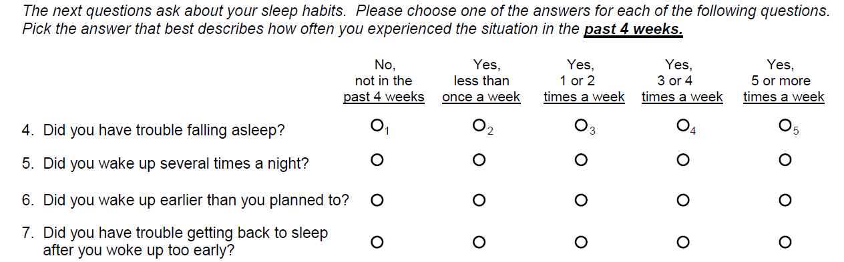

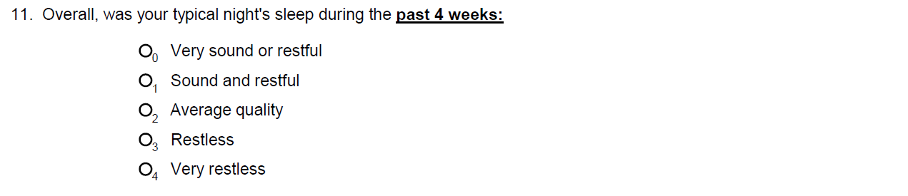

Sleep Questionnaire Computed Variables

Variable [whiirs5c] WHI Insomnia Rating Scale (WHIIRS) (continued)

MESA Variables

Variable | Variable Description | Value Labels
trbleslpng5 | PAST 4 WEEKS: TROUBLE FALLING ASLEEP | 1: NO, NOT IN THE PAST 4 WEEKS  2: YES, LESS THAN ONCE A WEEK  3: YES, 1 OR 2 TIMES A WEEK  4: YES, 3 OR 4 TIMES A WEEK  5: YES, 5 OR MORE TIMES A WEEK
wakeup5 | PAST 4 WEEKS: WAKE UP SEVERAL TIMES A NIGHT | 1: NO, NOT IN THE PAST 4 WEEKS  2: YES, LESS THAN ONCE A WEEK  3: YES, 1 OR 2 TIMES A WEEK  4: YES, 3 OR 4 TIMES A WEEK  5: YES, 5 OR MORE TIMES A WEEK
wakeearly5 | PAST 4 WEEKS: WAKE UP EARLIER THAN PLANNED | 1: NO, NOT IN THE PAST 4 WEEKS  2: YES, LESS THAN ONCE A WEEK  3: YES, 1 OR 2 TIMES A WEEK  4: YES, 3 OR 4 TIMES A WEEK  5: YES, 5 OR MORE TIMES A WEEK
bcksleep5 | PAST 4 WEEKS: TROUBLE GETTING BACK TO SLEEP AFTER YOU WAKING TOO EARLY | 1: NO, NOT IN THE PAST 4 WEEKS  2: YES, LESS THAN ONCE A WEEK  3: YES, 1 OR 2 TIMES A WEEK  4: YES, 3 OR 4 TIMES A WEEK  5: YES, 5 OR MORE TIMES A WEEK
typicalslp5 | PAST 4 WEEKS: OVERALL TYPICAL NIGHT SLEEP | 0: VERY SOUND OR RESTFUL  1: SOUND AND RESTFUL  2: AVERAGE QUALITY  3: RESTLESS  4: VERY RESTLESS

PLEASE NOTE: MESA variables (with exception of typicalslp5) need to be recoded to conform to the values applied to score the scale.

Sleep Questionnaire Computed Variables

Variable [whiirs5c] WHI Insomnia Rating Scale (WHIIRS) (continued)

Skip pattern

It appears that there should be a skip pattern applied to the questionnaire, such that if a respondent answers “No, not in the past 4 weeks” to Q6, they should not answer Q7. The majority of respondents (n=1,023) did skip Q7 if they answered “No, not in the past 4 weeks” to Q6. We attempted to contact Dr. Levine, who designed the WHI questionnaire, to ask about the skip pattern, but did not receive a response. It was decided that Q7 will be assigned a value of zero for all respondents that answered “No, not in the past 4 weeks” to Q6.

Summary of steps for calculation of WHIIRS in MESA

- Recode variables: trbleslpng5 wakeup5 wakeearly5 bcksleep5 :
- 1=0
- 2=1
- 3=2
- 4=3
- 5=4

- After recoding, replace [bcksleep5] =0 if [wakeearly5] =0 (variable [bcksleep5] may be missing or have a value).

- Sum the values in the variables [trbleslpng5], [wakeup5], [wakeearly5], [bcksleep5], and [typicalslp5] if none are missing. Participants with any missing values for the 5 variables are set to missing for the WHIIRS.

Sleep Questionnaire Computed Variables

Variable [epslpscl5c] Epworth Sleepiness Scale

The Epworth Sleepiness Score (ESS) is an 8 item questionnaire designed to measure general sleepiness. Each question is rated on a 4 point scale (0-3) with a summary score ranging from 0-24. A score of 9 or 10 and above is considered abnormal. MESA questionnaire Q 12, items a through h correspond to the ESS. The scoring of the ESS is as follows: if someone responds with “would never doze” they are assigned zero points, “slight doze chance” they are assigned 1 point, “moderate doze chance” with 2 points, and finally “high doze chance” with 3 points.

MESA Sleep Questionnaire Items

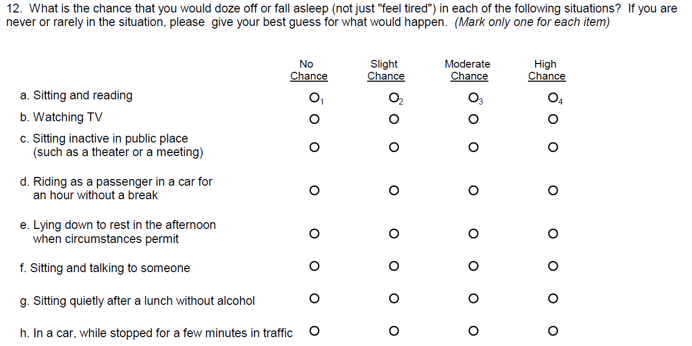

Sleep Questionnaire Computed Variables

Variable [epslpscl5c] Epworth Sleepiness Scale (continued)

MESA Variables

Variable | Variable Description | Value Labels
readng5 | CHANCE OF DOZING / FALL ASLEEP WHILE: SITTING AND READING | 1: NO CHANCE  2: SLIGHT CHANCE  3: MODERATE CHANCE  4: HIGH CHANCE
tv5 | CHANCE OF DOZING / FALL ASLEEP WHILE: WATCHING TV | 1: NO CHANCE  2: SLIGHT CHANCE  3: MODERATE CHANCE  4: HIGH CHANCE
sittng5 | CHANCE OF DOZING / FALL ASLEEP WHILE: SITTING INACTIVE IN PUBLIC | 1: NO CHANCE  2: SLIGHT CHANCE  3: MODERATE CHANCE  4: HIGH CHANCE
riding5 | CHANCE OF DOZING / FALL ASLEEP WHILE: RIDING AS PASSENGER IN CAR | 1: NO CHANCE  2: SLIGHT CHANCE  3: MODERATE CHANCE  4: HIGH CHANCE
lyngdwn5 | CHANCE OF DOZING / FALL ASLEEP WHILE: LYING DOWN TO REST IN AFTERNOON | 1: NO CHANCE  2: SLIGHT CHANCE  3: MODERATE CHANCE  4: HIGH CHANCE
talkng5 | CHANCE OF DOZING / FALL ASLEEP WHILE: SITTING AND TALKING TO SOMEONE | 1: NO CHANCE  2: SLIGHT CHANCE  3: MODERATE CHANCE  4: HIGH CHANCE
quietly5 | CHANCE OF DOZING / FALL ASLEEP WHILE: SITTING QUIETLY AFTER LUNCH (NO ALCOHOL) | 1: NO CHANCE  2: SLIGHT CHANCE  3: MODERATE CHANCE  4: HIGH CHANCE
car5 | CHANCE OF DOZING / FALL ASLEEP WHILE: IN CAR STOPPED IN TRAFFIC | 1: NO CHANCE  2: SLIGHT CHANCE  3: MODERATE CHANCE  4: HIGH CHANCE

PLEASE NOTE: All MESA variables used in calculating the ESS need to be recoded to conform to the values applied to score the scale.

Sleep Questionnaire Computed Variables

Variable [epslpscl5c] Epworth Sleepiness Scale (continued)

Summary of steps for calculation of Epworth Sleepiness Scale in MESA

- Recode variables [lyngdwn5], [talkng5], [quietly5], [car5], [riding5], [readng5], [sittng5], and [tv5]:
- 1=0
- 2=1
- 3=2
- 4=3

- Sum the values [readng5], [tv5], [sittng5], [riding5], [lyngdwn5], [talkng5], [quietly5], and [car5] if none are missing. Participants with any missing values for the 8 variables are set to missing (n=12).

Sleep Questionnaire Computed Variables

Variable [hoostmeq5c] Modified Horne-Ostberg Morningness-Eveningness Questionnaire

The Morningness-Eveningness Questionnaire (MEQ) is a questionnaire designed to assess morningness and eveningness. The modified version used in MESA consists of 5 items. Questions 16-20 from the MESA questionnaire correspond to the MEQ. Each answer has a value attached to it and the values are summed to calculate the total score. We maintained the same scales for these five questions with one exception: for the MESA question 20, one additional choice was added: “neither a morning nor an evening type.” This is an intermediate answer and was given an intermediate score ranking (approximately equivalent to the median/mean of the other points for that particular question). In order to obtain a summary score we simply added the points from each question as is done with the MEQ.

MESA Sleep Questionnaire Items

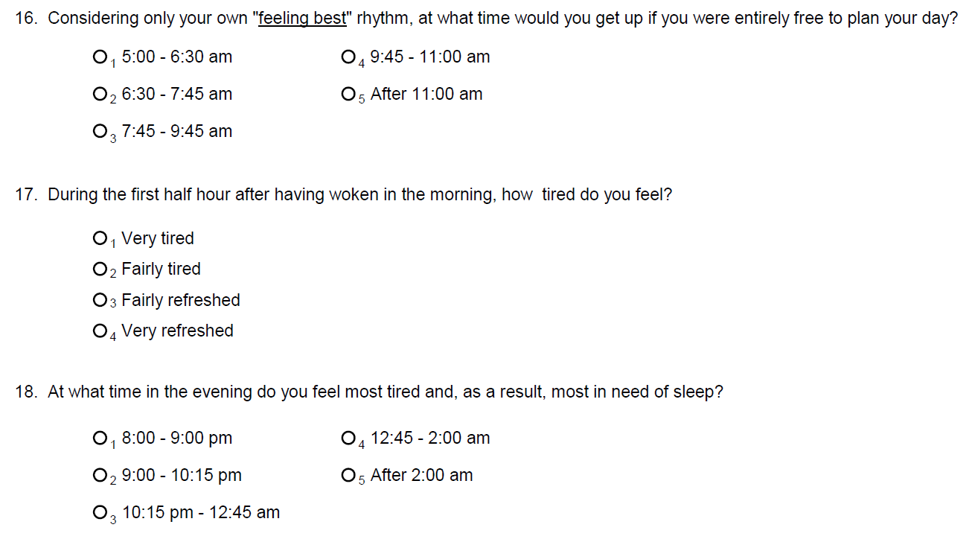
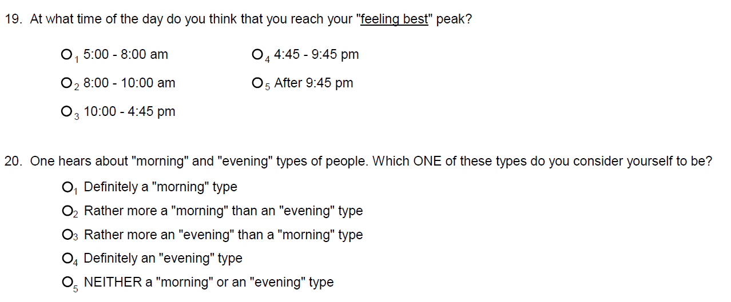

Sleep Questionnaire Computed Variables

Variable [hoostmeq5c] Modified Horne-Ostberg Morningness-Eveningness Questionnaire (continued)

MESA Variables

Variable | Variable Description | Value Labels
feelngbstr5 | TIME OF DAY FEELING BEST | 1: 5:00 - 6:30 AM  2: 6:30 - 7:45 AM  3: 7:45 - 9:45 AM  4: 9:45 - 11:00 AM  5: AFTER 11:00 AM
tired5 | HOW TIRED DURING FIRST HALF HOUR AFTER HAVING WOKEN IN MORNING | 1: VERY TIRED  2: FAIRLY TIRED  3: FAIRLY REFRESHED  4: VERY REFRESHED
mosttired4 | TIME IN EVENING FEEL MOST TIRED AND IN NEED OF SLEEP | 1: 8:00 - 9:00 PM  2: 9:00 - 10:15 PM  3: 10:15 - 12:45 AM  4: 12:45 - 2:00 AM  5: AFTER 2:00 AM
feelngbstpk5 | TIME OF DAY REACHING BEST FEELING PEAK | 1: 5:00 - 8:00 AM  2: 8:00 - 10:00 AM  3: 10:00 - 4:45 PM  4: 4:45 - 9:45 PM  5: AFTER 9:45 PM
types5 | TYPE OF PERSON: MORNING OR EVENING | 1: DEFINITELY A MORNING TYPE  2: RATHER MORE A MORNING THAN AN EVENING TYPE  3: RATHER MORE AN EVENING THAN A MORNING TYPE  4: DEFINITELY AN EVENING TYPE  5: NEITHER A MORNING OR AN EVENING TYPE

PLEASE NOTE: All but one of the MESA variables used in calculating the MEQ need to be recoded to conform to the values applied to score the scale.

Sleep Questionnaire Computed Variables

Variable [hoostmeq5c] Modified Horne-Ostberg Morningness-Eveningness Questionnaire (continued)

Summary of steps for calculation of Morning-Eveningness Score

- Recode variables: feelngbstr5, mosttired4, feelngbstpk5:
- 1=5
- 2=4
- 3=3
- 4=2
- 5=1

Recode types5:
- 1=6
- 2=4
- 3=2
- 4=0
- 5=3

Variable tired5 does not need to be recoded.

- Sum the values feelngbstr5, tired5, mosttired4, feelngbstpk5, types5 if none are missing. Participants with any missing values for the 5 variables are set to missing (n=11).

