MESA Abdominal Body Composition Ancillary Study Data

Overview
For the Abdominal Body Composition, Inflammation, and Cardiovascular disease ancillary study, a subset of the baseline MESA cohort had abdominal CT scans performed at exams 2 or 3. Of these, a small number were rescanned at exam 4 (variable ctexam indicates when the scan was performed). As part of the MESA Body Composition ancillary study, selected abdominal slices from these scans were processed using MIPAV 4.1.2 software (provided by the NIH) that produced areas of fat, lean, and total tissue measured in square centimeters, as well as densities expressed in Hounsfield units (HU), for each specific tissue type and anatomic structure. The structures were defined as total abdomen area of interest (AOI), subcutaneous AOI and visceral AOI, plus 4 sets of muscles consisting of the right and left psoas, right and left rectus abdominis, right and left paraspinal muscle group, and right and left oblique muscle group.
The Paraspinal muscle group includes:
- Quadratus Lumborum
- Spinalis
- Longissimus
- Illiocostalis
- Erector Spinae (mostly this one)
- Multifidus

Oblique muscle group includes:
- Internal oblique
- External oblique
- Transverse abdominus

Different types of tissues have different densities. For this ancillary study, fat tissue was identified as being between -190 and -30 Hounsfield units (HU). Lean tissue was identified as being between 0 and 100 HU. Densities outside of these 2 ranges were labeled as undefined tissue type.

During the scoring process, areas on the CT scan were identified by an operator as being an ‘area of interest’ (AOI). The CT scan represents tissue as density and the Mipav program processes each identified AOI pixel by pixel, assessing the density value assigned to each pixel. Using these pixel densities and the criteria provided above, the Mipav program then calculates the total, fat and lean areas of the AOI, as well as the average HU for fat, lean, and total areas of each AOI. Of note, the total area of an AOI can be greater than the sum of the fat and lean areas due to pixels falling outside the ranges for fat and lean HU (i.e. undefined area). Figure 1 identifies all AOIs scored.

Subcutaneous Area
Rectus Abdominis

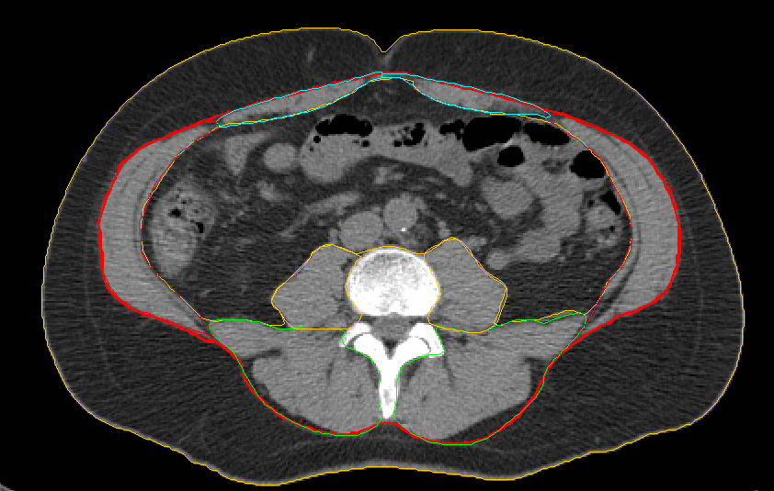
Paraspinal Muscle Group
Psoas Muscles
Oblique Muscle Group
Visceral Cavity
External Border of Ab_internal AOI
Fig. 1 Representative Abdominal CT Slice

For the MESA Body Composition ancillary study, 6 transverse cross section slices of data were analyzed; slice 0 is located at the L4/L5 vertebral junction and slice 1 is the immediately superior and adjacent to slice 0. Slice 2 is located at the L3/L4 junction with slice 3 superior and adjacent to slice 2. Slice 4 is located at the L2/L3 vertebral junction with slice 5 superior and adjacent to slice 4. A small number of subjects had fewer than 6 slices scored due to problems with the location where the scan was performed on the body. Scans for a few subjects missed L4/L5 and in other instances the scan missed L2/L3. In these cases, the area from L4/L5 to L2/L3 was not completely covered resulting in an incomplete set of scans for the subject. The slice data that is available uses the value for the ‘slicenum3’ variable to indicate the anatomical position of the slices scored.

Reliability
Intraclass correlations were computed for all AOIs scored. Inter and intra-rater reliabilities for total abdominal, subcutaneous, and visceral cavity areas were 0.99 for all measures. Inter and intra-rater reliability for all muscle groups ranged from 0.98 for psoas muscle and paraspinal muscle group to 0.93 for the smaller rectus abdominis and oblique muscle group. Artifact in the scan contributed to the reader’s difficulty identifying the muscle facia line outlining some oblique and rectus abdominis muscles. Additional training was provided to standardize identifying muscle fascia lines in problem muscle groups.

Subcutaneous Fat Data

The subcutaneous area is made up of mainly fat tissue with some lean area representing connective tissue, skin, and blood vessels. Due to artifact in some of the scans resulting in elevated values of HU for some of the pixels in a given slice, the lean area and unexplained area in the subcutaneous AOI may be overstated. As such, one may consider using the subcutaneous total area (SUBQTOT3) for the subcutaneous fat area. But if one is looking at fat density for the subcutaneous AOI, the subcutaneous fat HU variable (subqfathu3) may be used. Variable ‘subqtothu3’ represents the density of the entire subcutaneous AOI and includes HU values for lean and undefined areas.

Figure 2 shows a subcutaneous AOI with a significant amount of area that would fall in the range of -30 to 0 HU and would be classified as undefined area (white dotted markings). This would result in an underestimation of total subcutaneous fat if the subcutaneous fat variable (SUBQFAT3) were used.

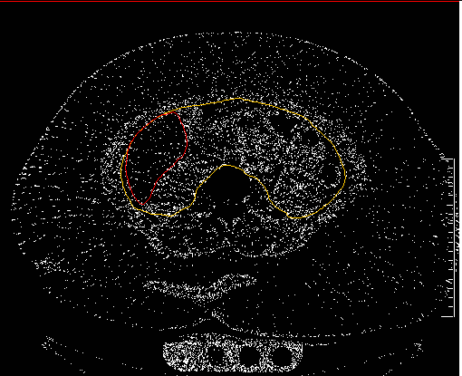
Fig. 2 Pixels Representing Area Between -30 and 0 Hu

Data Available in the MESA Body Composition Ancillary Study

There are 2 data files for the MESA Body Composition Ancillary study. File MESAe3a65_AbdFatCT_20130625 contains no imputed data. That is, all data is directly measured and there is some missing data. File MESAe3a65_AbdFatCT_Imp_20130625 contains all the measured data found in file MESAe3a65_AbdFatCT_20130625, as well as imputed data. All imputed data is marked with an associated flag variable. As an example, if the subcutaneous AOI was cut off on 1 side only, a ‘half_process method’ was used to impute the missing data, allowing the subcutaneous and abdomen AOIs to be measured. Using the variable ‘subqtot3’ as an example, File MESAe3a65_AbdFatCT_20130625 would not contain any of the imputed data and all values under subqtot3 would be actual measurements. An empty cell would indicate missing data. In file MESAe3a65_AbdFatCT_Imp_20130625, ‘subqtot3’ would contain actual and imputed data. Flag variable ‘processhalfabdomen3’ would be set to 0 if the data were actually measured and set to 1 if the data were imputed. The methods used to impute data are described in the next section.

Imputed Data
Due to the size of the field of view (FOV) used for the scan, the positioning of the subject in the scanner or the size of the subject, parts of the abdomen for some subjects fell outside the FOV and the affected anatomic data could not be processed. In these cases, different measures of imputation for missing data were employed to estimate the missing data. All imputed data has a flag associated with the imputed data and indicates which method of imputation was used.

Explanation of Imputation Methods:

- The abdomen was cut off through the subcutaneous area only on 1 side of the body.

In this case, half of the subcutaneous area could be scored correctly. This value was doubled to get a measure of the total subcutaneous area and added to the measured abdomen to get the entire abdomen area. Repeat measures t-tests were used to assess any differences between all actual and estimated values. Using a random sample of 40 subjects equally split between gender and ethnicity, no significant differences were found between actual and estimated measures. Variable ‘processhalfabdomen3’ with a value of 1 indicates when this method was used to impute missing data. Figure 3 demonstrates the scoring for this data imputation method.

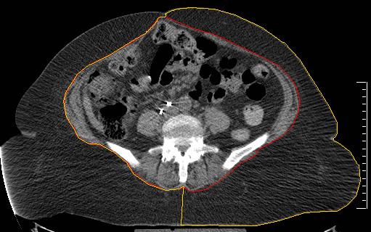
External Border of Ab_internal AOI
Subcutaneous AOI, half measured
Fig. 3 Example of half subcutaneous AOI scoring

- The abdomen was cut off through the subcutaneous area on more than 1 side of the body.

In this instance regression equations were used to estimate the total abdominal area and the subcutaneous area. Gender, ethnic, and location specific regression equations used in this method were developed. All regression equations and adjusted R² values are reported in Appendix 1 at the end of this document. Variable ‘Predicequat3’ with a value of 1 indicated that this method was used.

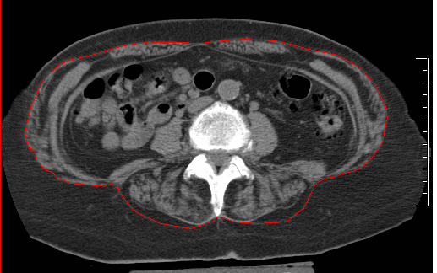
Fig. 4 Abdomen cut off on 2 sides

- The visceral cavity was truncated on 1 side with a maximum area < 10 square cm cut off.

A ruler line was used to determine the length of the cut off area in the visceral cavity. This ruler was then copied to the opposite side of the abdomen and an additional ruler was used to measure the approximate width of the cut off area. It was assumed that there was no gross distortion of the of the abdominal muscle wall. There were very few major structural anomalies of the abdomen wall noted on the scans. If a scoliosis or other distortion such as deformation of the rib cage was noted, this method was not used. If the cut off area of the visceral cavity was < 10 square centimeters, the AOI selection for the available visceral cavity was made. The imputed value would underestimate the visceral cavity AOI by less than 10 cm² or less than 5% of the area of the average visceral cavity (X+SD for visceral cavity VOI, 278+100 cm²). On review of the data, the smallest visceral cavity for which this process was used was 236 cm² and in only five of the situations where this process was used was the visceral cavity less than 278 cm².

Figure 5 shows an example of an area of approximately 7 square centimeters of area cut off and unmeasured. Variable ‘modifiedvisc3’ with a value of 1 indicated that this method was used.

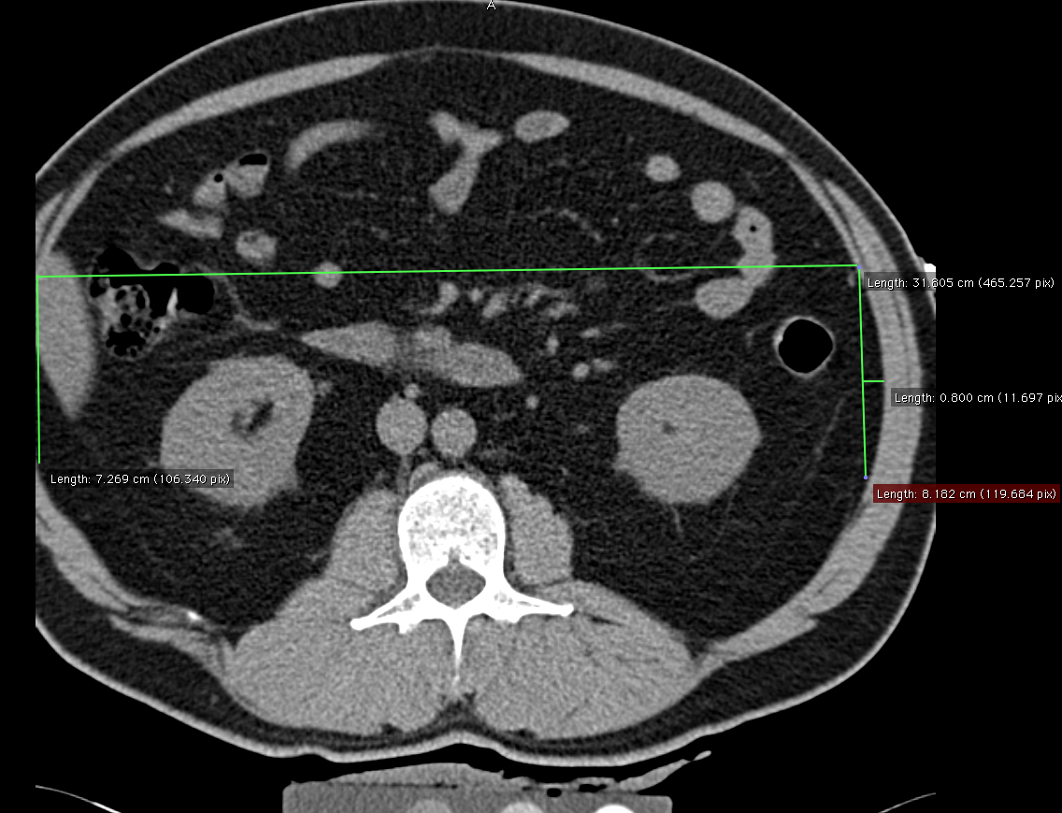
0.8 cm
8.1 cm

7.2779 cm
Fig. 5 Visceral cavity with < 10 cm² cut off

4. The rectus abdominis or oblique muscle group was cut off on only 1 side.

Figure 5 shows when this method was used for the case when the right oblique muscle group was truncated. The oblique muscle could be completely measured on the left side of the abdomen. This measured value was used to estimate the values for the right oblique muscle group. Flag variables imputerrec3, imputelrec3, imputerob3, and imputeob3 are used to indicate imputed data.

Multiple Visit data
The data file contains information on subjects from scans performed at visit 2 or visit 3. Some of the subjects were rescanned at visit 4. There may be multiple sets of data for some participants if they had 2 scans read. The variable used to indicate visit is ‘ctexam’.
MESA Ancillary Study 65 Data Set Variable Guide
Abdominal Fat CT & Abdominal Fat CT Imputed Dataset

Data Set Names : | MESAe3a65_AbdFatCT_20130625  MESAe3a65_AbdFatCT_Imp_20130625
As65 Principal Investigator : | Matthew Allison
As65 Contact Information : | mallison@ucsd.edu

Order | Variable | Variable Description | Value Labels
1 | idno | MESA Participant ID Number
2 | ctexam | Exam corresponding to CT scan | 2: Exam 2  3: Exam 3  4: Exam 4
3 | ctexamtt | Time from Baseline Exam to CT scan
4 | slicenum3 | Number of CT slice measured (0 lowest at L4/L5, 5 highest at L2/L3)
5 | pixelsize3 | Size of pixel used by CT scanner
6 | slicethickness3 | Thickness of CT scan slice (mm)
7 | abtot3 | Total abdominal area (in Sq Cm)
8 | abfat3 | Total abdominal Fat area (in Sq Cm)
9 | ablean3 | Total abdominal Lean area (in Sq Cm)
10 | abfathu3 | Mean Hounsfield value for Total abdominal Fat area
11 | ableanhu3 | Mean Hounsfield value for Total abdominal Lean area
12 | abtothu3 | Mean Hounsfield value for Total abdominal area
13 | subqtot3 | Total subcutaneous area (in Sq Cm)
14 | subqfat3 | Subcutaneous Fat area (in Sq Cm)
15 | subqlean3 | Subcutaneous Lean area (in Sq Cm)
16 | subqfathu3 | Mean Hounsfield value for subcutaneous Fat area
17 | subqleanhu3 | Mean Hounsfield value for subcutaneous Lean area
18 | subqtothu3 | Mean Hounsfield value for Total subcutaneous area
19 | visctot3 | Total visceral area (in Sq Cm)
20 | viscfat3 | Visceral Fat area (in Sq Cm)
21 | visclean3 | Visceral Lean area (in Sq Cm)
22 | viscfathu3 | Mean Hounsfield value for visceral Fat area
23 | viscleanhu3 | Mean Hounsfield value for visceral Lean area
24 | visctothu3 | Mean Hounsfield value for Total visceral area
25 | lpsoastot3 | Total Left Psoas muscle area (in Sq Cm)
26 | lpsoasfat3 | Left Psoas muscle Fat area (in Sq Cm)
27 | lpsoaslean3 | Left Psoas muscle Lean area (in Sq Cm)
28 | lpsoasfathu3 | Mean Hounsfield value for Left Psoas muscle Fat area
29 | lpsoasleanhu3 | Mean Hounsfield value for Left Psoas muscle Lean area
30 | lpsoastothu3 | Mean Hounsfield value for Total Left Psoas muscle area
31 | rpsoastot3 | Total Right Psoas muscle area (in Sq Cm)
32 | rpsoasfat3 | Right Psoas muscle Fat area (in Sq Cm)
33 | rpsoaslean3 | Right Psoas muscle Lean area (in Sq Cm)
34 | rpsoasfathu3 | Mean Hounsfield value for Right Psoas muscle Fat area
35 | rpsoasleanhu3 | Mean Hounsfield value for Right Psoas muscle Lean area
36 | rpsoastothu3 | Mean Hounsfield value for Total Right Psoas muscle area
37 | lobtot3 | Total Left Oblique muscle group area (in Sq Cm)
38 | lobfat3 | Left Oblique muscle group Fat area (in Sq Cm)
39 | loblean3 | Left Oblique muscle group Lean area (in Sq Cm)
40 | lobfathu3 | Mean Hounsfield value for Left Oblique muscle group Fat area
41 | lobleanhu3 | Mean Hounsfield value for Left Oblique muscle group Lean area
42 | lobtothu3 | Mean Hounsfield value for Total Left Oblique muscle group area
43 | robtot3 | Total Right Oblique muscle group area (in Sq Cm)
44 | robfat3 | Right Oblique muscle group Fat area (in Sq Cm)
45 | roblean3 | Right Oblique muscle group Lean area (in Sq Cm)
46 | robfathu3 | Mean Hounsfield value for Right Oblique muscle group Fat area
47 | robleanhu3 | Mean Hounsfield value for Right Oblique muscle group Lean area
48 | robtothu3 | Mean Hounsfield value for Total Right Oblique muscle group area
49 | lparatot3 | Total Left Paraspinal muscle group area (in Sq Cm)
50 | lparafat3 | Left Paraspinal muscle group Fat area (in Sq Cm)
51 | lparalean3 | Left Paraspinal muscle group Lean area (in Sq Cm)
52 | lparafathu3 | Mean Hounsfield value for Left Paraspinal muscle group Fat area
53 | lparaleanhu3 | Mean Hounsfield value for Left Paraspinal muscle group Lean area
54 | lparatothu3 | Mean Hounsfield value for Total Left Paraspinal muscle group area
55 | rparatot3 | Total Right Paraspinal muscle group area (in Sq Cm)
56 | rparafat3 | Right Paraspinal muscle group Fat area (in Sq Cm)
57 | rparalean3 | Right Paraspinal muscle group Lean area (in Sq Cm)
58 | rparafathu3 | Mean Hounsfield value for Right Paraspinal muscle group Fat area
59 | rparaleanhu3 | Mean Hounsfield value for Right Paraspinal muscle group Lean area
60 | rparatothu3 | Mean Hounsfield value for Total Right Paraspinal muscle group area
61 | lrectot3 | Total Left Rectus Abdominis area (in Sq Cm)
62 | lrecfat3 | Left Rectus Abdominis Fat area (in Sq Cm)
63 | lreclean3 | Left Rectus Abdominis Lean area (in Sq Cm)
64 | lrecfathu3 | Mean Hounsfield value for Left Rectus Abdominis Fat area
65 | lrecleanhu3 | Mean Hounsfield value for Left Rectus Abdominis Lean area
66 | lrectothu3 | Mean Hounsfield value for Total Left Rectus Abdominis area
67 | rrectot3 | Total Right Rectus Abdominis area (in Sq Cm)
68 | rrecfat3 | Right Rectus Abdominis Fat area (in Sq Cm)
69 | rreclean3 | Right Rectus Abdominis Lean area (in Sq Cm)
70 | rrecfathu3 | Mean Hounsfield value for Right Rectus Abdominis Fat area
71 | rrecleanhu3 | Mean Hounsfield value for Right Rectus Abdominis Lean area
72 | rrectothu3 | Mean Hounsfield value for Total Right Rectus Abdominis area
Additional Variables for
MESAe3a65_AbdFatCT_Imp_20130625
73 | abtotpredicted3 | Predicted total abdomen area (in Sq Cm) from regression equations
74 | subqtotpredicted3 | Predicted total subcutaneous area (in Sq Cm) from regression equations
75 | predicequat3 | Flag for use of prediction equations | 0: No, did not use  1: Yes, used imputation method
76 | processhalfabdomen3 | Flag for use of Half-abdomen process method | 0: No, did not use  1: Yes, used imputation method
77 | abinternaltot3 | Total abdominal internal area (in Sq Cm)
78 | abinternalfat3 | Abdominal internal fat area (in Sq Cm)
79 | abinternallean3 | Abdominal internal lean area (in Sq Cm)
80 | modifiedvisc3 | Flag for use of modified visceral measurement to obtain visceral measures | 0: No, did not use  1: Yes, used imputation method
81 | imputelrec3 | Flag indicating imputation of Left Rectus Abdominis values | 0: No, did not use  1: Yes, used imputation method
82 | imputerrec3 | Flag indicating imputation of Right Rectus Abdominis values | 0: No, did not use  1: Yes, used imputation method
83 | imputelob3 | Flag indicating imputation of Left Oblique muscle group values | 0: No, did not use  1: Yes, used imputation method
84 | imputerob3 | Flag indicating imputation of Right Oblique muscle group values | 0: No, did not use  1: Yes, used imputation method

Appendix 1: Regression Equations Used to Impute Missing Abdominal and Subcutaneous Areas

In order to get the best estimation of the total abdominal area, gender and race specific regression equations were developed. In addition, specific visit data such as BMI, height, WHR, and waist circumference that corresponded to the CT scan visit were used in the regression equation. Below are all regression equations used to predict total abdminal area (abtotpredicted3) . Total subcutaneous area was computed by subtracting the directly measured variable ‘abinternaltot3’ (all measured area excluding subcutaneous AOI ) from ‘abtotpredicted3’ . Variables ‘abtotpredicted3’ and ‘subqtotpredicted3’ contain the predicted values for Total abdominal area and total subcutaneous area and flag variable ‘predicequat3’ indicates when this process was used.

Adj R² | Slicenum3 | Regression Equations
Caucasian Female
.94 | 0 | (-32.748*(1))+(9.518*bmi)+(0.551*SUBQ_internal_TOT)+(8.411*waistcm)+(-585.235*whr)+(-0.963*LR_Para_fat)
.93 | 1 | +(-76.450*(1))+(10.346*bmi)+(0.522*SUBQ_internal_TOT)+(7.439*waistcm)+(-498.796*whr)+(3.513*LR_Para_Psoas_fat)
.94 | 2 | +(-141.240*(1))+(9.327*bmi)+(0.567*SUBQ_internal_TOT)+(6.416*waistcm)+(-375.414*whr)+(0.201*VISC_fat).
.93 | 3 | +(-201.718*(1))+(9.865*bmi)+(0.711*SUBQ_internal_TOT)+(5.747*waistcm)+(-309.183*whr)+(6.321*LR_Psoas_fat).
.94 | 4 | +(-307.709*(1))+(10.585*bmi)+(0.835*SUBQ_internal_TOT)+(1.423*waistcm)+(0.979*wtlb)
.94 | 5 | +(-301.920*(1))+(10.291*bmi)+(0.852*SUBQ_internal_TOT)+(1.271*waistcm)+(1.027*wtlb)
Asian Female
.84 | 0 | +(18.706*(1))+(6.601*bmi)+(0.700*SUBQ_internal_TOT)+(6.979*waistcm)+(-506.912*whr)
.83 | 1 | +(101.064*(1))+(4.400*bmi) +(0.444*SUBQ_internal_TOT)+(7.062*waistcm)+(-523.706*whr)+(0.445*VISC_fat)
.84 | 2 | +(-121.940*(1))+(0.582*SUBQ_internal_TOT)+(0.332*VISC_fat)+(1.680*wtlb)+(311.895*waist_ht_ratio)
.86 | 3 | +(-112.737*(1))+(0.589*SUBQ_internal_TOT)+(0.352*VISC_fat)+(1.637*wtlb)+(284.396*waist_ht_ratio)
.87 | 4 | +(-139.121*(1))+(0.833*SUBQ_internal_TOT)+(1.810*wtlb)+(197.370*waist_ht_ratio)
.89 | 5 | +(-154.915*(1))+(0.860*SUBQ_internal_TOT)+(-6.219*LR_Para_Psoas_fat)+(1.760*wtlb)+(249.749*waist_ht_ratio)
AA Female
.93 | 0 | +(-87.352*(1))+(6.844*bmi)+(7.504*waistcm)+(-448.143*whr)+(0.962*wtlb)+(0.631*VISC_tot
.93 | 1 | +(-104.313*(1))+(3.751*waistcm)+(-440.242*whr)+(2.031*wtlb)+(629.011*waist_ht_ratio)+(0.640*VISC_tot).
.93 | 2 | +(-71.950*(1))+(7.853*bmi)+(0.453*SUBQ_internal_TOT)+(8.647*waistcm)+(-624.747*whr)+(0.439*VISC_fat).
.93 | 3 | +(-109.161*(1))+(9.670*bmi)+(0.212*SUBQ_internal_TOT)+(7.633*waistcm)+(-532.111*whr)+(11.942*LR_Psoas_fat)+(0.562*VISC_tot).
.92 | 4 | +(-274.052*(1))+(5.049*bmi)+(0.195*SUBQ_internal_TOT)+(21.970*LR_Psoas_fat)+(2.115*wtlb)+(318.334*waist_ht_ratio)+(0.535*VISC_tot).
.93 | 5 | +(53.152*(1))+(10.178*LR_Para_Psoas_fat)+(3.041*wtlb)+(283.343*waist_ht_ratio)+(0.752*VISC_tot)+(-1.826*htcm)
Hispanic Female

.90 | 0 | +(14.990*(1))+(6.796*bmi)+(0.597*SUBQ_internal_TOT)+(8.512*waistcm)+(-610.014*whr).
.90 | 1 | +(38.360*(1))+(6.872*bmi)+(0.588*SUBQ_internal_TOT)+(7.627*waistcm)+(-582.065*whr)+(11.436*LR_Psoas_fat).
.88 | 2 | +(-72.299*(1))+(10.488*bmi)+(0.591*SUBQ_internal_TOT)+(5.404*waistcm)+(-395.788*whr)+(2.434*LR_Para_fat).
.89 | 3 | +(-89.931*(1))+(11.061*bmi)+(0.621*SUBQ_internal_TOT)+(5.017*waistcm)+(-373.734*whr)+(2.632*LR_Para_fat).
.90 | 4 | +(-230.114*(1))+(3.660*bmi)+(0.767*SUBQ_internal_TOT)+(2.281*LR_Para_fat)+(1.910*wtlb)+(212.431*waist_ht_ratio).
.90 | 5 | +(-165.742*(1))+(0.854*SUBQ_internal_TOT)+(-152.209*whr)+(2.011*wtlb)+(438.557*waist_ht_ratio).
Caucasian Male
.95 | 0 | +(-473.815*(1))+(15.695*bmi)+(0.111*SUBQ_internal_TOT)+(9.030*waistcm)+(-0.890*LR_Para_fat)+(-548.426*waist_ht_ratio)+(0.532*VISC_tot).
.96 | 1 | +(-482.493*(1))+(15.930*bmi)+(0.079*SUBQ_internal_TOT)+(9.177*waistcm)+(-567.727*waist_ht_ratio)+(0.529*VISC_tot).
.97 | 2 | +(-393.166*(1))+(17.293*bmi)+(0.105*SUBQ_internal_TOT)+(8.791*waistcm)+(1.061*LR_Para_fat)+(-770.333*waist_ht_ratio)+(0.508*VISC_tot).
.97 | 3 | +(-387.940*(1))+(17.421*bmi)+(0.133*SUBQ_internal_TOT)+(8.608*waistcm)+(1.394*LR_Para_fat)+(-2.072*LR_Para_Psoas_fat)+(-773.501*waist_ht_ratio)+(0.501*VISC_tot).
.96 | 4 | +(-348.743*(1))+(15.909*bmi)+(0.129*SUBQ_internal_TOT)+(7.933*waistcm)+(1.149*LR_Para_fat)+(-664.387*waist_ht_ratio)+(0.484*VISC_tot).
.97 | 5 | +(-342.932*(1))+(15.645*bmi)+(0.155*SUBQ_internal_TOT)+(7.740*waistcm)+(1.350*LR_Para_fat)+(-647.872*waist_ht_ratio)+(0.459*VISC_tot).
Asian Male
.94 | 0 | +(-221.096*(1))+(7.180*bmi)+(0.325*SUBQ_internal_TOT)+(7.826*waistcm)+(-322.117*whr)+(0.401*VISC_tot).
.94 | 1 | +(-248.709*(1))+(7.455*bmi)+(0.269*SUBQ_internal_TOT)+(7.443*waistcm)+(-264.191*whr)+(1.542*LR_Para_fat)+(0.418*VISC_tot).
.94 | 2 | +(-232.750*(1))+(5.228*bmi)+(0.721*SUBQ_internal_TOT)+(6.332*waistcm)+(-220.480*whr)+(1.685*LR_Para_fat).
.94 | 3 | +(-214.322*(1))+(5.150*bmi)+(0.718*SUBQ_internal_TOT)+(6.008*waistcm)+(-209.488*whr)+(2.324*LR_Para_fat).
.95 | 4 | +(-190.018*(1))+(5.345*bmi)+(0.743*SUBQ_internal_TOT)+(5.648*waistcm)+(-211.290*whr).
.94 | 5 | +(-173.864*(1))+(5.338*bmi)+(0.760*SUBQ_internal_TOT)+(5.277*waistcm)+(-212.750*whr)+(2.418*LR_Para_fat).
AA Male
.94 | 0 | +(-249.404*(1))+(9.993*bmi)+(0.189*SUBQ_internal_TOT)+(8.895*waistcm)+(-441.022*whr)+(0.623*VISC_tot).
.94 | 1 | +(-257.470*(1))+(9.781*bmi)+(0.165*SUBQ_internal_TOT)+(8.929*waistcm)+(-426.107*whr)+(0.632*VISC_tot).
.96 | 2 | +(-282.263*(1))+(9.690*bmi)+(0.050*SUBQ_internal_TOT)+(8.748*waistcm)+(-348.814*whr)+(2.010*LR_Para_fat)+(0.617*VISC_tot).
.96 | 3 | +(-245.074*(1))+(9.310*bmi)+(0.028*SUBQ_internal_TOT)+(8.932*waistcm)+(-395.176*whr)+(2.270*LR_Para_fat)+(0.639*VISC_tot).
.96 | 4 | +(-207.795*(1))+(10.468*bmi)+(0.119*SUBQ_internal_TOT)+(7.553*waistcm)+(-379.913*whr)+(1.811*LR_Para_fat)+(0.599*VISC_tot).
.95 | 5 | +(-232.951*(1))+(9.597*bmi)+(0.162*SUBQ_internal_TOT)+(7.778*waistcm)+(-359.431*whr)+(0.563*VISC_tot).
Hispanic Male
.94 | 0 | +(-250.970*(1))+(9.865*bmi)+(0.202*SUBQ_internal_TOT)+(9.246*waistcm)+(-446.836*whr)+(0.454*VISC_tot).
.97 | 1 | +(-265.028*(1))+(11.980*bmi)+(0.013*SUBQ_internal_TOT)+(9.877*waistcm)+(-266.297*whr)+(-447.105*waist_ht_ratio)+(0.697*VISC_tot).
.96 | 2 | +(-241.106*(1))+(13.656*bmi)+(-0.052*SUBQ_internal_TOT)+(9.588*waistcm)+(-178.144*whr)+(-662.185*waist_ht_ratio)+(0.739*VISC_tot).
.96 | 3 | +(-198.050*(1))+(16.406*bmi)+(-0.148*SUBQ_internal_TOT)+(8.959*waistcm)+(-145.661*whr)+(1.959*LR_Para_fat)+(-796.469*waist_ht_ratio)+(0.799*VISC_tot).
.96 | 4 | +(-217.193*(1))+(16.473*bmi)+(-0.097*SUBQ_internal_TOT)+(8.117*waistcm)+(-82.845*whr)+(2.605*LR_Para_fat)+(-775.181*waist_ht_ratio)+(0.740*VISC_tot).
.96 | 5 | +(-211.480*(1))+(16.186*bmi)+(-0.104*SUBQ_internal_TOT)+(7.981*waistcm)+(-88.879*whr)+(2.572*LR_Para_fat)+(-754.914*waist_ht_ratio)+(0.763*VISC_tot).

