Data Set name : | MESAe1to5_CystCCalib_20140514
CC Contact : | Craig Johnson
Contact Information : | wcraigj@u.washington.edu

Order | Variable | Variable Description | Notes
1 | idno | Participant ID Number
2 | cystatc1t | E1 Cystatin C (mg/L) - E1 assay scale | COMPUTE cystatc1c=RND((0.038 + (0.820 * cystatc1)), 0.01).  COMPUTE cystatc1t=cystatc1.
3 | cystatc2t | E2 Cystatin C (mg/L) - calibrated to E1 scale | COMPUTE cystatc2c=RND((0.030 + (0.921 * cystatc2)), 0.01).  COMPUTE cystatc2t=RND((cystatc2c + 0.1216667), 0.01).
4 | cystatc3t | E3 Cystatin C (mg/L) - calibrated to E1 scale | COMPUTE cystatc3c=RND((0.189 + (0.842 * cystatc3)), 0.01).  COMPUTE cystatc3t=RND((cystatc3c + 0.1216667), 0.01).
5 | cystatc4t | E4 Cystatin C (mg/L) - calibrated to E1 scale | COMPUTE cystatc4c=RND((0.065 + (0.968 * cystatc4)), 0.01).  COMPUTE cystatc4t=RND((cystatc4c + 0.1216667), 0.01).
6 | cystatc5t | E5 Cystatin C (mg/L) - calibrated to E1 scale | COMPUTE cystatc5c=RND((0.032 + (0.907 * cystatc5)), 0.01).  COMPUTE cystatc5t=RND((cystatc5c + 0.1216667), 0.01).

Notes

While variables systatc#c are not provided in the dataset, coding is provided since these variables are used as an interim step for coding cystatc#t.

Variable [cystatc1t] does not make use of the [cystatc1c] variable since it is already on the desired exam 1 scale (so [cystatc1t] = [cystatc1]).

Cystatin C Assay Drift Description

Table 0.1: Cystatin C distribution by Exam in 472 participants with measures at all 5 exams
 | N | Mean | SD | Min | 25th %ile | Median | 75th %ile | Max
Exam 1 Cystatin C (mg/l) | 472 | 0.87 | 0.175 | 0.50 | 0.75 | 0.85 | 0.95 | 1.75
Exam 2 Cystatin C (mg/l) | 472 | 0.80 | 0.196 | 0.39 | 0.68 | 0.77 | 0.90 | 2.00
Exam 3 Cystatin C (mg/l) | 472 | 0.74 | 0.197 | 0.25 | 0.61 | 0.71 | 0.83 | 2.05
Exam 4 Cystatin C (mg/l) | 472 | 0.77 | 0.207 | 0.24 | 0.64 | 0.73 | 0.87 | 2.43
Exam 5 Cystatin C (mg/dL) | 472 | 0.99 | 0.380 | 0.51 | 0.79 | 0.91 | 1.07 | 4.94

Figure 0.1: Boxplots of Cystatin C by Exam in 472 participants with measures at all 5 exams
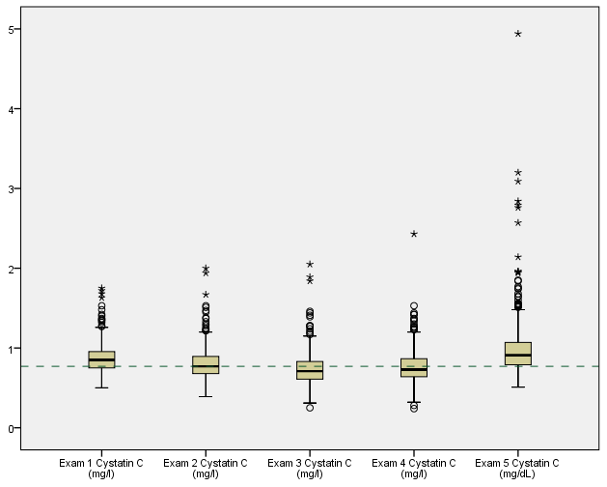

Table 0.2: Correlation matrix
 | E1 Cystatin C | E2 Cystatin C | E3 Cystatin C | E4 Cystatin C
E2 Cystatin C | 0.839
E3 Cystatin C | 0.797 | 0.827
E4 Cystatin C | 0.717 | 0.752 | 0.774
E5 Cystatin C | 0.679 | 0.708 | 0.757 | 0.755

Comments:
- Cystatin C trend over time is not consistent with what one would expect (Exams 1-3 decrease over time while Exams 3-5 are increasing over time).
- Exam 5 variability appears elevated compared to Exams 1-3 (E5 standard deviation is about double than at Exams 1-3).
- Correlation coefficients are moderate (and lower for longer duration between measures).
- Calibration appears warranted.

Cystatin C Reassay Selection Description
A total of 250 MESA specimens were selected for cystatin C reassay with 50 being selected from those with cystatin c having been measured at each exam. 5 were selected at random from each decile of the distribution at each exam (50 total from each exam) in order to ensure adequate distributional representation.

Exam 1

Table 1.1: Descriptive summary
 | N | Mean | SD | Min | 25th %ile | Median | 75th %ile | Max
E1 Cystatin C (mg/L) | 6,756 | 0.90 | 0.244 | 0.36 | 0.76 | 0.86 | 0.98 | 7.59
E1 Cystatin C (mg/L) - original | 50 | 1.02 | 0.963 | 0.62 | 0.76 | 0.87 | 1.00 | 7.59
E1 Cystatin C (mg/L) - reassay | 50 | 0.91 | 0.983 | 0.52 | 0.65 | 0.75 | 0.84 | 7.62
E1 Cystatin C difference (mg/L) | 50 | 0.11 | 0.093 | -0.36 | 0.09 | 0.12 | 0.15 | 0.30
E1 Cystatin C relative difference | 50 | 0.14 | 0.095 | -0.30 | 0.11 | 0.14 | 0.19 | 0.28

Figure 1.1: Scatterplot of Exam 1 reassay by original Cystatin C
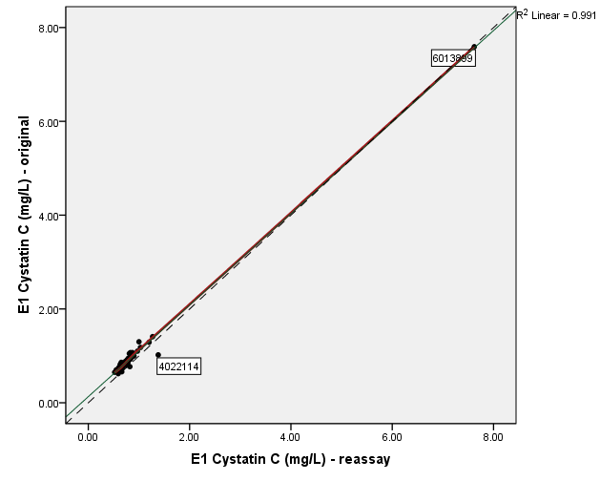

Figure 1.2: Bland-Altman (mean by difference) plot of Exam 1 Cystatin C
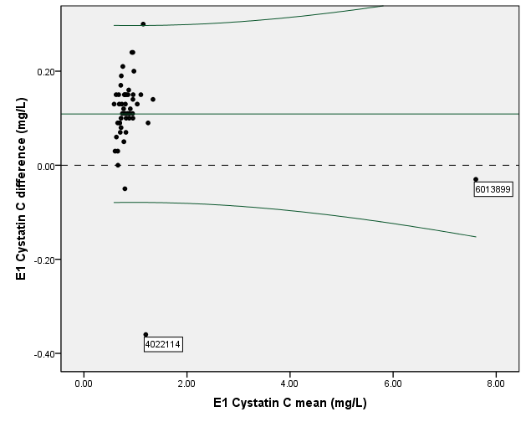
Outlier detected with cystatin C measure = 7.59 mg/L and reasssay measure = 7.62 mg/L (ID 6013899). The next closest measures are at approximately 1.40 mg/L. In order to avoid undue influence on the calibration equation estimates, these measures are dropped from the analysis.
Measurements for ID 4022114 also appear to be influential and should be inquired with Lab. We are dropping these measurements from use in calibration equation development.

Table 1.2: Descriptive summary (after removal of outliers)
 | N | Mean | SD | Min | 25th %ile | Median | 75th %ile | Max
E1 Cystatin C (mg/L) | 6,756 | 0.90 | 0.244 | 0.36 | 0.76 | 0.86 | 0.98 | 7.59
E1 Cystatin C (mg/L) - original | 48 | 0.89 | 0.176 | 0.62 | 0.76 | 0.86 | 0.98 | 1.41
E1 Cystatin C (mg/L) - reassay | 48 | 0.76 | 0.153 | 0.52 | 0.65 | 0.75 | 0.83 | 1.27
E1 Cystatin C difference (mg/L) | 48 | 0.12 | 0.061 | -0.05 | 0.09 | 0.12 | 0.15 | 0.30
E1 Cystatin C relative difference | 48 | 0.15 | 0.069 | -0.06 | 0.11 | 0.14 | 0.19 | 0.28

Figure 1.3: Scatterplot of Exam 1 reassay by original Cystatin C (after removal of outliers)
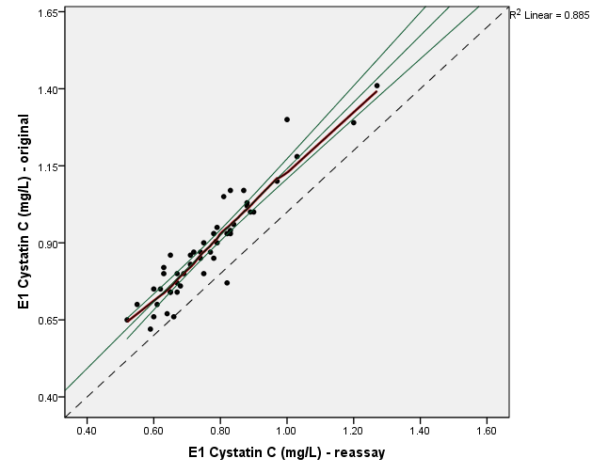

Figure 1.4: Bland-Altman (mean by difference) plot of Exam 1 Cystatin C
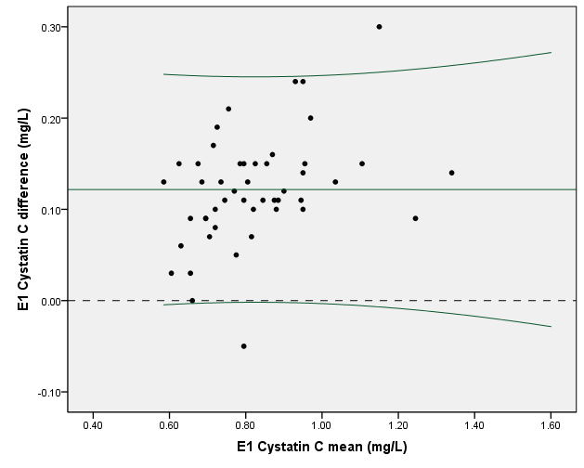

Table 1.3: Regression model of reassay predicting original cystatin c
 | Beta | SE | Standardized B | t | p-value
Constant | 0.061 | 0.045 |  | 1.355 | 0.182
E1 Cystatin C mg/L -reassay | 1.080 | 0.057 | 0.941 | 18.831 | <0.001

Table 1.4: Regression model of original predicting reassay cystatin c
 | Beta | SE | Standardized B | t | p-value
Constant | 0.038 | 0.039 |  | 0.970 | 0.337
E1 Cystatin C mg/L -original | 0.820 | 0.044 | 0.941 | 18.831 | <0.001

Recommended Exam 1 Calibration equation (for correcting E1 Cystatin C to 2014 assay):
Calibrated E1 Cystatin C mg/dL = 0.038 + 0.820 * [original E1 cystatin c]

Exam 2

Table 2.1: Descriptive summary
 | N | Mean | SD | Min | 25th %ile | Median | 75th %ile | Max
E2 Cystatin C (mg/L) | 770 | 0.84 | 0.244 | 0.39 | 0.69 | 0.79 | 0.93 | 5.36
E2 Cystatin C (mg/L) - original | 50 | 0.83 | 0.195 | 0.52 | 0.70 | 0.79 | 0.93 | 1.47
E2 Cystatin C (mg/L) - reassay | 50 | 0.79 | 0.186 | 0.52 | 0.68 | 0.75 | 0.85 | 1.41
E2 Cystatin C difference (mg/L) | 50 | 0.04 | 0.052 | -0.08 | 0.00 | 0.04 | 0.07 | 0.13
E2 Cystatin C relative difference | 50 | 0.04 | 0.063 | -0.09 | 0.00 | 0.04 | 0.09 | 0.16

Figure 2.1: Scatterplot of Exam 2 reassay by original Cystatin C
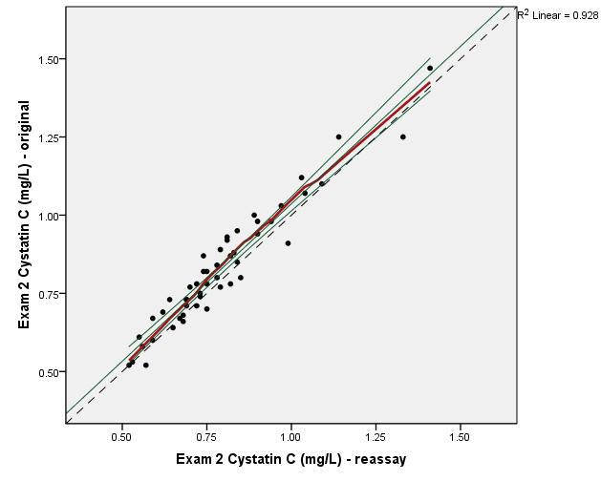

Figure 2.2: Bland-Altman (mean by difference) plot of Exam 2 Cystatin C
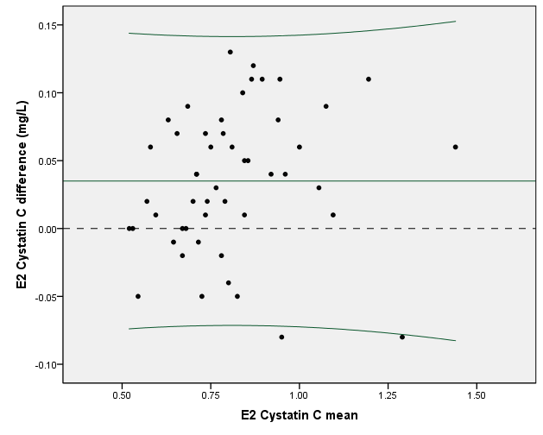

Table 2.2: Regression model of reassay predicting original cystatin c
 | Beta | SE | Standardized B | t | p-value
Constant | 0.029 | 0.033 |  | 0.892 | 0.377
E2 Cystatin C mg/L -reassay | 1.007 | 0.041 | 0.963 | 24.828 | <0.001

Table 2.3: Regression model of original predicting reassay cystatin c
 | Beta | SE | Standardized B | t | p-value
Constant | 0.030 | 0.032 |  | 0.955 | 0.344
E2 Cystatin C mg/L -original | 0.921 | 0.037 | 0.963 | 24.828 | <0.001

Recommended Exam 2 Calibration equation (for correcting E2 Cystatin C to 2014 assay):
Calibrated E2 Cystatin C mg/dL = 0.030 + 0.921 * [original E2 cystatin c]

Exam 3

Table 3.1: Descriptive summary
 | N | Mean | SD | Min | 25th %ile | Median | 75th %ile | Max
E3 Cystatin C (mg/L) | 5,550 | 0.74 | 0.259 | 0.05 | 0.60 | 0.70 | 0.82 | 6.76
E3 Cystatin C (mg/L) - original | 50 | 0.76 | 0.342 | 0.43 | 0.60 | 0.70 | 0.84 | 2.85
E3 Cystatin C (mg/L) - reassay | 50 | 0.85 | 0.411 | 0.51 | 0.70 | 0.76 | 0.91 | 3.50
E3 Cystatin C difference (mg/L) | 50 | -0.09 | 0.105 | -0.65 | -0.14 | -0.08 | -0.02 | 0.08
E3 Cystatin C relative difference | 50 | -0.11 | 0.097 | -0.28 | -0.19 | -0.09 | -0.03 | 0.08

Figure 3.1: Scatterplot of Exam 3 reassay by original Cystatin C
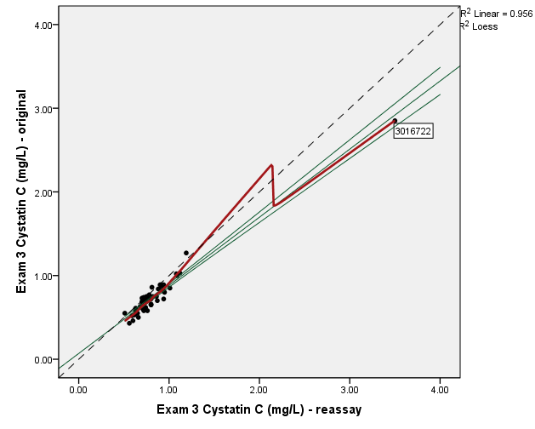

Figure 3.2: Bland-Altman (mean by difference) plot of Exam 3 Cystatin C
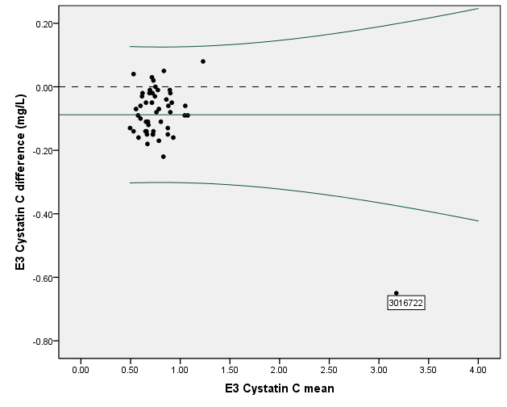
Comments:
- Outlier detected with cystatin C measure = 2.85 mg/L and reasssay measure = 3.50 mg/L (ID 3016722). The next closest measures are at approximately 1.20 mg/L. In order to avoid undue influence on the calibration equation estimates, these measures are dropped from the analysis.

Table 3.2: Descriptive summary (outlier removed)
 | N | Mean | SD | Min | 25th %ile | Median | 75th %ile | Max
E3 Cystatin C (mg/L) | 5,550 | 0.74 | 0.259 | 0.05 | 0.60 | 0.70 | 0.82 | 6.76
E3 Cystatin C (mg/L) - original | 49 | .72 | .163 | .43 | .60 | .70 | .81 | 1.27
E3 Cystatin C (mg/L) - reassay | 49 | .79 | .151 | .51 | .70 | .76 | .90 | 1.19
E3 Cystatin C difference (mg/L) | 49 | -.08 | .068 | -.22 | -.14 | -.08 | -.02 | .08
E3 Cystatin C relative difference | 49 | -.11 | .097 | -.28 | -.18 | -.09 | -.03 | .08

Figure 3.3: Scatterplot of Exam 3 reassay by original Cystatin C (outlier removed)
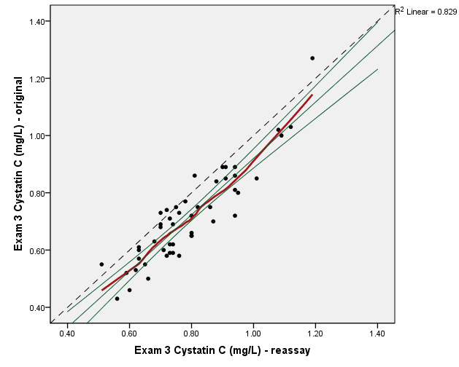

Figure 3.4: Bland-Altman (mean by difference) plot of Exam 3 Cystatin C
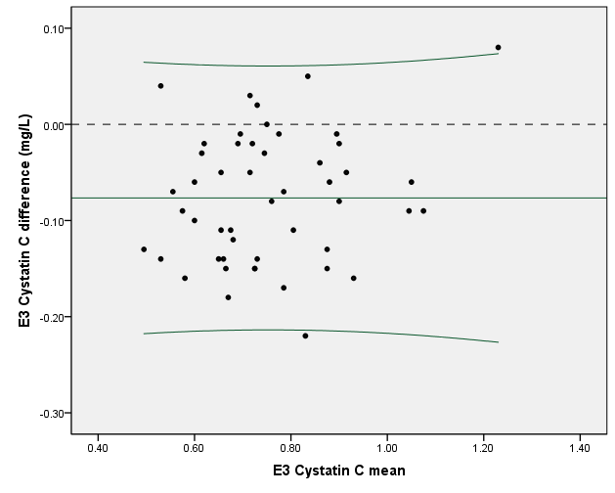

Table 3.3: Regression model of reassay predicting original cystatin c
 | Beta | SE | Standardized B | t | p-value
Constant | -0.064 | 0.053 |  | -1.210 | 0.232
E3 Cystatin C mg/L -reassay | 0.984 | 0.065 | 0.910 | 15.071 | <0.001

Table 3.4: Regression model of original predicting reassay cystatin c
 | Beta | SE | Standardized B | t | p-value
Constant | 0.189 | 0.041 |  | 4.621 | <0.001
E3 Cystatin C mg/L -original | 0.842 | 0.056 | 0.910 | 15.071 | <0.001

Recommended Exam 3 Calibration equation (for correcting E3 Cystatin C to 2014 assay):
Calibrated E3 Cystatin C mg/dL = 0.189 + 0.842 * [original E3 cystatin c]

Exam 4

Table 4.1: Descriptive summary
 | N | Mean | SD | Min | 25th %ile | Median | 75th %ile | Max
E4 Cystatin C (mg/L) | 5,260 | 0.78 | 0.261 | 0.11 | 0.65 | 0.74 | 0.86 | 5.67
E4 Cystatin C (mg/L) - original | 50 | 0.76 | 0.179 | 0.37 | 0.64 | 0.74 | 0.88 | 1.23
E4 Cystatin C (mg/L) - reassay | 50 | 0.80 | 0.179 | 0.52 | 0.67 | 0.78 | 0.91 | 1.29
E4 Cystatin C difference (mg/L) | 50 | -0.04 | 0.046 | -0.15 | -0.06 | -0.04 | -0.01 | 0.08
E4 Cystatin C relative difference | 50 | -0.05 | 0.070 | -0.34 | -0.08 | -0.05 | -0.02 | 0.11

Figure 4.1: Scatterplot of Exam 4 reassay by original Cystatin C
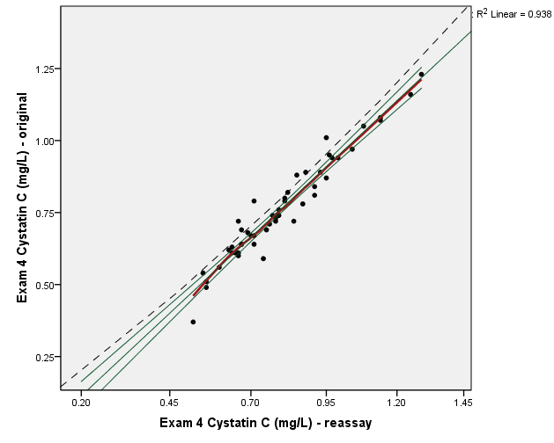

Figure 4.2: Bland-Altman (mean by difference) plot of Exam 4 Cystatin C
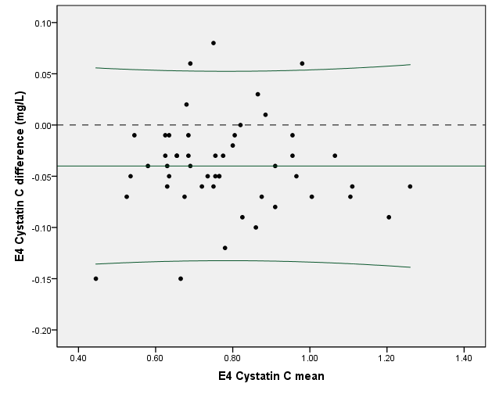

Table 4.2: Regression model of reassay predicting original cystatin c
 | Beta | SE | Standardized B | t | p-value
Constant | -0.014 | 0.030 |  | -0.465 | 0.644
E4 Cystatin C mg/L -reassay | 0.968 | 0.036 | 0.968 | 26.535 | <0.001

Table 4.3: Regression model of original predicting reassay cystatin c
 | Beta | SE | Standardized B | t | p-value
Constant | 0.065 | 0.029 |  | 2.267 | 0.028
E4 Cystatin C mg/L -original | 0.968 | 0.036 | 0.968 | 26.535 | <0.001

Recommended Exam 4 Calibration equation (for correcting E4 Cystatin C to 2014 assay):
Calibrated E4 Cystatin C mg/dL = 0.065 + 0.968 * [original E4 cystatin c]

Exam 5

Table 5.1: Descriptive summary
 | N | Mean | SD | Min | 25th %ile | Median | 75th %ile | Max
E5 Cystatin C (mg/L) | 4,583 | 0.96 | 0.334 | 0.39 | 0.78 | 0.89 | 1.05 | 7.00
E5 Cystatin C (mg/L) - original | 50 | 0.99 | 0.429 | 0.60 | 0.77 | 0.90 | 1.04 | 3.55
E5 Cystatin C (mg/L) - reassay | 50 | 0.92 | 0.385 | 0.58 | 0.75 | 0.84 | 1.03 | 3.20
E5 Cystatin C difference (mg/L) | 50 | 0.06 | 0.065 | -0.05 | 0.01 | 0.06 | 0.09 | 0.35
E5 Cystatin C relative difference | 50 | 0.06 | 0.057 | -0.07 | 0.02 | 0.07 | 0.10 | 0.23

Figure 5.1: Scatterplot of Exam 5 reassay by original Cystatin C
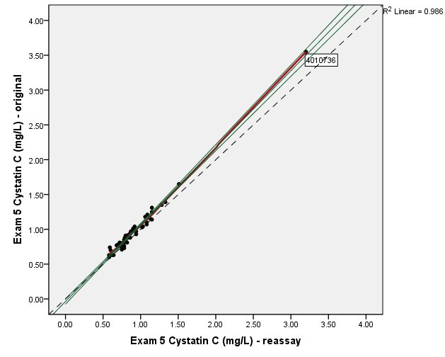

Figure 5.2: Bland-Altman (mean by difference) plot of Exam 5 Cystatin C
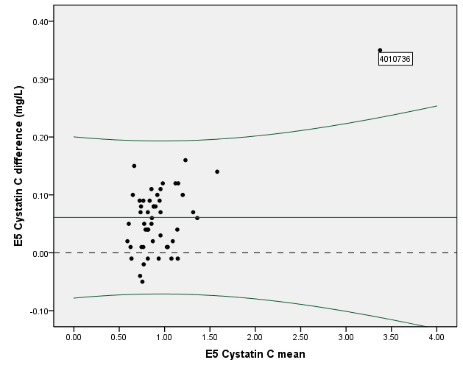
Comments:
- Outlier detected with cystatin C measure = 3.55 mg/L and reasssay measure = 3.20 mg/L (ID 4010736). The next closest measures are at approximately 1.60 mg/L. In order to avoid undue influence on the calibration equation estimates, these measures are dropped from the analysis.

Table 5.2: Descriptive summary (outlier removed)
 | N | Mean | SD | Min | 25th %ile | Median | 75th %ile | Max
E5 Cystatin C (mg/L) | 4,583 | 0.96 | 0.334 | 0.39 | 0.78 | 0.89 | 1.05 | 7.00
E5 Cystatin C (mg/L) - original | 49 | 0.93 | 0.219 | 0.60 | 0.77 | 0.89 | 1.04 | 1.65
E5 Cystatin C (mg/L) - reassay | 49 | 0.88 | 0.204 | 0.58 | 0.75 | 0.83 | 1.02 | 1.51
E5 Cystatin C difference (mg/L) | 49 | 0.06 | 0.051 | -0.05 | 0.01 | 0.06 | 0.09 | 0.16
E5 Cystatin C relative difference | 49 | 0.06 | 0.057 | -0.07 | 0.02 | 0.06 | 0.10 | 0.23

Figure 5.3: Scatterplot of Exam 5 reassay by original Cystatin C (outlier removed)
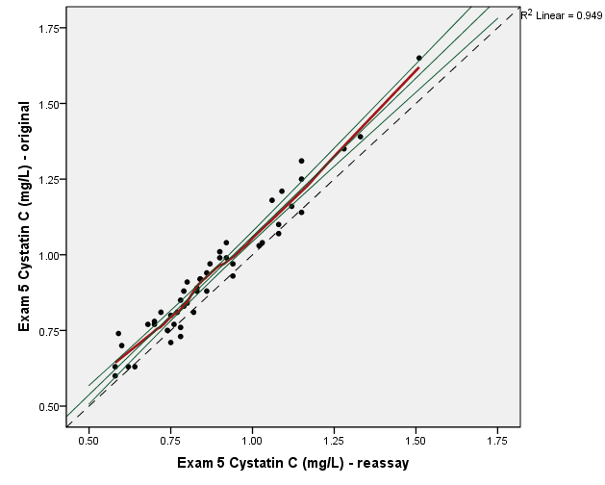

Figure 5.4: Bland-Altman (mean by difference) plot of Exam 5 Cystatin C
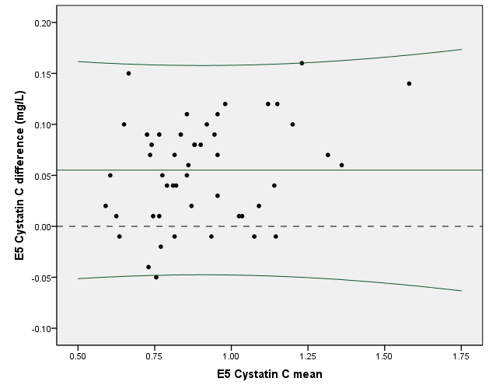

Table 5.3: Regression model of reassay predicting original cystatin c
 | Beta | SE | Standardized B | t | p-value
Constant | 0.015 | 0.032 |  | 0.458 | 0.649
E5 Cystatin C mg/L -reassay | 1.046 | 0.036 | 0.974 | 29.439 | <0.001

Table 5.4: Regression model of original predicting reassay cystatin c
 | Beta | SE | Standardized B | t | p-value
Constant | 0.032 | 0.030 |  | 1.080 | 0.286
E5 Cystatin C mg/L -original | 0.907 | 0.031 | 0.974 | 29.439 | <0.001

Recommended Exam 5 Calibration equation (for correcting E5 Cystatin C to 2014 assay):
Calibrated E5 Cystatin C mg/dL = 0.032 + 0.907 * [original E5 cystatin c]

Cystatin C Calibration Correction Assessment

Table 6.1: Calibrated Cystatin C distribution by Exam (472 participants with measures at 5 exams)
Calibrated to 2014 Assay Scale
 | N | Mean | SD | Min | 25th %ile | Median | 75th %ile | Max
Exam 1 Cystatin C (mg/l) | 472 | 0.75 | 0.143 | 0.45 | 0.65 | 0.74 | 0.82 | 1.47
Exam 2 Cystatin C (mg/l) | 472 | 0.77 | 0.181 | 0.39 | 0.66 | 0.74 | 0.85 | 1.87
Exam 3 Cystatin C (mg/l) | 472 | 0.81 | 0.166 | 0.40 | 0.70 | 0.79 | 0.89 | 1.92
Exam 4 Cystatin C (mg/l) | 472 | 0.81 | 0.201 | 0.30 | 0.68 | 0.77 | 0.90 | 2.42
Exam 5 Cystatin C (mg/dL) | 472 | 0.93 | 0.344 | 0.49 | 0.75 | 0.86 | 1.00 | 4.51

Figure 6.1: Boxplots of Cystatin C by Exam (472 participants with measures at 5 exams)
Calibrated to 2014 Assay Scale
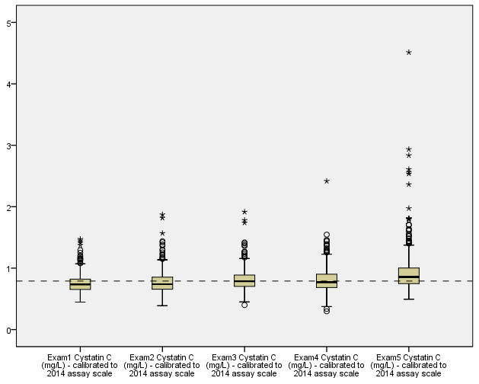

Calibration to Exam 1 scale
MESA Exam 1:
use Y:\Projects\MESA\Analyses\CystatinCSelection\ReassayDataFiles\MESAe1_CystatinC_Reassay_Merged_04242014.dta
Is linear regression derived slope different than 1?
regress cystatc1 Cystatin_C__mg_L
. regress cystatc1 Cystatin_C__mg_L

Source | SS df MS Number of obs = 48
-------------+------------------------------ F( 1, 46) = 354.59
Model | 1.28293488 1 1.28293488 Prob > F = 0.0000
Residual | .166431786 46 .003618082 R-squared = 0.8852
-------------+------------------------------ Adj R-squared = 0.8827
Total | 1.44936667 47 .030837589 Root MSE = .06015

------------------------------------------------------------------------------
cystatc1 | Coef. Std. Err. t P>|t| [95% Conf. Interval]
-------------+----------------------------------------------------------------
Cystatin_C~L | 1.079972 .0573521 18.83 0.000 .9645283 1.195416
_cons | .0605546 .0446782 1.36 0.182 -.029378 .1504873
------------------------------------------------------------------------------
lincom Cystatin_C__mg_L -1
. lincom Cystatin_C__mg_L -1

( 1) Cystatin_C__mg_L = 1

------------------------------------------------------------------------------
cystatc1 | Coef. Std. Err. t P>|t| [95% Conf. Interval]
-------------+----------------------------------------------------------------
(1) | .0799721 .0573521 1.39 0.170 -.0354717 .1954159
------------------------------------------------------------------------------

Conclusion: since the slope is not statistically different than 1, one could make the calibration adjustment by adding a constant to 2014 scale values in order to get calibrated E1 scale values.
What constant should be used?
ttest cystatc1 = Cystatin_C__mg_L
. ttest cystatc1 = Cystatin_C__mg_L

Paired t test
------------------------------------------------------------------------------
Variable | Obs Mean Std. Err. Std. Dev. [95% Conf. Interval]
---------+--------------------------------------------------------------------
cystatc1 | 48 .8858333 .0253466 .1756063 .8348426 .9368241
Cystat~L | 48 .7641667 .0220811 .1529822 .7197453 .8085881
---------+--------------------------------------------------------------------
diff | 48 .1216667 .0087688 .0607518 .1040262 .1393071
------------------------------------------------------------------------------
mean(diff) = mean(cystatc1 - Cystatin_C__mg_L) t = 13.8750
Ho: mean(diff) = 0 degrees of freedom = 47

Ha: mean(diff) < 0 Ha: mean(diff) != 0 Ha: mean(diff) > 0
Pr(T < t) = 1.0000 Pr(|T| > |t|) = 0.0000 Pr(T > t) = 0.0000

Conclusion: since the means are statistically significantly different, one could make the calibration adjustment by adding 0.1216667 to 2014 scale values in order to get calibrated E1 scale values.

Table 6.2: Calibrated Cystatin C distribution by Exam
Calibrated to 214 Assay Scale and to Exam 1 Assay Scale
 | N | Mean | SD | Min | 25th %ile | Median | 75th %ile | Max
E1 Cystatin C (mg/L) | 6756 | 0.90 | 0.244 | 0.36 | 0.76 | 0.86 | 0.98 | 7.59
E2 Cystatin C (mg/L) | 770 | 0.84 | 0.283 | 0.39 | 0.69 | 0.79 | 0.93 | 5.36
E3 Cystatin C (mg/L) | 5550 | 0.74 | 0.259 | 0.05 | 0.60 | 0.70 | 0.82 | 6.76
E4 Cystatin C (mg/L) | 5260 | 0.78 | 0.261 | 0.11 | 0.65 | 0.74 | 0.86 | 5.67
E5 Cystatin C (mg/L) | 4583 | 0.96 | 0.334 | 0.39 | 0.78 | 0.89 | 1.05 | 7.00
E1 Cystatin C (mg/L) - calibrated to 2014 scale | 6756 | 0.77 | 0.200 | 0.33 | 0.66 | 0.74 | 0.84 | 6.26
E2 Cystatin C (mg/L) - calibrated to 2014 scale | 770 | 0.80 | 0.261 | 0.39 | 0.67 | 0.76 | 0.89 | 4.97
E3 Cystatin C (mg/L) - calibrated to 2014 scale | 5550 | 0.81 | 0.218 | 0.23 | 0.69 | 0.78 | 0.88 | 5.88
E4 Cystatin C (mg/L) - calibrated to 2014 scale | 5260 | 0.82 | 0.253 | 0.17 | 0.69 | 0.78 | 0.90 | 5.55
E5 Cystatin C (mg/L) - calibrated to 2014 scale | 4583 | 0.90 | 0.302 | 0.39 | 0.74 | 0.84 | 0.98 | 6.38
E1 Cystatin C (mg/L) - E1 assay scale | 6756 | 0.90 | 0.244 | 0.36 | 0.76 | 0.86 | 0.98 | 7.59
E2 Cystatin C (mg/L) - calibrated to E1 scale | 770 | 0.92 | 0.261 | 0.51 | 0.79 | 0.88 | 1.01 | 5.09
E3 Cystatin C (mg/L) - calibrated to E1 scale | 5550 | 0.93 | 0.218 | 0.35 | 0.81 | 0.90 | 1.00 | 6.00
E4 Cystatin C (mg/L) - calibrated to E1 scale | 5260 | 0.94 | 0.253 | 0.29 | 0.81 | 0.90 | 1.02 | 5.67
E5 Cystatin C (mg/L) - calibrated to E1 scale | 4583 | 1.02 | 0.302 | 0.51 | 0.86 | 0.96 | 1.10 | 6.50

Table 6.3: Calibrated Cystatin C distribution by Exam (472 participants with measures at 5 exams)
Calibrated to 214 Assay Scale and to Exam 1 Assay Scale
 | N | Mean | SD | Min | 25th %ile | Median | 75th %ile | Max
E1 Cystatin C (mg/L) | 472 | 0.87 | 0.175 | 0.50 | 0.75 | 0.85 | 0.96 | 1.75
E2 Cystatin C (mg/L) | 472 | 0.80 | 0.196 | 0.39 | 0.68 | 0.77 | 0.90 | 2.00
E3 Cystatin C (mg/L) | 472 | 0.74 | 0.197 | 0.25 | 0.61 | 0.71 | 0.83 | 2.05
E4 Cystatin C (mg/L) | 472 | 0.77 | 0.207 | 0.24 | 0.64 | 0.73 | 0.87 | 2.43
E5 Cystatin C (mg/L) | 472 | 0.99 | 0.380 | 0.51 | 0.79 | 0.91 | 1.07 | 4.94
E1 Cystatin C (mg/L) - calibrated to 2014 scale | 472 | 0.75 | 0.143 | 0.45 | 0.65 | 0.74 | 0.83 | 1.47
E2 Cystatin C (mg/L) - calibrated to 2014 scale | 472 | 0.77 | 0.181 | 0.39 | 0.66 | 0.74 | 0.86 | 1.87
E3 Cystatin C (mg/L) - calibrated to 2014 scale | 472 | 0.81 | 0.166 | 0.40 | 0.70 | 0.79 | 0.89 | 1.92
E4 Cystatin C (mg/L) - calibrated to 2014 scale | 472 | 0.81 | 0.201 | 0.30 | 0.68 | 0.77 | 0.91 | 2.42
E5 Cystatin C (mg/L) - calibrated to 2014 scale | 472 | 0.93 | 0.344 | 0.49 | 0.75 | 0.86 | 1.00 | 4.51
E1 Cystatin C (mg/L) - E1 assay scale | 472 | 0.87 | 0.175 | 0.50 | 0.75 | 0.85 | 0.96 | 1.75
E2 Cystatin C (mg/L) - calibrated to E1 scale | 472 | 0.89 | 0.181 | 0.51 | 0.78 | 0.86 | 0.98 | 1.99
E3 Cystatin C (mg/L) - calibrated to E1 scale | 472 | 0.93 | 0.166 | 0.52 | 0.82 | 0.91 | 1.01 | 2.04
E4 Cystatin C (mg/L) - calibrated to E1 scale | 472 | 0.93 | 0.201 | 0.42 | 0.80 | 0.89 | 1.02 | 2.54
E5 Cystatin C (mg/L) - calibrated to E1 scale | 472 | 1.05 | 0.344 | 0.61 | 0.87 | 0.98 | 1.12 | 4.63

Figure 6.2: Boxplots of Cystatin C by Exam (472 participants with measures at 5 exams)
Calibrated to 2014 Assay Scale
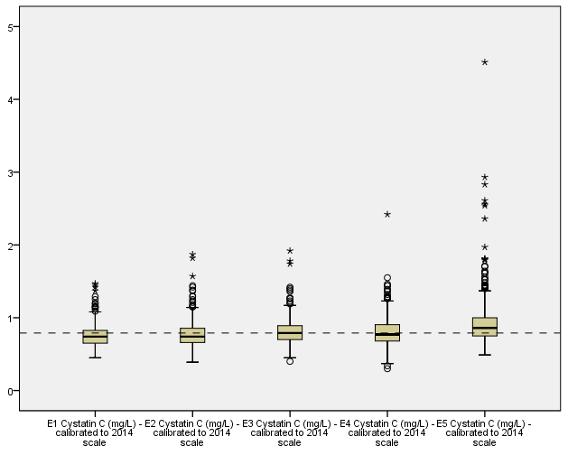

Figure 6.3: Boxplots of Cystatin C by Exam (472 participants with measures at 5 exams)
Calibrated to Exam 1 Assay Scale
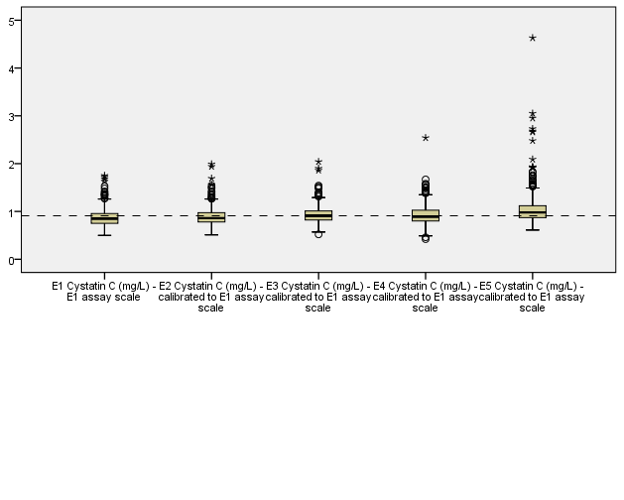

Dependent variable is original cystatin c
Dependent variable is reassayed cystatin c
Original precision should be maintained, so it is recommended that the calibrated values be rounded to the nearest 0.01.
Dependent variable is original cystatin c
Dependent variable is reassayed cystatin c
Original precision should be maintained, so it is recommended that the calibrated values be rounded to the nearest 0.01.
Dependent variable is original cystatin c
Dependent variable is reassayed cystatin c
Original precision should be maintained, so it is recommended that the calibrated values be rounded to the nearest 0.01.
Dependent variable is original cystatin c
Dependent variable is reassayed cystatin c
Original precision should be maintained, so it is recommended that the calibrated values be rounded to the nearest 0.01.
Dependent variable is original cystatin c
Dependent variable is reassayed cystatin c
Original precision should be maintained, so it is recommended that the calibrated values be rounded to the nearest 0.01.

