MULTIETHNIC STUDY OF ATHEROSCLEROSIS

COMPUTED TOMOGRAPHY

MANUAL OF OPERATIONS

DRAFT – July 26, 2001

I. Background and Goals 4
II. Qualifications of Personnel 4
III. Scanning Equipment and Centers 5
IV. Training for Field Center CT Technologists 5
V. Participant Scheduling 7
VI. Scanning Table and Calibration Phantom. 7
VII. Scanning Procedure 8
VIII. Scanner Quality Assurance 11
IX. Alerts 13
X. Data Transmission of Studies 13
XI. Data Flow 14
XII. CT Reading Procedure Operations Manual 16
INTRODUCTION 16
REVIEWING FOR NON CORONARY PATHOLOGY 16
SUBJECT CHOOSER 18
1. Launching The Subject Chooser 18
2. The Subject Chooser Window 18
3. Edit Scoring Defaults 19
BOXING 19
1. Description Of Boxing 19
2. Boxing The Heart 20
3. Identifying The Regions In The Phantom 21
TRACING 21
1. Launching The Tracing Program 21
2. Labeling The Vessels 22
3. Checking The Tracings 23
4. Editing the X’s 23
5. Finish Tracing 23
SCORING 23
1. Launching The Scoring Program 23
2. Checking Lesions 23
3. Quality Assessment Tool 24
4. Auto Archiving (Automatic CD Backup) 25
APPENDIX A: Protocol for Inter-scan, Inter-reader, and Intra-reader Variability 26
1. Interscan Variability: 26
2. Inter-reader Variability: 26
3. Intra-reader Variability: 26
APPENDIX B: Description Of Options In Scoring Defaults Menu 27
APPENDIX C: CD Backup Procedure (Manual) 29
APPENDIX D: How To Make and Test A Test Case 29
XII. Attachments 34
1. Sample Alert Letter 34
2. CT Study Transmission Sheet/ FAX to 310-533-1616 35
3. QA QCT Sheet FAX to 310-533-1616 36
MESA CT Reading Center Complete Scan Log 37
MESA CT Data Flow Sheet 39

I. Background and Goals

The Multiethnic Study of Atherosclerosis (MESA) is studying risk factors and measures of cardiovascular disease that relate to progression of subclinical to clinical disease. An integral part of this study is the measurement of coronary artery calcium using either electron beam computed tomography (EBCT) or helical computed tomography (HCT). Coronary calcium will be assessed in relation to the risk of future cardiac events, and from repeated scans in selected individuals, the progression of coronary calcium will be related to baseline risk factors and risk of future events.

Separate training sessions will be held in March 2000 in Los Angeles (for the EBCT centers) and in Wake Forest (for the Helical CT centers) for all technicians participating in the MESA study. A pilot feasibility study will take place in May 2000 on a selected sample of volunteers (10 from each Field Center). Approximately 6,500 participants will be scanned among the 6 centers during the initial (2-year) examination occurring between July 2000 and June 2002. A sample of about half of participants will receive repeated scans during three subsequent, follow-up examinations in future years.

Goals:

- To examine the relation of baseline measures of coronary calcium quantity (score and volume measures) to future risk of cardiac events
- To examine the relation of baseline measures of coronary calcium to other risk factors and measures of subclinical disease (e.g., MRI and ultrasound measures).
- To examine the relation of progression of coronary calcium to the risk of future cardiac events, as well as to risk factors at baseline and progression of risk factors.
- To examine the above goals by ethnic and gender strata, when possible.

II. Qualifications of Personnel

Each Field Center has a designated physician to oversee the general performance of CT examination. A reading center investigator will provide the necessary on-site training.

Field Center technologists should have appropriate knowledge of cross-sectional anatomy, physiology, and pathology related to the heart. Technologists must be certifed as RTs in their state. It is recommend that technologists also have at least two years of experience in chest computed tomography. The technologist should also have a basic knowledge of cardiac CT, knowledge of computer software applications, data formatting, and experience with the workstations and data formatting / transmission procedures used.

Each technologist involved in the study should also have a complete understanding of this protocol, be experienced at providing breath-holding instruction, ECG gating, operation of the EBCT or HCT equipment. To ensure quality control, each Field Center should have designated CT technicians who will perform the MESA examinations, once appropriate training, including the March 2000 training course, has been provided.

III. Scanning Equipment and Centers

The scanners used will be:

Imatron C-150: Saint Francis Hospital; Roslyn, New York
Imatron C-150 Northwestern University, Chicago, Illinois
Imatron C-150 UCLA School of Medicine, Los Angeles, CA
General Electric LightSpeed : Wake Forest Bowman Grey School of Medicine
Siemens S4+ Volume Zoom: Johns Hopkins Univ. Medical Center, Baltimore
Siemens S4+ Volume Zoom: Univ of Minnesota Medical Center, Minneapolis

Each center will be responsible for scanning approximately one sixth of the cohort of 6500 individuals. For purposes of increased reliability and quality control, each subject will be scanned twice during each session.

IV. Training for Field Center CT Technologists

Two days of intensive training will be required to insure that technologists gain a firm grasp of and demonstrate competency in performing scans. EBCT technologists will receive this training at Harbor UCLA Medical Center under the directions of Drs. Detrano and Carr. Helical CT technologists will receive this training under the direction of Drs Carr and Detrano at Wake Forest University. Drs. Detrano and Dr. Carr will attend and assist at both sessions. See also section VIII.

The training courses will take place on the following dates.

EBCT Course: March 6-7, 2000 Harbor UCLA Medical Center
Non EBT Course: March 9-10 Wake Forest University.

The proposed curriculum follows:

Day 1 – ALL FIELD CENTER AND READING CENTER STAFF ATTEND

9:00am - 9:30am The purpose, structure and methodology of the MESA study. Drs. Detrano or, Carr.

9:30am - 10:00am. Sources of Variability and Quality Assurance Issues. Drs. Detrano and Wong

10:00am - 10:15am Break

10:15am - 10:30am Non-coronary pathology: Dr. Fischer or Dr. Carr

10:30am – 11:15am The CT Protocol and Technique of Performing scans. Dr. Budoff (Harbor); Dr. Carr (Wake Forest)

11:15am - noon Other Discussions

Noon - 1:30pm - Lunch Break

1:30pm - 2:30pm - Detailed Demonstration of Proper Scanning Technique, including machine settings, manufacturer console review of scan, downloading of images to optical disk and ETHERNET
transmission to the reading center. Drs. Budoff and Carr.

2:30pm - 5:30pm - Begin pre-certification of technologists - each technologist
performs two scans followed protocol, reviews scans, downloads images, and transmits to reading center

During this period, each technologist assists at the performance of two scans, which are then reviewed immediately by the instructor for satisfaction of the seven technical quality criteria. Immediate feedback is given on each scan. Two scans of excellent (E) quality should be performed at the training session for provisional certification, and an additional three at the Field Center for full certification. Continued certification is contingent on satisfactory performance during quality control reviews.

Day 2 - Complete Pre-Certification of Remaining Technologists
All remaining technologists depart following satisfactory certification

Further Training and Certification

For full certification, prior to the pilot study, all technicians will be required to submit three sample images, performed and transmitted to the reading center according to protocol. Each of these scans will also be rated on the seven technical quality criteria and immediate feedback will be given. A telephone call will be made to technologists, as needed, to discuss areas for improvement and possible solutions.

Within four weeks after the initiation of scanning, either Dr. Carr or Dr. Detrano will travel to each of the Field Sites. There the instructor will teach and discuss the pilot test study protocol and the EBCT scanning protocol to the technologists. These visits will take one working day each and will concentrate on obtaining adequate and optimal scan images using the scanning protocol to be tested during the pilot study. Each Field Site technologist will perform at least four studies under the supervision of the instructor. At completion of this session, the instructor will examine the Field Site technologists who will receive certification for continuation in the pilot test study.

All techs will be assigned three digit id numbers once certified. These will be entered by the techs in the scan headers of each scan.

Reader Training and Certification

Readers will be trained by the director of the reading center. After training, each reader will undergo a certification exam conducted by the reading center director. The following essential elements will comprise this exam:

- Logging on and off of the work station
- Appropriate choosing of subjects
- Boxing and correcting the phantom regions
- Tracing of the major coronary arteries,
including pruning of arterial tree.
- Scoring and editing of lesions
- Editing when necessary the summary of scores.
- Completing the quality assurance menu.

The reader will be scored in each component above as either passed or failed. 100% pass rate will be necessary for certification.

V. Participant Scheduling

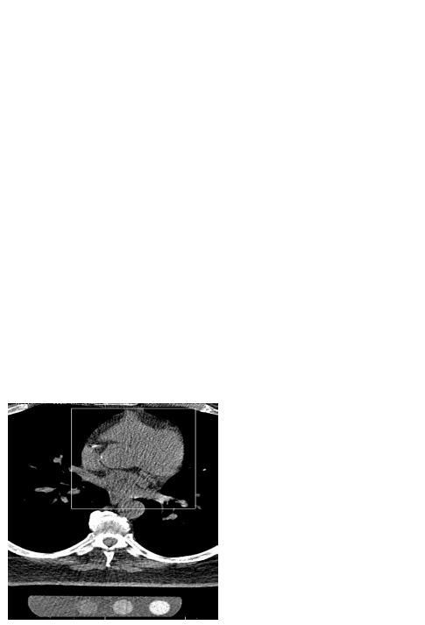 The MESA operations committee will arrange details of scheduling, Each scanning site will provide their local Field Center with the days/times when MESA participants may be scheduled and the Field Center will contact participants to arranging their appointments for their CT scan. Whether certain days/times will be held for MESA participants only, until 2 weeks or a certain amount of time prior to the day of the appointment, will be agreed upon between the scanning center and Field Center.
A Field Center interviewer/scheduler will be responsible for explaining and obtaining consent for the CT examination. Participants will be scheduled for a certain date and time, and transportation arrangements, if necessary, will be arranged by the Field Center interviewer/scheduler. A confirmation appointment letter will be sent, providing the time, date, and directions to the scanning center, and describing the procedure.

VI. Scanning Table and Calibration Phantom.

A special gel stuffed mat will be provided with the calibration pad phantom to prevent artifacts and for subject comfort. This pad is placed between the phantom and the patient. The calibration phantom will be placed inside the blue catcher bag with its long axis parallel to the long axis of the scanning table. The phantom is made of tissue equivalent plastic with rods of hydroxyapatite of known radiographic density. The technologist will position the subject so that the length of the phantom covers the expected length of the heart The phantom will be the one pictured on the right.

VII. Scanning Procedure

The scanning procedure described below, consisting of two scans done in succession on each subject, will require approximately 20 minutes of the subject’s time. Minimal respiratory motion and maximum accuracy and reproducibility require this duration. In unusual cases, this may require as many as 30 minutes. In many cases, the procedure will be completed in 15 minutes or less.

Entering the MESA ID and ACROSTIC

This very important step must be done correctly to prevent any irretrievable loss of CT data. All necessary information needs to be entered into the system, including your technician ID number, Field Center identification. The MESA seven digit ID number must be placed in the ID Field, and an acrostic defined below will be placed in the name field. The acrostic will consist of the first four letters of the last name followed by the first two letters of the first name and one letter for the gender. Each will be preceded by the letters “MESA”.
Example:

ID: MESA1212345 NAME: MESADETRROM

The time stamp on each CT record will determine whether the scan is the first or second in the sequence of two scans.

Preparation of the Subject (3 minutes). Subjects weighing more than 300 pounds will not be scanned due to technical difficulties. The technologist will ask women if they might be pregnant and will not scan them if they answer affirmatively. The technologist will attach three electrocardiographic electrodes under the left clavicle and on either side of the thorax near the axillae (to maximize ECG signal). The technologist will ask each subject for their self reported weight in pounds and will use this value to decide if the subject satisfies the “Large Patient” criterion.

Breath Holding Instruction (3 minutes). The technologist will instruct the subject on the importance of breath holding and immobility during scanning. An interpreter will assist in the instruction of subjects, not fluent in English. All centers will have access to interpreters fluent in languages spoken by at least 95 percent of potential volunteers. Our preliminary study suggests that at least 99.5% will be able to hold their breaths for more than 15 seconds and 80% will be able to hold their breaths for more than thirty seconds. Only after the technologist is satisfied that the subject understands the importance of breath holding, will he/she proceed.

Checking the Scout Image (1 minute). The technologist will instruct the subject to take three deep breaths, and then to hold his/her breath (at end-inspiration), while acquiring an 11 cm scout image, beginning 180 mm below the sternal notch. This will provide views of the chest on the image monitor at the operator console. From this, the technologist will check patient centering and choose the position for the highest scan (at the lower margin of the bifurcation of the main pulmonary artery). The couch will be moved to the start position. The technologist will check subject and phantom positioning in the scout image.

Default Scanner Settings. At least 10.5 cm of data in the z direction will be acquired with each scan and the scan Field of View will be 35 cm for all scanners (to incorporate the phantom in the image). For each scanner, the default settings will be as follows:

- GE Light Speed (800msec rotation time) - 120 kVp, 200 mA, .8 sec scan, 4 x 2.5mm collimation, sequential axial scans, segmented reconstruction, standard filter.
- GE Light Speed (500msec rotation time) - 120 kVp, 320 mA, .5 sec scan, 4 x 2.5mm collimation, sequential axial scans, segmented reconstruction, standard filter.
- Siemens Volume Zoom - 140 kVp, 139 mA, .361 sec scan, 4 x 2.5 mm collimation, sequential axial scans with prospective cardiac gating, standard filter reconstruction (as designated on the VZ). Note, set mAs at 50.
- Imatron EBCT scanners: 130 kVp, 630 mA, scan time 100 msec, 3mm collimation, sharp reconstruction filter. For EBCT scans, prospective cardiac gating will be used with scanner triggering at 80% of the electrocardiographic RR interval. The EBCT scanner table will pause after each table increment of 3 mm (sequential axial scans) . The technologist will acquire 35 to 40 image slices as needed to ensure that the entire heart is scanned
Large Patient Scanner Settings
For the helical (non Imatron) scanners only, the mA will be adjusted upwards for larger patients. For patients > 220 lbs, the mA will be increased by 25%. Specifically:

- For General Electric LightSpeed scanner (800msec rotation time): increase to 250 mA. All other parameters are to remain the same.
- For General Electric LightSpeed scanner (500msec rotation time): increase to 400 mA. All other parameters are to remain the same.
- For Siemens Volume Zoom scanners: increase to 174 mA. All other parameters are to remain the same. Note, increase mAs to 63.

Reconstruction The technologist will use the 35 cm field of view and the sharp reconstruction kernel for all EBCT scans and 35 cm field of view and the standard kernel for all other scans.

Imaging (6 minutes). All scanning will be done with a single breath hold. The Siemens Volume Zoom helical scan acquisition requires a breath hold for the participant ranging from 15 to 25 seconds depending upon the combination of heart rate and heart length. EBCT and General Electric scan acquisition requires a breath hold of between 25 and 40 seconds depending on the same factors. The technologist will always ask the subject to take two deep breaths and then a third before imaging commences.

Though total imaging time will be approximately 30 to 40 seconds, double scanning will require about 5 to 7 minutes to complete. The technologist will first acquire one entire series of image slices. The technologist will instruct the subject to relax on the table while he/she reconstructs and assesses the adequacy of positioning, ECG gating and lack of respiratory motion. If these are adequate, the technologist will immediately acquire another series of image slices while the subject remains immobile and in an identical position. Once again, he will assess the adequacy of the images.

Radiation Dose Considerations. The radiation dose during one set of scans is approximately 600 to 800 mrem (skin dose) for all scanners used in this protocol. This will be applied to the thorax covering from 10.5 to 12 cm in the z axis. This would have to be multiplied times the number of scans (2 ).

The following may be helpful for informing subjects and institutional review board regarding radiation exposure from this study.

Scanner | Skin Dose | Effective Dose | Background  Effective
Imatron | 1260 mrem | 2.0 mSv | 2.3 – 3.0 mSv
Siemens | 1900 mrem | 3.0 mSv | 2.3 – 3.0 mSv
GE | 1540 mrem | 2.4 mSv | 2.3 – 3.0 mSv

Current estimates of the risk of fatal cancer from ionizing radiation for the adult working population are .004% per mSv (effective dose) over a 20 year period (assuming linear extrapolation). Thus, the additional risk of developing cancer for a participant in MESA during the next twenty years is between 8 per 100,000 and 12 per 100,000 for each CT examination. Each CT examination adds the equivalent risk of one year of background ionizing radiation.

Ref: International Commission on Radiological Protection. “1990 Recommendations of the International Commission on Radiological Protection”, ICRP Publication 60, Ann ICRP 21(1-3), 1991.

Identification, Storage and Transport of Image Data. The following will ensure proper scan identification and subject confidentiality. The technologist will record each volunteer’s study id number in the medical record number field of each scan. A five character acrostic consisting of the subject’s first, middle and last initials and a digit for the field site will be put in the last name field of the header. The date and times of the two scans and the identity of the scanning site and technologist will be identified in the appropriate fields. The technologist will store images in retrievable format on optical disk (MODs). Images will be transferred to a local work station which has an INTERNET interface to be used for transfer to the reading center.

VIII. Scanner Quality Assurance

Regular Scanner Calibration to Water. It is strongly recommended that the technologist at each center check the scanner at least weekly using a standard water phantom. These will include zeroing and calibrating the scanner unit.

Twice a Month CT Calibration Measurements for Quality Assurance.

Each clinical site will have a QCT calibration phantom (Image Analysis Inc) and a torso QA phantom (Image Analysis Inc) containing a central plug with a known concentration of hydroxyapatite (100mg/cc). The calibration pad contains cylindrical rods and will be contained inside of a recess in the table pad for patient comfort.

Every two weeks, quality assurance scans of the torso phantom allow convenient and quick verification of accuracy and precision of the CT scanners at different sites.

Quality assurance calibration measurements will be done weekly during the period of the pilot test study and then twice a month during the active scanning period of the study.

Positioning the Calibration and Torso Phantoms.

Make the table height such that the center of the calibration phantom is located at a distance of 9.2 cm +/- 1.0 cm from isocenter of the scanner field of view. Place the torso phantom on top of the calibration phantom (positioned in couch pad) and using your laser alignment light, adjust the table height until the torso center insert is at the location of isocenter (on grid). This is the table height you will use for QA scans with your Torso phantom.

Torso
Cal. Phantom
isocenter
Table
9.2 cm

Scanning the TORSO QA Phantom

After the correct position has been determined, take a vertical axial slice through the center of the TORSO phantom. Use the same parameters as with patient exams. With helical scanners, you should acquire two centimeters of volume data including the center of the torso phantom. Use the same scanning parameters as are used during the study. Reconstruction should be done with the same parameters as in scanning study subjects.

Then display your axial image on your CT monitor and examine it to ensure that it is free of artifacts, such as air gaps and streaks. Ensure that the calibration phantom is included in the field of view. If there are significant artifacts over the calibration phantom, you should discard the image and rescan the phantom.

Using your CT software place ROI’s on the calibration phantom reference samples (0, 50, 100, 200 mg/cc). The 0 sample will be an apparent blank space on one end of the calibration phantom. Then place an ROI in the TORSO vertebral sample. The ROIs should be as large as practical while remaining completely within the reference cylinder. (We recommend ROIs about 70% of the sample area.) Record the five mean CT numbers within these five ROIs and send these numbers by FAX or E-mail to the MESA reading center (Email, fax) using the standard QA forms provided (attached QA Data Sheet). Record the five mean CT numbers within these five ROIs.

File the data sheet for your records.

Send these forms by FAX to the study reading center (310-533-1616)

Instructions to the Reading Center.

Use the QCT software available to the reading center that runs on a standard PC using Windows 95. Click on the QXCT-3000 icon on your desktop. Click the enter QA button on the toolbar. A QA data entry screen pops up. Enter the data from the QA data sheets from the field centers. When all the data is entered, click OK. This will save the data to the QA database and open a window showing the QA report. To discard the entries you have made, click cancel.

The QCT 3000 software computes the calibrated calcium density for the Torso phantom. The results are displayed in graphic and tabular format. The software also accesses the database and retrieves any previous data on the Torso phantom. Previous data and calculated changes are displayed in the tabular form.

The individual QA torso readings should be maintained at within + 3% of the mean value of all the reading. If the values fall out of range, the field site must be notified in order to have the scanner checked by the field engineers.

The QA report has three major parts:

- Phantom and Scanner Information. This includes the phantom type and the exam number, the details of the CT scanner and technique.

Click the image of the phantom which matches the one used at the field site and enter the serial number of the phantom.

- QA Readings, together with past readings are plotted in graphical format. The graph is color coded and includes a band that covers the mean + 3%.

- The QA readings are also printed in tabular form by date. The change in the reading is also tabulated. Also shown is the mean and standard deviation of all the readings.

Some common sources that cause poor results include, inappropriate table height (TORSO plug should be at isocenter when scanned), mispositioning of the phantom, old or improper CT calibrations, or use of improper scan parameters.

Given there are multiple technicians at each field center, on a quarterly basis, interscan percent variability by the reading center will be calculated for each technician, obtaining the mean percent difference in scores between all duplicate scans performed by a given technician. Where unacceptable variability exists within a given technician (greater than two standard deviations beyond the mean variability for a given center), the reading center will advise the field site and an investigation into the reasons for this and further training / recertification, as needed, will be done.

IX. Alerts

Communication with Field Center by Reading Center

The Reading Center will review all scans within two weeks and will indicate any alerts. A cardiologist or radiologist investigator will review all scans and will identify eventual alerts. The investigator will telephone the CT investigator at the field site and the coordinating center and will write a letter (see Attachment) with copies to both. Pathological findings constituting alerts will include pulmonary infiltrates, pericardial or pleural effusions, tumors, dilatation of the aorta greater than 4 cm and pathological rib fractures.

X. Data Transmission of Studies

The technologist will transmit the studies to the local work stations if this has not been done during scanning. He/she will archive each study locally and leave a copy on the hard disk of the work station until it has been successfully transferred to the reading center. He/she will transmit the studies electronically using DICOM transfer on the local workstation to the reading center on a given afternoon of each week. He will simultaneously FAX the list of MESA ID numbers and acrostics transmitted at that time to the FAX number 310-533-1616.

The CT Data Manager will check each study to ascertain if it has been completely received. If it has been so received, the study will be put on the queue to be read by the reader. If it has not been received, the data manager will immediately communicate the identity of the study to the field site technologist and request that another attempt be made to send that study. The CT data manager will enter the identity, scan date, scan time and date and time of transfer of each study into a running log, a copy of which will be sent weekly to the coordinating center.

The CT reader will backup studies onto CDs as they are read. The reader will label each disc with a volume name and the date the CD was created. The reader will print a directory to be stored with each CD. Each CD-R that is archived will thus have a printed list of its contents inserted into its sleeve. The Data Manager will back check the CDs to be sure that they contain complete studies.

XI. Data Flow

A complex data flow diagram is contained in the Appendix. In brief, the following illustrates the principles of data flow:

Images. (Data manager Chris Dailing( 310-222-8013), Nathan Wong)

- The coordinating center will keep a list of all id numbers of subjects that are scanned. This list will be the master list.
- The scanning tech will FAX to the reading center (310-533-1616) a separate list of all subjects for whom an attempt is being made at INTERNET electronic transmission of images.
- Simultaneous with this FAX in 2, the scanning tech will attempt transmission of images for all subjects whose ID numbers are on the FAX ed list.
- The reading center data manager will check the work station for the arrival and completeness of the images corresponding to the id numbers on the FAXed list.
- The data manager will log in study id numbers on an electronic spread sheet in EXCEL for all studies completely received.
- The data manager will print this spreadsheet as soon as it is complete and deliver it to the reading center director to begin the process of reading.
- Scans will be reviewed by a certified radiologist for non-coronary pathology. This radiologist will be working from a remote work station. He/she will enter the readings on an approved results form which will be electronically transferred to the coordinating center and the field site.
- The reader will then read the scan studies.
- The data manager will e mail this spread sheet labeled with the date sent to the coordinating center as soon as it is complete.
- The coordinating center will check the spread sheet from the reading center against the master list. On a weekly basis, the coordinating center will inform the Reading center data manager of missing studies.
- The reading center data manager will track down the studies that have not been received by communicating with the scanning sites on a weekly basis.
- The same procedure will be applied to studies which have not arrived.

Reading Results. (Data manager: Chris Dailing (office 310-2228019;cell 310-666-0860); Bob Detrano)

- The readers will automatically accumulate results as they read in their results files called summary of scores.
- The data manager will FTP these results to the coordinating center every Friday afternoon. The results file will be labeled with the readers initials and the date and time that it was electronically sent to the coordinating center.
- The coordinating center will communicate to the data manager whenever expected results are incomplete or not received.

XII. CT Reading Procedure Operations Manual

INTRODUCTION

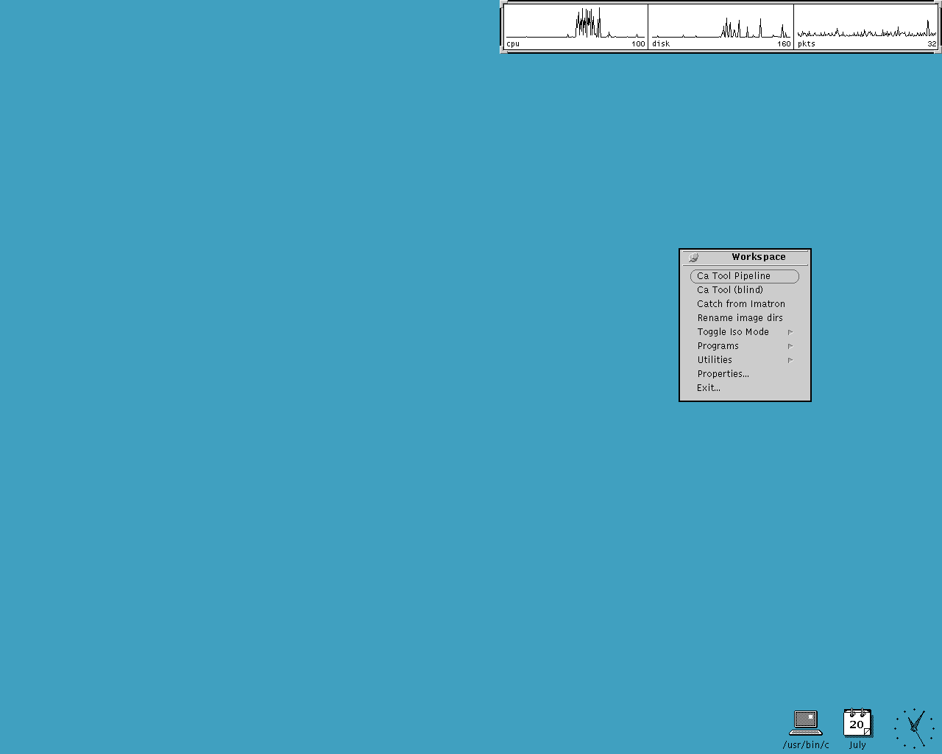
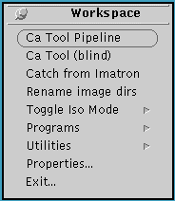
When you first log on the workstation, the screen will look like the image at the right. The blue part of the screen, reproduced in black and white in Fig 1.1, is called the Workspace. All the programs you will be using will be shown on the Workspace in separate windows like Windows98. Moving around this operating system is just like, moving around Windows. You have a left mouse button to click on icons and commands. To bring up various menus, use the right button. Clicking the right button on any part of a window border will bring up various options. These options will let you “CLOSE” the window, meaning minimize the window into a small icon, or “QUIT” programs and completely turn them off.
Fig 1.1

In the middle of the screen is a little gray box labeled “WorkSpace”, this is where you will launch various programs. To bring up this “WorkSpace” box, you will click any part of the blue workspace using the third mouse button; this is known as “Right Clicking”.

There are many items on this workspace box that will launch various programs. For now we will concentrate on the programs DICOM Viewer and Ca Tool Pipeline, that are the reviewing and scoring programs respectively.

REVIEWING FOR NON CORONARY PATHOLOGY

- Launch the subject chooser by clicking on the “DICOM Viewer “ entry in the Workspace menu. Do not use the “Calcium Tool” entry to review for non coronary pathology.

- Choose a subject using the mouse and scroll bar.

- Click on the “Take Heart” Icon.

4. A window will open which will scroll through the image slices for that study. On the bottom, you will see buttons labeled with the widths and levels of soft tissue, lung, bone, etc. Left click on the lung button (1500 –600). On the upper right of the screen, you will see projection surface rendered views of the chest. Left click with at the very top of these projection views and the window will jump to the first image and the contrast window you have chosen. Scroll rapidly through the images using right click and “Cycle Through”. Scroll, one by one, using the middle button. Change the contrast window in the same way. When you are finished, right click and choose “Abort, do not box”.

SUBJECT CHOOSER

1. Launching The Subject Chooser
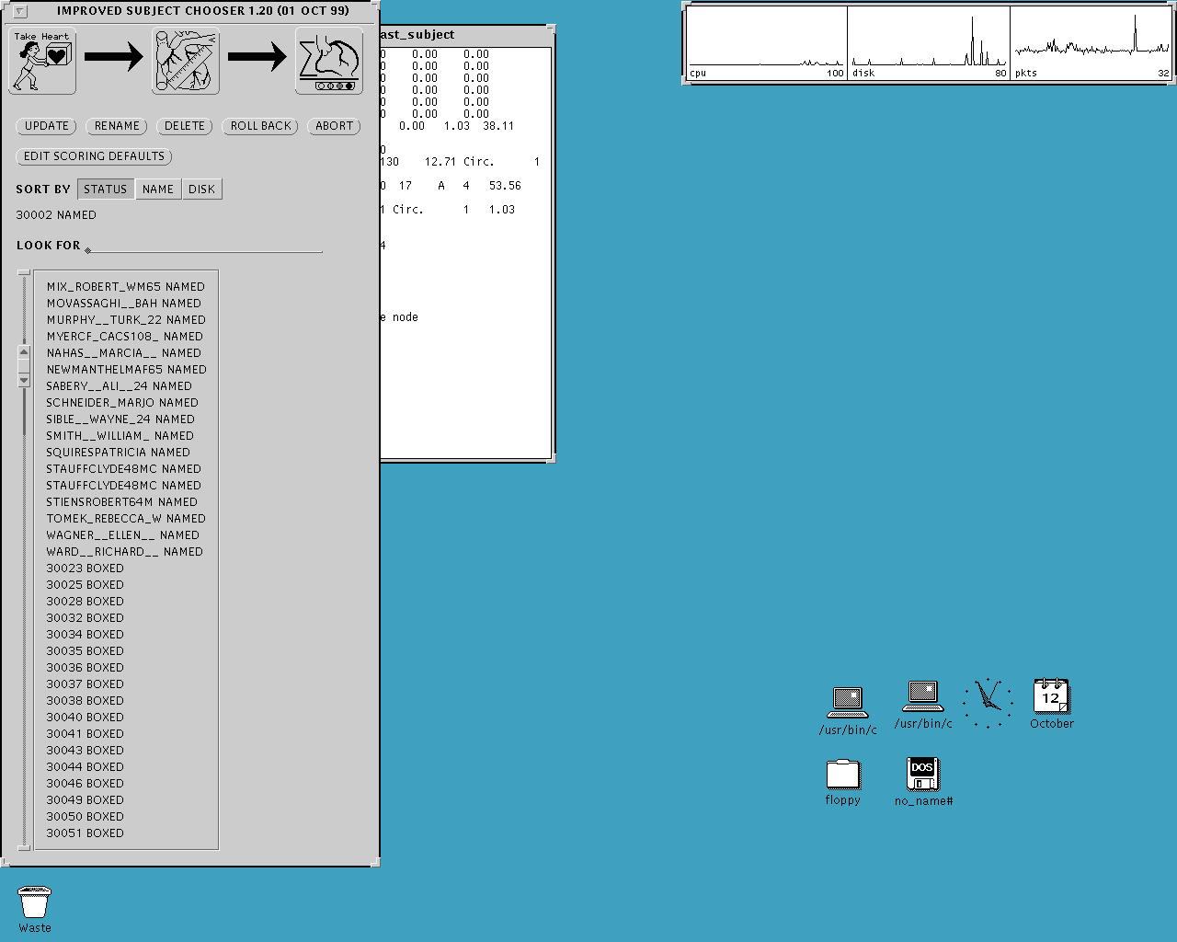
First bring up the “WorkSpace” box, by right clicking the desktop. Then you will right click the button labeled “Ca Tool Pipeline”. After a few seconds, the two windows on the right, Fig 2.1, will appear. The tall gray window on the left is the Subject Chooser menu of the Scoring Software. This is where you will be choosing studies to Box, Trace and Score.
Ca Tool Scoring Software

Fig 2.1

2. The Subject Chooser Window
On the Subject Chooser window, you will find three main icons:

Boxing: Used to launch the boxing program. This is where you will outline the entire heart in a box.
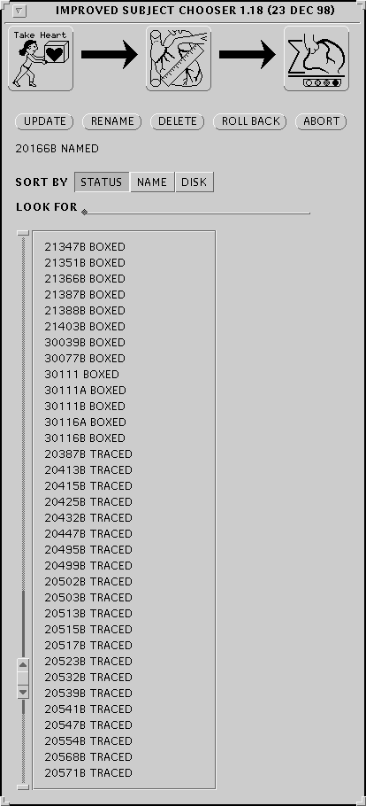
Tracing: Used to launch the tracing program. This is where you will identify the coronary arteries.
Scoring
Tracing
Boxing
Fig 2.2
Scoring: Used to identify plaque.

Under the icons are five buttons:

Update: Refreshes the window, and
updates the patient list.
Rename: Do Not Use
Delete: Do Not Use
Rollback: Used to rollback studies from
BOXED or TRACED status to
NAMED. This will delete scoring
and tracing files.
Abort: Closes the Ca Tool program
Edit Scoring Defaults: Setting defaults
(see below)

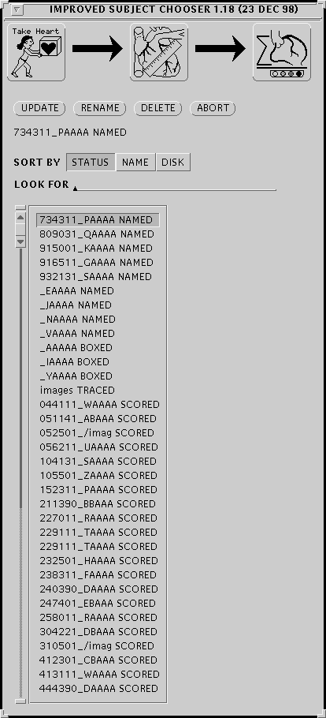
On the right is a close up view of the subject list, this is where you will be choosing a study and left-clicking on it to highlight it. The first sequence of numbers and letters is the study identifier. To the right of this is the status of the study. NAMED means that it has not been boxed yet. BOXED means that it has been boxed and is ready to be traced. TRACED means that it has been boxed and the coronary arteries have been identified but has yet to be scored. SCORED means that it has been scored and saved. To the right of the names is the scroll bar. To scroll down, left-click on the bottom arrow. Each click will move the patient list up and reveals a new name at the bottom of the window.
Scroll Bar
Fig 3.1

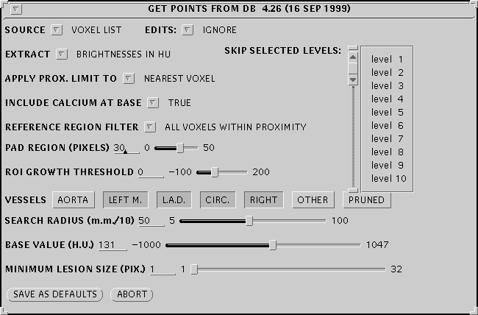
3. Edit Scoring Defaults
Fig 3.2
This is where you will set up the defaults for the Calcium Tool. Fill out the fields, Fig 3.2, according to the criteria set by a particular study’s protocol. You may alter the values either by directly entering numbers into the field and pressing ‘ENTER’ or by using the slider if one is provided. This has to be done only once during the start of one session of reading.

BOXING

1. Description Of Boxing

Note that a senior reader investigator must box every scan.

In the boxing window, you will view consecutive images of the patient’s heart. You will then enclose the heart in a white box. This procedure will produce the boxed view of the heart you will be using during the Tracing and Scoring procedures.

Another purpose of the boxing stage is to properly identify the hydroxy-apatite Phantom regions. To do this you will have to make sure that the bright white dots stay inside the cylindrical regions of the phantom.

To first get started you will have to launch the boxing program. On the Subject Chooser highlight a patient study by first left-clicking on it. Then move the mouse over the first icon labeled “Take Heart”, previously labeled in fig 2.2.
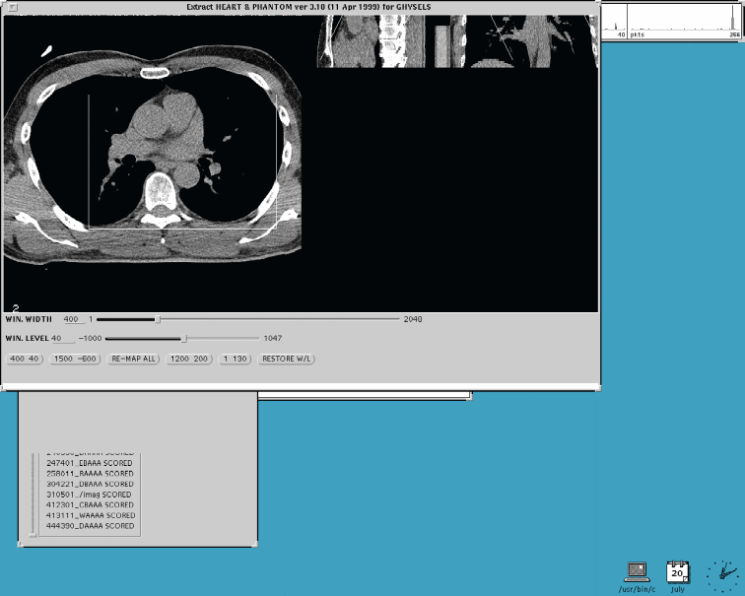
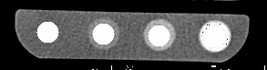
Surface Rendered Region
White box outlining heart

Fig 4.1

When the boxing window pops up, it will cycle through all the slices of the patient’s images. When this happens, you will have to keep an eye on the phantom to make sure that the bright white circles stay within the cylindrical regions of the phantom. To check the slices again after the initial cycle, right-click anywhere on the boxing window (to bring up the menu) and choose “Cycle Through”.

2. Boxing The Heart

The next step in the boxing process is to actually box the heart. This serves to isolate the image in the boxed portion for the next process, Tracing. After the

window finishes cycling through the

mages, there should be a white boxes urrounding the image of the heart. Resize the box by left clicking on either corner and stretching the white outline so as to completely encompass the heart.

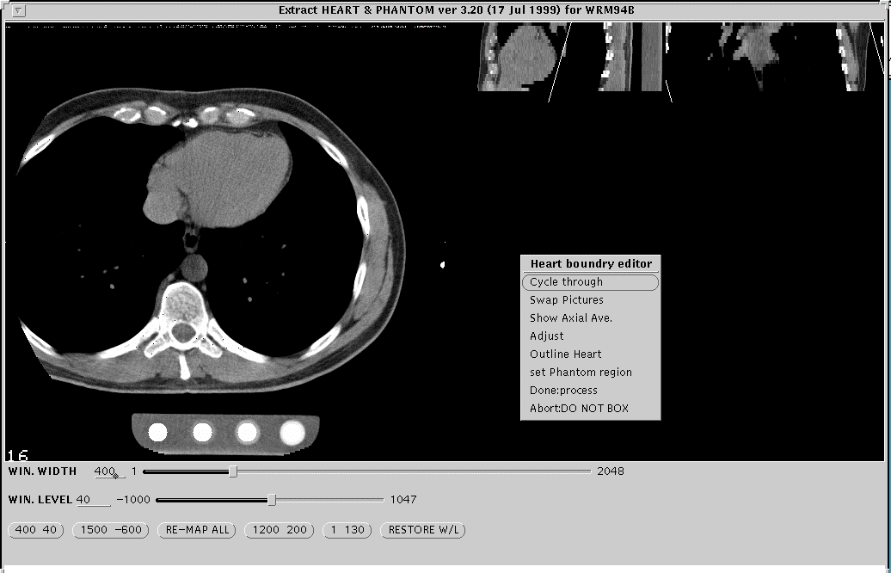
Once again you will have to check if all of the heart has been included in the boxed region. Do this by right clicking to bring up the menu and then choosing “Cycle Through”. Once you are sure the entire heart is boxed bring up the menu once again and click on “Done:process”. A small window will pop up on the top left corner of the screen, choose “begin tracing” to launch the second part of the Scoring process.
Phantom
Right-Click Menu
Fig 4.2

3. Identifying The Regions In The Phantom

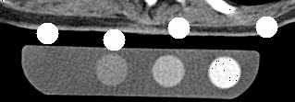
During the boxing stage you will be checking to see if the cylindrical regions of the calibration phantom have been properly identified. Figure 5.1 shows a phantom whose cylindrical regions have not yet been identified. And figure 5.2 shows a phantom with properly identified regions.
Fig 5.1
Cylindrical Hydroxy-apatite region

The purpose of identifying the hydroxy-apatite regions in the phantom is to let the scoring software have a way to
Fig 5.2
Properly centered regions

compare the known density of the hydroxy-apatite phantoms to that of calcification in the arteries.

When you do come upon a region which has not been properly identified, right-click the center of the nearest hydroxy-apatite region and choose “set Phantom Region” from the menu, Fig 5.3. The white circle nearest to the center of the hydroxy-apatite region you clicked will jump there. Do this with all the regions till the circles appear to be located within all regions. Figures 5.3 to 5.5 shows this process in order.
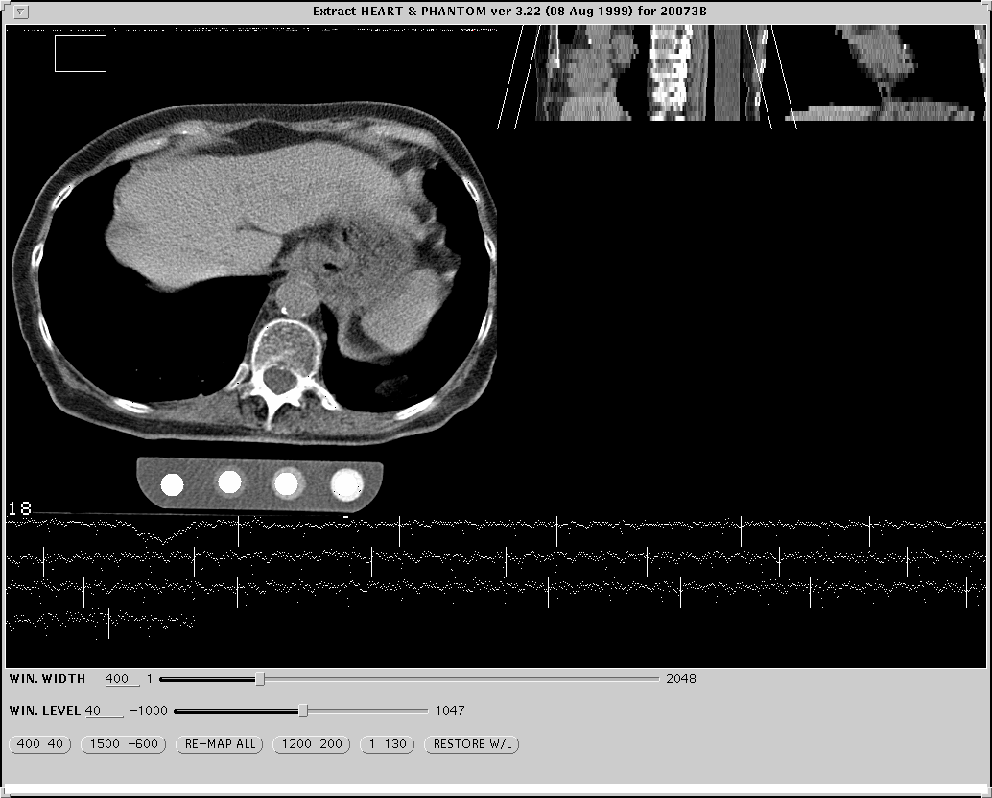
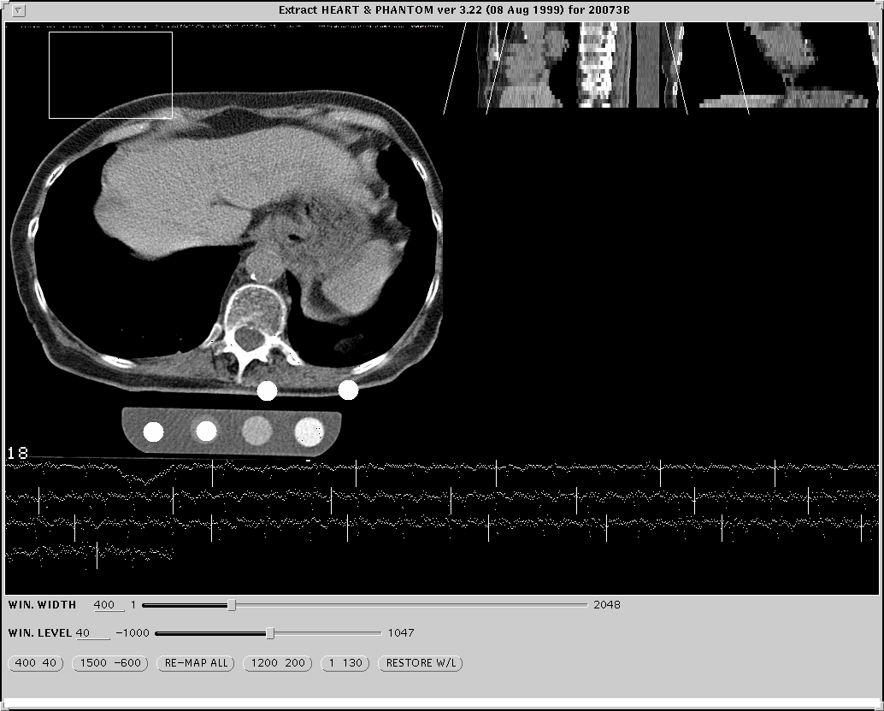
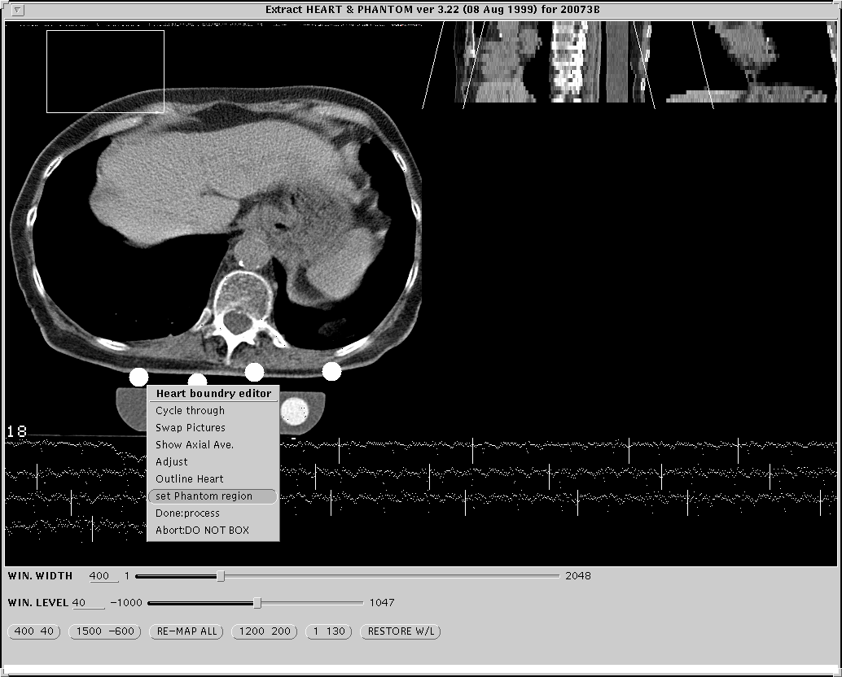
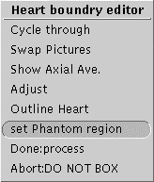
Fig 5.4
Fig 5.5
Right-click menu.
Fig 5.3

TRACING

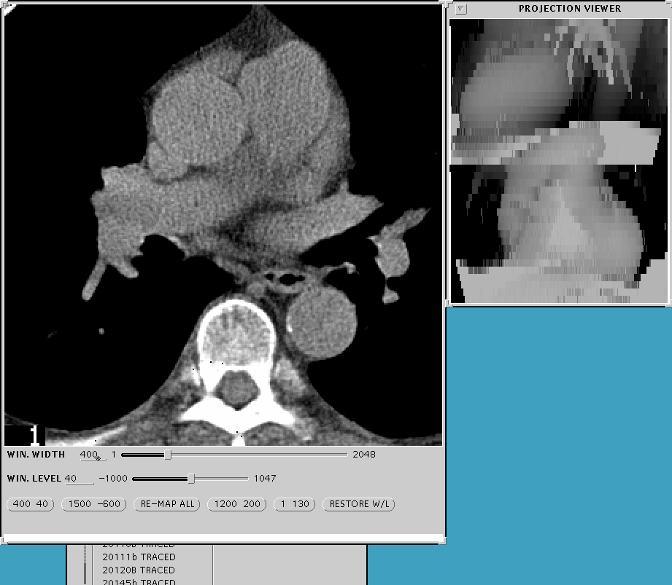
1. Launching The Tracing Program
Tracing Window
Projection Window
Fig 5.6
There are two ways to launch the Tracing program, by clicking on the Trace button (see Fig 2.2) or by finishing the Boxing process as described in the previous section. The purpose of the tracing program is to actually trace the path of the vessels through the heart, so that the Scoring software will know where to look for lesions. Basically you will scroll through all the slices and identify where the appropriate vessels are.

Navigating through the slices is simple. First you must left-click the tracing window. After, you may move forward through the slices by pushing the ‘down’ arrow key on the keyboard. To go in reverse, use the ‘up’ arrow key.

2. Labeling The Vessels
Now you will label the vessels. Follow through with the pictures at the bottom of the page, Fig 6.1 to Fig. 6.3. First scroll through the slices, using the arrow keys, till you see the first instance of the Left Main Artery, in this case it is on slice number six, Fig. 6.1. Now right click on the Left Main Artery and choose “L. Main” from the menu that pops up. A red “X” should hover over the vessel.

The computer will distinguish the vessels using colors, Red for Left Main, Green for the L.A.D., Yellow for the Circumflex, and Blue for the Right Coronary. Next look for any other identifiable vessels on the same frame, if there are any, identify them the same way, if not move on to the next frame. In our case, Fig. 6.1, the LAD is also present, so we label it by Right clicking on the vessel to bring up the pop-up menu and then choosing “L.A.D.”, a yellow arrow will now appear. On our next slice, Fig. 6.2, the L.A.D. is still present. To label a vessel in the following frame just Left click on the vessel and the program will label it accordingly. For example, in Fig. 6.2, we left click on the LAD to continuously mark it and we use the Right click pop-up menu to label the Circumflex and the LAD Branch.
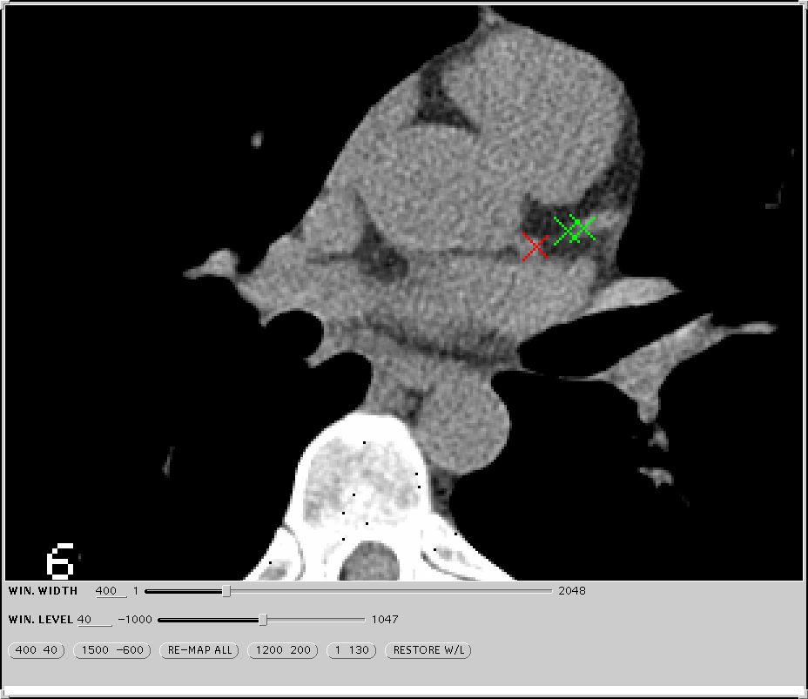
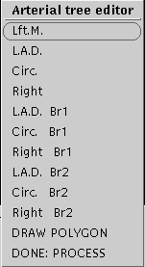
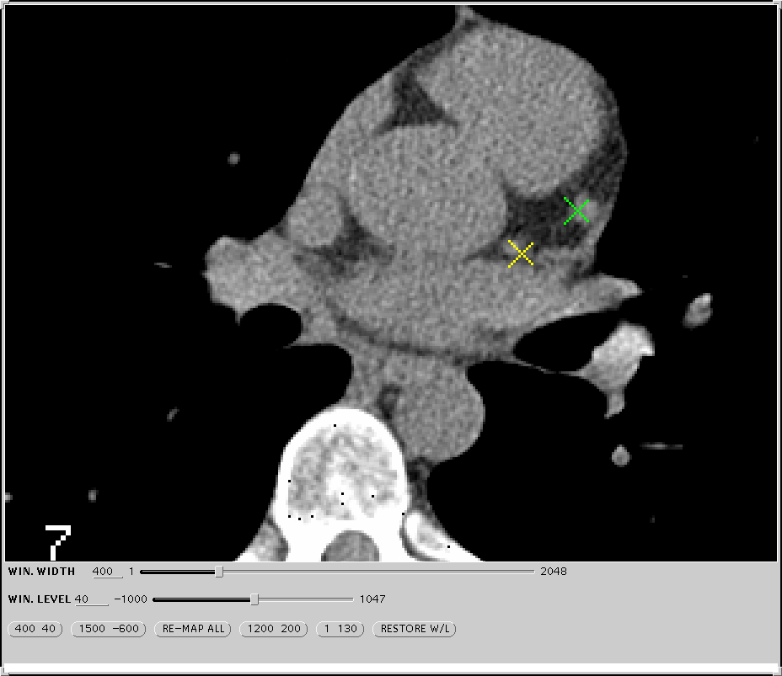
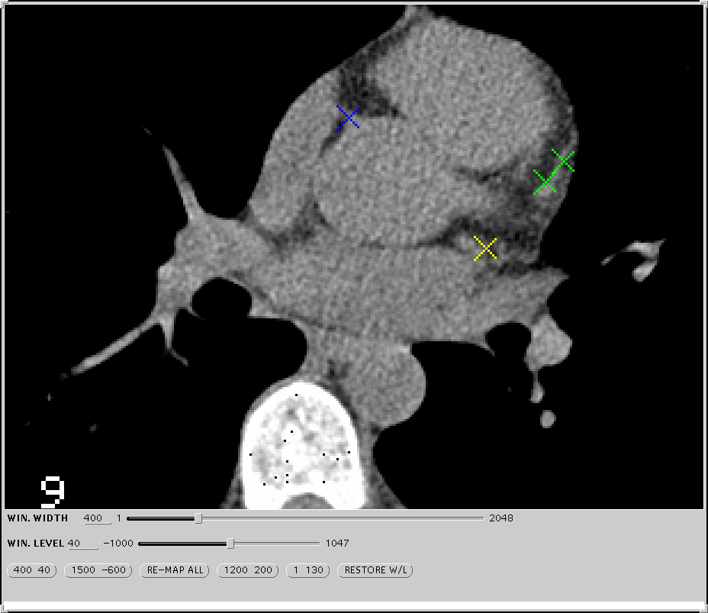
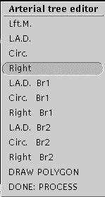
Right-Click Menu
Left Main
L.A.D
Fig 6.1
Circumflex
L.A.D.

Fig 6.2
Slice Number
Right Coronary
Fig 6.3

3. Checking The Tracings
After you have labeled all the vessels in the last slice where vessels appear, you should check your work by right clicking anywhere on the image and choosing “Done:process” from the pop up menu. When you do this you will see the images reappear consecutively with the circular regions surrounding the points, Fig 7.1, where you placed the X’s. Be sure that the entire coronary tree is included.

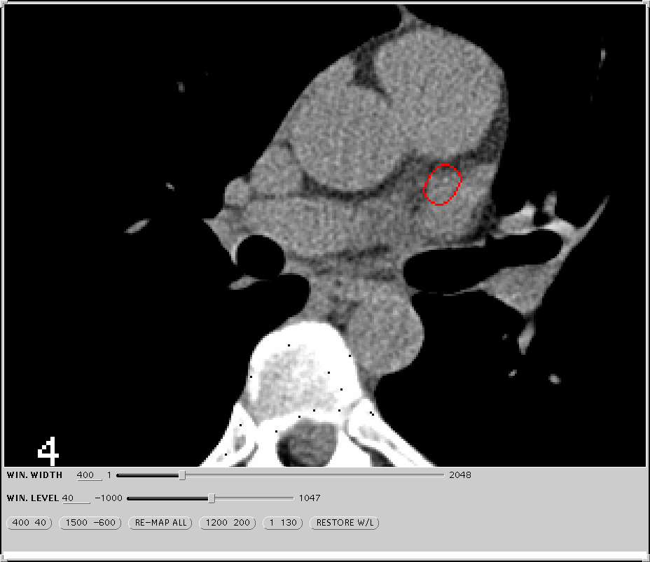
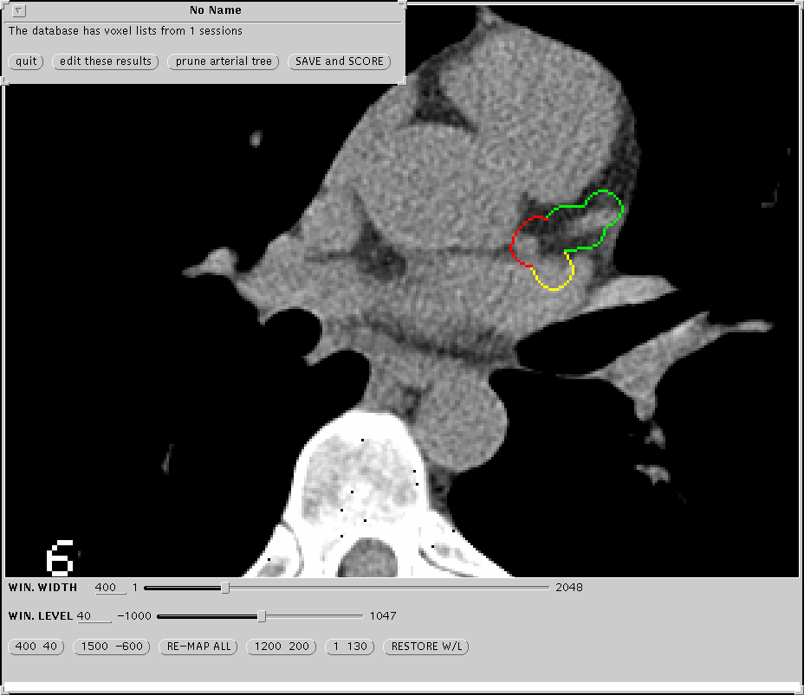
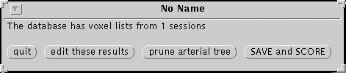
4. Editing the X’s
Fig 7.1
Circular region surrounding a vessel previously marked with an X.
7.2
If you note that the regions are not encircling the arteries in every image, you should then choose “Edit Points” from the little menu (Fig 7.2) you now see at the top of the screen. Then page through the images and delete the incorrect points by using ‘Shift’+Left-Clicking on the X’s. Then replace with a new X marker in the correct position. When you have finished editing the X’s, Right-Click again, and choose “Done:Process” from the pop-up menu and return to section 3 above.

5. Finish Tracing
If the regions are placed correctly, choose either “Save and Score” from the resulting options, Fig 7.2, to proceed to the Scoring program or “Exit” to end tracing and return to the Subject Chooser.

SCORING

1. Launching The Scoring Program
Launch the scoring program by either highlighting a ‘TRACED’ study in the Subject Chooser and clicking on the Scoring Icon, Fig 2.2, or by choosing “Save and Score” when finishing the Tracing program, see above.

2. Checking Lesions
If the scoring program cannot find calcium within the regions created during Tracing, image slice no. 1 will appear with no colored regions indicated. In this case, you will then have to Right-Click to bring up the pop up menu and choose “Quit”. The Quality Assurance Menu will then appear.

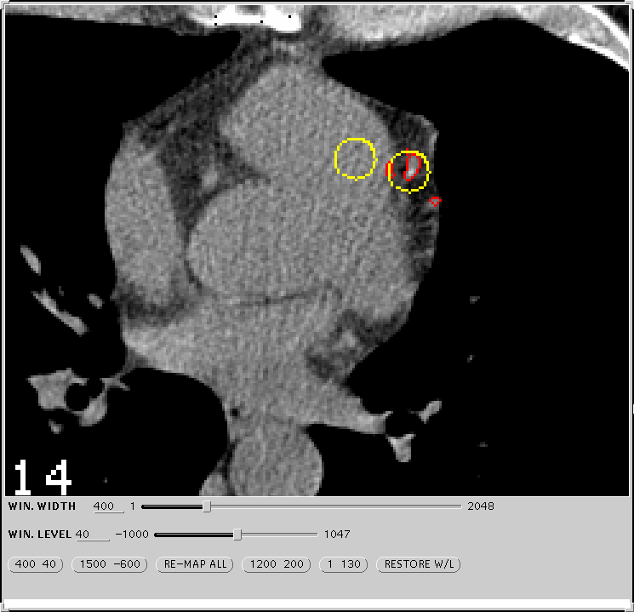
If the Program does find calcified lesions, you must decide whether or not these really represent coronary calcium. In this case, the program will take you directly to its choice for a lesion. These lesions, Fig 8.1, will be surrounded by a circle. A circle of the same color will appear somewhere else on the image. Move your mouse to drag the circle to a homogenous blood-pool near the lesion in question. Click the left button if you agree that this is coronary calcium. Otherwise click the middle button if you do not agree. Then repeat this same procedure for every “lesion” the program identifies in this image. The program will automatically jump to the next image with a calcified lesion after you have assessed all the lesions in this image.
Calcified lesion which program has identified.
Fig 8.1
Circle that follows the mouse. This must be in a homogenous blood pool when assessing a lesion

After you have assessed the last lesion in the last image, the QA menu will appear.

3. Quality Assessment Tool
The QA menu, Fig 8.2, has seven categories that you must assess. These are Motion Artifact, Streak, Phantom, Misreg, Noise, Arteries, and Coverage.

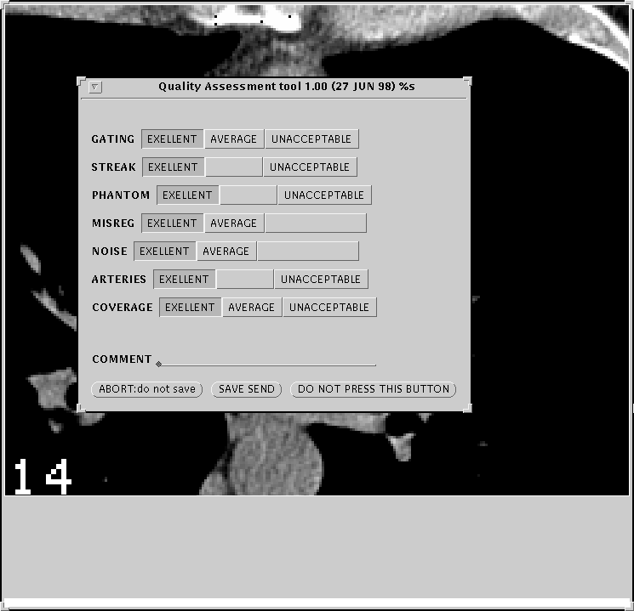
Choose your assessment by using the following guidelines:
Fig 8.2

Motion Artifact – Choose ‘Unacceptable’ if there is blurring of the distal RCA or other notable portion of the coronary arteries, otherwise choose ‘Excellent’

Streak- Choose ‘Unacceptable’ if streak artifact overlaps any calcified coronary lesion. Other wise choose Excellent’.

Phantom- Choose ‘Unacceptable’ if insufficient assessment of the phantom
occurs in any image. Otherwise choose ‘Excellent’.

Misreg- Choose ‘Average’ if the images in the projection window do not
show smooth epicardial borders. Otherwise choose ‘Excellent’.

Noise- Choose ‘Average’ if the image contains excessive noise such that
the program has mistaken noise for coronary calcium. Otherwise
choose ‘Excellent’.
Arteries- Choose ‘Unacceptable’ if part of a major coronary artery is cut by
the edge of an image. Otherwise choose ‘Excellent’.

Coverage- Choose ‘Unacceptable’ if the images do not
include the origin of the left main coronary artery or the
coronary sinus. Choose ‘Acceptable’ if ‘Unacceptable’ does
not apply but if any portion of the tree is excluded due to
insufficient coverage in the Z-direction. Otherwise choose
‘Excellent’.

Once finished click the “Save and Send” button.

4. Auto Archiving (Automatic CD Backup)

After scoring, immediately after you click the “Save and Send” button, the software automatically places a copy of the study you have just scored, including original images and all tracings, into a hidden archive folder.

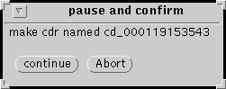
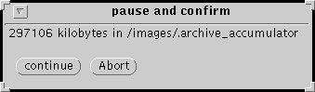
After each complete scoring a window will pop up, Fig 9.1, indicating the size of the archive. Once the size of the archive reaches over 600 megabytes another pop up window will appear asking if you would like to continue with the backup. It will then ask you to confirm the writing of the backed-up archive files to the CD Studio. Once you click continue in the window in Fig 9.2, you must then place your mouse over the “cmdtool” window of the CaTool software, Fig 9.3.
Fig 9.2
Fig 9.1

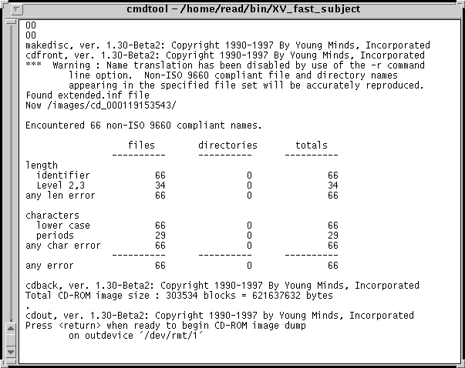
The software will then proceed to transfer the archive from the Sun Workstation onto the CD Studio. If you continually check on the “cmdtool” window it will show the progress of the transfer, it usually takes 15 minutes. Once it has transferred over the archive another window will pop-up asking if you would like to continue and write to the CD. After you click continue, the archive will be burned into the CD. This will take approximately 15 minutes, please note that you may open another CaTool window and continue scoring while you are backing up. Once the backup has completed the program will ask you to remove the CD and label it.
Fig 9.3

Test the CD to make sure all the files have been properly burned in.

APPENDIX A: Protocol for Inter-scan, Inter-reader, and Intra-reader Variability

This protocol is designed to serve as a guide to readers in preparing the necessary studies for scoring and transmission for the purposes of inter-scan, inter-reader, and intra-reader variability assessment, which will be done by the Coordinating Center.
Necessary log-in accounts will need to be created as follows:
For regular reading: MESA-SM, MESA-NZ
For inter-reader variability: MESA-RD, MESA-MB (senior readers)
For intra-reader variability: MESA-SM1, MESA-NZ1, *MESA-RD1, *MESA-MB1

*to be used for occasional checks of intra-reader variability on senior readers It is assumed that each account, subject chooser, and summary of scores file will be study-specific—e.g., only studies of one type (MESA or CARDIA, but not both) will be included in a given reader’s account.

1. Interscan Variability:
Since nearly all studies will be performed in duplicate (except for those where one of the studies is technically inadequate for transmission or reading), the coordinating center will select the appropriate sample of studies for examining inter-scan variability among each of the scanning sites. Transmitted summary of scores files will contain duplicate scans with the same identification number but slightly different scan times that the coordinating center will use to distinguish between first and second scans. This may require as much as 25-50% of the duplicate studies examined in order to obtain monthly inter-scan variability for each center and/or technician.

2. Inter-reader Variability:
A 5% sample of each reader’s read scans will be reread by a second, senior reader (RD or MB) on a monthly basis. Once the month’s scans have been read, with scores transmitted, the data manager will run a random number generator program that will determine which scans to select. The scored files that are selected will then be copied by the data manager to appear in the Subject Chooser and rolled back to “NAMED” status, and the reader responsible for reading such scans will then be notified to read them. After scoring, the reader will click on the indicator in the software menu designating this as a quality control study. Once read, the summary of scores file will be transmitted to the coordinating center, and since read by a different reader, it will be evaluated in determining inter-reader variability

3. Intra-reader Variability:
A 5% sample of each reader’s read scans will be reread by the same reader on a monthly basis. Once the month’s cans have been read, with scores transmitted, the data manager will run a random number generator program that will determine which scans to select. The scored files that are selected will then be copied by he data manager to appear in the Subject Chooser and rolled back to the “NAMED” status. The reader responsible for reading such scans will then be notified to read them. Once read, the summary of scores file will be transmitted to the coordinating center, and since read by the same reader, the study will be evaluated in determining intra-reader variability.

APPENDIX B: Description Of Options In Scoring Defaults Menu

Introduction. The tracing program creates a tubular region of interest of radius R. These tubes define the “voxel list”. Only these tubes of diameter R are available for evaluation of calcified plaque. R has been set at 7mm. This value is a compromise between higher values which would necessitate a lot of pruning and lower ones which would necessitate an excessive amount of editing during tracing.

1. Source. This can have two values: Voxel List or Pixels. Always set this as Voxel List. Setting at Pixels will cause the tracing program to search outside of the voxel list.

2. Edits. This can have three values: Override, Show, or Ignore. These are important in rescoring a case and in batch scoring.

Override – causes the scoring program to override prior edits and thus to start “from scratch”. This should always be used in Interactive Scoring.

Show – causes the lesions which have been edited out or removed during a prior scoring to be listed but not to be counted in adding up the score. They are listed in an intermediary file (REG) as noise.

Ignore – causes the scoring program to include edits from pror scorings and therefore to ignore regions which were removed during prior scorings. Ignore should usually be used for batch scorings.

3. Extract. This allows the user to choose whethter he/she wants to use the actual pixel values (Brightness in Hounsfield Units) or to scale these to the phantom (Scale to Phantom).

4. Skip Selected Levels. Do not use this option.

5. Apply Proximity Limit. Possible values for this are Nearest, Farthest, Peak and Each.

Nearest – causes plaques which are on the border defined by the search radius, R, to be entirely included.

Farthest – causes such plaques to be entirely excluded.

Peak – causes these plaques to be included only if the peak value is inside of R.

Each – causes the plaque to be split so that only the part within the R is included.

In general, always use NEAREST.

6. Include calcium at base. This can be True or False. True causes ostial calcium to be included. False causes it to be excluded. Set this at TRUE.

7. Reference Region Filter. Set as Brighter Than Threshold.

8. Pad Region. This defines, in units of pixels diameters, the distance the scoring program will search from a calcified lesion defined by the Base Value and Minimum Lesion Size. This will affect the arterial summation calcium mass estimates but should never affect the other measures. Set this at 8 pixels for interactive scoring. Set this at maximum for batch scoring.

9. Growth Threshold. This defines in HU the included pixels in the arterial summation mass formula. All pixels of at least this value within the pad region will be included in the arterial summation mass formula. Set this at 101 HU for interactive scoring. Set this at maximum for batch scoring.

10. Vessels. This allows the user to exclude or include vessels in scoring. By blanking out a vessel, the reader causes a zero contribution from that vessel to be counted in the summary of scores file. The vessels allowed are: Aorta, Left, Main, LAD, CX, RCA, Noise, Other. In general only Left Main, LAD, CX, and RCA should be highlighted.

11. Search Radius [r]. This, in mm/10, defines the outer limit of the search for lesions and the outer limit for the extension of lesions for the arterial summation calcium mass algorithm. It is limited by the radius of the voxel list, R. Therefore, if r is greater than R, Then R defines the search limits. Set the search radius at 100 mm/10 for both interactive and batch scoring.

12. Base Value. This defines the definition of a calcified plaque. Set it at 131 HU for both interactive and batch scoring. Do no change the base value.

13. Minimum Lesion Size. This defines the minimum size of a calcified plaque. It is the minimum number of contigious pixels (sharing a side) that define a calcified lesion.

APPENDIX C: CD Backup Procedure (Manual)

1) Place blank CDR into Young Minds device.

2) Select studies to backup and place in separate folder.

3) Left click the folder, containing the files to be backed up, to select it.
Then right click “File” ➔ “Custom Commands” ➔ “How Big?” to determine the size of the folder. The value that is reported is in kilobytes and it should be less than 640,000.

4) When you are ready to backup,
Right-click “File” ➔ “Custom Commands” ➔”MakeDisc”.

5) The MakeDisc program window will appear.

First, Left-click the “Base Directory” button to specify the which folder contains the data to be backed-up. In the ‘selections’ space, type in the name of the folder to be backed-up (i.e. /home/rd/forbackup). Click “O.K.”

Second, Left-click “image” ➔ “Premaster”, to start the backup process.

Once dumping has been completed, you may then “Left-click” “Image” ➔ “Cut” to begin writing to the CDR.

6) Once the status bar has indicated that the disc is finished, eject the disc, label it, and close the MakeDisc program.

APPENDIX D: How To Make and Test A Test Case

The test case software has been created by Mr. Reed in order to allow us to “check up” on the software periodically to be sure that it is working correctly. All readers should know how to make and test a test case.

- First, delete the “testcase” already present by using the cmdtool
( command tool ).

%rm –ri /images/testcase

2) Select a good case ( one with a cal. Phantom and clear arteries ).

3) Box it using Reed Scoring software.

4) Copy its directory to the “testcase” directory using the cmdtool
( command tool ).

% cp –r /images/(name of study) /images/testcase

5) Click the “Update” button on the subject chooser and trace the “testcase” you just made. Place X’s only where you would like to “create” a known calcified lesion.

After Tracing, choose “DONE: Process” ➔ “Save and score”.
Then quit Scoring window.

6) Using the ‘File Manager’, rename the file “trajectory” with the name “phanplaque”.

Right-click desktop to bring up the “Workspace menu”
Right-click “Programs” ➔ “File Manager”
Use the “File Manager” to bring up the ‘/images/testcase’ directory.
Left-click the file ‘trajectory’ file ( it will be highlighted ).
Type in ‘phanplaque’ ➔ press “Enter”.

Now you are going to create calcified lesions. You can create one or more than one. For starters, try a simple case like the following:

150 | 140 | 131
90 | 240 | 156
140 | 100 | 166

Assume that the default Hounsfield number defining a lesion is greater than 130 and that the default minimal lesion size is 3 adjacent pixels (.8 mm² with a 30 cm F o V). Remember that adjacency is defined as sharing a side, not a corner. So the score for the above lesion would be (number of adjacent pixels over 130) X (weight determined by max HU in lesion) X (area of one pixel) For a 30 cm F o V and a minimum lesion size of 3 this gives a score of:

6 * 2 * (.52 * .52) or 3.24.

Now to make this lesion in the ‘phanplaque’ file, double-click the file in the “File Manager” and edit as follows.

The lesion making program only makes square lesions like the one above. Delete the first two numbers from the first line of the file.

Add a lesion size, in pixels,‘n’ at the end of the first line.

Press “enter” to go to next line.

Add matrix of ‘n’ lines and ‘n’ columns of densities of “HU” numbers. In above case, this would be 3 columns and 3 lines. Separate these entries by tabs.
Repeat this process for as many lines in the original file as you like.
Save by Right-clicking “File” ➔ “Save”
Record on a piece of paper the matrix for the lesion you have created. Score it by hand and record the score under your matrix.
Exit Text Editor by right clicking “File” ➔ “Quit”

**See examples on next page**

8) Run the program ‘fake_phan’ in the ‘testcase’ directory by using the cmdtool ( command tool ).

% cd /images/testcase
% fake_phan

9) Save results in ‘boxed’ image file.

% mv the_phantom the_heart.skw

- Trace and score the case called “testcase” in the subject chooser.

- Check the results and compare them with what you calculated in number 7 above.

- When you have created the test case correctly. Delete the ‘.img’ file from the test case directory by typing in the following:

% rm –i /images/testcase/*.img

Answer yes to the following question only if it is deleting the image file for the testcase (it should end in ‘.img’)
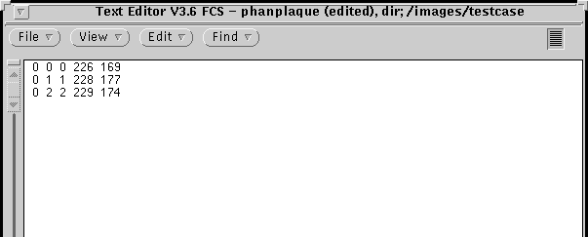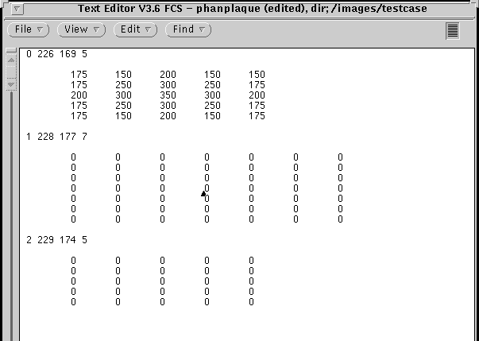
Numbers to be deleted from each row.
Number added to indicate size of lesion
Each row represents one vessel per slice which you identified during tracing

Edited ‘phanplaque’ file.

5 x 5 matrix of HU units.
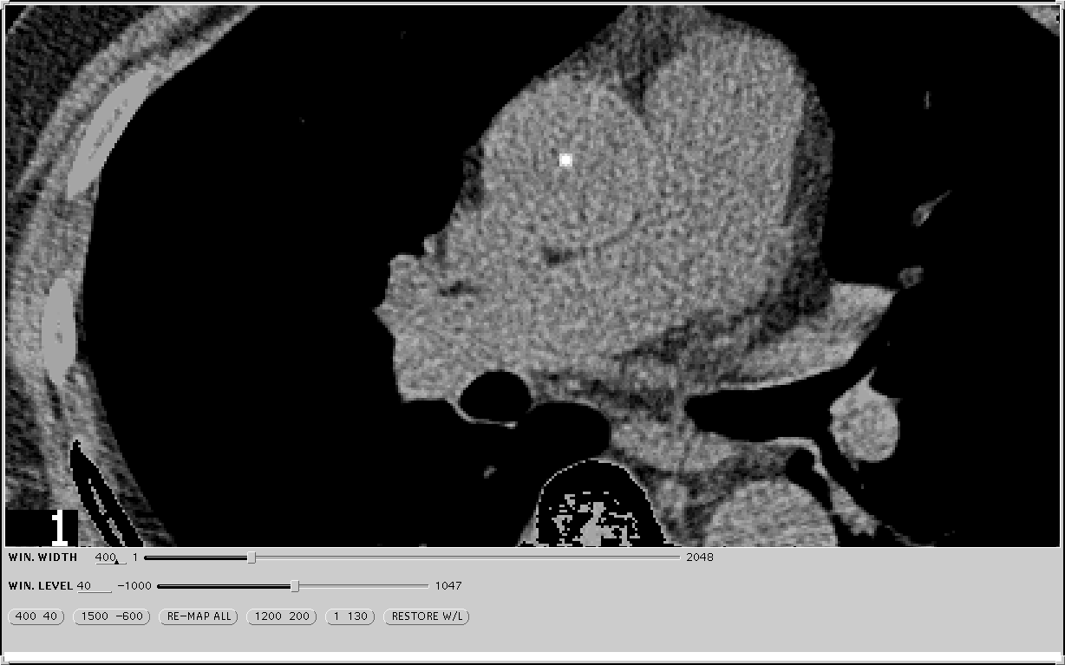
Lesion from first matrix of phanplaque file.
Unfinished matrices for two other lesions
Resulting image from first slice of testcase file..

XII. Attachments

1. Sample Alert Letter

[Date]

CT Investigator Name
Address

Dear Dr. {}

I have evaluated the CT scan of the MESA participant (participant number and acrostic). The following finding which constitutes pathology suggesting an urgent referral alert was noted:

Pericardial Effusion ________ Size ___________
Pleural Effusion ________ Location ___________
Tumor ________ Location ___________
Infiltrate ________ Location ___________
Fracture ________ Location ___________
Aortic Dilatation ________ Location ___________ Diameter _________

If you have any question, please call me at 310-222-5290
Sincerely,

[ M.D.]

cc. MESA Coordinating Center

2. CT Study Transmission Sheet/ FAX to 310-533-1616

CT STUDY TRANSMISSION SHEET

STUDY (CIRCLE): MESA CARDIA EDIC

Transmission Date ____/ ____ / __________
Transmission Time _______:_________

Scanning Center Location ______________________ ID ____________
Staff sending form: ___________________ Phone: _________________

Patient ID Number | Acrostic | Date Scanned | Archived  (Y/N) | Number of Slices | Comments

3. QA QCT Sheet FAX to 310-533-1616

Quality Assurance QCT Data Sheet for MESA Study

Mesa Site ___________________________ CT Scanner Mfgr._____________________

CT Scanner Model______________________ Phantom Serial Number____________________

QA Date | Tech.  Initials | Kvp | MA | FOV | Slice Thickness | Table Height | Hounsfield Numbers
 |  |  |  |  |  |  | 0 | 50 | 100 | 200 | Torso PIN

ID number | Scan Date | Scan Time | Send Date | Check  Sum | Send Time | Checked  for completeness | Phantom

MESA CT Reading Center Complete Scan Log

MESA CT Data Flow Sheet


