MESA EXAM 2 READING CENTER MANUAL

MR Imaging for Detection and Morphologic Characterization of Carotid Atherosclerosis

Table of Contents

Page
Background Exam 2: Carotid MRI 3
Background for use of gadolinium contrast agent in conjunction with carotid MRI 3
Overview: MRI protocol 4
MRI measured parameters of the carotid artery 4
Potential risks 5
Participant exclusions for the contrast enhanced carotid artery MRI 6
Participant burden 7
Feedback provided to the participants 7
Abnormal Findings Reported by RC 8
References 8
GE CV/i Carotid artery MRI scanning protocol 9
Siemens Carotid artery MRI scanning protocol 19
Categorization and Atheroma Based on Contrast-Enhanced MR Images 26
VESSELMASS analytical software for evaluating the carotid arteries 28

Background Exam 2: Carotid MRI

MRI is rapidly becoming a standard method for plaque evaluation throughout the body, including the carotid arteries, aorta, renal arteries and coronary arteries. Carotid MRI provides 1) a measure of plaque burden, 2) characterization of plaque components (eg, lipid content), 3) detail regarding the plaque wall/ fibrous cap integrity. It is noninvasive and has no significant risk for the patient. As such, it is well suited to study an asymptomatic normal population.

Because of these features, the Steering Committee and Monitoring Board have previously evaluated and approved a study of 600 MESA participants who would receive carotid MRI for Exam 2 of MESA. These participants would be chosen based on Exam 1 ultrasound data of the carotid artery as the top decile of carotid wall thickness. Participants will receive a letter inviting them to participate because their ultrasound showed that they had thickening in the wall of the carotid artery. (Participants have previously received a letter with these results as part of Exam 1 feedback to participants.)

The aims of the carotid MRI study are 1) relate carotid plaque by MRI to traditional risk factors for cardiovascular disease, 2) relate carotid plaque measurements to MESA outcome events, 3) determine if MR characterization of plaque components and fibrous cap integrity is an independent risk factor for events over and above that associated with carotid US IMT thickness. The hypotheses to be evaluated are that 1) carotid MRI findings will correlate with traditional risk factors and inflammatory serum markers of disease, 2) MRI detects atherosclerotic plaque at an earlier stage than CT and correlates better with risk factors than CT, 3) plaque characterization by MRI improves prediction of events relative to carotid US. This complete proposal is included in Appendix 1 for reference.

Background for use of gadolinium contrast agent in conjunction with carotid MRI

Enhancement with Gadolinium has proven to be an invaluable marker of pathology in MRI of all organ systems. For the carotid artery, Gadolinium enhancement results in images that more readily identify plaque substructure. In particular, the fibrous cap shows increased signal on T1-weighted images. Gadolinium enhancement may reflect increased endothelial permeability, neovascularity, or inflammatory changes. Enhancement has been shown to detect vascular inflammation in an animal model with histologic confirmation (1), and in human iliac arteries following stent implantation (2). Enhancement has also been demonstrated in thickened aortic walls in subjects with active Takayasu’s arteritis, and the degree of enhancement correlated with levels of the inflammatory marker C-reactive protein (3).
Weiss et al. (4) showed a strong association between in vivo carotid MRI images and levels of inflammatory markers in 51 human carotid and aortic arteries. The vessel wall was considered abnormal if any of three MR parameters (wall thickness, T2-weighted hyperintensity, or post-contrast enhancement) was increased 2 SD above the mean for healthy subjects (n=17). Twenty two abnormal vessels were identified. It is noteworthy that 7 of the 22 (32%) abnormal vessels had enhancement abnormalities, and 5 had enhancement abnormalities despite having no detectable increased wall thickness. The abnormal vessels so identified had significantly higher serum levels of IL-6, VCAM-1, ICAM-1, and CRP (p<0.02). Abnormal contrast enhancement without evidence of wall thickening or abnormal T2-weighted signal change was detected in 4 of 22 (18%) abnormal vessels. These results indicate that some vessels with normal morphology show evidence of inflammation that may not be seen without contrast administration.

Overview: MRI protocol

MR imaging will be performed on a 1.5T scanners. A dual 3-inch phased array surface coil will be placed on each side of the neck just below the angle of the mandible. MRI sequences will be as follows:

- Coronal Scout
- Axial Scout
- Carotid TOF MR angiogram
- Oblique DIR FSE through the carotid bifurcation using (3) as a scout
TR 1-RR interval, TE minimum, 14 cm field of view, frequency selective fat suppression, 256x256 matrix, 2 mm slice thickness, zero-filled interpolation to 512 matrix
- Axial T1 DIR FSE of the CCA
Same imaging parameters as (4)
- Axial T2 DIR FSE of the CCA
TR 2-RR interval, TE 60 msec, 14 cm field of view, frequency selective fat suppression, 256x256 matrix, 2 mm slice thickness, zero-filled interpolation
- Second oblique T2 DIR FSE through ICA plaque
Same imaging parameters as (7)
- Second oblique T1 DIR FSE through ICA plaque
Same imaging parameters as (4)

If the participant has consented to contrast injection, add the following:
- Coronal contrast-enhanced 3D MRA
- Repeat steps 8 and 5, 5 minutes after contrast injection.

DIR = Double Inversion Recovery
FSE = Fast spin echo (GE) or Turbo spin echo (Seimens)
CCA = Common carotid artery
ICA = Internal carotid artery

MRI measured parameters of the carotid artery

Participants who receive contrast injection will have images that undergo additional data analysis. Lack of participation will not affect evaluation of the standard noncontrast MRI examination of the carotid artery for that participant.

The measured parameters for the carotid MR study are listed below. Items with a (*) indicate these data will only be available for the contrast enhanced MR examination:

Continuous measures of the carotid wall:
Wall thickness
T2 signal change
Percent contrast enhancement*

Continuous measures of plaque:
Plaque volume
Lipid core volume
Fibrous cap volume
Percent stenosis (based on area measurements of the actual outer wall and the lumen)
Calcification volume
Ulcer volume

Binary measures of plaque:
  - Lipid core present
  - Lipid core absent

Potential risks

Gadolinium contrast is injected into a peripheral vein through a small needle, such as a 22-24g butterfly needle. At some centers, if the blood draws for MESA are performed the same day as the MRI, an angiocath could be placed at the FC and left for the MRI to avoid an additional needle stick.
The risks of gadopentetate dimeglumine (gadolinium) injection are minor and most commonly include those of a needle stick (bruising), headache and nausea. In a trial of 2102 patients at 27 centers, headache, nausea and other minor adverse events were observed in 3.1% with gadodiamide (23). No serious adverse events were reported. Unlike CT contrast agents, renal dysfunction is not associated with gadolinium MRI contrast agents. Severe anaphylactoid reactions have been reported in about 0.01-0.003% of doses (24).
Consent form issues: Introduction and background section:
Magnetic Resonance Imaging (MRI): MRI will be used to examine the large arteries in the neck and to measure artery size and function. Only 100 participants at our center will have this test. Subjects with be selected to have this test on the basis of the ultrasound study done in the first MESA examination. Those who have relatively thicker walls of the carotid arteries are more likely to be selected to have the MRI study. This is to further evaluate the relation between wall thickness and risk of future development of disease. The clinic staff will let you know if you will have this test or not. MRI uses magnetic fields to create medical pictures. The MRI examination is limited to the evaluation of the of the large arteries in your neck. No other organs or systems will be evaluated as a part of this study. There will be two parts to your MRI; one before and the other after injecting a dye called gadolinium in a vein in your arm. This dye will help improve the quality of the scans and provide more information about the blood vessel wall. You can choose not to have the injection. In this case, you will have only one part to the MR exam. At the end of this consent form, there is a check list to indicate if you want to have the scan with the dye or not. You will be asked to lie still on a table and will be placed inside a large machine. The MRI examination does not involve irradiation (such as x-rays) and is safe. You will be asked to use ear plugs because the machine generates noise. This examination will take about 30 minutes if you have only one scan and 45 minutes if you have two scans.

Approved “Risks” section of the consent for language, University of Minnesota:
The injection of dye (gadolinium) does not cause pain, but you may get a feeling of discomfort, tingling, or warmth in the lips, or metallic taste in the mouth, tingling in the arm, nausea, or headache. These symptoms occur in less than 1% (1 in 100) of people and go away quickly. Very rarely, there may be an allergic reaction, but there is less than a one in 300,000 chance that this will be severe. Insertion of the needle (small plastic tube) may also cause minor pain, bruising, and/or infection at the injection site.

Participant exclusions for the contrast enhanced carotid artery MRI
Participants will be excluded for MRI of the carotid artery examination if they have the following:

1. Standard exclusion criteria for MRI (e.g., pacemaker, cochlear implant or other internally implanted incompatible MRI devices, metal in the eye).
2. Bilateral carotid endarterectomy.
3. Severe claustrophobia. Participants who were classified as claustrophobic from Examination 1 will be identified by the coordinating center and excluded prospectively.

Participants will be excluded from receiving gadolinium contrast under the following circumstances:

1. Allergy (allergic reaction) to Gadolinium contrast for MRI. This situation is exceedingly rare.
2. Profound allergies (e.g., history of laryngospasm resulting in intubation, multiple allergies) or severe asthma requiring regular use of bronchodilators. Participants will be screened for these contraindications; individuals identified with potential high allergic or asthmatic potential will be interviewed by a Field Center physician. The MR center physician will be available to provide additional consultation in these cases. Since the overall number of participants is only 100 at each center, we do not expect more than 10-15 participants to have these questionable medical histories.
Participants who are excluded for gadolinium injection will receive only the noncontrast portion of the MRI examination.

Participant burden
The noncontrast MRI examination will take 30 minutes. The additiona time burden for participant receiving contrast injection is 15 minutes (45 minutes total examination time).

Feedback provided to the participants
Information provided to the participant will be provided as one of the following categories:
1. Your MRI of your carotid arteries shows that you have no evidence of significant disease.
2. Your MRI of your carotid arteries shows that you have narrowing of the carotid artery by 50 to 70%.
3. Your MRI of your carotid arteries shows that you have narrowing of the carotid artery by greater than 70%. You should see your physician for further evaluation.
In addition, for categories 2 or 3 above, the report will specify if there is any ulceration of the plaque in the carotid artery. Reporting to the participant’s physician will be done as in the Exam 1 component of MESA. The patient and his/her physician will be notified if there are any unusual findings that require immediate attention, such as a neck mass incidentally seen on the MRI.

Abnormal Findings Reported by RC
1. Abnormal mass in the neck
2. Internal carotid artery narrowing greater than 70%
3. Occluded internal carotid artery
4. Ulcerated plaque

References:
1. Schurmann K, Vorwerk D, Bucker A, et al. Perigraft inflammation due to Dacron-covered stent-grafts in sheep iliac arteries: correlation of MR imaging and histopathologic findings. Radiology 1997;204:757-63.
2. Kellner W, Kuffer G, Pfluger T, Rosa FT, Hahn K. MR imaging of soft-tissue changes after percutaneous transluminal angioplasty and stent placement. Radiology 1997;202:327-31.
3. Choe YH, Han BK, Koh EM, Kim DK, Do YS, Lee WR. Takayasu's arteritis: assessment of disease activity with contrast-enhanced MR imaging. AJR Am J Roentgenol 2000;175:505-11.
4. Weiss CR, Arai AE, Bui MN, et al. Arterial wall MRI characteristics are associated with elevated serum markers of inflammation in humans. J Magn Reson Imaging 2001;14:698-704.
5. Carr S, Farb A, Pearce WH, Virmani R, Yao JS. Atherosclerotic plaque rupture in symptomatic carotid artery stenosis. J Vasc Surg 1996;23:755-65; discussion 765-6.
6. Fernandez-Ortiz A, Badimon JJ, Falk E, et al. Characterization of the relative thrombogenicity of atherosclerotic plaque components: implications for consequences of plaque rupture. J Am Coll Cardiol 1994;23:1562-9.
7. Toussaint JF, Southern JF, Fuster V, Kantor HL. T2-weighted contrast for NMR characterization of human atherosclerosis. Arterioscler Thromb Vasc Biol 1995;15:1533-42.
8. Martin AJ, Gotlieb AI, Henkelman RM. High-resolution MR imaging of human arteries. J Magn Reson Imaging 1995;5:93-100.
9. Serfaty JM, Chaabane L, Tabib A, Chevalier JM, Briguet A, Douek PC. The value of T2-weighted high spatial resolution magnetic resonance
imaging in classifying and characterizing atherosclerotic plaques: An in
vitro study. Radiology 2001;219:403-10.
10. Wasserman BA, Smith WI, Trout III HH, Cannon III RO, Balaban RS, Arai AE. In Vivo Morphologic Characterization of Carotid Artery Atherosclerosis by Gadolinium Enhanced Double Oblique MR Imaging - Initial Results. Radiology 2002;In press.
11. Yuan C, Kerwin WS, Ferguson MS, et al. Contrast-enhanced high resolution MRI for atherosclerotic carotid artery tissue characterization. J Magn Reson Imaging 2002;15:62-7.
12. Wassmuth R, Sorger J, Wasserman BA, Taylor J, Arai A. MRI Shows Contrast-Enhancement in Rabbit Atheromas. J of Cardiovasc Mag Res 2002;4:80.
13. Ross R. Atherosclerosis--an inflammatory disease. N Engl J Med 1999;340:115-26.
14. Caro CG, Fitz-Gerald JM, Schroter RC. Arterial wall shear and distribution of early atheroma in man. Nature 1969;223:1159-60.
15. Glagov S, Zarins C, Giddens DP, Ku DN. Hemodynamics and atherosclerosis. Insights and perspectives gained from studies of human arteries. Arch Pathol Lab Med 1988;112:1018-31.
16. Levesque MJ, Nerem RM. The elongation and orientation of cultured endothelial cells in response to shear stress. J Biomech Eng 1985;107:341-7.
17. Loree HM, Kamm RD, Atkinson CM, Lee RT. Turbulent pressure fluctuations on surface of model vascular stenoses. Am J Physiol 1991;261:H644-50.
18. Zhang Y, Cliff WJ, Schoefl GI, Higgins G. Immunohistochemical study of intimal microvessels in coronary atherosclerosis. Am J Pathol 1993;143:164-72.
19. O'Brien ER, Garvin MR, Dev R, et al. Angiogenesis in human coronary atherosclerotic plaques. Am J Pathol 1994;145:883-94.
20. McCarthy MJ, Loftus IM, Thompson MM, et al. Angiogenesis and the atherosclerotic carotid plaque: an association between symptomatology and plaque morphology. J Vasc Surg 1999;30:261-8.
21. Aso H, Takeda K, Ito T, Shiraishi T, Matsumura K, Nakagawa T. Assessment of myocardial fibrosis in cardiomyopathic hamsters with gadolinium-DTPA enhanced magnetic resonance imaging. Invest Radiol 1998;33:22-32.
22. Ross JS, Delamarter R, Hueftle MG, et al. Gadolinium-DTPA-enhanced MR imaging of the postoperative lumbar spine: time course and mechanism of enhancement. AJR Am J Roentgenol 1989;152:825-34.
23. Aslanian V, Lemaignen H, Bunouf P, Svaland MG, Borseth A, Lundby B. Evaluation of the clinical safety of gadodiamide injection, a new nonionic MRI contrast medium for the central nervous system: a European perspective. Neuroradiology 1996;38:537-41.
24. Murphy KJ, Brunberg JA, Cohan RH. Adverse reactions to gadolinium contrast media: a review of 36 cases. AJR Am J Roentgenol 1996;167:847-9.
GE CV/i Carotid artery MRI scanning protocol
Use peripheral pulse gating
(For older subjects with poor peripheral pulse: Use ECG)

Series 1: Coronal Scout
Coil | Dual 3” phased array
Plane  Pulse sequence | Coronal  Fast SPGR
TR | 100
TE | Min
Flip angle | 60°
FOV | 24 cm
Matrix | 256 x 128 (f x p)
Slice Thickness | 7 mm
Slice Gap | 3 mm
NEX | 1
BW | 16 kHz
Options | Variable bandwidth (VB), Flow comp (FC)
Imaging time | 6 images in 0:16
Locations: Scan from P__ to A__

Instructions:

Resulting Image

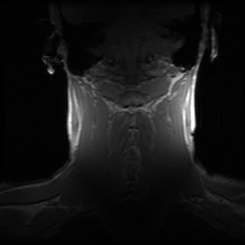

Series 2: Axial Scout
Coil | Dual 3” phased array
Plane  Pulse sequence | Axial  Fast SPGR
TR | 100
TE | Min
Flip angle | 60°
FOV | 24 cm
Matrix | 256 x 128 (f x p)
Slice Thickness | 4 mm
Slice Gap | 3 mm
NEX | 1
BW | 16 kHz
Options | VB, FC
Imaging time | 10 images in 0:32

Locations: Scan axially centered on the carotid bifurcations. (The coils should
cover the bifurcations so center the slices in the region of greatest signal.)

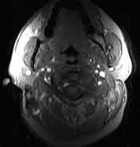
Prescription: Resulting image:

Series 3: Carotid 3D TOF MRA
Coil | Dual 3” phased array
Plane  Pulse sequence | Axial  TOF GRE
TR | 23 msec
TE | 3.8 msec
Flip angle | 25°
FOV | 13 cm
Matrix | 256 x 256
Thickness | 2 mm
NEX | 2
Slices | 28
BW | 16 kHz
Options | Use ramped excitation I to S,  inferior sat band,  VB, FC, 1 MIP, no projection recons
Imaging time | Approximately 5 minutes
Locations: Determine location of carotid bifurcation based on Series 2.
Scan axially centered on the carotid bifurcation.

Tip: When positioning the slab, it is better to include more of the
internal carotid artery than the common carotid artery particularly
if the patient has known internal carotid stenosis.

Prescription: Resulting image:
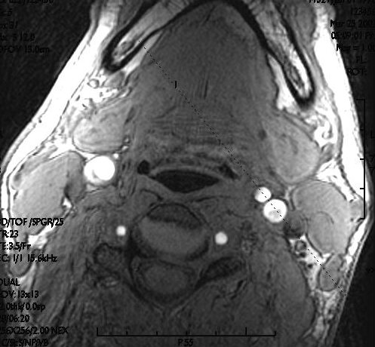

Series 4: Oblique Proton Density
Coil | Dual 3” phased array
Plane  Pulse sequence | Oblique  fseuno
TR | 2 R-R msec
TE | min full
TI | Auto
ETL | 10
FOV | 14x14 cm (f x p) (phase A to P)
Matrix | 256 x 256 (f x p)
Slice Thickness | 2 mm
Slice Gap | 0 mm
Slice number | 3
NEX | 1
BW | 62.5 kHz
Options | VB, BSP, PG, ZIP512
Gating | Trigger type: PG  Trigger window: 10%
Imaging time | 3 images in 1:50 (heart rate dependent)

Locations: This image uses the 3D TOF MRA slice just above the
bifurcation as a scout. Orient 3 slices through the internal and
external carotid arteries so the center slice bisects both lumens.
Use the image that best depicts the carotid bifurcation/internal
carotid artery as a scout for series 5.

Prescription: Resulting image:

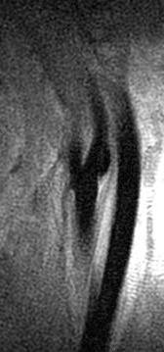

Series 5: Second Oblique PD through the Common Carotid
Coil | Dual 3” phased array
Plane  Pulse sequence | Oblique  fseuno
TR | 2 R-R msec
TE | min full
TI | Auto
ETL | 10
FOV | 14x14 cm (f x p) (phase A to P)
Matrix | 256 x 256 (f x p)
Slice Thickness | 2 mm
Slice Gap | 0 mm
NEX | 1
BW | 64 kHz
Options | VB, BSP, PG, ZIP512, Fat sat
Gating | Trigger type: PG  Trigger window: 10%
Imaging time | 1 image in 0:50 (heart rate dependent)

Locations: This uses the image obtained in step 4 as a scout.
Orient this slice 1.5 cm below the tip of the flow divider so it is
perpendicular to the axis of the common carotid artery.

Instructions: Make sure to record the prescan values.

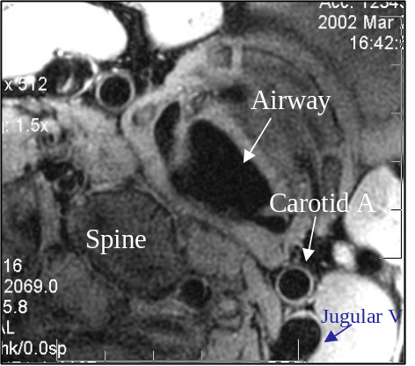
Prescription: Resulting image:
1.5 cm

Series 6: Second Oblique T2 through the Common Carotid
Coil | Dual 3” phased array
Plane  Pulse sequence | Oblique  fseuno
TR | 2 R-R msec
TE | 69 msec
TI | Auto
ETL | 10
FOV | 14x14 cm (f x p) (phase A to P)
Matrix | 256 x 256 (f x p)
Slice Thickness | 2 mm
Slice Gap | 0 mm
NEX | 1
BW | 62.5 kHz
Options | VB, BSP, PG, ZIP512, Fat sat
Gating | Trigger type: PG  Trigger window: 10%
Imaging time | 5 images in 4:30 (heart rate dependent)

Locations: Same slice positions as in step 5.

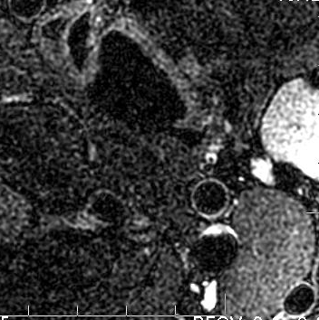
Prescription: Resulting image
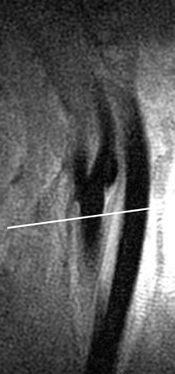

Series 7: Second Oblique T2 through the ICA
Coil | Dual 3” phased array
Plane  Pulse sequence | Oblique  fseuno
TR | 2 R-R msec
TE | 69 msec
TI | Auto
ETL | 10
FOV | 14x14 cm (f x p) (phase A to P)
Matrix | 256 x 256 (f x p)
Slice Thickness | 2 mm
Slice Gap | 0 mm
NEX | 1
BW | 64 kHz
Options | VB, BSP, PG, ZIP512, Fat sat
Gating | Trigger type: PG  Trigger window: 10%
Imaging time | 5 images in 4:30 (heart rate dependent)

Locations: 5 slices oriented perpendicular to the long axis of the
ICA (centered at point of greatest narrowing if plaque is present)
using image from step 4 as a scout.

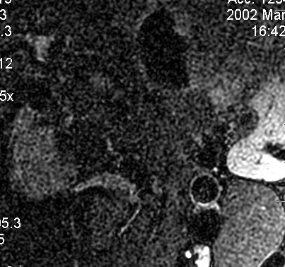
Prescription: Resulting image:

Series 8: Second Oblique T1 through the ICA
Coil | Dual 3” phased array
Plane  Pulse sequence | Oblique  fseuno
TR | 1 R-R msec
TE | min full
TI | Auto
ETL | 10
FOV | 14x14 cm (f x p) (phase A to P)
Matrix | 256 x 256 (f x p)
Slice Thickness | 2 mm
Slice Gap | 0 mm
NEX | 1
BW | 64 kHz
Options | VB, BSP, PG, ZIP512, Fat sat
Gating | Trigger type: PG  Trigger window: 10%
Imaging time | 5 images in 2:15 (heart rate dependent)

Locations: Same slice positions as in step 7.

Instructions: Make sure to record the prescan values. Set ophrep = 1
under CV options.

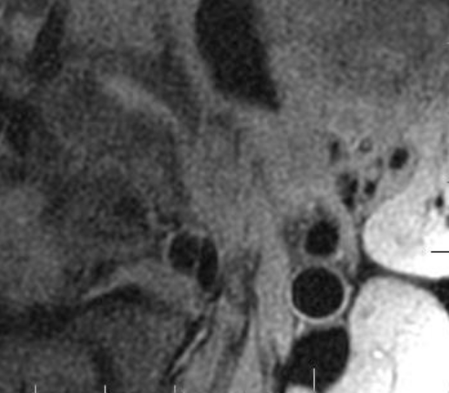
Prescription: Resulting image:

Give Contrast: Single dose (0.1 mmol/kg) at 2cc/sec
Inject Right Arm

Series 9 during arterial phase:
  - First do a mask. For this, set to 1 phase. Repeat if necessary to
ensure appropriate FOV. May adjust phase FOV to avoid aliasing.
  - After step a is complete, change to 3 phases and get ready to scan. Inject the gad
and wait exactly 10 seconds before hitting scan button.

Series 9: CEMRA (Mask = 1 phase, Contrast = 3 phases)
Coil | Dual 3” phased array
Plane  Pulse sequence | Coronal  3D MRA
TR | Min
TE | Min
FOV | 28cm
Matrix | 256 x 128 (f x p)
Slice Thickness | 2 mm
NEX | 1
z-axis slices | 32 (30-40)
BW | 31 kHz
Flip angle | 45°
Options | VB, ZIPx2
Imaging time

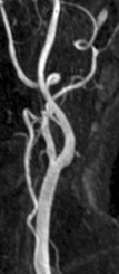
Resulting image:

WAIT 5 MINUTES FROM TIME OF GAD INJECTION BEFORE SERIES 10.

Series 10: Repeat step 8 (Second Oblique T1 through the ICA)
Coil | Dual 3” phased array
Plane  Pulse sequence | Oblique  fseuno
TR | 1 R-R msec
TE | min full
TI | 200 msec
ETL | 10
FOV | 14x14 cm (f x p) (phase A to P)
Matrix | 256 x 256 (f x p)
Slice Thickness | 2 mm
Slice Gap | 0 mm
NEX | 1
BW | 64 kHz
Options | VB, BSP, PG, ZIP512, Fat sat
Gating | Trigger type: PG  Trigger window: 10%
Imaging time | 5 images in 2:15 (heart rate dependent)
Locations: Same slice positions as in step 8.
Instructions: Same prescan values as in step 8. Set ophrep =1
under CV options.

Series 11: Repeat step 5 (Second Oblique PD through the Common Carotid)
Coil | Dual 3” phased array
Plane  Pulse sequence | Oblique  fseuno
TR | 2 R-R msec
TE | min full
TI | 200 msec
ETL | 10
FOV | 14x14 cm (f x p) (phase A to P)
Matrix | 256 x 256 (f x p)
Slice Thickness | 2 mm
Slice Gap | 0 mm
NEX | 1
BW | 64 kHz
Options | VB, BSP, PG, ZIP512, Fat sat
Gating | Trigger type: PG  Trigger window: 10%
Imaging time | 1 image in 0:50 (heart rate dependent)
Locations: Same slice position as in step 5.
Instructions: Same prescan values as in step 5.
Siemens Carotid artery MRI scanning protocol

Series # 1 |  | Coronal Scout
Parameter | Tab card | Settings to be used
Coil | Geometry | Bilateral carotid coil (MACHNET); both elements on
Plane | Routine | coronal
Pulse sequence |  | trufi (tfi2d1)
Number of echoes | Sequence | single echo
TE | Routine | 1.89
TR | Routine | 3.77
Flip angle: | Contrast | 60 degrees
FOV / Phase enc. direction | Routine | 240 mm / A-P
Baseline resolution | Resolution | 256
rFOV factor | Routine | 100% phase encode resolution (partial Fourier off)
Interpolation | Resolution | No
Slice thickness / gap | Routine | 7 mm / 50%
Number of slices | Routine | 5
Averages (NEX): | Routine | 1
Bandwidth/pixel | Sequence | 977 Hz/pixel
Fat suppression | Contrast | none
Adjustments | System | Shim mode: standard
RF pulse type | Sequence/2 | Normal
Gradient mode | Sequence/2 | Fast
Physio Signal Mode | Physio | none
Acquisition Window | Physio | n/a
Acquisition Time |  | 0:05 min
Series # 2 |  | Axial Scout
Parameter | Tab card | Settings to be used
Coil |  | Bilateral carotid coil (MACHNET); both elements on
Plane | Routine | Scan axially centered on the carotid bifurcation
Pulse sequence |  | trufi (tfi2d1)
Number of echoes | Sequence | single echo
TE | Routine | 1.89
TR | Routine | 3.77
Flip angle: | Contrast | 60 degrees
FOV / Phase enc. direction | Routine | 240 mm / A-P
Baseline resolution | Resolution | 256
rFOV factor | Routine | 100% phase encode resolution (partial Fourier off)
Interpolation | Resolution | No
Slice thickness / gap | Routine | 4 mm / 50%
Number of slices | Routine | 10
Averages (NEX): | Routine | 1
Bandwidth/pixel | Sequence | 977 Hz/pixel
Fat suppression | Contrast | none
Adjustments | System | Shim mode: tune-up
RF pulse type | Sequence/2 | Normal
Gradient mode | Sequence/2 | Fast
Physio Signal Mode | Physio | none
Acquisition Window | Physio | n/a
Acquisition Time |  | 0:11 min
Series # 3 |  | 3D Time-of-Flight MRA
Parameter | Tab card | Settings to be used
Coil |  | Bilateral carotid coil (MACHNET); both elements on
Plane | Routine | transverse (scan axially centered on the carotid bifurcation)
Pulse sequence |  | fl_tof (fl3d1r_tm)
Number of echoes | Sequence | single echo
TE | Routine | 3.8 ms
TR | Routine | 27 ms
Flip angle: | Contrast | 25 degrees
FOV / Phase enc. direction | Routine | 140 mm / not applicaple
Baseline resolution | Resolution | 256
rFOV factor | Routine | 100% phase encode resolution; 69% slice resolution; 6/8 partial Fourier
Interpolation | Resolution | yes
Slice thickness / gap | Routine | 2 mm / not applicable
Number of slices | Routine | 32 (1 slab)
Averages (NEX): | Routine | 2
Bandwidth/pixel | Sequence | 150 Hz/pixel
Fat suppression | Contrast | no / no
Adjustments | System | Shim mode: tune-up
RF pulse type | Sequence/2 | n/a
Gradient mode | Sequence/2 | Fast
Physio Signal Mode | Physio | none
Acquisition Window | Physio | n/a
Inflow setting | TOF | medium (foot to head; F >> H); MTC OFF
Acquisition Time/Note |  | Please generate MIP's of the carotid of interest to help slice placement to for later sequences and capture plaque features. Use 15 degree reconstruction intervals
Series # 4 |  | Turbo Spin-Echo Proton Density (TSE-PD)
Parameter | Tab card | Settings to be used
Coil |  | Bilateral carotid coil (MACHNET); only one element switched on
Plane | Routine | Use axial TOF MRA (series #3) image just above bifurcation as localizer. Center slice of 3 slices should bisect lumens of ICA and EC.
Pulse sequence |  | tse (tse2d1_9)
Number of echoes | Sequence | 9 (set turbo-factor to 9)
TE | Routine | 7.4 ms
TR | Routine | max. allowed by acquisition window
Flip angle: | Contrast | 180 degrees
FOV / Phase enc. direction | Routine | 140 mm / A-P
Baseline resolution | Resolution | 256
rFOV factor | Routine | 100% phase encode resolution (partial Fourier off)
Interpolation | Resolution | yes
Slice thickness / gap | Routine | 2 mm / 0%
Number of slices | Routine | 3
Averages (NEX): | Routine | 1
Bandwidth/pixel | Sequence | 235 Hz/pixel (no flow compensation)
Fat saturation/ dark blood | Contrast | no / no
Adjustments | System | Shim mode: tune-up
RF pulse type | Sequence/2 | fast
Gradient mode | Sequence/2 | fast
Physio Signal Mode | Physio | ECG; trigger delay = 0 ms; trigger pulse = 2
Acquisition Window | Physio | 50-100 ms less than average R-to-R duration
Acquisition Time |  | 1:18 min
Series # 5 |  | PD through common carotid
Parameter | Tab card | Settings to be used
Coil |  | Bilateral carotid coil (MACHNET); only one element switched on
Plane | Routine | perpendicular through common carotid; 1.5 cm below flow bifurcation;
Pulse sequence |  | tse (tse2d1_9)
Number of echoes | Sequence | 9 (set turbo-factor to 9)
TE | Routine | 7.4 ms
TR | Routine | 700 ms; set TD to maximum allowed by acquisition window to push echo train into diastole;
Flip angle: | Contrast | 180 degrees
FOV | Routine | 140 mm
Baseline resolution | Resolution | 256
rFOV factor | Routine | 100% phase encode resolution (partial Fourier off)
Interpolation | Resolution | yes
Slice thickness / gap | Routine | 2 mm / 0%
Number of slices | Routine | 1
Averages (NEX): | Routine | 1
Bandwidth/pixel | Sequence | 235 Hz/pixel
Fat saturation / dark blood | Contrast | ON / ON
Adjustments | System | Shim mode: standard (small shim volume centered on bifurcation)
RF pulse type | Sequence/2 | normal
Gradient mode | Sequence/2 | normal
Physio Signal Mode | Physio | ECG; trigger delay = 0 ms; trigger pulse = 2
Acquisition Window | Physio | 50-100 ms less than average R-to-R duration
Acquisition Time
Series # 6 |  | T2 through common carotid
Parameter | Tab card | Settings to be used
Coil |  | Bilateral carotid coil (MACHNET); only one element switched on
Plane | Routine | copy position parameters from series #5
Pulse sequence |  | tse (tse2d1_9)
Number of echoes | Sequence | 9 (set turbo-factor to 9)
TE | Routine | 68 ms
TR | Routine | 700 ms; set TD to maximum allowed by acquisition window to push echo train into diastole;
Flip angle: | Contrast | 180 degrees
FOV / Phase enc. direction | Routine | 140 mm / A-P
Baseline resolution | Resolution | 256
rFOV factor | Routine | 100% phase encode resolution (partial Fourier off)
Interpolation | Resolution | yes
Slice thickness / gap | Routine | 2 mm / 0%
Number of slices | Routine | 1
Averages (NEX): | Routine | 1
Bandwidth/pixel | Sequence | 235 Hz/pixel
Fat saturation / dark blood | Contrast | ON / ON
Adjustments | System | Shim mode: tune-up
RF pulse type | Sequence/2 | low SAR
Gradient mode | Sequence/2 | normal
Physio Signal Mode | Physio | ECG; atrigger delay = 0 ms; trigger pulse = 2
Acquisition Window | Physio | 50-100 ms less than average R-to-R duration
Acquisition Time |  | 0:22 min
Series # 7 |  | T2 ICA
Parameter | Tab card | Settings to be used
Coil |  | Bilateral carotid coil (MACHNET); only one element switched on
Plane | Routine | position perpendicular to ICA axis (use series #4 as scout)
Pulse sequence |  | tse (tse2d1_9)
Number of echoes | Sequence | 9 (set turbo-factor to 9)
TE | Routine | 68 ms
TR | Routine | max. allowed by acquisition window
Flip angle: | Contrast | 180 degrees
FOV / Phase enc. direction | Routine | 140 mm / A-P
Baseline resolution | Resolution | 256
rFOV factor | Routine | 100% phase encode resolution (partial Fourier off)
Interpolation | Resolution | yes
Slice thickness / gap | Routine | 2 mm / 0%
Number of slices | Routine | 5
Averages (NEX): | Routine | 1
Bandwidth/pixel | Sequence | 235 Hz/pixel
Fat saturation / dark blood | Contrast | ON / ON
Adjustments | System | Shim mode: tune-up
RF pulse type | Sequence/2 | low SAR
Gradient mode | Sequence/2 | normal
Physio Signal Mode | Physio | ECG; trigger delay = 0 ms; trigger pulse = 2
Acquisition Window | Physio | 50-100 ms less than average R-to-R duration
Acquisition Time |  | 1:33 min
Series # 8 |  | T1 ICA
Parameter | Tab card | Settings to be used
Coil |  | Bilateral carotid coil (MACHNET); only one element switched on
Plane | Routine | perp. to ICA axis; copy position parameters from series # 7
Pulse sequence |  | tse (tse2d1_9)
Number of echoes | Sequence | 9 (set turbo-factor to 9)
TE | Routine | 7.4 ms
TR | Routine | 700 ms; set TD to maximum allowed by acquisition window to push echo train into diastole;
Flip angle: | Contrast | 180 degrees
FOV / Phase enc. direction | Routine | 140 mm / A-P
Baseline resolution | Resolution | 256
rFOV factor | Routine | 100% phase encode resolution (partial Fourier off)
Interpolation | Resolution | yes
Slice/Slab thickness | Routine | 2 mm
Slice gap: | Routine | 0%
Number of slices | Routine | 5
Averages (NEX): | Routine | 1
Bandwidth/pixel | Sequence | 235 Hz/pixel
Fat saturation / dark blood | Contrast | ON / ON
Adjustments | System | Shim mode: tune-up
RF pulse type | Sequence/2 | fast
Gradient mode | Sequence/2 | fast
Physio Signal Mode | Physio | ECG; trigger delay = max. allowed by acq. window; trigger pulse = 1
Acquisition Window | Physio | 50-100 ms less than average R-to-R duration
Acquisition Time |  | 1:47 min
 |  | Give Contrast: (0.1 mmol/kg) at 2cc/sec. Inject Right Arm. Record time of injection
Series # 9 |  | Contrast-Enhanced MRA
Parameter | Tab card | Settings to be used
Coil |  | Bilateral carotid coil (MACHNET); only one element switched on
Plane | Routine | transverse
Pulse sequence |  | fl3d_ce (fl3d1)
Number of echoes | Sequence | single
TE | Routine | 2.94
TR | Routine | 25
Flip angle: | Contrast | 25 degrees
FOV / Phase enc. direction | Routine | 240 mm / R-L
Baseline resolution | Routine | 256
PE resolution | Resolution | 75% phase encoding resolution; 63% slice resolution
Interpolation | Resolution | yes
Slice thickness / gap | Routine | 2 mm / not applicable
Number of slices | Routine | 32
Averages (NEX): | Routine | 1
Bandwidth/pixel | Sequence | 490 Hz/pixel
Fat saturation / dark blood | Contrast | OFF / no
Adjustments | System | Shim mode: tune-up
RF pulse type | Sequence/2 | n/a
Gradient mode | Sequence/2 | n/a
Physio Signal Mode | Physio | none
Acquisition Window | Physio | n/a
Acquisition Time |  | First obtain pre-contrast mask with this sequence (measurements = 1); adjust FOV if necessary to avoid aliasing; for CE MRA wait 10 seconds after injection before starting scan (measurements=3 to capture 3 phases of CE, pause between measurements = 12 s); total duration 1:00 min
Series # 10 |  | TSE T1 ICA
Parameter | Tab card | Settings to be used
Coil |  | Bilateral carotid coil (MACHNET); only one element switched on
Plane | Routine | copy from series # 8
Pulse sequence |  | tse (tse2d1_9)
Number of echoes | Sequence | 9 (set turbo-factor to 9)
TE | Routine | 7.4 ms
TR | Routine | 500 ms; set TD to maximum allowed by acquisition window to push echo train into diastole;
Flip angle: | Contrast | 180 degrees
FOV / Phase enc. direction | Routine | 140 mm / not applicable
Baseline resolution | Resolution | 256
rFOV factor | Routine | 100% phase encode resolution (partial Fourier off)
Interpolation | Resolution | yes
Slice thickness / gap | Routine | 2 mm / 0%
Number of slices | Routine | 5
Averages (NEX): | Routine | 1
Bandwidth/pixel | Sequence | 235 Hz/pixel
Fat saturation / dark blood |  | ON / ON
Adjustments |  | Shim mode: tune-up
RF pulse type | Sequence/2 | fast
Gradient mode | Sequence/2 | fat
Physio Signal Mode | Physio | ECG; trigger delay = max. allowed by acq. window; trigger pulse = 1
Acquisition Window | Physio | 50-100 ms less than average R-to-R duration
Acquisition Time |  | 1:47 min; start acquisition exactly 5 minutes after contrast injection!
Series # 11 |  | PD post contrast enhancement through CC
Parameter | Tab card | Settings to be used
Coil |  | Bilateral carotid coil (MACHNET); only one element switched on
Plane | Routine | copy from series 5
Pulse sequence |  | tse (tse2d1_9)
Number of echoes | Sequence | 9 (set turbo-factor to 9)
TE | Routine | 7.4 ms
TR | Routine | 500 ms; set TD to maximum allowed by acquisition window to push echo train into diastole;
Flip angle: | Contrast | 180 degrees
FOV / Phase enc. direction | Routine | 140 mm / A-P
Baseline resolution | Resolution | 256
rFOV factor | Routine | 100% phase encode resolution (partial Fourier off)
Interpolation | Resolution | yes
Slice thickness / gap | Routine | 2 mm / 0%
Number of slices | Routine | 1
Averages (NEX): | Routine | 1
Bandwidth/pixel | Sequence | 235 Hz/pixel
Fat saturation / dark blood |  | ON / no
Adjustments |  | Shim mode: tune-up
RF pulse type | Sequence/2 | fast
Gradient mode | Sequence/2 | fast
Physio Signal Mode | Physio | ECG; trigger delay = 0 ms; trigger pulse = 2
Acquisition Window | Physio | 50-100 ms less than average R-to-R duration
Acquisition Time |  | 0:23 min
 |  | Note: With trigger pulse = n the effective repetition time for a sequence is equal to n*RR. Therefore, for T1 weighting we choose n=1, while for PD and T2w we choose n=2 for a longer repetition time.

Categorization and Atheroma Based on Contrast-Enhanced MR Images

Bruce A. Wasserman, MD
Johns Hopkins University School of Medicine
Multi Ethnic Study of Atherosclerosis

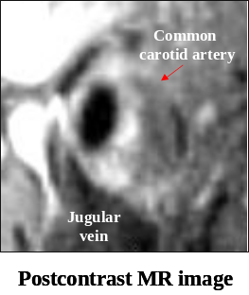
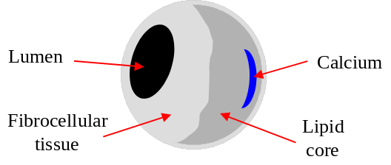

^{Ϯ}Outer wall ROI is drawn along outer border of enhancing outer wall.
*Lipid core ROI is inclusive of any calcification or hemorrhage within the core.
#Fibrous cap ROI is drawn along outer border of enhancing tissue that marginates the lumen.

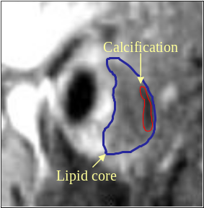
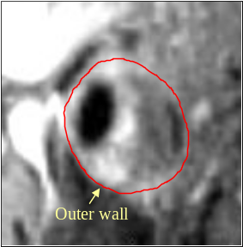
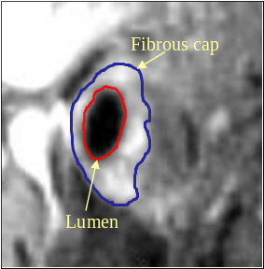

Analysis of additional morphologic features:

Ulceration
Calcification
Hemorrhage

^{ϮϮ} ROI measured on the double oblique image that shows greatest overall dimensions of the ulcer, calcification, or hemorrhage.

Examples of morphologic features of plaque


1. Diffuse wall thickening, no lipid core
Category: 1
u)ulceration

Category: 1u

2. Eccentric wall thickening with a thin lipid core but compensatory enlargement of lumen (ii – iii below):

u1) ulceration not affecting lipid core
u2) ulceration exposing lipid core to lumen
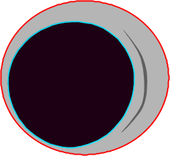

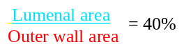
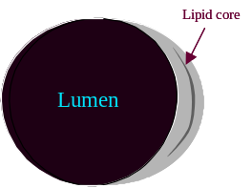
i) Normal lumen ii) Early plaque formation iii) Plaque encroaches 40% of area circumscribed by outer wall; No stenosis though MRA may show irregularity.

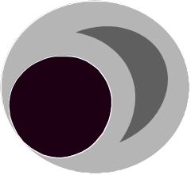
As plaque develops, it forms eccentrically (ii). During its early formation the vessel compensates by dilating to maintain a normal luminal area. The vessel can continue to compensate until the plaque encroaches 40% of the area circumscribed by the outer wall (iii), beyond which luminal encroachment occurs (iv).
iv) Stenosis develops as plaque formation continues
VESSELMASS analytical software for evaluating the carotid arteries

For carotid artery evaluation, all participants have images of the common carotid artery. In addition, there are 5 consecutive 2 mm slices through the internal carotid artery or thickest area of plaque. Analysis is performed on
a) all common carotid arteries
b) the internal carotid artery for the slice with the a) the thickest lipid core as identified on the contrast enhanced series if present, or the T2 series. If a lipid core is not present, the slice with the thickest wall is used for analysis.

The common and internal carotid arteries are analyzed by manually tracing the outer wall, inner lumen, and lipid core using a mouse-driven cursor. The non-physician reader using the Vesselmass software will perform quantitative carotid measurements.

Instructions for Initializing the VesselMass Software

Using the right mouse button, click and hold on the background:

- Scroll down to “New Terminal”

- Release the right mouse button to select “New Terminal”

- A new terminal will appear

- Type vesselmass and press the Enter button

- Type 1 and press the Enter button

- The Vesselmass Software will load

Study Selection within the vesselmass Program

- With the right mouse button, click on the “Database Button”

- From the pull down menu choose “select study”

- change the path to /DATA/Images or WINDOWS/New_Images(these are the two folders containing carotid images)

- Select the first study from your assigned list of studies by highlighting the name and clicking the “select” button at the bottom of the database pop-up window. By default, all series will be loaded.

- Left click the “multiple Select”

- A check will appear in the box

- Left click to highlight series to be evaluated

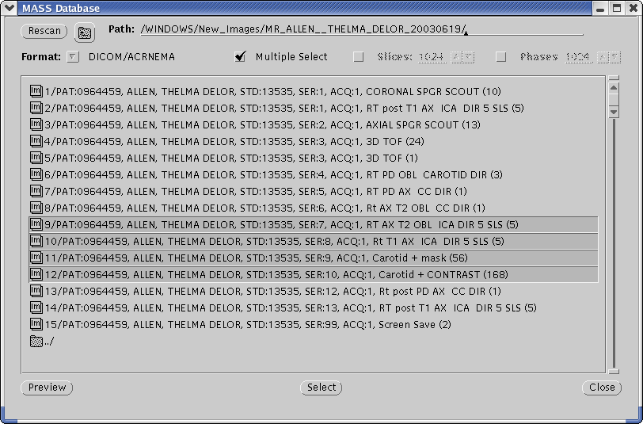
- Click the “select” button

- Click on “Accept Selection”

Note: If the wrong study is selected, leave the image matrix display in the database popup window by selecting “Undo Selection”

Selecting Settings to enable contouring

Setting window brightness and contrast

- To set brightness and contrast, you must first center the appropriate vessel.

- to center the vessel, from “Mode” settings click on the four direction arrow button.

- Left click and hold in the window to drag and center the vessel

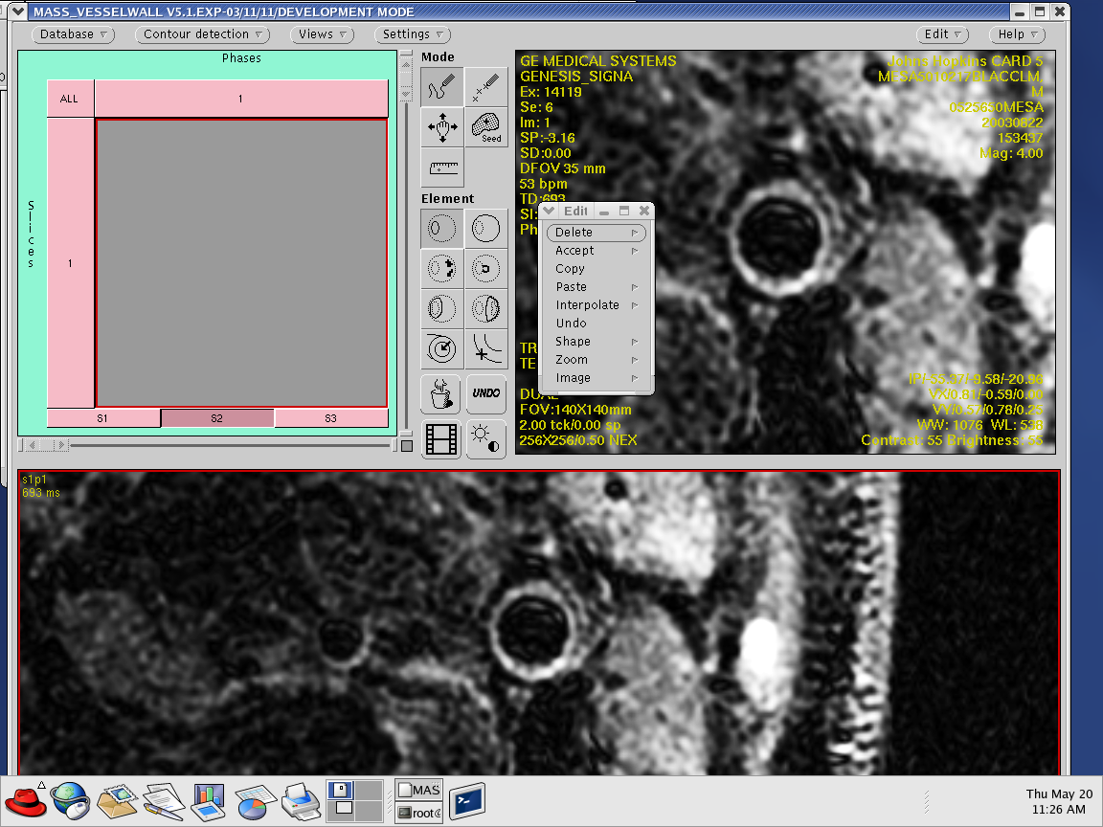

- Then right click in the window

- Scroll down to ”Zoom”

- Select “400”

- Left click on “Settings” and the “Settings” pop-up menu will appear

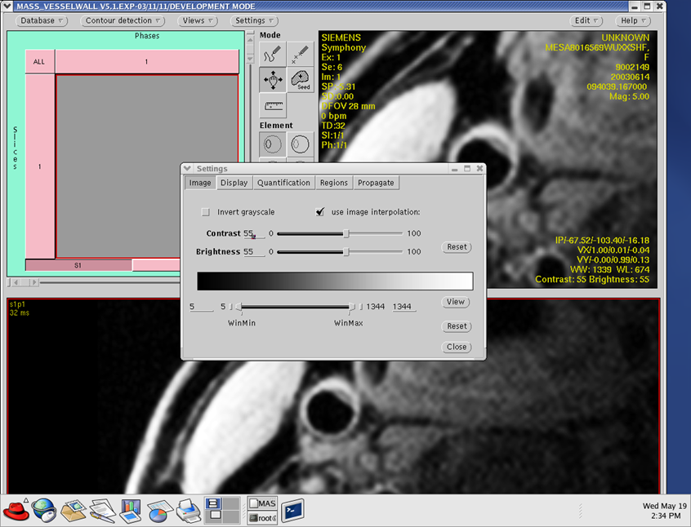
- In the “Image” setting, left click on the box in front of “use image interpolation”

- Left click on “Reset” button located to the right of the contrast and brightness tools. By default the contrast and brightness tool will both reset to 55%.

- Then left click on the “Reset” button located directly under the “View” button.

*Note: Moderate modifications may be made by click and holding the middle mouse button and dragging in all directions to better adjust the window contrast and brightness.

- Then left click the “VIEW” button located to the right of the WinMin and WinMax tool

Setting Window Display Settings

- At the top of the “Settings” pop-up menu, left click on the “Display” button

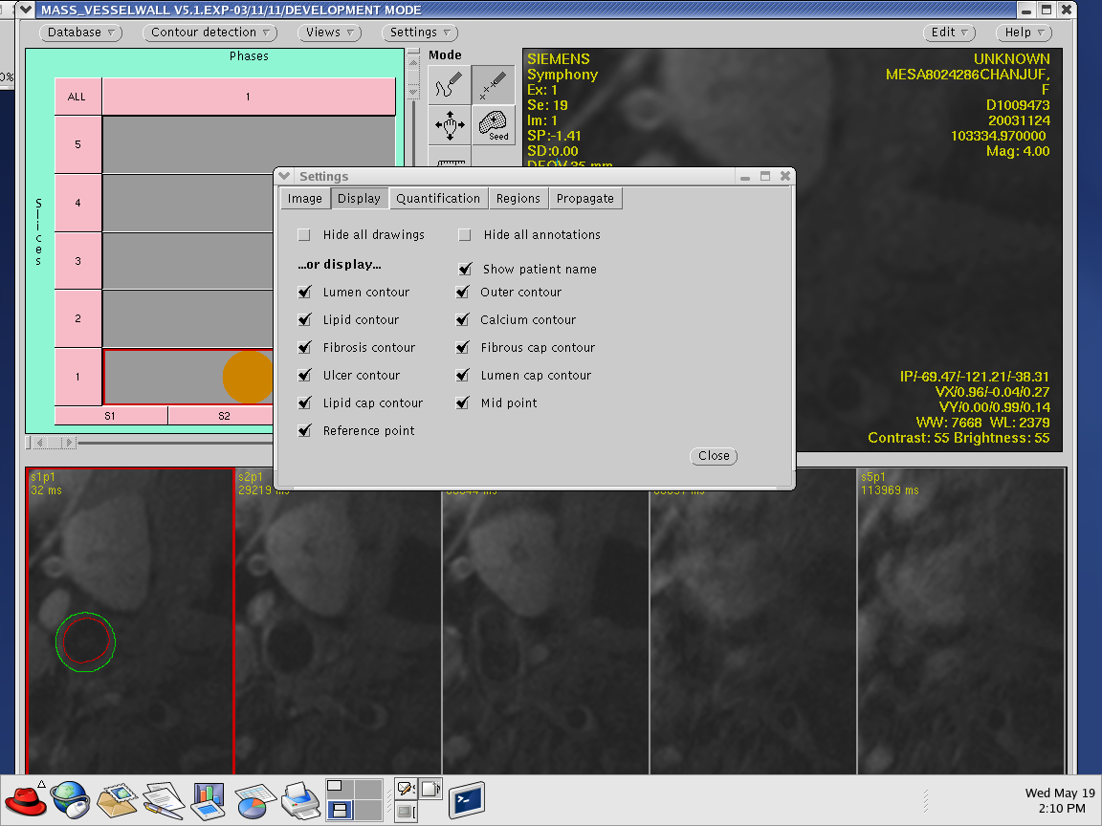

- Left click on the boxes to check all the features EXCEPT “Hide all drawings” and “Hide annotations.”

- Left click “Quantification” button

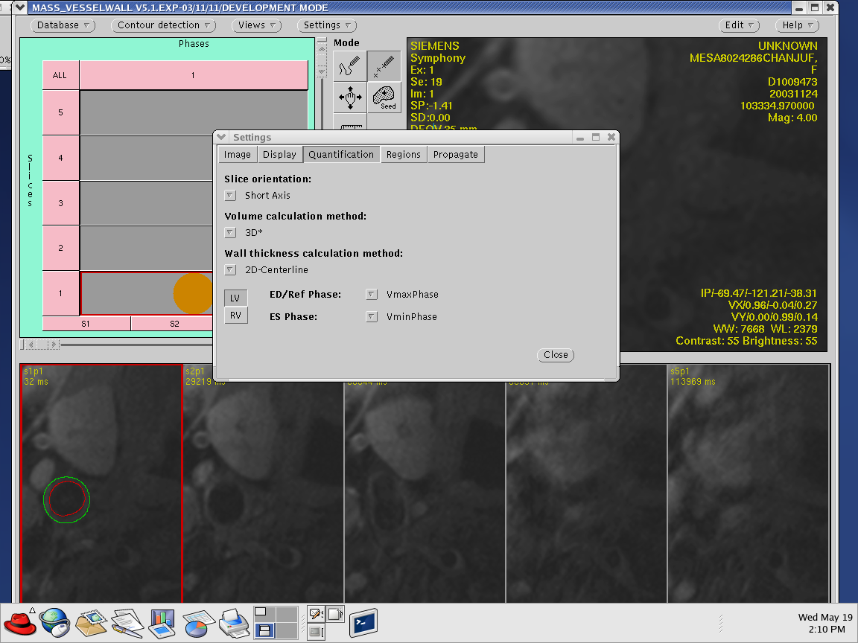

- Under “slice Orientation” right click and select “Short Axis”

- Continue down to “Volume calculation method.” Right click and select “3D*”

- Right click and select “2D Centerline”located below “Wall thickness calculation method”

- Finally, right click “LV” button

- Left click “Regions” button

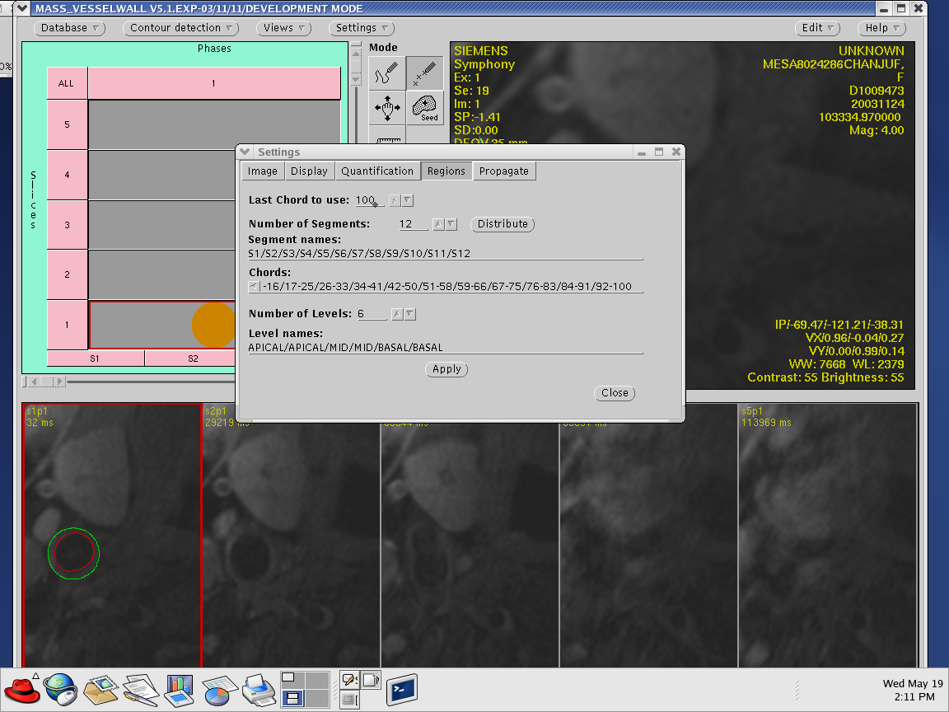

- Set the “Last Chord to use” to “100”

- Set “Number of Segments” to “12”

- . Then click the “Apply” button, The other setting will be set by default

- Left click “Propagate” button

- All the settings except for the “Centerline reference Point.” should be set to “ Same image orientation”,

- This can be done simply by right clicking on the down arrow and scrolling down to “Same image orientation”

- “Centerline reference point” should be set to “Current Slice” by right clicking on the down arrow; scrolling down and selecting “Current Slice.

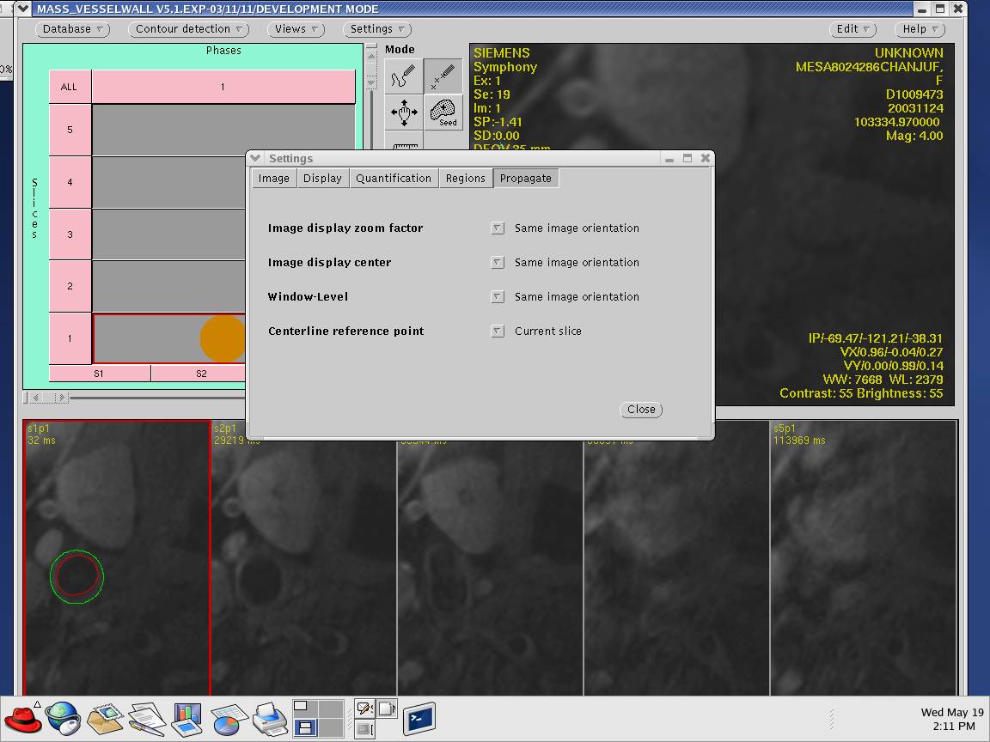
- Then at the bottom of the pop-up menu right click the “close” button.

Manual Contour Detection

Contour Default Colors

- Outer Contour (Green)
- Lumen Contour (Red)
- Lipid Contour (Blue)
- Calcium Contour (Orange)
- Ulcer Contour (Pink)
- Reference Point Contour (Blue)
- Noise Marker Contour (Yellow)

Trace Mode

- When the mouse cursor is moved into the active view, it will change to a cross shape and the color corresponding to the default color of the selected contour.

Point Mode

- Click on the point button in the mode setting and select the contour from the element setting. When the mouse cursor is moved into the active image view, it will become cross-shaped and assume the color corresponding to the default color of the selected contour. To define the contour, single-click the mouse, select the button with the mouse cursor placed at a position along the boundary. Repeat this procedure for any number of boundary points (at least twice), but keep to either a clockwise or counterclockwise order. To stop defining points and close the contour, double-click the mouse select button for the last definition.

Note: If only two points are set in the point mode, Vesselmass Software will create a circular contour through those points with its mid-point in the between the indicated points.

Modified Centerline Algorithm

All Vesselmass common carotid arteries and internal carotid arteries wall parameter calculations are based on the modified Centerline algorithm, which needs a reference point along with the endo and epicardial contours. These will be calculated after the centerline reference points have been set in the respective images and both endo and epicardial contours are available. This reference point must be manually positioned if any of these calculations are to be done

Setting Mark Reference Point(blue)

- To position the center-line reference point, click on the Reference Point Contour (blue) marker located under the “Element” settings

- Select either the “Trace” or “Point” tool located under the “Mode” setting

- Move the mouse cursor inside the active image view

- Single click the mouse selection button on the outer wall appropriate vessel, where both vessels are bisected

Contouring Internal Carotid Artery

- From “Mode” setting click on “Point” tool

- From “Element” click on “Lipid Contour Element”(blue)

- Click on the Gadolinium (GD) series to check slices for presence of a lipid core(series noted by S1, S2, S3, etc…)
Note: The series can be identified by checking the parameters.
T1 Proton Density →TR = long, TE = short
T2 Weighted → TR = long, TE = long
Gadolinium → TR = short, TE = long

- If there is lipid core present, use the “Lipid Contour Element”( blue) to contour

- Click several points around the lipid core and double the final point to enclose the contour

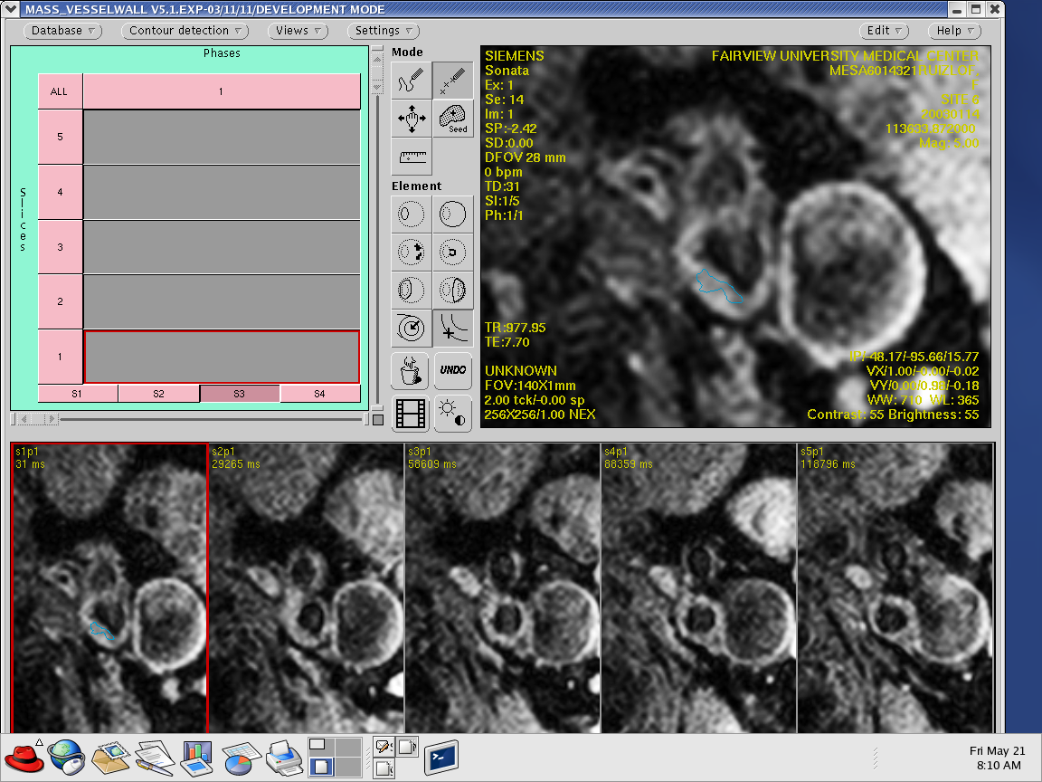
- “Transfer 3D*” the contour from the PD Gadolinum image to the T1 Proton Density image, by right clicking on “Views” and scrolling down to “Transfer 3D*”

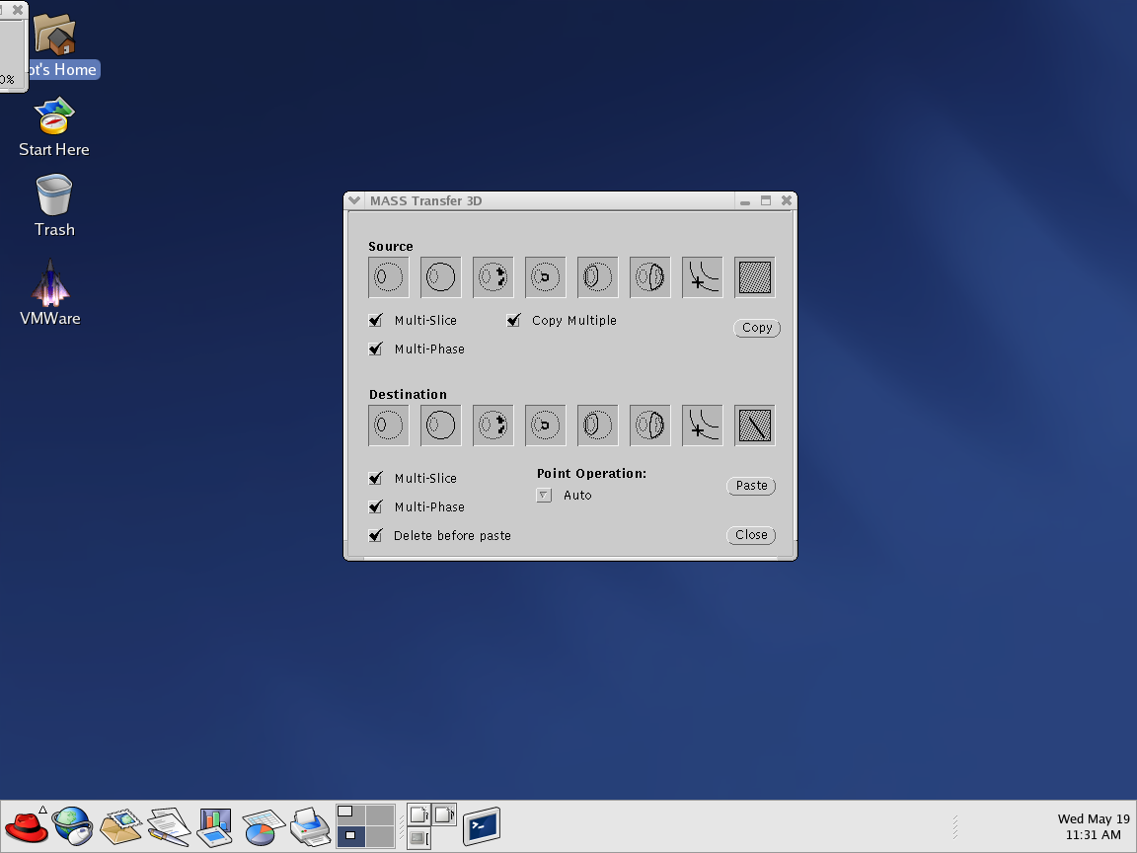
- A “Mass Transfer 3D*” pop-up menu will appear

- All the icons located under “Source” and “Destination” should contain checked boxes. If they do not, do so by right clicking on the empty boxes.

- With the PD Gadolinium image still in the active viewing window, left click on “Copy”

- Left click on the T1 Proton Density series button (ex. S1, S2, S3, S4, etc….). This will load the series to the active viewing window.

- right click on “Views” and scroll down to “Transfer 3D*”

- “Mass Transfer 3D*” pop-up menu will re-appear

- Left click on “Paste”

- This will paste the lipid core contour from the Gadolinium image to the T1 Proton Density image

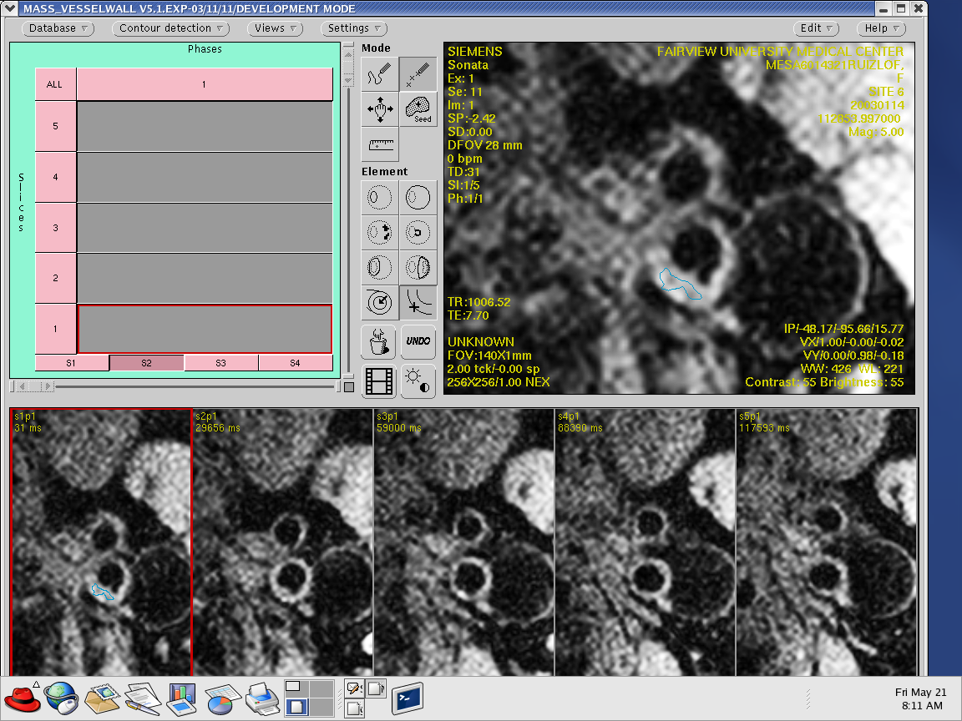
- Make moderate modifications

Note: If a lipid core IS NOT present, begin with contouring the “Outer Lumen” on the T1 Proton Density series.
- From the “Element” setting click the “Mark Reference Point”(blue)

- Place the “Mark Reference Point” on the outer lumen wall at a point where if a line were drawn it would bisect both vessels.

- Next, using the “Outer Contour”(green) drawing tool, begin to draw points around the outer wall. Double click on the last point to close the contour.

- Then using the “Inner lumen” (red) drawing tool, do the same for the inner lumen wall. Double click on the last point to close the contour.

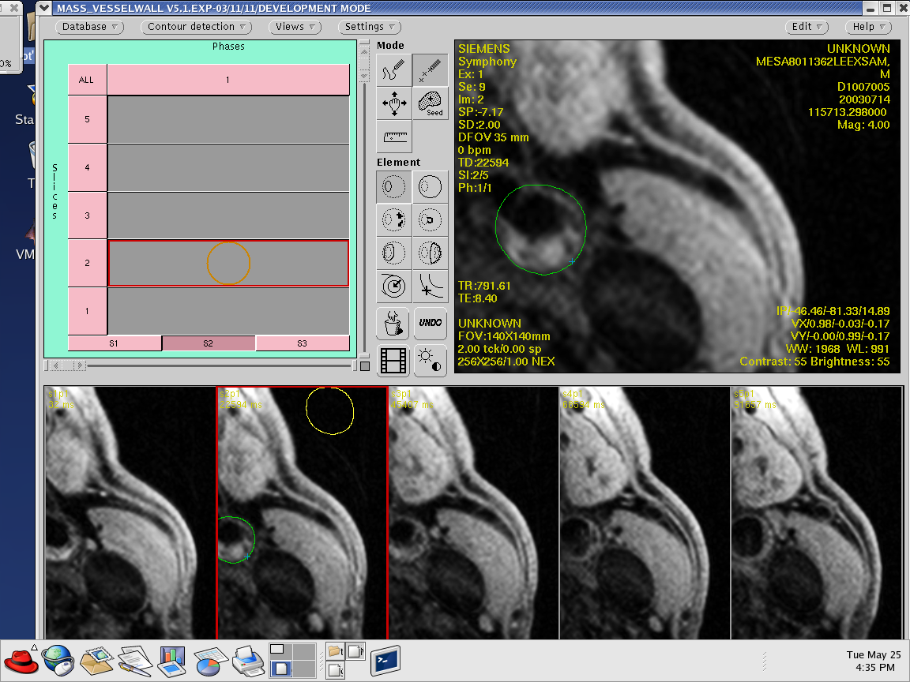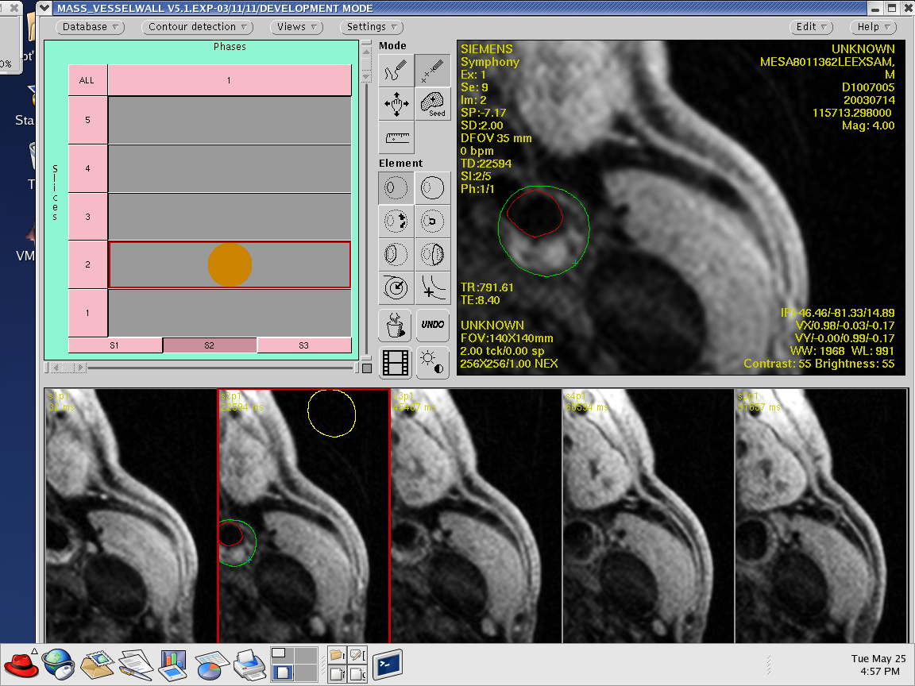

- Once the “Outer Lumen Contour”, “Inner Lumen Contour”, “Lipid core” “Calcium Contour”, and “Ulcer Contour”(If Present) are completed, Click the “Views” button to re-open the “Mass Transfer 3D*” pop-up menu.
- Follow the same copy and paste instructions given before to transfer the completed contour from the T1 Proton Density image to the T2-weighted and Gadolinium image.

- Remember to make only moderate modifications to the T2-weighted and Gadolinium image.

Placing the noise marker

- Under the “Mode” setting select the point tool

- Choose the “Noise Marker contour” tool (yellow) which is located under the “Element” setting.

- Begin drawing points around the outer wall. Double click on the last point to close the contour.

- After the “Noise Marker contour” has been drawn, press and hold the CRTL key located on the keyboard while left clicking and holding on the mouse to drag and drop the “Noise Marker contour”

- The contour should be done in the air close to the coil.

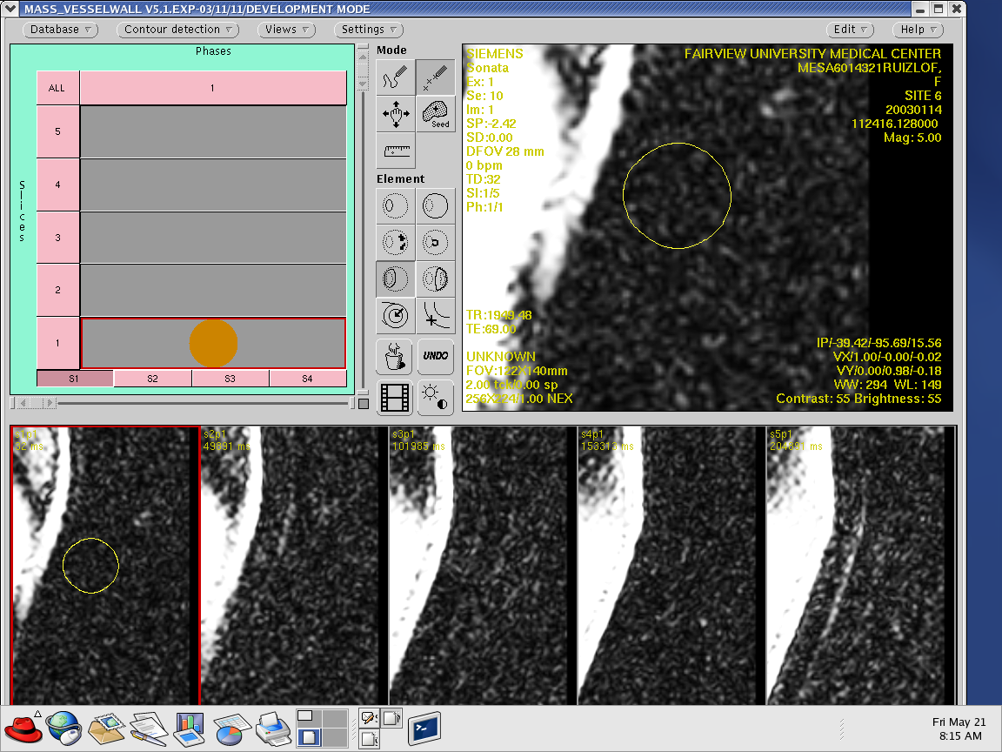

Generating a text report

- Right click on “Views”

- Scroll down to “Report” and left click

- “MASS Report”(Text Report) pop-up menu will appear

- Left click “Text Report”

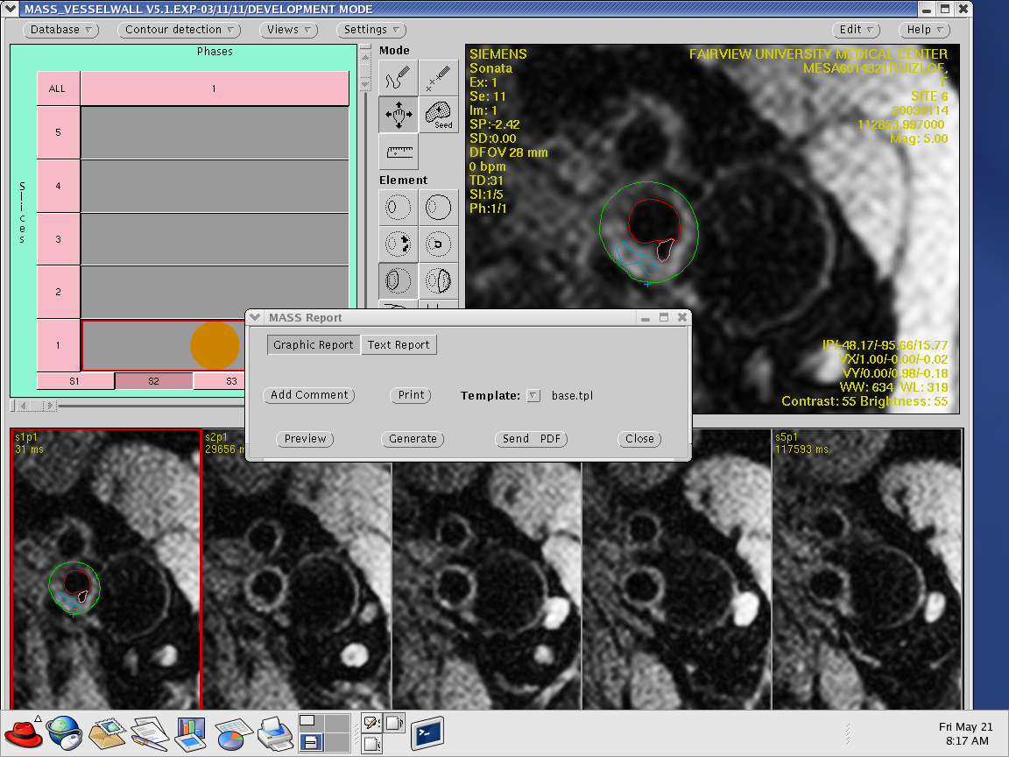

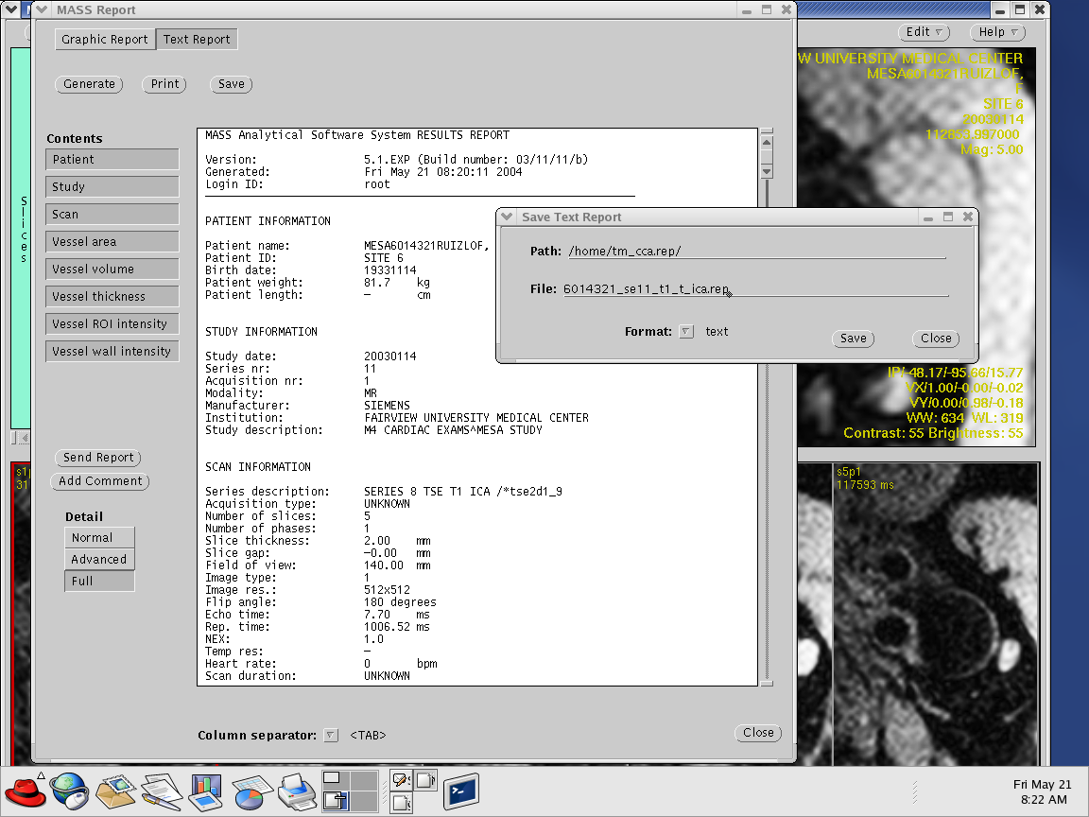

- All the tabs located under the “Contents” setting should be highlighted. Left click on the tab to highlight
- Under the “Detail” setting, left click the “Full” tab

- Then, left click “Generate” to generate the report

- Left click the “Save” button

- “Save Text Report” pop-up menu will appear

Internal Carotid Artery file reporting convention
File naming convention:

1234567_se#_**_id_ica.rep
1234567_se#_**_id_ica.rep

Where:
1234567 mesa ID

se# MRI series number. This is designated as “se7” for series 7, or “se12” for series 12, for example.

** designation as to the type of MRI. Possibilities are
t1 proton density
t2 t2 weighted
gd gadolinium

id reader initial. Only 1 initial is used. It is either “t” or “m”

ica indicates internal carotid artery

.rep a report file, ascii text

Several examples

5435567_se6_t1_t_ica.rep mesa id 5435567, series 5, T1 proton density, reader “t”, internal carotid artery report

5435567_se13_gd_t_ica.rep mesa id 5435567, series 13, gadolinium, reader “t”, internal carotid artery report

5435567_se7_t2_t_ica.rep mesa id 5435567, series 7, t2-weighted, reader “t”, internal carotid artery report

Internal Carotid Artery contour saving convention

- Right click on the “Database” button

- Scroll down and left click to “Save Contours”

- Left click to deselect the “save for all studies” check box.

- Once this is done, a path and file name can be given as done when saving report files.

- Use the same naming convention as the report files, except this files will be “.con” for example:
5435567_se7_t2_t_ica.con

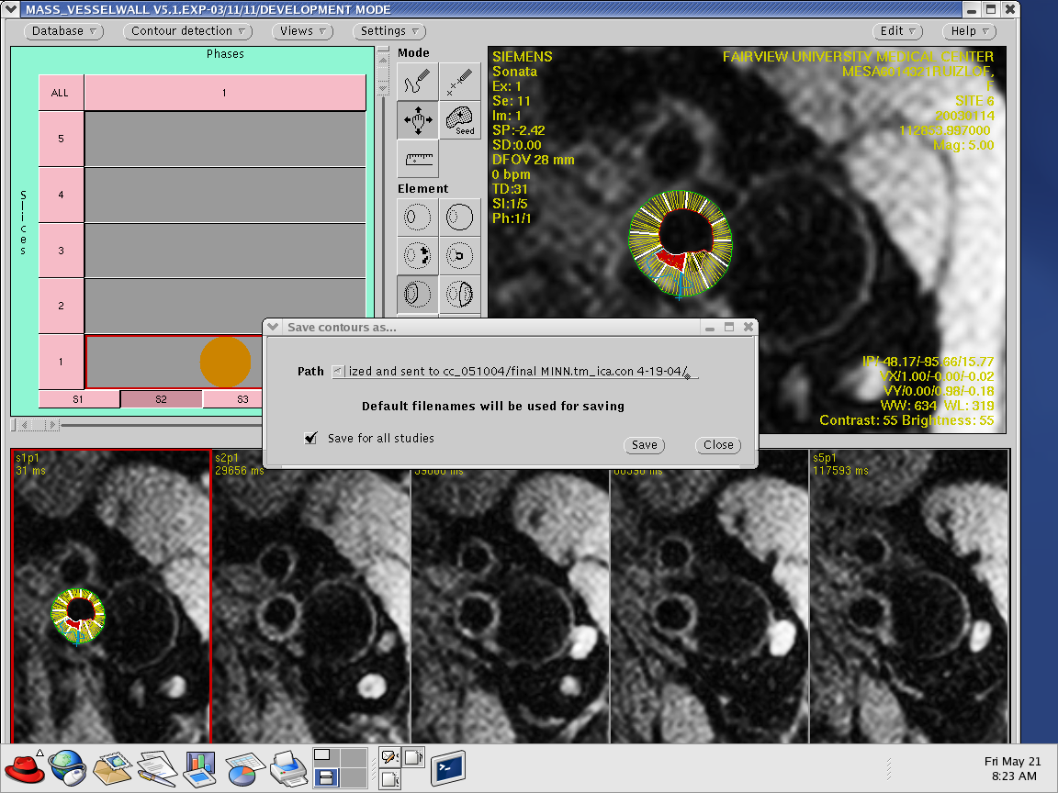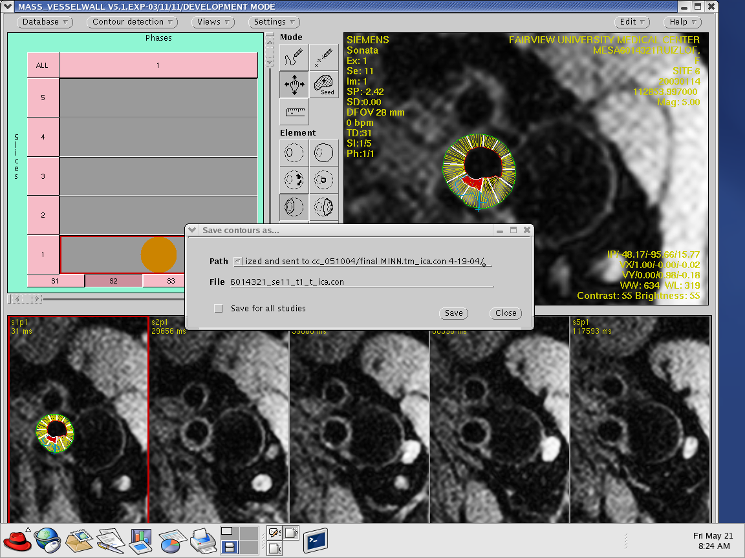

Contouring Common Carotid Artery

- With the right mouse button, click on the “Database Button”

- From the pull down menu choose “select study”

- change the path to /DATA/Images or WINDOWS/New_Images(these are the two folders containing carotid images)

- Select the first study from your assigned list of studies by highlighting the name and clicking the “select” button at the bottom of the database pop-up window. By default, all series will be loaded.

- Left click the “multiple Select”

- A check will appear in the box

- Left click to highlight series to be evaluated. Highlight the PD, T2, PD Gadolinium, 3DTOF, and any ICA series

Note: 3DTOF and any ICA series will only be used to help identify the internal and external and to aid in placing the mark reference point.

- Click the “select” button

- Click on “Accept Selection”

Note: If the wrong study is selected, leave the image matrix display in the database popup window by selecting “Undo Selection”

- Begin by selecting the ICA series

- Select the slice that shows the two vessels separated. You may also refer to the 3DTOF if the vessels do not separate or for any reason you can not accurately identify them.

- Once you are able to identify the two vessels, place the “Mark Reference Point on the outer lumen of external carotid artery, so that it will bisect both the internal and external carotid arteries.

Note: you may select the “Ruler” tool located under the “Mode” setting to assist with correctly bisecting the two vessels and placing the “Mark Reference Point”.

- From “Mode” setting click on Point tool

- From “Element” setting click on the “Outer LumenContour”(green) tool

- Next, using the “Outer Contour”(green) drawing tool, begin to draw points around the outer wall. Double click on the last point to close the contour. (At this time, if necessary, you may want to adjust the “Mark Reference Point”)

- Right click in the active viewing window

- A “Edit” pop-up menu will appear

- Then scroll down to “copy”(this will copy the “outer lumen contour”)

- Click on “PD” series to put it in the active window

- Right click in the active image

- A “Edit” pop-up menu will appear

- Then scroll down to “paste”(this will paste the “outer lumen contour” to the “PD” series)

- Now, from the “Element” setting click the “Mark Reference Point” tool”(blue)

- Use the same steps to copy and paste the “Mark Reference Point” to the “PD” series.

- Using the keyboard press and hold the Shift and Ctrl keys while pressing the left button on the mouse to make necessary adjustments to the positions of the “Outer Lumen” and “Mark Ref”.

- Repeat the copy and paste procedures to copy and paste the “Outer Lumen Contour” and “Mark Reference Point” to the other CCA series(T2, and PD Gadolinium)

- Click on the “PD” series to put it in the active viewing window

- Make sure the Point tool is highlighted under the Mode setting and Outer Lumen Contour is highlighted on the “Element” setting

- Right click in the active viewing window

- A “Edit” pop-up menu will appear

- Scroll down to delete(this will delete the Outer Lumen Contour leaving only the Mark Ref. Point)

- Next, using the “Outer Contour”(green) drawing tool, begin to draw points around the outer wall. Double click on the last point to close the contour

- Then using the “Inner lumen” (red) drawing tool, do the same for the inner lumen wall. Double click on the last point to close the contour.

- Under the “Mode” setting select the point tool

- Choose the “Noise Marker contour” tool (yellow) which is located under the “Element” setting.

- Begin drawing points around the outer wall. Double click on the last point to close the contour.

- After the “Noise Marker contour” has been drawn, press and hold the CRTL key located on the keyboard while left clicking and holding on the mouse to drag and drop the “Noise Marker contour”

- The contour should be done in the air close to the coil

- 3D*Transfer the entire contour to the T2 and PD Gadolinium series by right clicking on “Views” and scrolling down to “Transfer 3D*”

- A “Mass Transfer 3D*” pop-up menu will appear

- All the icons located under “Source” and “Destination” should contain checked boxes. If they do not, do so by right clicking on the empty boxes.

- With the PD image still in the active viewing window, left click on “Copy”

- Left click on the T2 series button (ex. S1, S2, S3, S4, etc….). This will load the series to the active viewing window.

- right click on “Views” and scroll down to “Transfer 3D*”

- “Mass Transfer 3D*” pop-up menu will re-appear

- Left click on “Paste”

- This will paste the entire contour from the PD image to the T2 and PD Gadolinium image

- Once you have finished the copy and paste procedures, make moderate modifications to the T2 image and then do the same for the PD Gadolinium image

- Now you are ready to generate and save a text report the same way you did ICA. There will be small changes in the naming conventions.

** designation as to the type of MRI. Possibilities are
pd proton density
t2 t2 weighted
gd gadolinium

cca indicates common carotid artery
Two Examples

5435567_se6_pd_t_cca.rep mesa id 5435567, series 5, proton density, reader “t”, common carotid artery report

5435567_se13_gd_t_cca.rep mesa id 5435567, series 13, gadolinium, reader “t”, common carotid artery report

Loading Contours

- Select the appropriate study. The study ID and loaded contours ID must be the same, otherwise loaded contours may be loaded onto the incorrect study resulting in incorrect data.

- To load a set of contours, click on “Load Contours” from the database menu.

- The load contours pop-up window appears. A list of files and directories is shown in the window. When a default contour file exists, it is pre-selected; otherwise a manual selection must be made by clicking on the appropriate file name. Any contour file can be selected. A warning will appear when an attempt is made to load contours that do not belong to the current study.

- Right click on “Database” button

- Left click on “Load Contours”

- Type in the path where the contours have been saved.
Ex. /home/tm_cca.con

- Once the path has been chosen, scroll down to select the appropriate contour

- Left click to highlight it and then click the “Select” button

- This will load the contours

