

MULTI-ETHNIC STUDY OF ATHEROSCLEROSIS

MAGNETIC RESONANCE IMAGING

READING CENTER

MANUAL

Revised
3/1/01

© Johns Hopkins University
Linda J. Wilkins

1.0 GOALS and OBJECTIVES 6
2.0 READING CENTER EQUIPMENT 6
3.0 READING CENTER PERSONNEL 7
3.1 MR RC PI 7
3.2 MR RC CO-PI 7
3.3 MR RC Project Manager 7
3.4 MR RC Adjudication Panel 7
3.5 MRI RC Non-Physician Readers 7
3.6 MRI Research Programmer 7
4.0 PILOT STUDY 8
4.1 Reading Assignments 8
4.2 Qualitative Image Analysis 8
4.3 Quantitative Image Analysis 8
4.4 Image Analysis Quality Control 8
4.5 Alerts 8
5.0 READER TRAINING 8
5.1 Case Selection for Pilot Study Training and QC 9
5.2 Training Sessions for Non-physician Readers 9
5.2.1Training Session 1 9
5.2.2 Training Session 2 9
5.2.3 Training Session 3 9
5.2.4 Training Session 4 9
5.2.5 Training Session 5 9
5.2.6 Training Session 6 9
5.2.7 Training Session 7 10
5.2.8 Training Session 8 10
6.0 READER CERTIFICATION 10
7.0 READING ASSIGNMENTS 10
8.0 MESA MRI STUDY MAIN TRIAL READING CENTER ORGANIZATION 10
9.0 QUALITY CONTROL 12
9.1 MEETINGS 12
9.2 SELECTION OF SCANS FOR EVALUATION OF 12
INTER-READER AND INTRA-READER RELIABILITY 12
9.3 STATISTICAL ANALYSIS OF INTRA- AND INTER-RATER RELIABILITY 12
10.0 THE MESA DATABASE DESIGN / STRUCTURE 13
10.1 Mass Database: Contour_reports.fp5 13
10.2 Flow Database: flow_reports.fp5 13
10.3 Completions.fp5 14
10.4 Users and Groups 14
10.5 Required Fields 14
11.0 MRI READING ENVIRONMENT AND GENERAL GUIDELINES 16
12.0 WEEKLY READING ASSIGNMENTS FOR NON-PHYSICIAN READERS 16
13.0 MASS ANALYTICAL SOFTWARE v4.0 (MEDIS, THE NETHERLANDS) 16
13.1 Instructions for Initializing the Mass Software 16
13.2 Study Selection within the MASS Program 16
13.3 Creating A Contour 17
13.3.1 Window Level and Width Settings 17
13.3.2 Contour Default Colors 17
13.3.3 Contour Detection Settings 18
13.4 Performing Contour Detection 18
13.4.1 Slice 1 Checking for Heart Muscle 18
13.4.2 (7 - 10) Reference Points Around Ventricle for Automatic Contour Detection 19
13.4.3 Resulting Contours - Apical Slice Where Endo is Not Always Present 19
13.4.4 Contour That Needs Manual Editing 20
13.4.5 Corrected Contour 20
13.4.6 Slice 2 Contours 21
15.4.7 Slice 3 Contours 21
13.4.8 Basal Slice before Manual Contour 22
13.4.9 Basal Slice after Manual Contour 22
13.4.10 Basal Phases Where LV Is Not Always Present 23
13.5 Manual Editing Contours / Correction And Accepting 23
13.6 Contour State Display 24
13.7 Loaded State 24
13.8 Manual Contour Detection 24
13.8.1 Trace Mode 25
13.8.2Point Mode 25
13.9 Modified Centerline Algorithm 25
13.9.1 Auto-Contour Blue Marker Point with Wall Thickness Chords 26
13.10 RC Non-Physician Reader Contour QC 26
13.11 Saving Reports and Contours 29
13.12 LOADING CONTOURS 30
13.13 Results Calculation Algorithms 30
14.0 FLOW ANALYTICAL SOFTWARE v4.0 (MEDIS, THE NETHERLANDS) 30
14.1 Creating A Flow Contour 30
14.2 Window Level and Width Settings 30
14.3 Study Selection 31
14.4 Automatic Contour Detection 31
14.5 Detecting the FLOW Contour 34
14.6 Manual Contour Detection 34
14.7 Saving Reports and Contours 34
15.0 QUALITATIVE CINE ANALYSIS 35
15.1 Left Ventricular Wall Motion 35
16.0 ALERT STATUS CATEGORIES 36
16.1 Normal 36
16.2 Abnormal 36
16.3 Urgent Referral 37
16.4 Communication of results by RC to FC 38
17.0 Attachments 39
17.1 Attachment 1 40
MASS DEFAULT SETTINGS 40
17.2 Attachment 2 43
Field Center Report - Data Received 43
17.3 Attachment 3 44
Qualitative Interpretation Form 44
17.4 Attachment 4 45
Physicians Data Sheet View 45
17.5 Attachment 5 46
Example of Alert Letter 46
17.6 Attachment 6 47
Examples of Results Letters 47
17.7 Attachement 7 54
Mass Ini. Settings 54
17.8 Attachment 8 57
Copywright Permission from the Leiden University 57

PART I: OVERVIEW OF MESA MR READING CENTER

1.0 GOALS and OBJECTIVES

The purpose of the MR Reading Center is to provide interpretation of magnetic resonance imaging studies for 6,500 participants enrolled in the Multi-Ethnic Study of Atherosclerosis (MESA). The MR studies will be performed at the six MESA Field Centers. The MESA MRI Reading Center will conduct a pilot project of 10 MRI studies at each Field Center (60 studies) before the main study begins. The pilot study data will be used to train the non-physician readers to perform consistent image processing for the quantitative image analysis.

The goals of the MESA MRI Reading Center are to develop quantitative measurements of cardiac morphological structure and physiological function that are precise enough to measure variation within the normal range and to identify clinically significant abnormalities from MRI measures. The MRI RC will identify which characteristics are related to progression of subclinical to clinical cardiovascular disease and their relationship to established measures for identifying asymptomatic persons at highest risk for clinical events.

The MR RC intends to accomplish these goals via the following objectives:

1. Determine characteristics related to progression of subclinical cardiovascular disease to clinical cardiovascular disease.

2. Identify factors related to newer measures of subclinical disease and examine relationship of new measures to established measures.

3. Develop population-based methods suitable for identifying asymptomatic persons at highest risk of clinical events.

2.0 READING CENTER EQUIPMENT

The preferred image data transmission and archiving format will be DICOM. That is the common image format in the Picture Archive and Communication system (PACS).

The PACS provides for immediate as well as long-term storage. The hardware includes network connections and a tape based storage medium (Siemens) and a workstation (Siemens Magic View) for initiating file transfers. The PACS accepts digitized images via DICOM-internet. The PACS will store the images on tape for later retrieval. For the duration of the study, the Field Centers will be required to maintain a copy of all studies on a back-up tape or disk in case of network failure. If network failures occur, the Field Centers may mail studies to the RC. The tapes/discs can be restored from the disk drive on the GE Signa scanner or Siemens scanner and transmitted to the PACS for permanent storage.

After the Magic View workstation receives the DICOM images, the studies will be auto- routed to the PACS for permanent storage. The images will then be pulled from the PACS and displayed on the SUN Workstation that houses the MASS (v4.2) and FLOW (v2.0) MR Analytical software for reader interpretation (registered trademarks of Leiden University Medical Center and Medis Corporation, The Netherlands). After completion of the image analysis, the image contours and reports will be archived on CD.

Interpretation data is exported into a Macintosh Computer running the FileMaker Pro 5.0 interpretation database. The Macintosh computer transmits the data files to the coordinating center via E-mail.

3.0 READING CENTER PERSONNEL

MR RC PI David A. Bluemke, M.D., Ph.D.
MRI-RC CO-PI Joao Lima, MD
MR RC PROJECT MANAGER Linda Wilkins, R.T.
MRI RC NON-PHYSICIAN READER Aisha Abdur-Rahman
MR RC ADJUDICATION PANEL David A. Bluemke, M.D., Ph.D.
Joao Lima, MD
Cardiology Fellow
MR Research Programmer Arvind Bakhru, BS

3.1 MR RC PI

Oversee the design and implementation of the data base management system, implement the computer image analysis software, supervise the pilot study, and prepare the final protocol. Will oversee the quality control of the database, evaluate, and monitor intra- and inter-reader reliability of MRI interpretation including delineation of clinically meaningful differences in MRI scan interpretation. Will oversee the design and interpretation of data analyses performed to identify clinically and statistically significant predictors of clinically important cardiovascular events. Will design and implement any change in the methodology used for the MR RC for the final study. Participate in the analysis and publication of the MESA MR data.

3.2 MR RC CO-PI
Will assist the PI in finalizing the protocol for radiologic reporting/interpretation of MRI scans.

3.3 MR RC Project Manager
Responsibilities include assisting in implementation and maintenance of the MESA MR RC data management system. Will act as a liaison between the MR RC and the MESA FC and Coordinating Center on issues relating to the MR RC. The Project Manager will report to the MR RC PI results of the FC quality control monitoring, MR RC turnaround and results of interpretation analyses. Will communicate to the Coordinating Center and FC any changes in protocol or MR data management as directed by the MR RC PI. The project manager will assist in the planning, implementation, and control modifications regarding the MR RC resulting from the pilot project. Responsibilities include coordination and communication of the MR RC data entry inputs and outputs. Will also maintain schedules for readers, report problems or concerns relating to the MR RC operations at the monthly QC meetings. Communicates to FC’s any protocol changes and issues regarding operations. The project manager will communicate to the appropriate personnel status of alerts and data transfer.

3.4 MR RC Adjudication Panel
The members of the panel will perform all qualitative interpretations of the MESA MRI studies. The panel will evaluate each scan for the presence or absence of alert values and record findings in the MESA MRI database. All members will attend monthly QC meetings.

3.5 MRI RC Non-Physician Readers
Will perform all quantitative analysis using MASS and FLOW MR Analytical Software System. If an alert is identified, they will report the findings to the PI.

3.6 MRI Research Programmer
Responsible for construction and maintenance of MESA relational interpretation database.

4.0 PILOT STUDY

4.1 Reading Assignments

During the pilot study, each of the six field centers will perform 10 MRI scans (60). The 60 MRI Scans will have both quantitative and qualitative analysis. The two non-physician readers will perform quantitative analysis on all the exams. Qualitative analysis will be performed by the Adjudication Panel, which consists of the RC PI, C0-PI, and a cardiology fellow/fellows. Data will be communicated to the CC for analysis.

4.2 Qualitative Image Analysis

• The adjudication panel will perform qualitative analysis on all the pilot studies (60). An assessment form (attachment 3) will be completed by the panel and entered into the interpretation database by the project manager.

4.3 Quantitative Image Analysis

• Two non-physician readers will be assigned to perform quantitative analysis using MASS & FLOW software on all the pilot studies (60). Having both readers re-read all 60 cases will assess inter-reader observation. MASS and FLOW reports are generated for each examination and analyzed in the interpretation database. Re-reads will be considered within acceptable ranges if they are within 10% +/- of the recommended indexed value range.

4.4 Image Analysis Quality Control

• Quantitative statistical variation of more than 10% between the left ventricular end diastolic mass and left ventricular end systolic mass for both inter and intra reader QC will require retraining by the RC PI.

• Qualitative analysis will be the consensus of the adjudication panel consisting of the PI, Co-PI and cardiology fellow/fellows.

• Additionally, a time log for each reader will be kept to determine the average reading/processing time per case. The RC will collaborate with the CC in the analysis of pilot data, reporting results to the Steering Committee and designing and implementing necessary corrective actions.

4.5 Alerts

When an alert is identified at the RC, the RC PI will review the scan and the information will be documented on the MESA Scan Coding Form. If the alert is considered urgent, the RC PI will also dictate a letter (attachment 5) including all pertinent information regarding the alert. The RC project manager will fax the letter to the designated FC representative. If the person designated at the FC is unavailable, the RC data manager will contact the FC PI and/or the FC radiologist.

5.0 READER TRAINING

New readers will be trained to perform quantitative image processing in a standard fashion by participating in a training course which will draw on a library of representative scans (30 studies) from the pilot project. Additionally, each non-physician reader will be required to complete a series of lectures including; MESA protocol and study design, cardiac MRI anatomy, and the MESA MRI scanning protocol.

5.1 Case Selection for Pilot Study Training and QC

• All pilot study cases were selected to be read by each reader (n57).
• All 57 cases were double read independently by the MESA pilot trial readers (n57 inter-reader reads).
• Each reader then read 28 cases that they read previously.
(n28 intra-reader reads).

5.2 Training Sessions for Non-physician Readers

5.2.1Training Session 1

Information Covered During Session

- Reviewed the overall MESA Protocol and Study Design
- Review of the MESA MRI scanning protocol series
- Cardiac MRI Anatomy
- Review of Cardiac Function and Segmentation
- Orientation to the workstation
- Introduction to the MASS and FLOW analysis software
package.
- Contour detection
- Report generation
- Reviewed results from reports
Review of MESA MRI pilot study images

5.2.2 Training Session 2

- Assignment of six practice cases per reader
Note: Average reading time per case for Session 2 = 1 hour

5.2.3 Training Session 3

Reviewed quantitative analysis from training session 2

Reviewed each case slice per slice for
accuracy in contour detection
- Further instruction on how to perform
the contours on the basal slices.

5.2.4 Training Session 4
• Readers assigned to perform contour detection
on all 60 pilot study cases

Note: Average reading time per case for Session 4 = 45min

5.2.5 Training Session 5
• Reviewed contours and reports for all 60 cases.
• Readers assigned to perform contour detection on all 60 pilot study cases
Inter reader assessment.
Note: Average reading time per case for Session 6 = 45min

5.2.6 Training Session 6
• Reviewed contours and reports for all 60 inter-reader cases.

5.2.7 Training Session 7
• Readers instructed to perform contour detection on one half the pilot study cases for the intra reader comparison.
Note: Average reading time per case for Session 8 = 20min

5.2.8 Training Session 8
• Reviewed contours and reports for all 60 intra-reader cases.

Contour data results were transferred to the MESA MRI interpretation database for comparison of inter- and intra-reader variation.

6.0 READER CERTIFICATION

Readers are considered certified if results from the training sets are within acceptable ranges as deemed by the Reading Center PI and the CC. Quantitative statistical variation of more than 10% between the left ventricular end diastolic mass and left ventricular end systolic mass for both inter and intra reader QC will require retraining by the RC PI.

Unacceptable results will require additional training. The reader will be required to perform interpretations on 15 additional cases. Studies for retraining will be selected by the Reading Center PI to determine which areas need improvement. Results will be sent to the CC for analysis. Throughout the main trial, the RC PI will closely monitor readers who required additional.

7.0 READING ASSIGNMENTS

During the main trial, approximately 6,500 MRI scans will be performed; 1083 per field center over 2 years. These 6,500 scans will be divided equally among the readers at the MR RC. The full baseline study of 6,500 participants will be read at a capacity of 65 studies per week. This will include 5% quality control re-reads.

Two Non-physician readers will be assigned to read 32 MESA cases per week. The adjudication panel will be assigned to read 65 cases per week each. Interpretation results will be transmitted to the CC within (30) days of receipt of the MRI scans form the FC.

The RC will not make any effort to stratify scan reading assignments based on the particular field center at which the scan was performed. The RC will examine the distribution of scans performed at each of the FC’s across MRI readers on a monthly basis. If the observed distribution of scans by FC is markedly distorted, we will revise our MRI reading assignment strategy in order to achieve a better balance.

If a reader is sick during all or part of a week during which they have been assigned to read, the scans to be read on a particular day during that week or during the entire week will be read by a substitute reader. The program manager will revise the reading assignment reader id into the database.

8.0 MESA MRI STUDY MAIN TRIAL READING CENTER ORGANIZATION

Network communication between the Field Centers and the Reading Centers was established with each Field Center during the Pilot Study.

Required number of MRI examinations performed per week for each Field Centers is 10. The designated Field Center representative will transmit the MRI data to the Reading Center, either at the completion of the exam or on a specified day each week. Studies will remain on the Magic View workstation for approximately 2 weeks after which time they will be auto routed to the Magic Store Archive for permanent storage. Recommendations for the organization of data transmission to the Reading Center were made. It is at the discretion of each Field Center to determine the organizational flow of data transmission that works best for their MRI center.

At the completion of the MRI exam, the MESA MRI technician will scan the MRI completion form into the coordinating center database.

• The scanned information from the completion form will generate an output file that the Field Center coordinators will transmit to the Reading Center via E-mail on the same day that the exams are performed.

• The output file will be imported into the Reading Center completion form database. Daily, the Reading Center project manager will query the database for examinations received.

• A copy of the completion form will be printed and used to reference the Magic View Workstation to determine if each image from each series was received. If all images were received, an output file of completed studies received containing the study ID, acrostic, date of scan, date data was received and any pertinent comments (attachment 2) will be transmitted to the FC coordinator, FC network representative and the CC.

• The completion forms will then be placed in the queue for reader assignment.

• Problems with data received will be reported to the Field Centers and Coordinating Center.

• Studies will be auto-routed daily from the Magic View workstation to the PACS for permanent storage and later retrieval.

The project manager will transmit the assigned studies from the Magic View workstation to the SUN workstation that houses the MASS and FLOW analysis software. At the completion of the transfer of data, the project manager will perform a DICOM sort (dcm_sort) in a command window on the Sun workstation. This creates a folder for each study. The studies are transferred from the home directory into the directory listed below:

carr/images/MR/

Weekly, each non-physician reader will be assigned 30 original studies from the queue and 2 QC studies. Reader ID's will be entered into the database in the reading assignment layout. A list for each reader will be generated and placed by the analysis workstation. At completion of an exam, the non-physician reader will open the completion form database and change the case finished field to "yes" to indicate the study is completed. The database will update the reading assignments to reflect completed cases.

During image processing if the non-physician is unable to process the data because of poor image quality, or difficulty loading images into the MASS or FLOW program, he/she will indicate so in the completions database.

• At the completion of the quantitative analysis, the project manager will print the interpretation forms. The studies will be then be transferred to the adjudication workstation for qualitative analysis. A copy of the interpretation form (attachment 4) and a copy of the qualitative analysis form (attachment 3) will be placed in the designated area.

• The adjudication panel will perform qualitative analysis daily. During the adjudication, the panel will also perform image quality control. The technical adequacy will be indicated on the Qualitative Analysis Form (attachment 3). Additionally, the studies will be reviewed for alert status. Alerts values will also be documented on the qualitative analysis forms and a brief description of the alert status will be recorded. The project manager will enter the information from the qualitative analysis form into the database. If an alert is identified, a formal alert letter describing the findings will be sent to the designated alert contacts at the Field Center and to the Coordinating Center.

• The quantitative analysis data will be imported into the MESA database.

- Weekly, a designated non-physician reader will archived the MASS and FLOW contours and reports on to a CD. In a command window on the Sun workstation, type :

- cp -r
- add the following files:
- flowcontours
- flowreports
- completed_FLOW_reports
- completed_MASS_reports
- masscontours
- massreports
- type cdtmp
- type cdbackup
- enter current date

The file name of the back-up will be the date the CD was burned.

• At the completion of the quantitative and qualitative analysis, the project manager will export the data into the format specified by the Coordinating Center and transmit the file via E-mail to the Coordinating Center.

9.0 QUALITY CONTROL

9.1 MEETINGS

These meetings will be held on a weekly basis throughout the pilot study and monthly during the main trial. All MESA MR RC personnel will be required to attend. The meetings will serve to address any problems with MR RC data management, data transmission, and MR interpretations.

The MR RC PI will periodically review interpretations completed by the MESA MR readers. This will provide a check on the accuracy of data entry and demonstrate whether any reader needs re-training regarding interpretation of MR scans.

Results obtained from the analysis of the inter- and intra-reader reliability will be reviewed. Variations that are found statistically significant will be discussed and, if needed, the reference manual will be modified or readers will be retrained.

9.2 SELECTION OF SCANS FOR EVALUATION OF

INTER-READER AND INTRA-READER RELIABILITY

Once a month the MESA Coordinating Center will send a list of QC assignments to the Data Manager. The list will specify the reader and the reading assignment (intra- or inter) for those cases that have been randomized to QC reading by the coordinating center. The Data Manager will display 2-3 cases per week with the new cases that are to be interpreted. Statistical variation of more than 10% will require retraining by the RC PI.

9.3 STATISTICAL ANALYSIS OF INTRA- AND INTER-RATER RELIABILITY

The Reading Center and the Coordinating Center will monitor the analysis for both intra-rater and inter-rater reliability. Agreement will be considered within acceptable ranges if they are within 10% +/- of the recommended indexed value range.

PART II: MESA MR READING CENTER READERS MANUAL

10.0 THE MESA DATABASE DESIGN / STRUCTURE

The MESA Cardio-MRI Database takes data from the quantitative and qualitative MR interpretations, combining them into a single, clinically useful database. The quantitative reads using the Mass and Flow software are output using a structured, tab-delimited format. These Mass and Flow reports are then converted using an in-house, PC-based program. The conversion program creates a single output file that can be read into FileMaker. The Mass reports are imported into the contour_reports.fp5 database; the Flow reports are imported into the flow_reports.fp5 database. These two databases contain records for each quantitative read of a patient. In the Mass and Flow database, many calculations are performed on the data. The Mass and Flow databases, moreover, are linked to a master database, completions.fp5. The completions database contains the completion form for each subject. The completions database also holds the physician interpretations of the cardio-MR scan. Thus, the data from Mass, Flow, the Completion Form, and the Physician Interpretation are all united here. (The databases are joined by a join field, based on the MESA ID & Scan Date.) Quantitative reads are assigned here, physician interpretations are entered here, completion forms are imported here, and quantitative reports are linked/imported here from the Mass and Flow databases. Furthermore, from the completions database, reading lists are generated for the quantitative readers. Those reading lists indicate which studies need reports. Once those reports are generated and imported into the Mass/Flow databases, the reading list is updated. The completions.fp5 database serves as the master database.

The MESA Database uses FileMaker Pro 5.0 (1999, Claris Corporation), a Macintosh commercial software application (computer program). A FileMaker Pro database consists of records fields layouts and files. A record contains all the information for one MR scan interpretation. A layout refers to the manner in which the fields of one record are displayed on the computer screen (e.g., one layout may be used for tabular data entry, and another layout used for columnar line item printing). A file consists of all of the records contained in the database.

10.1 Mass Database: Contour_reports.fp5

- 1 record per Quantitative Read
- Import all Mass Reports into here
• Assigns QC Status based on Date & Time of Report: Original, Inter-Observer, and Intra-Observer
• Detects areas of low and high wall thickness for infarct and hypertrophy alerts
• Detects areas of rapid wall thickening and thinning
• Compares original, inter-, and intra-observer reads, calculating percent variation between and within readers.

Notes:
QC status is determined by the following algorithm:
- If there is only 1 read, it is the original read.
- If there are two reads, the earlier report is the original. The other report is either the inter or intra read.
- If there are three quantitative reports, the person that has read the subject twice is the original and intra reader; the third read is the inter-observer read.

10.2 Flow Database: flow_reports.fp5

• 1 record per Quantitative Read
• Import all Flow Reports into here
• Assigns QC Status based on Date & Time of Report: Original, Inter-Observer, and Intra-Observer
• Calculates min, max, and average aortic area
• Calculates distensibility, peak positive area change, and normalized peak positive area change
• Compares original, inter-, and intra-observer reads, calculating percent variation between and within readers

Notes:
QC status is determined by the following algorithm:
• If there is only 1 read, it is the original read.
• If there are two reads, the earlier report is the original. The other report is either the inter or intra read.
• If there are three quantitative reports, the person that has read the subject twice is the original and intra reader; the third read is the inter-observer read.

10.3 Completions.fp5
• Imports data from flow_reports.fp5 and contour_reports.fp5
• Exports data to quantitative readers' Reading Lists
• Exports reports to FC
• Exports data to CC

10.4 Users and Groups

FileMaker Pro offers two levels of file protection: passwords and groups. Passwords are assigned to individual users to limit access to an entire file, also limit activities within a file. Groups are categories of users with the same access privileges (e.g., all readers have the same group privileges, but each reader has a separate password).

The MESA Database has defined user groups:

Root: system manager may access the entire file including design of layouts and setting of access privileges.

Reader: may only browse (view), and print records.
The reader is also blinded from quality control information (e.g., the QC status field).

Project
Manager: may browse, edit, print, create and delete records, and may edit scripts (automated macros for routine printing or data exporting).

Help: For further information regarding FileMaker Pro, on-line help is available from within the application (located in the upper left-hand corner of the pull-down Apple menu).

10.5 Required Fields

MESA completion form data will be imported into the database

MESA ID number
• must be within the range (3000000 - 8999999)
• required value
• Checkdigit: the 7th digit of the MESA ID number
Checkbit: a calculated value that must match the checkdigit
Acrostic is the first four digits of the last name, first two digits of the first name and the gender (m or f)

Date of MR scan
• required value

Date received from FC
• required value

Date of interpretation
• automatic entry of record creation date

Date sent to Coordinating Center
• for use by data manager

Alert status
• required value

Comments
• for use by data manager

Reading assignments

Reader assignments are as follows:
Thus, each MESA participant may have 1-3 different records corresponding to different readings:
• original
• intra-reader
• inter-reader

Technical adequacy

The data manager assesses initial image quality and completes the following two fields.

- Adherance to Protocol
- Image Quality

• As a minimum, the subject must complete the short axis cine image acquisitions (Series 5).
• The data manager will initially assess examination quality, followed by the readers, who will modify this data entry if necessary.
• adequate: no problems, or minor technical problems
• minimally adequate: images are suboptimal, but are minimally adequate for diagnostic interpretation
• inadequate: major problems; examination is not of diagnostic quality. If examination is inadequate, there is no quantitative analysis.

Some criteria for a minimally adequate exam include:

• mild or moderate motion artifact
• missing series or missing images which are not essential for data entry

MRI READING ENVIRONMENT AND GENERAL GUIDELINES

• All extraneous light, noise, and interruptions must be minimized.
• Non-physician readers will take a minimum of 10-minute breaks every two hours

12.0 WEEKLY READING ASSIGNMENTS FOR NON-PHYSICIAN READERS

The non-physician reader is assigned to perform quantitative cardiac measurements generated in the MASS and FLOW software on 65 MESA cases per week. Two physician readers will provide the interpretation that addresses the qualitative analysis as well as incidental findings and alerts. Each physician reader will be assigned 32 cases per week.

The MESA database is located in the Macintosh hard drive.
• A list of your assigned studies per week will be printed and placed in the reader assignment book.
- Place a check in the appropriate box upon completion of MASS and FLOW reports.

13.0 MASS ANALYTICAL SOFTWARE v4.0 (MEDIS, THE NETHERLANDS)

The MASS and FLOW instructional manual is available at the Reading Station and contains detailed description of the software components.

Ventricular and atrial chamber volumes are analyzed by manual and semi-automated tracing of the epicardial and endocardial surfaces using a mouse-driven cursor. The non-physician reader using the MASS software will perform quantitative cardiac measurements.

Default settings are listed in the appendix (Attachment 1)

13.1 Instructions for Initializing the Mass Software

Using the right mouse button click on the background:
• Select Programs
• Scroll down to MASS

13.2 Study Selection within the MASS Program

• with the right mouse button, click on the “Database Button”

• from the pull down menu choose “select study”

• change the path:/carr/images/MR/

- select the folder “Main Trial Studies”

• select the first study from your assigned list of studies by highlighting the name and clicking on “select” button at the bottom of the database pop-up window. By default, all images will be loaded.

- select the short axis cine images

- if the number of phases are more than 20 check the number of phases check box
and type in 20. Delete additional phases by holding down the shift key and clicking on the top number of phases to exclude, or by using the middle mouse button.

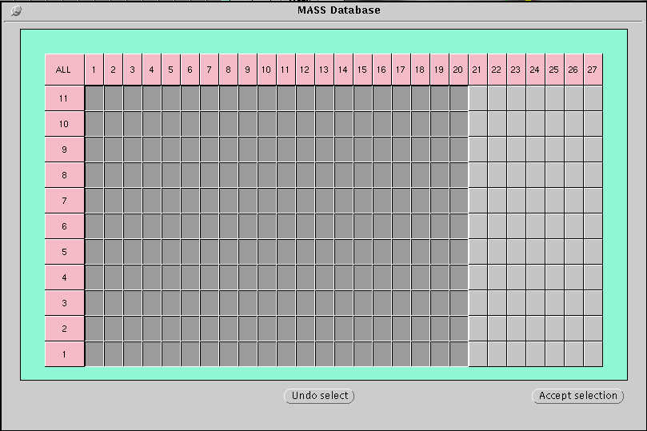

- Click on “Rescan”

• click on “Accept Selection”

Note: If the wrong study is selected, leave the image matrix display in the database popup window by selecting “Undo Selection”

13.3 Creating A Contour

Contours must be completed and saved before performing image analysis.

- Use the “AUTOMATIC CONTOUR DETECTION” for all apical slices.
- Use “MANUAL CONTOUR DETECTION” for all basal slices.

13.3.1 Window Level and Width Settings

• To set the window level and width, click on slice 5 or 6 phase 1( a mid slice) Zoom to 300% to fill the window with the left ventricle.

- Click on the window / level button

13.3.2 Contour Default Colors

• Left Ventricular Endocardial Contour (Red)
• Left Ventricular Epicardial Contour (Green)

Note: Use the space bar on the keyboard to switch the active contour between endo- and epicardial contours.

13.3.3 Contour Detection Settings

• From the Contour Detection menu select “Selection”
• Choose “Epi and Endo” contours
• Choose “Study View”
• Close

13.4 Performing Contour Detection

• From “Mode” click on Point mode

• From “Element” click on Epicardial Element.

• Start on slice 1 check for evidence of heart muscle, if no
heart muscle is visible, go to slice 2

13.4.1 Slice 1 Checking for Heart Muscle

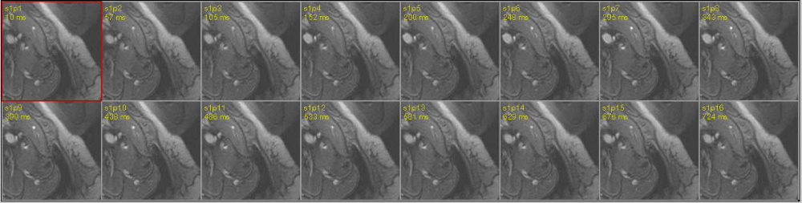

• On slice 2 phase 1 begin drawing the epicardial contours

• Click approximately 7 - 10 points around the ventricle.

13.4.2 (7 - 10) Reference Points Around Ventricle for Automatic Contour Detection

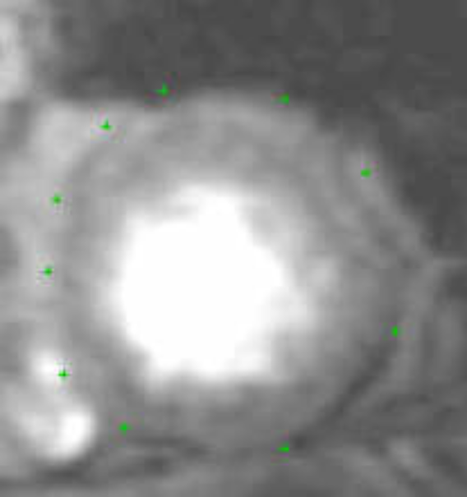
• Click on “Contour Detection”

• There will be slices that do not have endocardium, present. The MASS program determines the absence of endocardial pixel values and eliminates the calculation of the endocardial contours.

13.4.3 Resulting Contours - Apical Slice Where Endo is Not Always Present

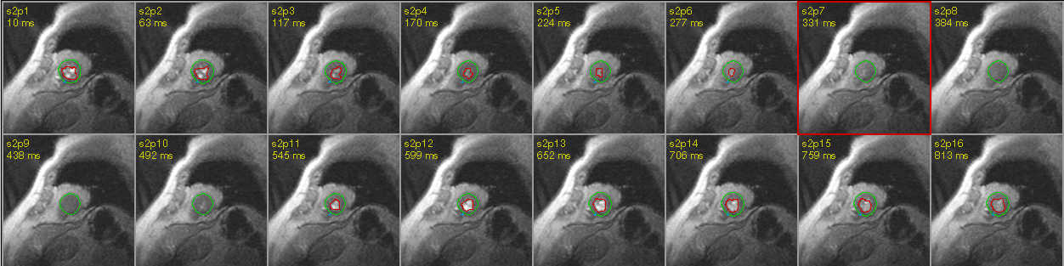

- Check images to make sure the contour encapsulates the heart muscle.

13.4.4 Contour That Needs Manual Editing

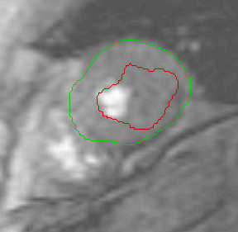

- To manually edit incorrect slices go to a slice where the contours look acceptable.

- Select slice 1 phase 1, if contours are acceptable, right click on the mouse, the “edit” dropdown menu appears. Go to “smooth”. This will refine the contour. Go to “accept endo and epi”

- Select slice 1 phase 4, if contours are acceptable, right click on the mouse, the “edit” dropdown menu appears. Go to “accept endo and epi”
- Click on “Contour Detection”. Slices 1 phases 2 & 3 will also be corrected.

13.4.5 Corrected Contour
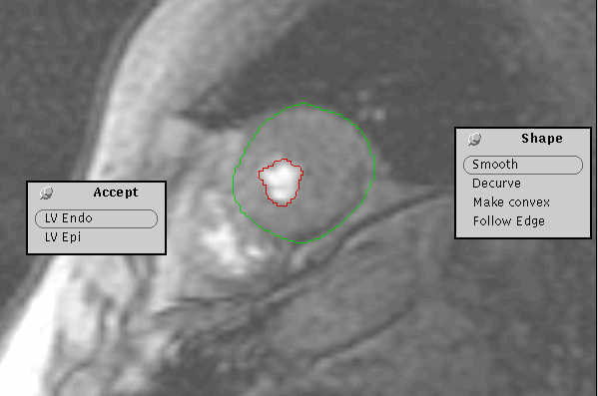

Note: Manually corrected contours are denoted by orange on the contour grid.

• On slice 2 phase 1 begin drawing the reference points for the epicardial contours.

- Click on “Contour Detection”

13.4.6 Slice 2 Contours

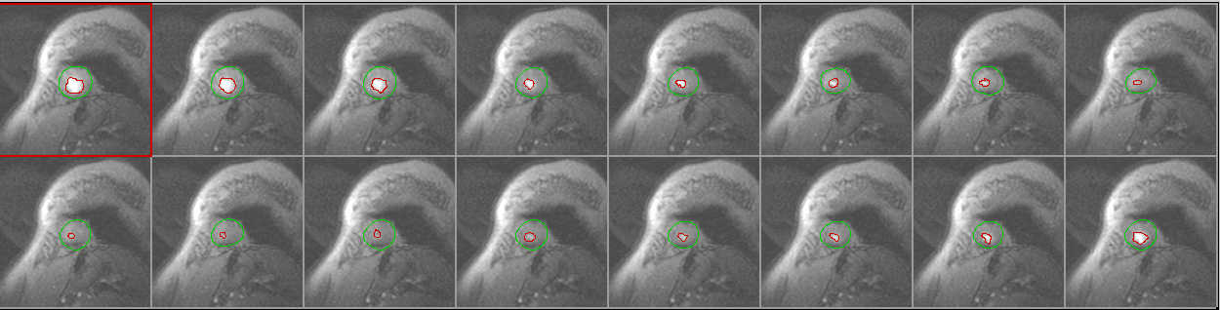

- Go to slice 3

Slice 3 Contours

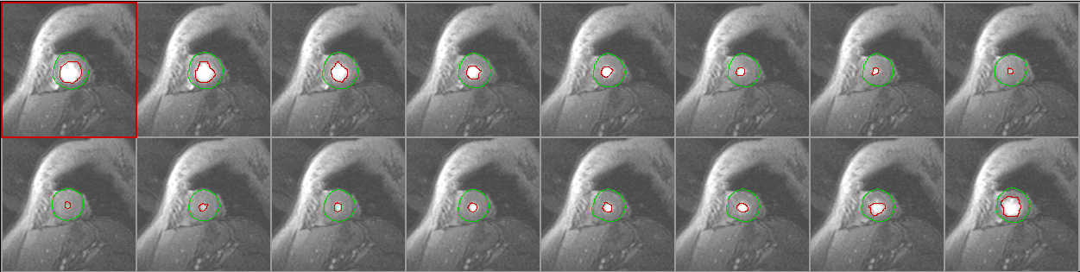

- Check images to make sure the contour encapsulates the heart muscle.

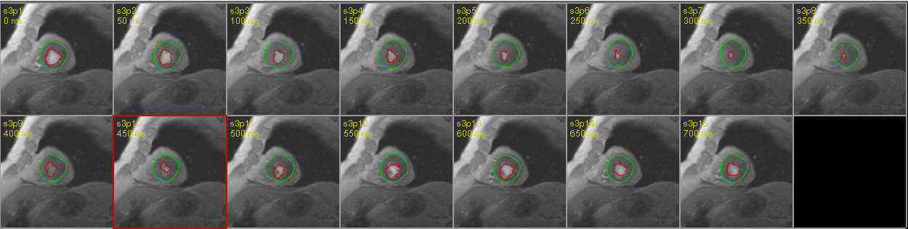

- Go to next slice and repeat the process.

When performing contours on the basal slices edit as follows:

13.4.8 Basal Slice before Manual Contour

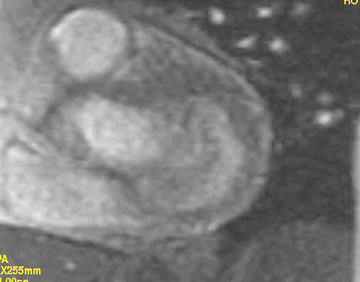

13.4.9 Basal Slice after Manual Contour

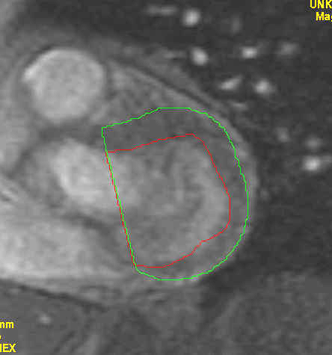

• The end-systolic largest areas of LV chamber determined at each level of the left ventricle. It is always possible to restart contour detection with any additional number of contours already present.

Notes: The contour detection will NOT try to correct or improve any of the existing contours and that it may even use them as models for detecting adjacent contours. Any contours available at the time of starting contour detection must therefore be correct.

13.4.10 Basal Phases Where LV Is Not Always Present

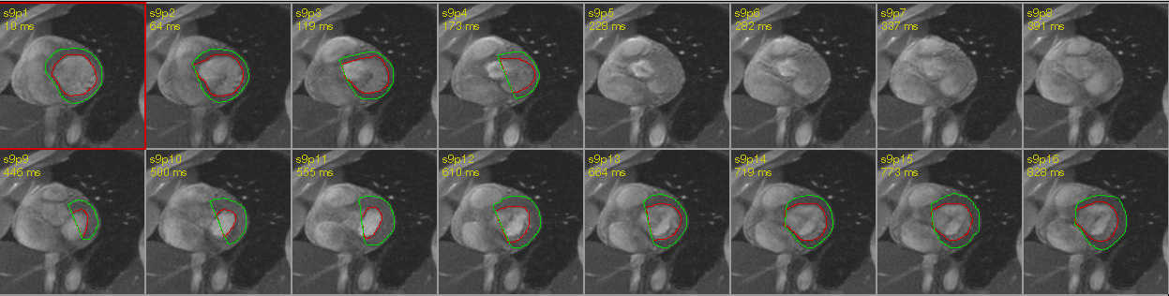

A “stop” button will appear enabling interruption of the contour detection process. Note that it might take a few seconds for the process to react to a stop request.

13.5 Manual Editing Contours / Correction And Accepting

After automated contour detection, it is always necessary to visually inspect the results. An existing contour can be manually edited in both the trace and point modes used for the initial contour drawing. Manual editing will be documented by listing the phase and slice number for each manually edited contour.

- Use a slice or phase movie to review the contours

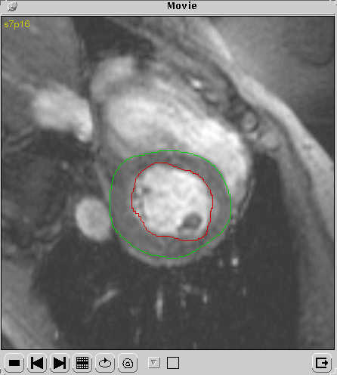

• Edit incorrect contours if errors are small

• Undo - When an edit operation does not produce the desired result, click on the undo button on the tool bar to restore the contour to its previous state.

• Extra Tools - There are three functions available to change the contour’s shape. Select them form the edit/shape menu.

• Smooth - removes only small irregularities
• Decurve - smoothes the most extreme curves
• Make Convex - removes all parts of the contour that point inward using a convex hull calculation

• Delete incorrect contours if editing would be too time consuming

• Contours that are neither edited nor deleted will be considered correct and no further action is required to accept these contours.

Note: When all automatically detected contours have been visually analyzed, contour detection can be performed again. With more correct contours as a reference, the contour detection will probably perform better on the remaining images in this second run.

13.6 Contour State Display

When using automated contour detection, it is important to keep track of the state of each contour. MASS helps by defining four different contour states:

1) Automatic (Red)
2) Edited or Manually Drawn (Orange)
3) Accepted Contour (Green)
4) Contour Loaded from a Contour File (Blue)

13.7 Loaded State

Because contour states are not saved in the contour file, it is impossible to retrieve contour states from a former session. Each loaded contour will therefore always have a special loaded contour state (blue), which does not relate to the certainty of it being correct. The contour detection will, however, use these contours as a model if no accepted or edited contours are available.

13.8 Manual Contour Detection

Note: These modes for contour detection should only be used for the following conditions. Please document the reason and the type of contour performed on the MRI Interpretation form:

• The image quality of the study is very poor causing the automated detection to fail.

Note: If one slice is very poor quality, judged poor quality, do not contour this slice. MASS using the 3D+ algorithm will correct for this "gap" in the data.

• Contours are needed of structures other than the left ventricle. Use the user contour to draw the contours of these structures or the special contour for the right ventricle when appropriate.

13.8.1 Trace Mode

• Click on the “trace button” in the mode setting and select the contour from the element setting.

• When the mouse cursor is moved into the active image view, it will change to a cross shape and the color corresponding to the default color of the selected contour.

• To define the contour, follow the boundary with the mouse cursor while keeping the mouse select button pressed. When the mouse
select button is released; contour tracing ends and the contour will be closed automatically.

13.8.2Point Mode

• Click on the point button in the mode setting and select the contour from the element setting. When the mouse cursor is moved into the active image view, it will become cross-shaped and assume the color corresponding to the default color of the selected contour. To define the contour, single-click the mouse select button with the mouse cursor placed at a position along the boundary. Repeat this procedure for any number of boundary points (at least twice), but keep to either a clockwise or counterclockwise order. To stop defining points and close the contour, double-click the mouse select button for the last point definition.

Note: If only two points are set in point mode, MASS will create a circular contour through those points with its mid-point in between the indicated points.

13.9 Modified Centerline Algorithm

All MASS left ventricular wall parameter calculations are based on the modified Centerline algorithm which needs a reference point along with the endo and epicardial contours. These will be calculated after the centerline reference points have been set in the respective images and both endo and epicardial contours are available. This reference point must be manually positioned if any of these calculations are to be done.

Upon completion of the contours, use the “blue marker point” to determine wall thickness. This is usually done on each automated slice but only on the first phase (and can not be done on manual basal slices.

13.9.1 Auto-Contour Blue Marker Point with Wall Thickness Chords

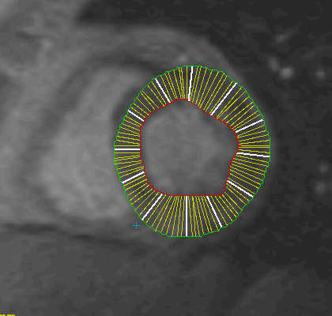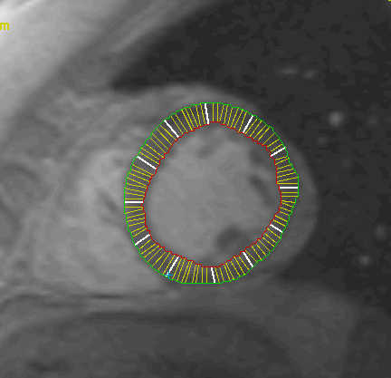

To position the center-line reference point, (CRP) click on the reference point button on the tool bar, move the mouse cursor inside the active image view and single-click the mouse selection button at the preferred position for the CRP. By default, the selected position will be copied to all images in the current slice where no CRP is already present.

Although the user may position the CRP anywhere in the image, the best results are achieved when keeping to the following guidelines:

• Use the internal posterior junction of the RV free wall with interventricular septum to position the CRP.

• Adjust the CRP’s in those images to which they have been automatically copied to follow the movement of the RV-LV junction.

Note: If these guidelines are followed, the algorithms concerned with wall motion/thickening calculations will be able to compensate for left ventricular rotation during the cardiac cycle, and the generated results will therefore be more accurate.

13.10 RC Non-Physician Reader Contour QC

Generate a “temporary report” for verifying accuracy of the contours. Use the set ranges below, if contours are not within the specified ranges, “Repeat the Contours before generating the Final Report”.

- Compare LVED mass and LVES mass. The results are expected to be within 10%
of each other. If not, re-inspect the contours, especially at the base of the heart.

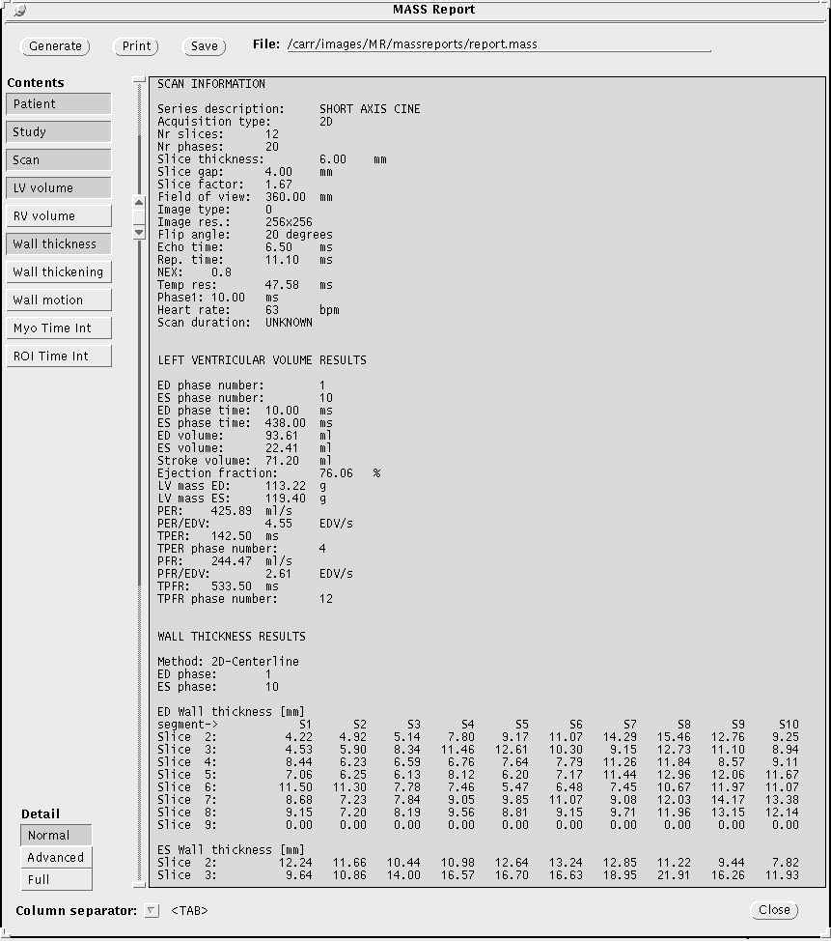

Gender-Related LV parameters*
Ventricular Parameters (mean +/- 1 SD) with 95% Confidence Intervals (1.96 SD)
in Parentheses
Parameter | Males | Females
LV ED volumes (ml) | 136 ± 30 (77 195) | 96 +/- 23 (52 - 141)
RV ED volumes (ml) | 157 ± 35 (88 - 227) | 106 +/- 24 (58 - 154)
LV ES (ml) | 45 ± 14 (19 - 72) | 32 +/- 9 (13 - 51)
RV ES (ml) | 63 ± 20 (23 - 103) | 40 +/- 14 (12 - 68)
IVSM (g) | 61 ± 11 (40 - 82) | 42 +/- 8 (26 - 58)
LVFWM (g) | 117 ± 22 (75 - 159) | 82 +/- 19 (46 - 119)
LVTM (g) | 178 ± 31 (118 - 238) | +/- 26 (75 - 175)
RVFWM (g) | 50 ± 10 (30 - 70) | 40 +/- 8 (24 - 55)
LV EF (%) | 67 ± 5 (56 - 78) | 67 +/- 5 (56 - 78)
RV EF (%) | 60 ± 7 (47 - 74) | 63 +/- 8 (47 - 80)
LVSV (ml) | 92 ± 21 (51 - 33) | 65 +/- 16 (33 - 97)
RVSV (ml) | 95 ± 22 (52 - 138) | 66 +/- 16 (35 - 98)
LVTM/LVEDV (g/ml) | 1.34 ± 0.19 (0.96 - 1.71) | 1.31 +/- 0.16 (0.99 - 1.63)
RVFWM/RVEDV (g/ml) | 0.33 ± 0.06 (0.21 - 0.44) | 0.38 +/- 0.05 (0.28 - 0.48)
LVTM/RVM | 3.64 ± 0.72 (2.23 - 5.04) | 3.17 +/- 0.43 (2.33 - 4.01)
CO (1/min) | 5.8 ± 3.0 (2.82 - 8.82) | 4.3 +/- 0.9 (2.65 - 5.98)

IVSM= interventricular septal mass (septum between areas of RV attachment)
LVTM=left ventricle total mass, including septum (INCLUDING papillary muscles)
RVFWM=right ventricle free wall mass (no septum)

Body surface area calculator: http://www.intmed.mcw.edu/clincalc/body.html

Ventricular Parameters Normalized to BSA (95% Confidence Interval [1.96 SD] in Parentheses)
Parameter | Males | Females
LV ED volume/BSA (ml/m2) | 69 ± 11 (47-92) | 61 +/- 10 (41 - 81)
RV ED volume/BSA (ml/m2) | 80 ± 13 (55 - 105) | 67 +/- 10 (48 - 87)
LVTM/BSA (g/m2) | 91 ± 11 (70 - 113) | 79 +/- 8 (63 - 95)
LVFWM/BSA (g/m2) | 60 ± 8 (44 - 76) | 52 +/- 6 (40 - 64)
IVSM/BSA (g/m2) | 31 ± 4 (23 - 39) | 27 +/- 4 (20 - 34)
RVFWM/BSA (g/m2) | 26 ± 5 (16 - 36) | 25 +/- 4 (18 - 33)
LVSV/BSA (ml/m2) | 47 ± 8 (32 - 62) | 41 +/- 8 (26 - 56)
RVSV/BSA (ml/m2) | 48 ± 8 (32 - 64) | 42 +/- 8 (27 - 57)
CO/BSA (1/min/m2) | 3.0 ± 0.6 (1.74 – 4.20) | 2.8 +/- 0.5 (1.75 – 3.80)

Ventricular Parameters Normalized to Weight (95% Confidence Interval in Parentheses)
Parameter | Males | Females
LV ED volume/WT(ml/m2) | 1.8 ± 0.3 (1.2-2.3) | 1.8 ± 0.2 (1.2 – 2.4)
RV ED volume/WT (ml/kg) | 2.0 ± 0.3 (1.5 – 2.6) | 2.0 ± 0.3 (1.3 – 2.6)
LVTM/WT (g/kg) | 2.4 ± 0.3 (1.9 – 3/.0) | 2.3 ± 0.3 (1.8 – 2.8)
LVFWM/WT (g/kg) | 1.6 ± 0.2 (1.2 – 2.0) | 1.5 ± 0.2 (1.2 – 1.9)
IVSM/WT (g/kg) | 0.8 ± 0.1 (0.6 – 1.0) | 0.8 ± 0.1 (0.5 – 1.0)
RVFWM/WT (g/kg) | 0.7 ± 0.1 (0.5 – 0.9) | 0.7 ± 0.1 (0.5 – 1.0)
LVSV/WT (ml/kg) | 1.2 ± 0.2 (0.8 – 1.6) | 1.2 ± 0.2 (0.7 – 1.7)
RVSV/WT (ml/kg) | 1.2 ± 0.2 (0.8 – 1.6) | 1.2 ± 0.2 (0.8 – 1.7)
*Lorenz, C.H. et al. Normal human right and left ventricular mass, systolic function, and gender differences by cine magnetic resonance imaging. J Cardiovasc
Magnetic Resonance 1999: 1(1); 7-21

Normal Cardiac Parameters

Left Ventricle Mean ± S.D. Range (2 S.D.)

End diastolic volume 68.9 ± 13.1 ml/m2 (42.7 - 95.1)
End-systolic volume 27.1 ± 7.8 ml/m2 (11.5 - 42.7)
Stoke volume 41.8 ± 10.9 ml/m2 (20 - 63.6)
Ejection fraction 60 ± 11% (38 - 82)
Mass (includes septum) 91.6 ± 3.2 g/m2 (85.2 - 98.0)

References

Ref: Boxt, L. Radiographics 1999; 19:1009-1025
Katz et al. J Am Coll Cardiol 1993; 21:1475-1481
Boxt, L, et al. J Am Coll Cardiol 1992; 19:1508-1515

13.11 Saving Reports and Contours

Saving Reports

• After verification that the report is correct, under “views” click on “save”

- The directory should read: carr/images/MR/3D*massreports/

Example: carr/images/MR/3D*massreports/123456_091200a.rep

Click on the “save” button.

Saving Contours

• Click on “save contours as” from the database menu using the right mouse button. The “saved contours” as pop-up window will appear.

- The directory should read: carr/images/MR/masscontours/

Example: carr/images/MR/masscontours/123456_091200a.con
Example: carr/images/MR/masscontours/123456_091200k.con

Click on the “save” button.

13.12 LOADING CONTOURS

- Select the appropriate study. The study ID and loaded contours ID must be the same, otherwise loaded contours may be loaded onto the incorrect study resulting in incorrect data.

• To load a set of contours, click on “Load Contours” from the database menu.

• The load contours pop-up window appears. A list of files and directories is shown in the window. When a default contour file exists, it is preselected; otherwise a manual selection must be made by clicking on the appropriate file name. Any contour file can be selected. A warning will appear when an attempt is made to load contours that do not belong to the current study.

13.13 Results Calculation Algorithms

Volume Calculations are done only on those slices where (endocardial) contours are available. The complete blood-pool volume can only be calculated when endocardial contours exist for the complete ventricle

Wall Motion for the active image is calculated using the Centerline method on the endocardial contours of the active image and the ED image. Before applying the Centerline calculation, the contour in the active image is translated and rotated to compensate for non-radial movement.

14.0 FLOW ANALYTICAL SOFTWARE v4.0 (MEDIS, THE NETHERLANDS)

Aorta -Borders of the vessel lumen will be detected using an edge detection algorithm on the magnitude-reconstructed data. The area of the lumen will be calculated for each slice and time point. This ROI will be used to segment the vessel lumen in the corresponding phase images.

Stroke Volume and Cardiac Output
Measurement outputs are directly available from the software program FLOW.

14.1 Creating A Flow Contour

AUTOMATIC CONTOUR DETECTION- Contours must be completed and saved before performing image analysis. All contours for MESA will be performed using the automatic contour detection unless indicated otherwise on the interpretation form.

14.2 Window Level and Width Settings

• to set the window level and width, click on an image. Click on the contrast/brightness icon and adjust using the settings.

Contrast will be set to 100%

Brightness will be set from 50 to 65%

14.3 Study Selection

• With the left mouse button, click on the
“Database Button”

• from the pull down menu choose “select study”

• select the first study from your assigned list of studies by highlighting the name and clicking on “select” button at the bottom of the database pop-up window. By default, all images will be loaded.

- Select the blood pressure series (axial phase contrast ), the images will load automatically.

• click on “Accept Selection”

Note: If the wrong study is selected, leave the image matrix display in the database popup window by selecting “Undo Selection”

14.4 Automatic Contour Detection

Three methods of detection are offered in this popup window, which are selected from the “Method” selection.

Select the following options:
Model: Closest
Which: Missing
Method: Motion
Max Motion: 10

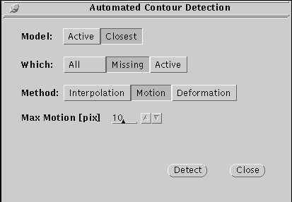

Note: Detection algorithm takes the model contour and tries to position it in the target image such that as much flow containing pixels as possible are within it. All detected contours have the original model contours shape. This method is good for following a moving vessel in time. For each of these methods, the ‘Which’ selection determines in which image (s) contours should be detected. This can be the current image (‘Active’), the images without contours (‘Missing’) or all images regardless of existing contours (‘All’)

For the Motion and deformation detection algorithms, a model contour should also be selected from the model selection. A model is used as an example for the contour detection and should be a contour, which is likely to resemble the contour (s), that need to be detected. Options are to select the current image contour as a model (‘Active’), or the contour nearest in time to the one to be detected (‘Closest’). You may re-detect a contour, which is already there in which case the closest contour is the old contour in the target image.

In order to give FLOW an indication where to start the automated detection, one center point of a vessel should be indicated. This should preferably be done at the image phase with the highest blood flow within the vessel.

• First, indicate a midpoint in Aorta using the “ROI 1” tool (red) in the object selection. Select the “Detection” button on the FLOW menu bar.

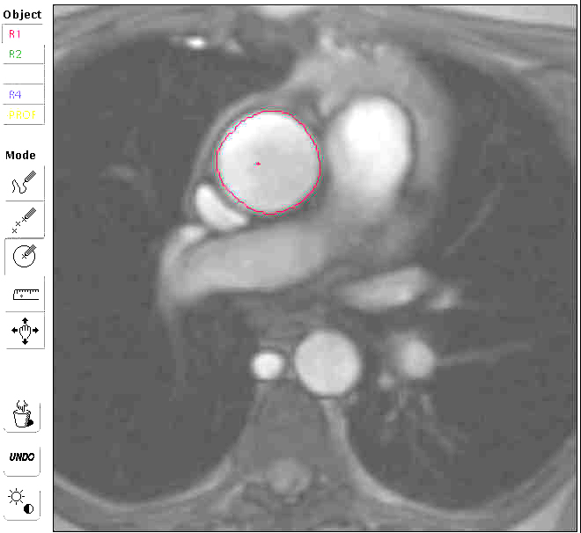

• An initial contour will then be detected. You are then given the opportunity to correct this contour until it is satisfactory. When you are finished editing the contour, select the “Detection” button again, and contours will be detected in all images.

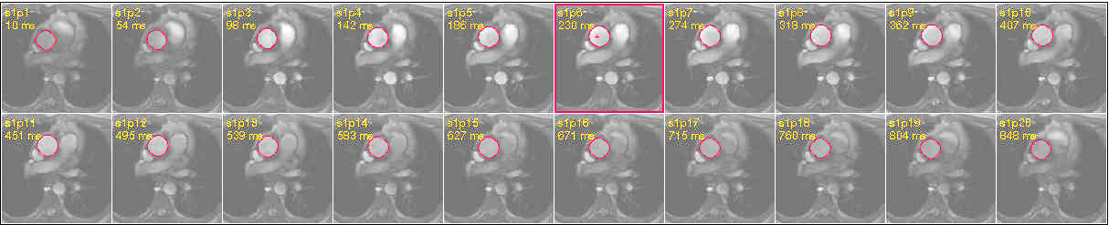

- Using “ROI 4” tool (blue), on the background of the image on the left, trace a circle resembling the detection used on the aorta. This circle must be drawn within the cavity.

- Left click on the “Settings” menu and select the “Background Subtraction” option. From the drop down menu, choose “ROI 4 area”. This will subtract any noise or movement on the images.

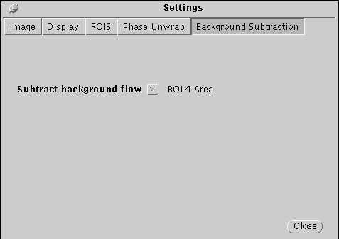

- Using the right mouse button, click on the “paste to all” option. ROI 4 tracing will appear on all the images

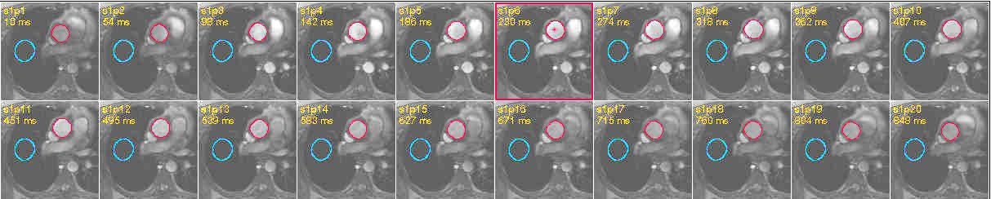

- From the views menu, select and generate a report.

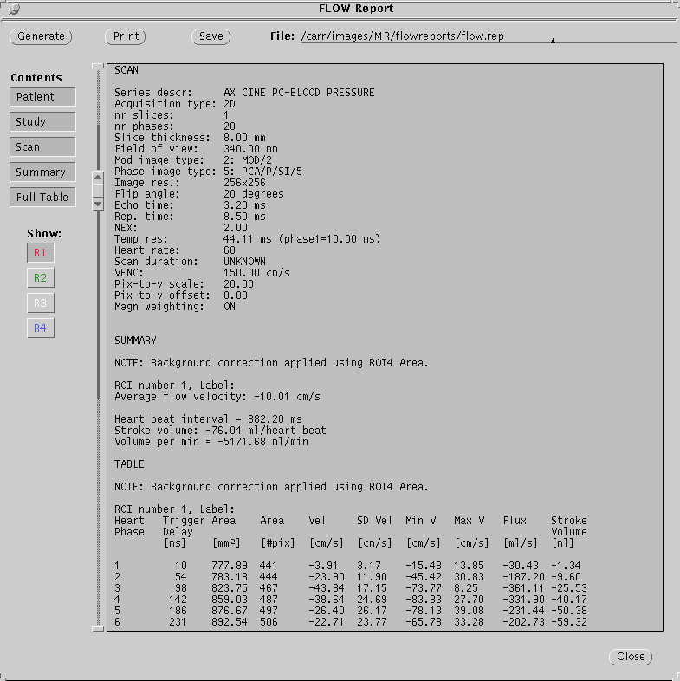

14.5 Detecting the FLOW Contour

- When the appropriate detection method with its associated settings, model contour and target contours are selected, press the “Detect” button on the popup window to perform the detection.

Note: If the detection from only a midpoint produces less than optimal results, it is also possible to draw a complete initial vessel contour in any image.

14.6 Manual Contour Detection

Use these modes for contour detection only for the following conditions. Please document the reason and the type of contour performed on the MRI Interpretation form:

• The image quality of the study is very poor causing the automated detection to fail.

Trace Mode- click on the trace icon in the mode selection and select the contour from the object selection. When the mouse cursor is moved into the active image viewport, it will change to a thin cross shape and the color corresponding to the color of the selected contour. To define the contour, follow the vessel boundary with the mouse cursor while keeping the mouse select button pressed. When the mouse select button is released, contour tracing ends and the contour will be closed automatically.

Point Mode - click on the point icon in the mode selection and select the contour from the object selection. When the mouse cursor is moved into the active image view, it will change into a thick cross and assume the color corresponding to the color of the selected contour. To define the contour, single-click the mouse select button with the mouse cursor placed at a position along the boundary. Repeat this procedure for any number of boundary points (at least twice), but keep to either a clockwise or counterclockwise order. To stop defining points and close the contour, double-click the mouse sect button for the last point definition.

Note: To create a circular contour, select point mode and indicate only two boundary points on opposite sides of the vessel circumference.

14.7 Saving Reports and Contours

Saving Reports

• After verification that the report is correct, under “views” click on “save”

- The directory should read: carr/images/MR/flowreports/

Example: carr/images/MR/flowreports/123456_091200a.rep
carr/images/MR/flowreports/123456_091200k.rep

Click on the “save” button.

Saving Contours

• Click on “save contours as” from the database menu using the right mouse button. The “saved contours” as pop-up window will appear.

- The directory should read: carr/images/MR/flowcontours/

Example: carr/images/MR/flowcontours/123456_091200a.con

Click on the “save” button.

15.0 QUALITATIVE CINE ANALYSIS

The adjudication panel consisting of (1-2) senior fellows in the Noninvasive Cardiology Fellowship program will visually assess left ventricular wall motion. Requirements for fellow participation will be 6 months basic training in the echocardiography laboratory, and 6 month advanced training. The readers will view MRI images using a multi-section cine viewer developed in our cardiac MRI laboratory. Systolic function will be based on the American Society of Echocardiography standards.

15.1 Left Ventricular Wall Motion

Note: Do not continue running the movie while performing other processing, it slows processing speed.

• Using the slider below, set frame speed to 20 frames/second
• From the main menu bar select “Movie” button
• To start the movie, click on the start button
• To stop it, click on the stop button

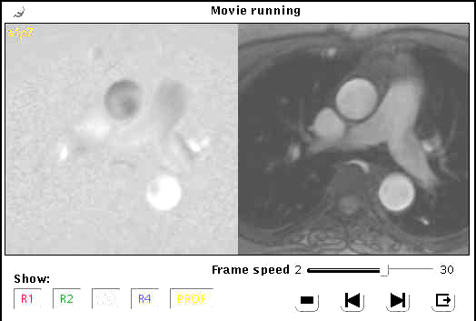

The left ventricle is divided into 16 segments, grade each segment using the guidelines below:

1=normal
2=mild hypokinesis
3=severe hypokinesis
4=akineses
5=dyskinesis

16.0 ALERT STATUS CATEGORIES

The MR Reading Center physician will record the participant’s alert
status on the MR qualitative analysis form at the time of image interpretation.
The project manager will record the alert result in the MESA interpretation database. There are two levels of alert status that correlate, the "Referral Status" and the "Physician Alert Codes". During the qualitative analysis, the physician uses the following guidelines to determine the alert status.

Alert Guidelines:
Abnormal values Urgent values
(≥11 mm female,
LV hypertrophy (check) _____min. ≥12 mm male) ___mod. (≥15 mm) ___marked ≥20mm urgent*
Aneurysm (size, mm) _____mm (≥40 mm) ≥50mm urgent*
Pericardial effusion (mm) _____mm (≥ 5 mm) ≥15 mm urgent*
Lung mass (mm) Rt / Lt _____mm urgent*
Mediastinal mass/node _______________________ any mass, urgent*
Bone/soft tissue _______________________ any potential malignant mass, urgent*
Other (short statement) ______________________________________

Referral Status Database Codes Physician Alert Codes

No referral - 1 0 = Normal
Abnormal referral required - 2 2 = Abnormal
Urgent referral required- 3 3 = Urgent referral

16.1 Normal

Example of database codes:

Referral Status: No referral - 1
Physician Alert Codes 0 = Normal

- No clinically significant findings

• Cardiac function parameters: < 2 measures beyond 2 standard deviations of normal

• Findings which either (1) do not require further medical evaluation, or (2) if the subject is interested in discussing these findings with a physician, do not require medical consultation in an urgent (weeks) or immediate (days) time frame.

16.2 Abnormal

Example of database codes:

Referral Status: Abnormal referral required - 2
Physician Alert Codes 2 = Abnormal

• Abnormality which may require medical evaluation as deemed by the participant's physician.

- Findings which either (1) require further medical evaluation, or (2) the participant should be made aware of the finings so they may discuss these findings with a physician.

• The Reading Center physician will type a brief
description of the findings in the database field physician alert description.
This information will be transmitted to the Coordinating Center.
Abnormal values
(≥11 mm female,
LV hypertrophy (check) _____min. ≥12 mm male) ___mod. (≥15 mm)
Aneurysm (size, mm) _____mm (≥40 mm)
Pericardial effusion (mm) _____mm (≥ 5 mm)

16.3 Urgent Referral

Example of database codes:

Referral Status: Urgent referral required - 3
Physician Alert Codes 3 = Urgent referral

• Requires direct referral to a hospital or clinic

• Abnormality which requires immediate medical evaluation, typically within one to
several days following the MRI examination

• Phone call and written report to field center required (attachment 5)

• If the alert had previously been handled at the
Field Center (see below), then no further action is
necessary.

• If the alert had not been triggered at the Field
Center the Coordinator will contact the MESA
participant and the referring physician.
Arrangements for further medical
evaluation will be made through discussions
involving the MESA participant, referring physician,
Field Center coordinator and the Reading Center
radiologist.

Immediate values

LV hypertrophy (check) ___marked ≥20mm urgent*
Aneurysm (size, mm) _____mm ≥50mm urgent*
Pericardial effusion (mm) _____mm ≥15 mm urgent*
Lung mass (mm) _____mm urgent* Rt / Lt
Mediastinal mass/node _______________________ any mass, urgent*
Bone/soft tissue _______________________ any potential malignant mass, urgent*
Other (short statement) ______________________________________

Alerts identified during a quality control reading will be handled in the following manner:

• The Reading Center will first determine if an alert was reported on the original reading. If the alert is identical to the one previously reported, no alert letter for the QC interpretation will be sent. If the alert was not reported on the original interpretation, the Principal Investigator will review the case. The Field Center and Coordinating Center will be contacted by telephone and an alert letter will be generated.

Further description of the MESA reporting procedures and alert system are contained in the MESA MR Field Center Manual.

16.4 Communication of results by RC to FC

• The MR Reading Center will send the participant's MR results data
file to the Coordinating Center by electronic mail.

• The participants MRI result letters will be determined by the physician alert description and the referral status derived from the MESA MR database.

• The Coordinating Center will in turn send the MR results to
the respective Field Center by electronic mail and each Field Center will generate theparticipant's
results letters according to the data received from the Coordinating Center. (Attachment 6)

17.0 Attachments

17.1 Attachment 1

MASS DEFAULT SETTINGS

Display Settings
The following settings should be activated:

Endocardial Contour
Papillary Contour
RV Contour
Midpoint
Epicardial Contour
Papillary Contour
User Contour
Center Line
Show Patient Name

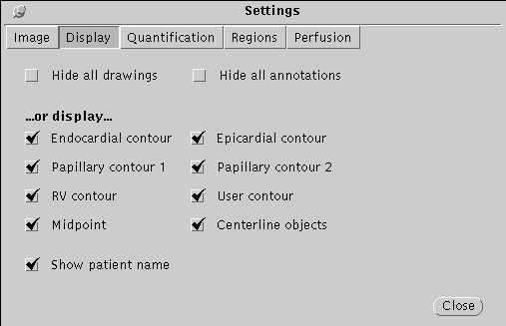

Quantification
The following settings should be activated:

LV ED/Ref Phase - Vmax Phase

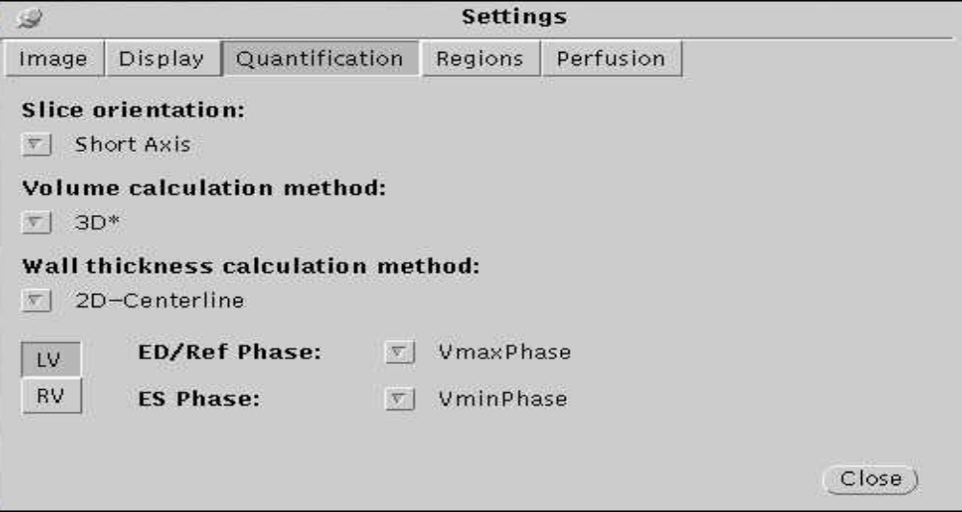

Regions
The following settings should be activated:

NR Segments (12)

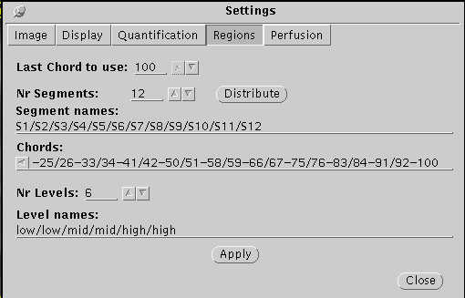

Perfusion
The following settings should be activated:

Epi 0 Endo100

Calibration - Divide by baseline value

NR Fitting Points (5)

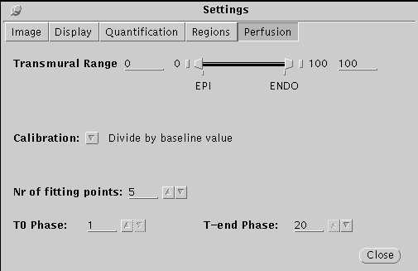

Contour Settings

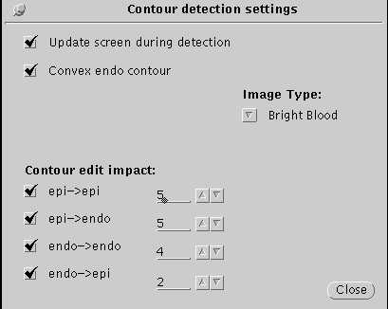

17.2 Attachment 2

Field Center Report - Data Received

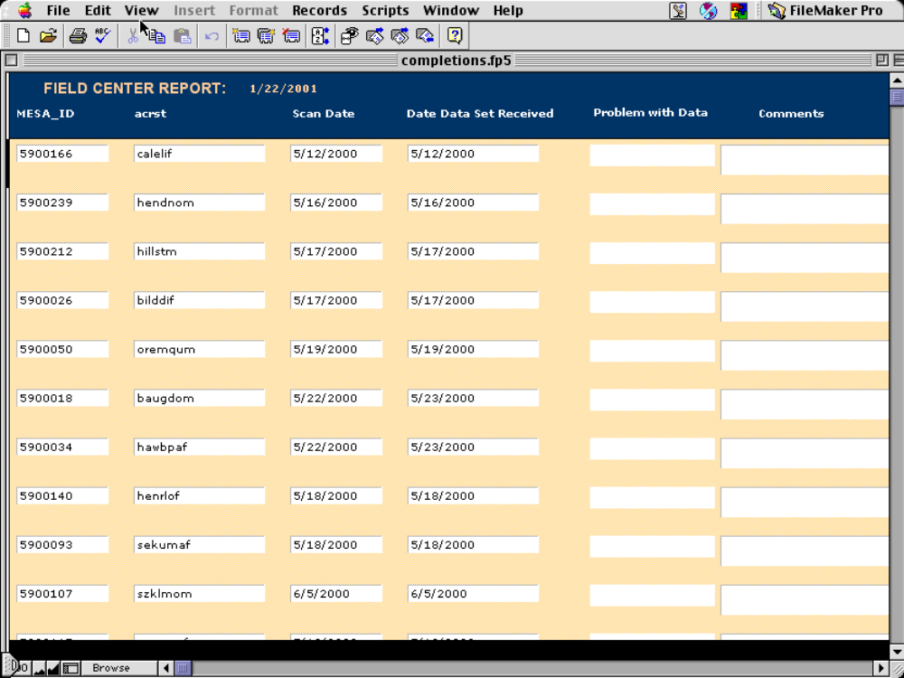

17.3 Attachment 3

Qualitative Interpretation Form

Adjudicated Cardiac MR Interpretation
MESA ID: ________________Scan Date:__________
Interpretation date: ____________________________
- Image assessment:
Note: If other than 1, please indicate reason in the space provided.
Adhered to protocol? 1 2 3_____________________
Image quality 1 2 2_____________________ (1=good, 2=minimally adequate, 3=inadequate)

2. Comments for Linda Wilkins re: attached data sheet:

3. Indicate number of interpretable short axis slices: (a=apex,m=mid,b=base)
4 5 6 7 8 9 10
AA AA AA AAA AAA AAA AAAA
M MM MM MM MMM MMM MMM
B B BB BB BB BBB BBB

4. Score the wall motion on the diagrams:
0 = not visualized
1 = normal systolic wall thickening > 40%
2 = hypokinesis systolic wall thickening < 30%
3 = akinesis systolic wall thickening < 10%
4 = dyskinesis myocardial segment moves outward during systole
5 = aneurysm persistent bulge in diastole

normal wall motion (check if applicable): ___________

5. Indicate global score: (if not normal) minimal / moderate / severe dysfunction

6. Indicate alerts Abnormal values Urgent values
(≥11 mm female,
LV hypertrophy (check) _____mild ≥12 mm male) ___mod. (≥15 mm) ___marked ≥20mm urgent*
Aortic Dilatation (size, mm) _____mm (≥40 mm) ≥50mm urgent*
Pericardial effusion (mm) _____mm (≥ 5 mm) ≥10 mm urgent*
Lung mass (mm) Rt / Lt _____mm urgent*
Mediastinal mass/node _______________________ any mass, urgent*
Bone/soft tissue _______________________ any potential malignant mass, urgent*
Other (short statement) ______________________________________
(do not repeat the above) ______________________________________
Impression
0=Normal 2=Abnormal 3=Immediate referral Alert*
(Circle) (“normal” CC letter) (“abnormal” CC letter) (MR RC letter, phone call)
*M.D. must attach Alert letter

Readers: DB JL BG KW _______ (circle only 2)
Revised February 15, 2001

17.4 Attachment 4

Physicians Data Sheet View
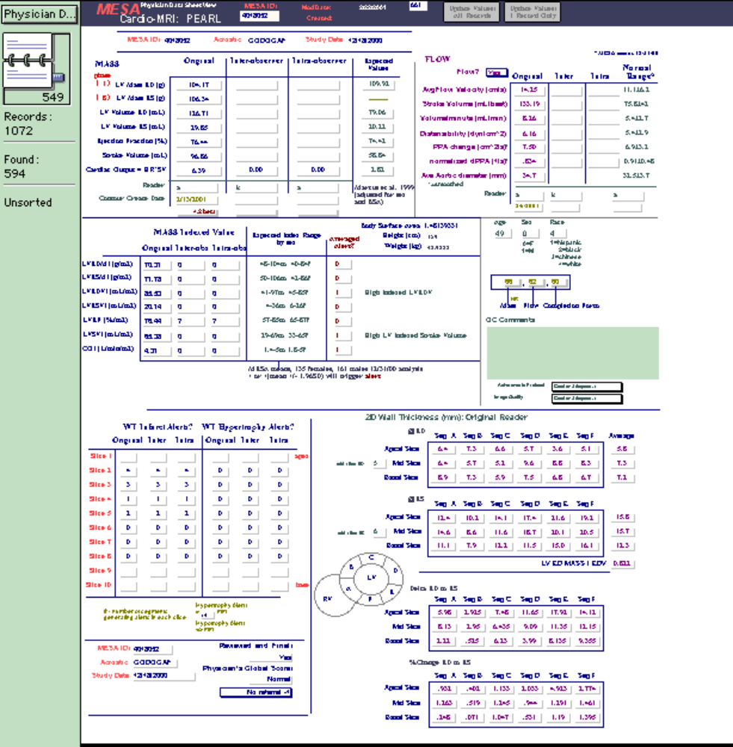

Attachment 5

Example of Alert Letter

Mohammed Saad, M.D.
Division of Endocrinology
UCLA School of Medicine
924 Westwood Blvd., Suite 335
(Mail Box 15)
Los Angeles, CA 90024

September 19, 2000

Dear Dr. Saad:

For your records and information, the MRI on MESA participant 8015015 dated 8/30/00 demonstrates moderate left ventricular hypertrophy and moderate global left ventricular dysfunction with septal akinesis.

MRI Results
LV Mass ED (g) | 209.6
LV Volume ED (mL) | 181.8
LV Volume ES (mL) | 118.0
Ejection Fraction(%) | 35.0

 | Mass Indexed Value  Body Surface Area | Expected Index Range by sex
 |  | Male | Female
LV Mass ED (g) | 105.9 | 48 -104 | 40 - 84
LV Volume ED (mL) | 91.9 | 50 - 106 | 42 - 86
LV Volumes ES (mL) | 59.6 | 4 - 36 | 6 - 26

Sincerely yours,

David Bluemke, M.D., Ph.D.
MESA MRI Reading Center

Cc: Antoinette Gomes, M.D.
Sujata Jinagouda
Coordinating Center

Attachment 6

Examples of Results Letters

Clinic Report

Date
Name

Dear Mr./Ms. _____________,

We truly appreciate your participation in the Multi-Ethnic Study of Atherosclerosis (MESA). The time you spent volunteering will help improve our understanding of heart disease and methods of its diagnosis and prevention. The purpose of this letter is to provide you with some of the results of your examination. We will be sending you two additional reports, one on your blood tests and the electrocardiogram (EKG), and the other on the scans (CT scan, MRI, and ultrasound) when these results become available.

Weight:_________lb. Height:______ ft.____in

Body Mass Index:_________kg/m²

Please note that a body mass index of 25 kg/m² or greater is considered overweight.

Blood Pressure:_____/_____ mmHg

These values indicate that your blood pressure is:

_____ Normal (systolic below130 and diastolic below 85 mmHg)
Please Recheck your blood pressure in two years

_____ High Normal (systolic 130-139 or diastolic 85-89 mmHg)
Please Recheck your blood pressure in one year

_____ Hypertension, Stage I (systolic 140-159 or diastolic 90-99 mmHg)
Please have your doctor check your blood pressure in the next few weeks

_____ Hypertension, Stage 2 or 3 (systolic above159 or diastolic above 99)
Please have your doctor check your blood pressure sin two weeks

If you are taking blood pressure medications, please do not stop taking them or change them without your doctor’s advice.

If you have any questions about these results, please contact_______ at __________.

_______________
Study Coordinator

Letter for Participant
(Clinic and Lab Results)

Date

Name
Address

Dear Mr./Ms. _____________,

Thank you again for your participation in the Multi-Ethnic Study of Atherosclerosis (MESA). We appreciate your efforts to help improve our understanding of heart disease and how to prevent it. We are providing the results of some of the blood tests, the ankle-arm index, and the electrocardiogram (EKG) which were done during the MESA examination on ___________. A report on the results of your scans (CT scan, MRI, ultrasound) will be sent later.

Your fasting plasma glucose was ______ mg/dl which (choose one of the following):

- is normal (<110)
- is mildly elevated but not in the diabetic range (110-125)
- is in the diabetic range (>125). This result should be discussed with your physician
- indicates that your diabetes is controlled (if diabetic and fasting glucose <140)
- indicates that your diabetes is not well controlled (if diabetic and fasting glucose 140-200)
- indicates that your diabetes is out of control (if diabetic and fasting glucose>200) and should see your doctor soon.

Your cholesterol level was _______ mg/dl, which is (choose one):

- normal (<200)
- borderline elevated (200-239)
- elevated (>239)
- controlled by medications (if cholesterol<200 and subject on hypocholesterolemic agent
- not controlled by medications (if cholesterol>=200 and subject on hypocholesterolemic agent).

Your triglycerides level (a blood fat) was ______. A value less than 200 mg/dl is recommended.

Your creatinine level which reflects kidney function was ___ mg/dl which is normal (<1.5)/ elevated (=>1.5) and should be discussed with your physician.

Your heart tracing (EKG) was normal/ shows some findings that could be discussed with your physician.

The Ankle/Brachial Index (ankle blood pressure divided by arm blood pressure) was ______ in the right leg and _______ in the left leg. A value less than 0.8 could indicate the presence of atherosclerosis (hardening) in the leg arteries and should be discussed with your physician.

If you requested it, a copy of the EKG, along with the laboratory results has been sent to your doctor. Otherwise, you may wish to take this letter with you when your visit your doctor.

If you have any questions, please call <program coordinator> at <phone number>.
Again, thank you for your participation in MESA.

Sincerely,

Principal Investigator

Enclosures ( )

Letter for Physician
(Clinic and Lab Results)

Date

Doctor Name
Doctor Address

Dear Dr. ___________:

Your patient, Mr./Ms. ______________ (Date of Birth:______________) is a participant in the Multi-Ethnic Study of Atherosclerosis Study (MESA), an epidemiologic study of subclinical cardiovascular disease and risk factors. He/She volunteered for an examination during <month> of <year>. Enclosed is a copy of the letter sent to Mr./Ms. __________ describing some of the examination results. We are also enclosing a copy of the EKG along with the laboratory results obtained during the examination for his/her file. If you have any questions, please contact <program coordinator> at <phone number>. Thank you.

Sincerely,

Principal Investigator

Enclosures ( )

MESA Laboratory Results

MESA #:____________

Name:

Date of Birth:

Examination Date:______________

Reference Range
Plasma Glucose (fasting) :___________ mg/dl .......................

Serum Cholesterol :___________ mg/dl .......................

LDL-Cholesterol :____________ mg/dl .......................

HDL-Cholesterol :____________ mg/dl .......................

Triglycerides :____________ mg/dl .......................

Creatinine :____________ mg/dl .......................

NCEP Recommendations for Lipids

Desirable Borderline High Low

Cholesterol <200 200-239 >=240
LDL-Cholesterol <130 130-159 >=160
Triglycerides <200
HDL-Cholesterol <35

Letter for Participant
(High-tech Procedures)

(Please delete the part pertaining any component [CT, MRI, or US] not done)
Date

Name
Address

Dear Mr./Ms. _____________,

Thank you again for your participation in the Multi-Ethnic Study of Atherosclerosis (MESA). We appreciate your efforts to help improve our understanding of heart disease and how to prevent it. The purpose of this letter is to provide you with the results from scans you underwent as part of your examination in MESA.

The CT scan of the heart (done on __________) showed that you have a total coronary artery calcium score of ______. The coronary arteries are the vessels that supply blood to the heart. The calcium score indicates the amount of calcium found in the walls of these arteries. Your calcium score indicates that you have some hardening of these arteries. For your age, you have (less than an average amount, an average amount, a greater than average amount) of calcium in your arteries. Everyone, whether he/she has a low or high calcium score, should strive to lead a heart-healthy lifestyle and control any heart-related risk factors that they have (for example, high cholesterol, high blood pressure, and cigarette smoking, among others).
OR
The CT scan of the heart (done on ________) showed that you have a total coronary artery calcium score of zero. The coronary arteries are the vessels that supply blood to the heart. The presence of calcium (that is, a score higher than zero) is correlated with hardening of these arteries. However, a calcium score of zero does not necessarily mean that no hardening of these arteries is present. Everyone, whether he/she has a zero, low or high calcium score, should strive to lead a heart-healthy lifestyle and control any heart-related risk factors that they have (for example, high cholesterol, high blood pressure, and cigarette smoking, among others).

The MRI study of the heart and blood vessels (done on ________) showed that your heart structure and function and your aorta were normal for your age.
OR

The MRI study of the heart and blood vessels (done on _______ ) showed (describe the abnormality in lay language)....................... ..................................................
OR
You did not have the MRI study

The ultrasound study (done on ________) of the carotid arteries (the large blood vessels in your neck) was normal (if Doppler flow velocity <120 cm/sec)

OR

The ultrasound study (done on _________) of the carotid arteries (the large blood vessels in your neck) showed significant (Doppler flow velocity >120 and<250 cm/sec) narrowing (50% or more) in the right/left/both side(s) and suggests the need for further evaluation and possible treatment.

Please note that the above studies were performed as a part of a research study and were done to understand how they may be related to heart disease. They may not be the same as tests done as a part of a patient’s medical care. Nonetheless, we recommend that you discuss any abnormal findings with your doctor. If you requested it, a copy of the results was sent to your doctor. Otherwise, you may wish to take this letter to your doctor.

Once again, we greatly appreciate your continued participation in MESA and look forward to seeing at the next examination. If you have any questions, please call <program coordinator> at <phone number>.

Sincerely,

Principal Investigator

Letter for Physician
(High-tech Results)

(Please delete the part pertaining any component [CT, MRI, or US] not done)

Date

Doctor Name
Doctor Address

Dear Dr. ___________:

Your patient, Mr./Ms. ______________ (Date of Birth____________), is a participant in the Multiethnic Atherosclerosis Study (MESA). He/She volunteered for an examination during <month> of <year>. Enclosed is a copy of the letter sent to Mr./Ms. __________ describing the results of the CT study of coronary calcium, cardiac MRI, and carotid ultrasound. We are also enclosing a summary of these results. Please note that the above studies were performed as a part of a research study to answer certain research questions. They are therefore limited in scope and may not be equivalent to tests done as a part of routine medical care. A report from the American Heart Association on the role of various tests for risk assessment may be of interest to you. This can be found at www….].

If you have any questions, please contact <program coordinator> at <phone number>. Thank you.

Sincerely,

Principal Investigator

Enclosures ( )

MESA Report
(High-Tech Results)

Cardiac Magnetic Resonance Imaging (date)

Left ventricular end diastolic volume ______________

Ejection Fraction ______________

Stroke Volume ______________

Cardiac Output ______________

Left Ventricular Mass ______________

Diameter of Ascending Aorta ______________

No focal wall motion abnormalities are present in the left ventricle

Carotid Ultrasound (date)

Doppler Flow Velocity:

Right Carotid:______________ cm/sec

Left Carotid :_______________ cm/sec

(Values above >120 cm/sec indicate >50% narrowing of carotid artery)

Coronary Computed Tomography (date)

Coronary Calcium Score:______________

17.7 Attachement 7

Mass Ini. Settings

[MAIN]
version=4.2
screen_size=xlarge

[DATABASE]
studypath=/carr/images/MR
contourspath=/carr/images/MR/masscontours
reportpath=/carr/images/MR/3D*massreports
contours.autoload=0
philips.convert3DtoDICOM=0
split_series_if_slices_not_parallel=0

[PRINTER]
papersize=LETTER
;postscript_print_command=lpr -Plaserjet $FILE
text_print_command=lpr $FILE
textprinter=lexmark
postscript_printer=lexmark
;postscript_printer=FILE:/tmp/mass.ps

[DISPLAY]
contrast=55
brightness=55
active_image.overlay=@{4,16}!{ma}@{4,+16}!{mm}@{4,+16}${Ex: }!{ex}@{4,+16}${Se: }!{sn}@{4,+16}${Im: }!{im}@{4,+16}${SP:}!{sp}@{4,+16}${SD:}!{sd}@{4,+16}${DFOV }!{DV}${ mm}@{4,+16}!{hr}${ bpm}@{4,+16}${TD:}!{td}@{4,+16}${Sl:}!{sl}${/}!{ns}@{4,+16}${Ph:}!{ph}${/}!{np}@{4,98%}!{mx}${X}!{my}${/}!{nx}${ NEX}@{4,-16}!{th}${ tck}${/}!{ga}${ sp}@{4,-16}${FOV:}!{fx}${X}!{fy}${mm}@{4,-16}!{rc}@{4,-32}${TE:}!{te}@{4,-16}${TR:}!{tr}@{98%,16}!{in}@{98%,+16}!{na}@{98%,+16}!{sx}@{98%,+16}!{id}@{98%,+16}!{da}@{98%,+16}!{ta}@{98%,+16}${Mag: }!{IZ}@{98%,98%}${Contrast: }!{CO}${ Brightness: }!{BR}@{98%,-16}${WW: }!{WW}${ WL: }!{WL}@{98%,-16}${VY/}!{vy}@{98%,-16}${VX/}!{vx}@{98%,-16}${IP/}!{ip}
active_sequence.overlay=@{4,14}${s}!{sl}${p}!{ph}@{4,+14}!{td}${ ms}
movie.overlay=@{4,14}${s}!{sl}${p}!{ph}
nrgrayvalues=64
movie.window_size=300
movie.window_size.max=800
movie.frame_speed=20
active_image.contour_linethickness=1
active_image.annotation_font=-*-helvetica-bold-r-normal-*-14-*-*-*-*-*-*-*
active_sequence.annotation_font=-*-helvetica-medium-r-normal-*-12-*-*-*-*-*-*-*
movie.annotation_font=-*-helvetica-medium-r-normal-*-12-*-*-*-*-*-*-*
;movie.contour_linethickness=2
annotation_color=7

[REPORT]
show_missing_phases=ON ; valid values ON and OFF
show_missing_slices=ON ; valid values ON and OFF
contents=47 ; this is a binary encoding: 1-> patient, 2->study, 3-> patient+study, etc
column_separator=1 ; 0-><SPACE>, 1-><TAB>, etc

[CONTOUREDITING]
contour_smooth_depth=5
contour_decurve_value=8
edit_impact.epi.epi=5
edit_impact.endo.endo=4
edit_impact.epi.endo=5
edit_impact.endo.epi=2
;autoconnect_rv_lv=ON
;user_contour=rv_epi
;edit_mid_auto=ON
;edit_la_refpoint_auto=ON

[CONTOURDETECTION]
which_contours=endo+epi
which_images=study_view

[QUANTIFICATION]
slice_orientation=short-axis
volume.method=3D* ; 3D / 3D+ / 3D*
wallthickness.method=2D-centerline
chord_numbering=clockwise ; clockwise / counter_clockwise
perfusion.calibration_method=1
perfusion.slope_numpoints=5

[VIEWER3D]
check_slices_parallel=1
use_3D_image_plane_info=0
scene.palette_show=not
palette.bases=4
palette.shades=32
palette.type=standard
scene.axis.axis-mode=cube
scene.axis.lettre-mode=off
scene.axis.lettre-size=30.
scene.axis.minimum=-40. -30. -20.
scene.axis.maximum=80. 60. 40.
scene.axis.reference=40 30 20
;================================================= default settings ====
endo.thickness.min=5.0
endo.thickness.max=25.0
endo.thickening.min=0.0
endo.thickening.max=100.0
endo.motion.min=0.0
endo.motion.max=10.0
epi.thickness.min=5.0
epi.thickness.max=25.0
epi.thickening.min=0.0
epi.thickening.max=100.0
epi.motion.min=0.0
epi.motion.max=10.0

endo.contour=off
endo.contour.shade_mode=depth
endo.contour.color_mode=object
endo.line=off
endo.line.shade_mode=depth
endo.line.color_mode=object
endo.surface=on
endo.surface.shade_mode=depth
endo.surface.color_mode=object

epi.contour=off
epi.contour.shade_mode=depth
epi.contour.color_mode=object
epi.line=on
epi.line.shade_mode=depth
epi.line.color_mode=object
epi.surface=off
epi.surface.shade_mode=depth
epi.surface.color_mode=object

rv.contour=off
rv.contour.shade_mode=depth
rv.contour.color_mode=object
rv.line=off
rv.line.shade_mode=depth
rv.line.color_mode=object
rv.surface=on
rv.surface.shade_mode=depth
rv.surface.color_mode=object

[GRAPH]
;lv_volume.show_current_slice=ON
;lv_volume.show_myo_volume=ON
perfusion.start_at_zero=1
perfusion.set_missing_phases_to_zero=0
myoperfusion.show_bloodpool_signal=1

[BULLSEYE]
motion_min=0.0
motion_max=15.0
thickness_min=5.0
thickness_max=25.0
thickening_min=0.0
thickening_max=120.0
smoothing_factor=5

[REGION]
last_chord=100
num_segments=12
segment_labels=S1/S2/S3/S4/S5/S6/S7/S8/S9/S10/S11/S12
segment_chords=1-8/9-16/17-25/26-33/34-41/42-50/51-58/59-66/67-75/76-83/84-91/92-100
num_levels=6
level_labels=low/low/mid/mid/high/high
num_teritories=3
teritories=LAD/LCX/RCA
teritories.low=LAD/LAD/LAD/LAD
teritories.mid=LAD/LAD/LCX/RCA
teritories.high=LAD/LAD/LCX/RCA

[HELP]
htmlbrowser=/mri/solaris5/netscape/netscape

17.8 Attachment 8

Copywright Permission from the Leiden University

