MULTIETHNIC STUDY OF ATHEROSCLEROSIS

COMPUTED TOMOGRAPHY

MANUAL OF OPERATIONS

EXAM II

November 14, 2003

I. Background and Goals 4
II. Qualifications of Personnel 4
III. Scanning Equipment and Centers 4
IV. Training for Field Center CT Technologists 5
V. Participant Scheduling 5
VI. Scanning Table and Calibration Phantom. 6
VII. Scanning Procedure 6
VIII. Scanner Quality Assurance 8
IX. Alerts 11
X. Data Transmission of Studies 11
XI. Data Flow 12
XII. CT Reading Procedure Operations Manual 22
INTRODUCTION 22

SUBJECT CHOOSER 23
1. Launching The Subject Chooser 23
2. The Subject Chooser Window 23
3. Edit Scoring Defaults 24
BOXING 24
1. Description Of Boxing 24
2. Boxing The Heart 25
3. Identifying The Regions In The Phantom 26
TRACING 26
1. Launching The Tracing Program 26
2. Labeling The Vessels 27
3. Checking The Tracings 28
4. Editing the X’s 28
5. Finish Tracing 28
SCORING 28
1. Launching The Scoring Program 28
2. Checking Lesions 28
3. Quality Assessment Tool 29
4. Auto Archiving (Automatic CD Backup) 30
APPENDIX A: Protocol for Inter-scan, Inter-reader, and Intra-reader Variability 31
1. Interscan Variability: 31
2. Inter-reader Variability: 31
3. Intra-reader Variability: 31
APPENDIX B: Description Of Options In Scoring Defaults Menu 32
APPENDIX C: CD Backup Procedure (Manual) 34
APPENDIX D: How To Make and Test A Test Case 34
XII. Attachments 39
1. Sample Alert Letter 39
2. CT Study Transmission Sheet/ FAX to 310-533-1616 40
3. QA QCT Sheet FAX to 310-533-1616 41
4. MESA CT Reading Center Complete Scan Log 422
5. MESA CT DATA FLOW CHART ……………………………………………………………………43

I. Background and Goals

The Multiethnic Study of Atherosclerosis (MESA) is studying risk factors and measures of cardiovascular disease that relate to progression of subclinical to clinical disease. An integral part of this study is the measurement of coronary artery calcium using either electron beam computed tomography (EBT) or multi-detector sub-second computed tomography (MDCT). Coronary calcium will be assessed in relation to the risk of future cardiac events, and from repeated scans in selected individuals, the progression of coronary calcium will be related to baseline risk factors and risk of future events.

During exam II, approximately 3,350 participants will be scanned among the 6 centers between September 2002 and January 2004.

II. Qualifications of Personnel

Each Field Center has a designated physician to oversee the general performance of CT examination. A reading center investigator will provide the necessary on-site training.

Field Center technologists should have appropriate knowledge of cross-sectional anatomy, physiology, and pathology related to the heart. Technologists must be certifed as RTs in their state. It is recommended that technologists also have at least two years of experience in chest computed tomography. The technologist should also have a basic knowledge of cardiac CT, knowledge of computer software applications, data formatting, and experience with the workstations and data formatting / transmission procedures used.

Each technologist involved in the study should also have a complete understanding of this protocol, be experienced at providing breath-holding instruction, ECG gating, operation of the EBT or MDCT equipment. To ensure quality control, each Field Center should have designated CT technicians who will perform the MESA examinations.

III. Scanning Equipment and Centers

The scanners used will be:

Imatron C-150: Saint Francis Hospital; Roslyn, New York
Imatron C-150: Northwestern University, Chicago, Illinois
Imatron C-150: UCLA School of Medicine, Los Angeles, CA
General Electric LightSpeed: Wake Forest Bowman Grey School of Medicine
Siemens S4+ Volume Zoom: Johns Hopkins Univ. Medical Center, Baltimore
Siemens S4+ Volume Zoom: Univ. of Minnesota Medical Center, Minneapolis
After Spring 2004:
Siemens Sensation 16: Johns Hopkins Univ. Medical Center, Baltimore
Siemens Sensation 16: Univ. of Minnesota Medical Center, Minneapolis
Each center will be responsible for scanning approximately one sixth of the cohort of 3350 individuals. For purposes of increased reliability and quality control, each subject will be scanned twice during each session.

IV. Training for Field Center CT Technologists and Readers.

CT technologists are already trained. There will be a site visit to all sites during the period between September 11, 2002 and January 31, 2003. At this visit, the site visitor will witness at least two MESA participants being scanned. Attention will be paid to factors leading to mis-registration and motion artifact. These are considered partially controllable by the technologists and are important for determining image quality and the accuracy of the data.

Readers (two) will be re-trained by the director of the reading center. A training session involving re-reading of cases for which there was discordance between reads of the same reader or of different readers will be used for re-training. After training, each reader will undergo a certification exam conducted by the reading center director. The following essential elements will comprise this exam:

- Logging on and off of the work station
- Appropriate choosing of subjects
- Boxing and correcting the phantom regions
- Tracing of the major coronary arteries,
including pruning of arterial tree.
- Scoring and editing of lesions
- Editing when necessary the summary of scores.
- Completing the quality assurance menu.

The reader will be scored in each component above as either passed or failed.

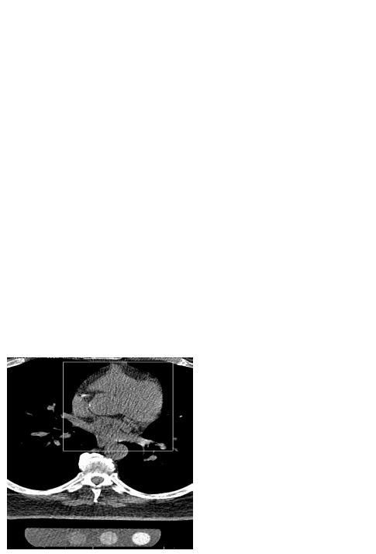V. Participant Scheduling

The MESA operations committee will arrange details of scheduling. Each scanning site will provide their local Field Center with the days/times when MESA participants may be scheduled and the Field Center will contact participants to arrange their appointments for their CT scan. Whether certain days/times will be held for MESA participants only, until 2 weeks or a certain amount of time prior to the day of the appointment will be agreed upon between the scanning center and Field Center.
A Field Center interviewer/scheduler will be responsible for explaining and obtaining consent for the CT examination. Participants will be scheduled for a certain date and time, and transportation arrangements, if necessary, will be arranged by the Field Center interviewer/scheduler. A confirmation appointment letter will be sent, providing the time, date, and directions to the scanning center, and describing the procedure. The CT completion form will be electronically sent to the reading center.

VI. Scanning Table and Calibration Phantom.

A special gel stuffed mat will be provided with the calibration pad phantom to prevent artifacts and for subject comfort. This pad is placed between the phantom and the patient. The calibration phantom will be placed inside the blue catcher bag with its long axis parallel to the long axis of the scanning table. The phantom is made of tissue equivalent plastic with rods of hydroxyapatite of known radiographic density. The technologist will position the subject so that the length of the phantom covers the expected length of the heart. The phantom will be the one pictured on the right.

VII. Scanning Procedure

The scanning procedure described below, consisting of two scans done in succession on each subject, will require approximately 20 minutes of the subject’s time. Minimal respiratory motion and maximum accuracy and reproducibility require this duration. In unusual cases, this may require as many as 30 minutes. In many cases, the procedure will be completed in 15 minutes or less.

Entering the MESA ID and ACROSTIC

This very important step must be done correctly to prevent any irretrievable loss of CT data. All necessary information needs to be entered into the system, including your technician ID number, Field Center identification. The MESA seven digit ID number must be placed in the ID Field, and an acrostic defined below will be placed in the name field. The acrostic will consist of the first four letters of the last name followed by the first two letters of the first name and one letter for the gender. Each will be preceded by the letters “MESA”.
Example:

ID: MESA1212345 NAME: MESADETRROM

The time stamp on each CT record will determine whether the scan is the first or second in the sequence of two scans.

Preparation of the Subject (3 minutes). Subjects weighing more than 300 pounds will not be scanned due to technical difficulties. The technologist will ask women if they might be pregnant and will not scan them if they answer affirmatively. The technologist will attach three electrocardiographic electrodes under the left clavicle and on either side of the thorax near the axillae (to maximize ECG signal). The technologist will ask each subject for their self reported weight in pounds and will use this value to decide if the subject satisfies the “Large Patient” criterion.

Breath Holding Instruction (3 minutes). The technologist will instruct the subject on the importance of breath holding and immobility during scanning. An interpreter will assist in the instruction of subjects, not fluent in English. All centers will have access to interpreters fluent in languages spoken by at least 95 percent of potential volunteers. Our preliminary study suggests that at least 99.5% will be able to hold their breaths for more than 15 seconds and 80% will be able to hold their breaths for more than thirty seconds. Only after the technologist is satisfied that the subject understands the importance of breath holding, will he/she proceed.

Checking the Scout Image (1 minute). The technologist will instruct the subject to take three deep breaths, and then to hold his/her breath (at end-inspiration), while acquiring an 11 cm scout image, beginning 180 mm below the sternal notch. This will provide views of the chest on the image monitor at the operator console. From this, the technologist will check patient centering and choose the position for the highest scan (at the lower margin of the bifurcation of the main pulmonary artery). The couch will be moved to the start position. The technologist will check subject and phantom positioning in the scout image.

Default Scanner Settings. At least 10.5 cm of data in the z direction will be acquired with each scan and the scan Field of View will be 35 cm for all scanners (to incorporate the phantom in the image). For each scanner, the default settings will be as follows:

- GE Light Speed (800msec rotation time) - 120 kVp, 200 mA, .8 sec scan, 4 x 2.5mm collimation, sequential axial scans, segmented reconstruction, standard filter.
- GE Light Speed (500msec rotation time) - 120 kVp, 320 mA, .5 sec scan, 4 x 2.5mm collimation, sequential axial scans, segmented reconstruction, standard filter.
- Siemens Volume Zoom –140 kVp, 50 mAs, (139 mA, .361 sec scan), 4 x 2.5 mm collimation, sequential axial scans with prospective cardiac gating, standard filter reconstruction (as designated on the VZ).
- Siemens Sensation 16. 140 kVp, 50 effective mAs, .5 second/rotation scan time, (139 mA, .361 sec exposure time), 3mm slice thickness using 12 x 1.5 mm collimation, Sequential axial scans with prospective cardiac gating, 35 cm FOV and standard reconstruction filter (B35F HeartView Medium ), ECG triggering would be at 50% of RR.
- Imatron EBT scanners: 130 kVp, 630 mA, scan time 100 msec, 3mm collimation, sharp reconstruction filter. For EBT scans, prospective cardiac gating will be used with scanner triggering at 80% of the electrocardiographic RR interval. The EBT scanner table will pause after each table increment of 3 mm (sequential axial scans) . The technologist will acquire 35 to 40 image slices as needed to ensure that the entire heart is scanned
Large Patient Scanner Settings
For the MDCT scanners only, the mA will be adjusted upwards for larger patients. For patients > 220 lbs, the mA will be increased by 25%. Specifically:

- For General Electric LightSpeed scanner (800msec rotation time): increase to 250 mA. All other parameters are to remain the same.
- For General Electric LightSpeed scanner (500msec rotation time): increase to 400 mA. All other parameters are to remain the same.
- For Siemens Volume Zoom scanners: increase to 174 mA. All other parameters are to remain the same. Note, increase mAs to 63.
- Siemens Sensation 16. 140 kVp, 63 effective mAs, .5 second/rotation scan time, (174 mA, .361 sec exposure time),

Reconstruction The technologist will use the 35 cm field of view and the sharp reconstruction kernel for all EBT scans and 35 cm field of view and the standard kernel for all other scans.

Imaging (6 minutes). All scanning will be done with a single breath hold. The Siemens Volume Zoom helical scan acquisition requires a breath hold for the participant ranging from 15 to 25 seconds depending upon the combination of heart rate and heart length. EBT and General Electric scan acquisition requires a breath hold of between 25 and 40 seconds depending on the same factors. The technologist will always ask the subject to take two deep breaths and then a third before imaging commences.

Though total imaging time will be approximately 30 to 40 seconds, double scanning will require about 5 to 7 minutes to complete. The technologist will first acquire one entire series of image slices. The technologist will instruct the subject to relax on the table while he/she reconstructs and assesses the adequacy of positioning, ECG gating and lack of respiratory motion. If these are adequate, the technologist will immediately acquire another series of image slices while the subject remains immobile and in an identical position.

Identification, Storage and Transport of Image Data. The following will ensure proper scan identification and subject confidentiality. The technologist will record each volunteer’s study id number in the medical record number field of each scan. A seven character acrostic consisting of the subject’s first, middle and last initials and a digit for the field site will be put in the last name field of the header. The date and times of the two scans and the identity of the scanning site and technologist will be identified in the appropriate fields. The technologist will store images in retrievable format on optical disk (MODs). Images will be transferred to a local work station which has an INTERNET interface to be used for transfer to the reading center.

VIII. Scanner Quality Assurance

Discussion of quality assurance is divided into three parts. The first concerns assurance that equivalent brightness levels are used and that brightness adjustment during reading is appropriate. The second involves tracking of scan technique and quality and the third is assessment of reader error and precision.

1. Brightness Levels. Each clinical site will have a QCT calibration phantom and a torso QA phantom (Image Analysis Inc.) containing a central plug with a known concentration of hydroxyapatite (100mg/cc). Every month, quality assurance scans of the torso phantom allow convenient and quick verification of equivalence of brightness adjusted densities for the CT scanners at different sites.

Procedure for Performing Brightness Calibration Checks.

Make the table height such that the center of the calibration phantom is located at a distance of 9.2 cm +/- 1.0 cm from isocenter of the scanner field of view. Place the torso phantom on top of the calibration phantom (positioned in couch pad) and using your laser alignment light, adjust the table height until the torso center insert is at the location of isocenter (on grid). This is the table height you will use for QA scans with your Torso phantom.
Torso
Cal. Phantom
isocenter
Table
9.2 cm

After the correct position has been determined, take a vertical axial slice through the center of the TORSO phantom. Use the same parameters as with patient exams. With helical scanners, you should acquire two centimeters of volume data including the center of the torso phantom. Use the same scanning parameters as are used during the study. Reconstruction should be done with the same parameters as in scanning study subjects.

Then display your axial image on your CT monitor and examine it to ensure that it is free of artifacts, such as air gaps and streaks. Ensure that the calibration phantom is included in the field of view. If there are significant artifacts over the calibration phantom, you should discard the image and rescan the phantom.

Using your CT software place ROI’s on the calibration phantom reference samples (0, 50, 100, 200 mg/cc). The 0 sample will be an apparent blank space on one end of the calibration phantom. Then place an ROI in the TORSO vertebral sample. The ROIs should be as large as practical while remaining completely within the reference cylinder. (We recommend ROIs about 70% of the sample area.) Record the five mean CT numbers within these five ROIs and send these numbers by FAX or E-mail to the MESA reading center (Email, fax) using the standard QA forms provided (attached QA Data Sheet). Record the five mean CT numbers within these five ROIs.

File the data sheet for your records.

Send these forms by FAX to the study reading center (310-533-1616)

Instructions to the Reading Center.

Use the QCT software available to the reading center that runs on a standard PC using Windows 95. Click on the QXCT-3000 icon on your desktop. Click the enter QA button on the toolbar. A QA data entry screen pops up. Enter the data from the QA data sheets from the field centers. When all the data is entered, click OK. This will save the data to the QA database and open a window showing the QA report. To discard the entries you have made, click cancel.

The QCT 3000 software computes the calibrated calcium density for the Torso phantom. The results are displayed in graphic and tabular format. The software also accesses the database and retrieves any previous data on the Torso phantom. Previous data and calculated changes are displayed in the tabular form.

The individual QA torso readings should be maintained at within + 3% of the mean value of all the reading. If the values fall out of range, the field site must be notified in order to have the scanner checked by the field engineers.

The QA report has three major parts:

- Phantom and Scanner Information. This includes the phantom type and the exam number, the details of the CT scanner and technique.

Click the image of the phantom which matches the one used at the field site and enter the serial number of the phantom.

- QA Readings, together with past readings are plotted in graphical format. The graph is color coded and includes a band that covers the mean + 3%.

- The QA readings are also printed in tabular form by date. The change in the reading is also tabulated. Also shown is the mean and standard deviation of all the readings.

Some common sources that cause poor results include inappropriate table height (TORSO plug should be at isocenter when scanned), mis-positioning of the phantom, old or improper CT calibrations, or use of improper scan parameters.

Where unacceptable variability (greater than 3% from the mean), the reading center will advise the field site and an investigation into the reasons for this and further training/re-certification, as needed, will be done. This can involve requesting that field engineers examine the scanning equipment.

2. Tracking of Scan Technique

The coordinating center will review scans quarterly for inter scan variability. Cases of variability outside of the 98th percentile will be listed and the total brightness adjusted Agatston scores for these cases will be sent with the ID numbers for these scans to the reading center. The reading center director will review these cases to determine the potential for reader error and in cases of reader error, the director will re-read these cases in the presence of the original reader and re-transmit these results to be used in the corrected database.

- Reader Assessments for Accuracy and Precision

On a weekly basis, the co-director of the reading center will review a portion of scans read that week for accuracy of the arterial tracings. Cases of questionable tracing will be reviewed with the director of the reading center and if the director concurs, he will address these inaccuracies with the CT reader responsible.

Quarterly the coordinating center will generate a list of scans to be reread by the same reader and another list of scans to be reread by a different reader. The results of these assessments will be relayed to the reading center director who will address cases of inter or intra reader discordance with the readers. Scans will NOT be reread.

IX. Alerts

Communication with Field Center by Reading Center

The Reading Center will review all scans within two weeks of receipt. If an obvious non-coronary abnormality is noted, this will be communicated to supervisory personnel immediately and a radiologist will review the scan. If the radiologist feels that an alert is warranted, he/she will write a report and this will be transmitted immediately to the field site PI, coordinator and a copy sent to the coordinating center.

X. Data Transmission of Studies

The technologist will transmit the studies to the local work stations if this has not been done during scanning. He/she will archive each study locally and leave a copy on the hard disk of the work station until it has been successfully transferred to the reading center. He/she will transmit the studies electronically using DICOM transfer on the local workstation to the reading center on a given afternoon of each week. He will simultaneously FAX the list of MESA ID numbers and acrostics transmitted at that time to the FAX number 310-533-1616.

The CT technical assistant will check each study to ascertain if it has been completely received. If it has been so received, the study will be put on the queue to be read by the reader. If it has not been received, the data manager will immediately communicate the identity of the study to the field site technologist and request that another attempt be made to send that study. The CT data manager will enter the identity, scan date, scan time and date and time of transfer of each study into a running log, a copy of which will be sent weekly to the coordinating center.

The CT reader will backup studies onto CDs as they are read. The reader will label each disc with a volume name and the date the CD was created. The reader will print a directory to be stored with each CD. Each CD-R that is archived will thus have a printed list of its contents inserted into its sleeve. The Data Manager will back check the CDs to be sure that they contain complete studies.

XI. Data Flow

Setting Up The Scan Log

Data management will be done in collaboration and consultation with the Coordinating Center using a master spreadsheet. The columns of this spreadsheet from exam I and exam II are shown below. The reading center data management personnel will enter the scan completion date into the appropriate column from the forms emailed daily from the clinics to the Reading Center (See below).
This scan log will reside on the snap servers in the Reading Center. The color red indicates exam I data; the color green indicates exam II data.

ID # | Acrostic | Incorrect  ID Number (Exam I) | Date of Exam I Scan | Date complete exam I scan received | Number  Of scans received (exam I) | Non coronary columns (exam I) | Tech  Asst  Initials (exam I) | Incorrect  ID Number (Exam II) | Date of Exam II Scan | Date complete exam II scan received | Number  Of scans received (exam II)

Interaction with Field and Scanning Site

The Data Manager, Supervisor and Technical Assistant will introduce themselves and get to know the Field and Scanning Site personnel, including the technologists, the field site coordinator, investigators, etc.

The field site coordinator will electronically transmit (email, FTP, etc) the completed CT completion forms to the Reading Center on a weekly basis. This form is completed by the coordinator and indicates the date when the CT scan was actually done. The Technical Assistant will compile these forms daily and enter (cut and paste) the dates of scan completion in the third column of the scan log spreadsheet above.

The technologist will electronically transmit or mail CDs with CT scans to the Reading Center using DICOM transfer software on either end or using DICOM formatted CDs and overnight courier. The technologist will FAX a transmission sheet (appendix I) to the Reading Center at the time of electronic transmission or mailing. This sheet will contain the ID numbers on the image studies of all scans transmitted or mailed. The Technical Assistant at the Reading Center will collect the Faxed Transmission Sheets (See appendix 1). If there are any discrepancies between the transmission sheets and the studies actually received, these discrepancies will be settled between the technologist and Technical Assistant immediately so that the technologist can retransmit the scans (See below).

Introduction to the Workstation

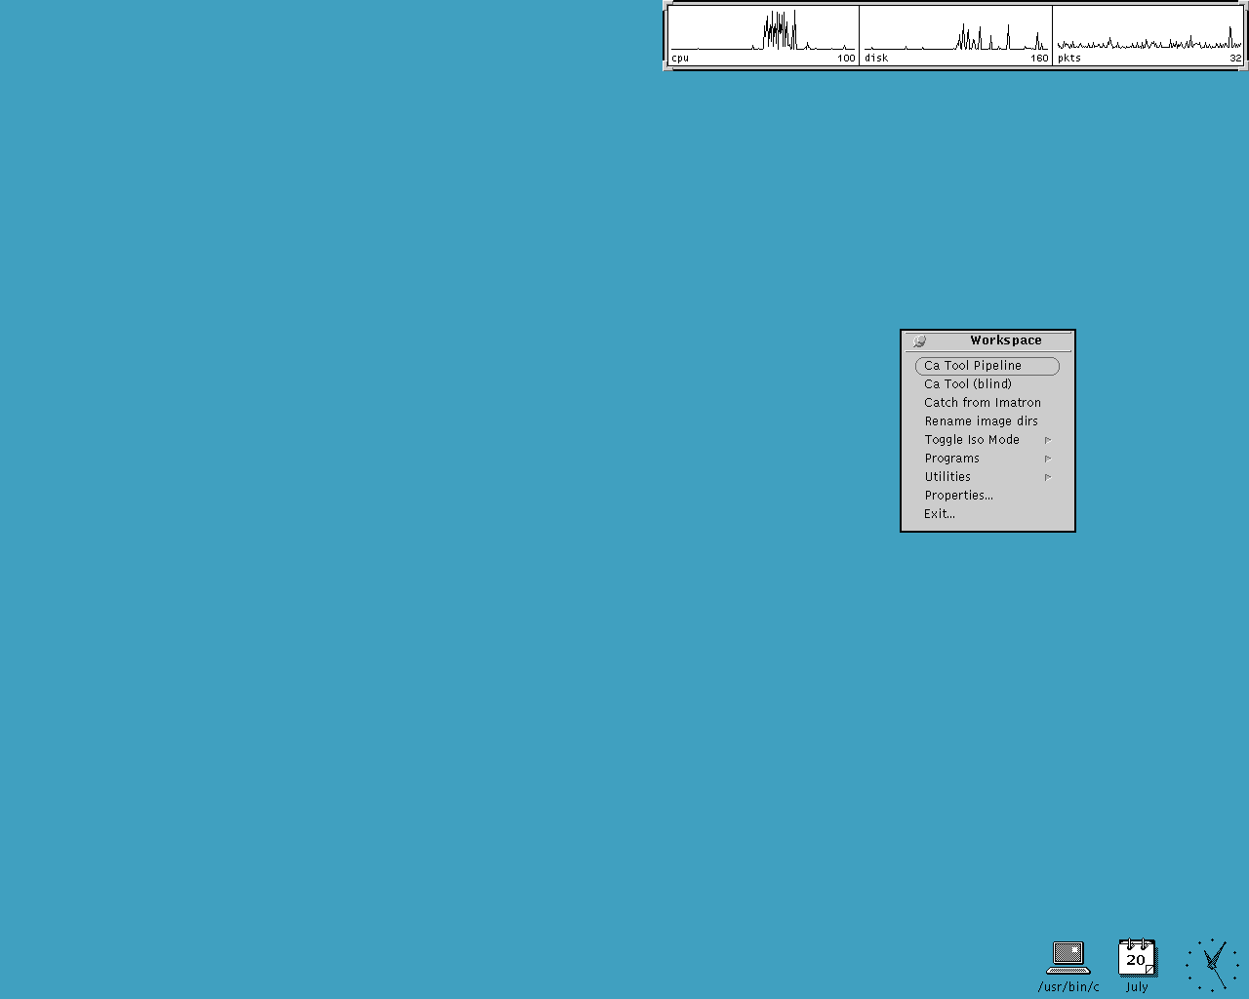
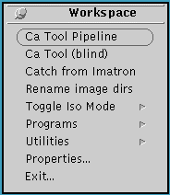
When you first log on the workstation, the screen will look like the image at the right. The blue part of the screen, reproduced in black and white in Fig 1.1, is called the Workspace. All the programs you will be using will be shown on the Workspace in separate windows like Windows98. Moving around this operating system is just like moving around Windows. You have a left mouse button to click on icons and commands. To bring up various menus, use the right button. Clicking the right button on any part of a window border will bring up various options. These options will let you “CLOSE” the window, meaning minimize the window into a small icon, or “QUIT” programs and completely turn them off.
Fig 1.1

In the middle of the screen is a little gray box labeled “WorkSpace”, where you will launch various programs. To bring up this “WorkSpace” box, you will click any part of the blue workspace using the third mouse button; this is known as “Right Clicking”.

Checking Receipt of Studies

The Technical Assistant will compare ID numbers on fax transmittal sheets sent by the scan sites to the images processed by our workstation. To do this, the Technical Assistant will run the “que_man” program. Once this program has finished processing all the images, s/he will launch the “File Manager” to see the list of new images listed. After sorting the files by date, s/he will check the studies off in the order they appear in the “File Manager. S/he will recheck to be sure that all the studies on the sheets appear on the Transmission Sheet. Once a study is found to be complete (correct number of images/slices per scan, correct number of scans per patient), s/he will make a check mark on the Faxed Transmission sheet. In the case of erroneous numbers, the Technical Assistant will copy the incorrect number in the column designated so that this can be corrected at the Coordinating Center. After each study is checked for completeness, s/he will enter the dates that the complete scans were actually received at the Reading Center in the log sheet. S/he will transmit this log to the Coordinating Center and the appropriate part of it to the respective field site when he sends the summary of scores to the Coordinating Center.

S/he will inform the Scanning Site of all scans that are or are not received. S/he will also email a list of all received scans to the field site coordinators on a weekly basis. The Technical Assistant will inform the scanning site of the studies which need to be retransmitted. Also, in the case of incomplete studies, the entire study folder must be deleted to prevent a Reader from inadvertently evaluating it. The Technical Assistant will keep a binder with the faxed transmission sheets.

More on (“que_man”)

Processing Dicom Files
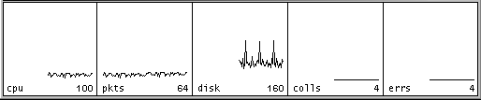
Log on as “read” and only begin the Image Processing step when there are no incoming DICOM transmissions; we have noticed a tendency for the DICOM transmission to quit if Image Processing is carried out at the same time. On the top left corner of the workspace is a box with running graphs, fig 2.1; this is the Performance Meter. Each graph is running and shows what that particular component of the workstation is doing.
Fig 2.1

For now we are interested in the second box, labeled “pkts”. This graph displays the number of packets, or data, coming through the internet. Since we use the workstations solely for Calcium Scoring this line only shows activity if there are incoming electronic DICOM images or if someone else is logged on using X-Windows. When this line is flat, as in fig2.1, it is okay to proceed with Image Processing, otherwise wait until it is finished.

With the Faxed Transmission Sheets handy, type the following into the command tool window:

% cd /home/read/DICOM/CT
% que_man

“que_man” takes the raw DICOM files which have been stored in the “/home/read/DICOM/CT” directory and transfers them into the “/images” directory where they will be ready for the Readers to evaluate. Once “que_man” is run, you will see various messages as it goes through each DICOM file. During this period you will notice that the Hard-Drive is working and that the graphs in fig2.1 are active.

**** If “que_man” will not run, please check the following:
**** % cd /home/read/DICOM/CT
**** % ls –lat | grep busy
****
**** If a file “.busy” is present, please delete this file:
**** % rm –i .busy
****
**** Run “que_man” again, and it will now process the images normally.

Once “que_man” has finished processing all the images, launch the “File Manager”. Using the “File Manager”, go to the “/images” directory and you will see all the new images listed.
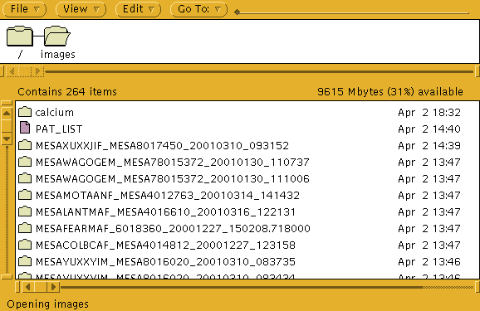
Fig 2.2
After sorting the files by date, check the studies off in the order they appear in the “File Manager”, fig2.2, instead of the order on the Faxed Transmission Sheet. Occasionally, a scanning technician will send a study and not include it in the Faxed Transmission Sheet; if you will be checking off the Faxed Transmission Sheet, you will miss these studies.
Then recheck to be sure that all the studies on the sheets appear on the Transmission Sheet.

Double-click on a study folder in the “File Manager”; you will see a series of files labeled with long strings of numbers, these are the DICOM files and each one represents a single slice/image for an entire scan. The number of DICOM files in a study folder should be equal to the number of slices indicated in the Faxed Transmission Sheet. Once a study is found to be complete (correct number of images/slices per scan, correct number of scans per patient), make a check mark on the Faxed Transmission sheet. If there are any missing or incomplete studies, the Data Manager will have to contact the Scanning Site and inform them of the studies which need to be retransmitted. In the case of incomplete studies, the entire study folder must be deleted to prevent a Reader from inadvertently evaluating it. To delete a study folder, right click on its folder and choose the delete option, fig2.3.
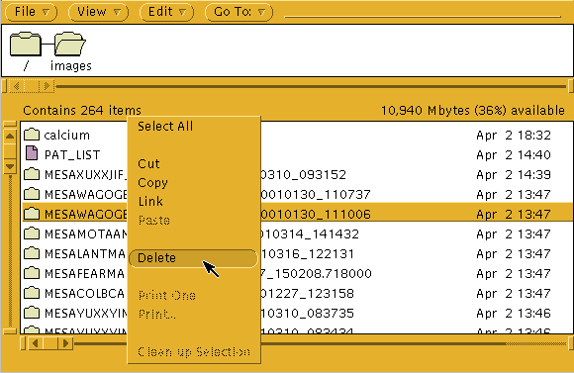
Fig 2.3
It is best to treat a Faxed Transmission Sheet and the studies listed on it as a batch. In this case, a batch is not complete unless all the studies listed on a Transmission Sheet have been checked off. Treating the Transmission Sheets this way will make it easier to track which studies are needed for retransmission, and to address any questions a Scanning Site may have about a retransmission by looking at the sheet. All unfinished Transmission Sheets should be in the front pocket of the Study Folder in case anyone needs to look at the information.

The Data Manager will then take the Faxed Transmission Sheet and count the studies on it, and enter this number into its respective column, appendix 3. This cumulative Study Count Log is located at \mydocument\chris\ebctscds\”Study Name” StatsMonthly.
Excel Files:

For Cardia and Mesa, the excel Log Sheets are located in Chris Dailing’s computer:

/MyDocument/Chris/EBCTSCDS/Daily Log Sheets/…

Finally, the Faxed Transmission sheet will be placed in its appropriate place in the study folder. Please keep the Faxed Transmission Sheets grouped together by Scanning Site and in chronological order.

Presentation to the Calcium CT Reader

The Data Manager will inform the Calcium CT Reader of the new studies in the workstation. It will not be necessary to enumerate the studies, since it will be the Reader’s responsibility to read all NAMED studies; NAMED studies are scans that have been processed, but not yet read. Rather than providing a list of IDs (or the scan log) for the readers to read, this procedure keeps the study order randomized so that the reader does not read scan pairs in sequence (except rarely).

The Final Scan Log is Sent to the Coordinating Center

As a final step, the Technical Assistant will submit the cumulative scan log on a weekly basis to the CT Supervisor who will generate a report of cumulative work done and of outstanding scans not yet processed. This will be performed every Friday.

Protocol Violations

During the boxing stage, the phantom finder software checks the image header of the scan for any deviation from its particular study protocol. All protocols are listed in a text file in the “/home/read/bin” directory. This is an ASCII text file containing relevant protocol information taken directly from the Dicom header of a particular scan site’s image.

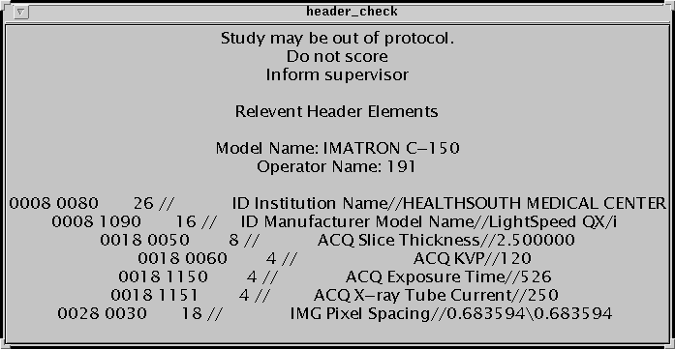
If a protocol violation has been detected, a window (fig 3.1) will pop up on the top left of the screen. This window will list the relevant information in the Dicom header for the scan. It is the reader’s responsibility to take note of these values and to inform the Reading Center Supervisor of the violation. The Reading Center Supervisor will then check the header information against the proper protocols for that particular site and study. If a violation has indeed occurred, the Supervisor will then inform the Study Coordinating Center, the PI of the Scanning Site, and the Lead Tech of the Scanning Site. The reader will then read the study normally.

Fig 3.1

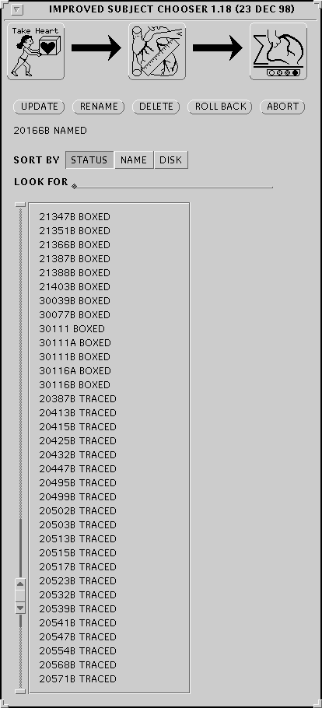
House Keeping and Archiving
Fig 4.1

It will be the Data Manager’s responsibility to periodically check the contents of the “/images”. The number of studies in this folder should not exceed the maximum allowable, 248 image folders, by the Reading Software’s Subject Chooser, fig4.1. When the number of image folders exceeds this number, the reader will only see 248 studies in the Subject Chooser and will not be able to read any of the excess studies.

If the number of studies in the subject chooser exceeds 248, there are relatively few options:

1. Move studies into a sub-directory temporarily.
2. Delete studies that have already been stored and archived.

Moving Files

If the number of studies in the “/images” folder exceeds 248 and deleting is not an option, some studies will need to be temporarily moved to a subdirectory. These studies should be moved in batches according to scan date, the earlier scanned studies to be left in the “/images” folder. This procedure will ensure that the earlier studies are read first and that any inconvenience to the Study Coordinating Center or to the Scanning Site will be kept to a minimum.

The best way to move studies in batches is through the “cmdtool”, or the Command Tool window. This allows us to use Unix wildcards and the study headers to move folders with ease. First, determine the most recent studies that can be moved, noting their scan dates.
Then type in the following:
Changes directory to /images

% cd /images

This command makes a directory. I suggest you use the study name, there will be less confusion if there multiple studies on one workstation.

% mkdir studyname

% mv /images/*yyyymmdd* /images/studyname
The folders to be moved. Replace “yyyymmdd” with the appropriate date, i.e. “20010301” will move all studies scanned on March 1, 2001.
The Target Directory. Change “studyname” to whatever directory you created in the previous command.

Renames the file.

Alternatively, this same procedure may be used to move batches of studies based on the Study (for workstations with multiple Studies) or Scanning Site. Replace the “yyyymmdd” string in the third command into whatever string is common to all the studies you intend to move.

Deleting Scored/Archived Studies

Studies should not be erased from the hard disk unless they have gone through the complete reading process, from boxing to scoring to archiving. The safest way to delete studies from the hard disk would be to delete those that have already been archived onto CDs. Also, a benefit to using the CD’s as the basis for deleting is that by loading it onto the workstation and checking its directory structure, we inadvertently check if it went through the CD-burning process properly.

First, we will create a list of studies on a particular CD. The lists I have previously created for the CARDIA and MESA studies are in “/home/read/temporary”. For the MESA study, the lists are labeled as “mesalistxxx” where “xxx” is the cd number which the Reader created. For CARDIA, the lists are labeled “listxxx”.

Insert the CD in the cdrom drive of the workstation, please note the CD number. Then type the following:

% cd /home/read/temporary
Extra Info;

The files on the CD are TAR files, these are similar to ZIP files on PCs. One TAR file actually contains the whole study folder (including images and tracings). It is also labeled with the same name as its original study folder in the “/images” directory, plus the date the TAR file was created.

% ls /cdrom/cdrom0 > ./studylistxxx

You have created the file “studylistxxx” that contains an ascii based list of the files on the CD. Next, this file should be edited to reflect the actual folder names (see “Extra Info”) in the “/images” directory. Open up the file you just created with “textedit”, the Unix text based editor:

% textedit ./studylistxxx

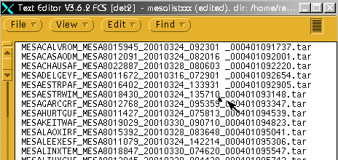
Now, place a space before the last underscore of each entry, see fig4.2 where the first five entries have been modified. Notice that the last underscore separates the actual study folder name from the appended TAR creation date. Now, save the file by right clicking on the “File” menu and choosing “Save”. Then “Quit” textedit.
Fig 4.2

Run the following command which will strip the appended TAR creation date from entries in the file:

% more studylistxxx | cut –d” “ –f1 > temp
% mv temp studylistxxx

Now you have a list of study folder names formatted exactly like the study folder names in “/images”. You can verify this by typing:
This means to delete all folders in “/images” that have are identical to any entries in the file “mesalistxxx”.

% more studylistxxx

The next step is to delete studies based on the entries on this list that were created. Please note, type in the following command very carefully; any typo in any part of the command may delete EVERYTHING in the “/images” directory. Again, please type carefully, if anything, this should be done by someone who understands UNIX commands and who is comfortable running them.

% rm –r /images/`more /home/read/temporary/mesalistxxx`

Unix delete command.

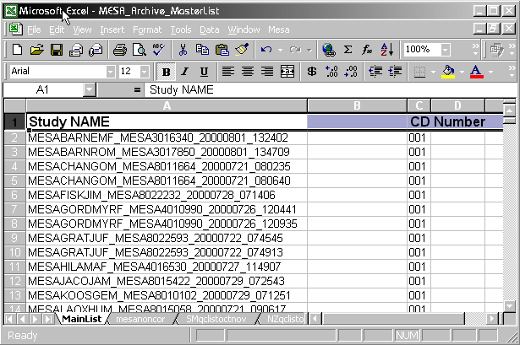
After deleting, import the entries in “mesalistxxx” into an excel file. For MESA and CARDIA, they are in an excel file, see fig 4.3, called “MESA_Archive_MasterList” and “CARDIA_Archive_MasterList”, respectively. This will help facilitate searching and reloading studies in the future.
Fig 4.3
Excel Files:

For Cardia and Mesa, the excel Archive Lists are located in Chris Dailing’s computer:

/MyDocument/Chris/EBCSCDS/Daily Log Sheets/…

Printing

Printing files (and standard output) to the HPLJ printer

Operation:
To print an ASCII file to the default printer in portrait mode, type:
Enscript filename

To print an ASCII file to the default printer in landscape mode, type:
Enscript filename –r

To print the text output of a UNIX command, type:
command | enscript [-r]

Examples:
ls | enscript
dcm_dump_file | enscript –r

Notes:

Enscript is a GNU public domain program. Additional
-options [eg, -G] are documented on the GNU web site.

Additional Archives.

The technical assistant will make two additional copies of each scan every week by copying all CDs generated that week onto DVDs using the data management and archiving computer with high speed DVD and CD drives. One CD will be mailed to the MESA coordinating center. The other will be kept on campus in another location.

Mailed CDs

Transferring DICOM data from CD-Rs

Operation:
To transfer DICOM files from a CD-R, insert the CD into a network accessible PC
running Windows 2000 or NT; Double-click on the CD-TO-DET[1,2, or 3] desk-
top icon; Remove the disk when the DOS dialog box closes, and multi-line output
no longer displays; Store the CD-R; Transfer the resulting “big-endian” DICOM
files on DET[1,2,or 3] by invoking “que_man” on the UNIX workstation as normal.

Requirements:
Three files must be present on the PC:
CD-2-DET1,2,3].LNK [A desktop shortcut, with target: C:\cd2det3_2k.bat]
CD2DET[1,2,3]_2K.BAT [A script which involves transfer of all DCM files on CD.]
CDR-TO-DCM.EXE [A program which transfers data to det[1,2,3] via port 4000].

Notes:
All DCM files on a CD will be transferred to the selected workstation unless the above
Script file is run from the DOS-Prompt from C:\, after first selecting the appropriate parent
directory of E:, and from below which all DCM files will be selected.

On running this program, a constant stream of DOS-level messages should scroll. Each
group parsed represents one slice transferred to the workstation.

IP address, port number [4000 is our default], and AE title may be changed by altering
Default values in the CD2DET[1,2,3]_2K.BAT NT script file.

Reloading Studies

The files on the CDs are TAR files, which are similar to ZIP files on PCs. One TAR file contains the whole study folder (including images and tracings). It is also labeled with the same name as its original study folder in the “/images” directory, plus the date the TAR file was created.

The basic TAR file command is

% tar xvf /cdrom/cdrom0/tarfilename

This command takes the TAR file on the CD and places all of the original files (DICOM files, tracings, and others) back into the proper directory in “/images”. The above command is good for taking TAR files off of the CD one by one.

When reloading a large amount of studies from the CD’s it is best to make an ASCII based list and to use this list in a UNIX script. Using the Excel Archive List file, fig3.3, it is easy to search for individual studies by ID number and by Scan Time. Once a particular scan is found in this Excel file, highlight the whole row, copy, and paste into a new worksheet. Once all studies needed to reload are found, print the file; this print-out will be used to physically locate the CD on the shelves and to check off each study loaded. Then, take this list and save it as a tab-delimited text this file and save it in the “/images” directory of the workstation where the studies are to be reloaded.

Next take the list you printed with the numbers of the CDs needed and use this to find the CDs on the shelf. Next, place the CD in the workstation’s CD-drive and run the following command:

% tar xvf /cdrom/cdrom0/`more /images/imagelist.txt`

Do this for all the CDs on the list.

Troubleshooting

The Readers report that the CD-Archiver is not writing to the CDStudio–
Log in as “Read” and type the following:

% rm cd_doing_now

A Scanning Site is reporting that the DICOM receiver is not working—

Log in as “Read” and type the following:

% ps –cafe | grep simple

The last field of the output lists all the DICOM Receiver Port numbers which are running. If the Scanning Sites’ particular port number is not present, reboot the computer and restart the DICOM receiver.

XII. CT Reading Procedure Operations Manual

INTRODUCTION

When you first log on the workstation, the screen will look like the image at the right. The blue part of the screen, reproduced in black and white in Fig 1.1, is called the Workspace. All the programs you will be using will be shown on the Workspace in separate windows like Windows98. Moving around this operating system is just like, moving around Windows. You have a left mouse button to click on icons and commands. To bring up various menus, use the right button. Clicking the right button on any part of a window border will bring up various options. These options will let you “CLOSE” the window, meaning minimize the window into a small icon, or “QUIT” programs and completely turn them off.
Fig 1.1

In the middle of the screen is a little gray box labeled “WorkSpace”, this is where you will launch various programs. To bring up this “WorkSpace” box, you will click any part of the blue workspace using the third mouse button; this is known as “Right Clicking”.

There are many items on this workspace box that will launch various programs. For now we will concentrate on the programs DICOM Viewer and Ca Tool Pipeline, that are the reviewing and scoring programs respectively.

SUBJECT CHOOSER

1. Launching the Subject Chooser
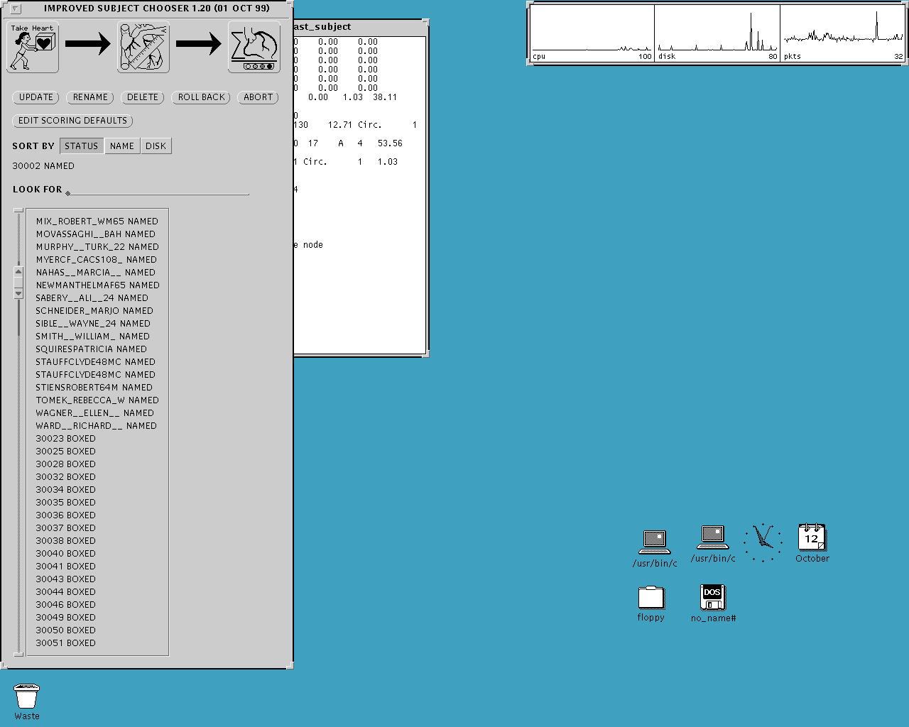
First bring up the “WorkSpace” box, by right clicking the desktop. Then you will right click the button labeled “Ca Tool Pipeline”. After a few seconds, the two windows on the right, Fig 2.1, will appear. The tall gray window on the left is the Subject Chooser menu of the Scoring Software. This is where you will be choosing studies to Box, Trace and Score.
Ca Tool Scoring Software

Fig 2.1

2. The Subject Chooser Window
On the Subject Chooser window, you will find three main icons:

Boxing: Used to launch the boxing program. This is where you will outline the entire heart in a box.
Tracing: Used to launch the tracing program. This is where you will identify the coronary arteries.
Scoring
Tracing
Boxing
Fig 2.2
Scoring: Used to identify plaque.

Under the icons are five buttons:

Update: Refreshes the window, and
updates the patient list.
Rename: Do Not Use
Delete: Do Not Use
Rollback: Used to rollback studies from
BOXED or TRACED status to
NAMED. This will delete scoring
and tracing files.
Abort: Closes the Ca Tool program
Edit Scoring Defaults: Setting defaults
(see below)

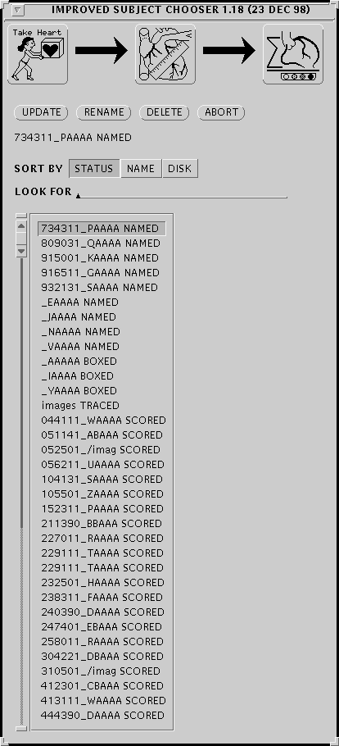
On the right is a close up view of the subject list, this is where you will be choosing a study and left-clicking on it to highlight it. The first sequence of numbers and letters is the study identifier. To the right of this is the status of the study. NAMED means that it has not been boxed yet. BOXED means that it has been boxed and is ready to be traced. TRACED means that it has been boxed and the coronary arteries have been identified but has yet to be scored. SCORED means that it has been scored and saved. To the right of the names is the scroll bar. To scroll down, left-click on the bottom arrow. Each click will move the patient list up and reveals a new name at the bottom of the window.
Scroll Bar
Fig 3.1

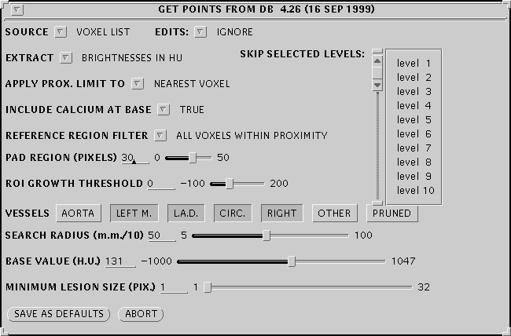
3. Edit Scoring Defaults
Fig 3.2
This is where you will set up the defaults for the Calcium Tool. Fill out the fields, Fig 3.2, according to the criteria set by a particular study’s protocol. You may alter the values either by directly entering numbers into the field and pressing ‘ENTER’ or by using the slider if one is provided. This has to be done only once during the start of one session of reading.
Scans will be read using a HU threshold of >= 131, a minimum number of pixels of 4, a pad region of 8 pixels, a growth threshold of 101 HU and a search radius of 100 mm.

BOXING

1. Description Of Boxing

Note that a senior reader investigator must box every scan.

In the boxing window, you will view consecutive images of the patient’s heart. You will then enclose the heart in a white box. This procedure will produce the boxed view of the heart you will be using during the Tracing and Scoring procedures.

Another purpose of the boxing stage is to properly identify the hydroxy-apatite Phantom regions. To do this you will have to make sure that the bright white dots stay inside the cylindrical regions of the phantom.

To first get started you will have to launch the boxing program. On the Subject Chooser highlight a patient study by first left-clicking on it. Then move the mouse over the first icon labeled “Take Heart”, previously labeled in fig 2.2.
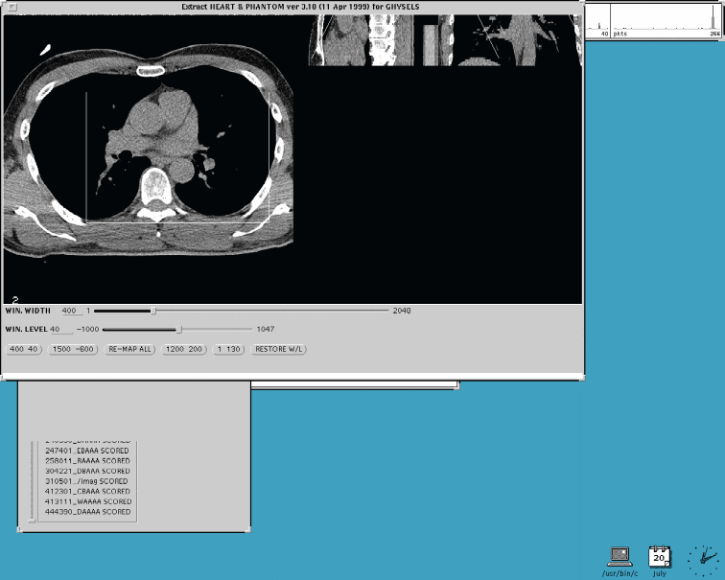
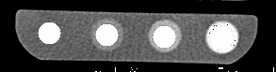
Surface Rendered Region
White box outlining heart

Fig 4.1

When the boxing window pops up, it will cycle through all the slices of the patient’s images. When this happens, you will have to keep an eye on the phantom to make sure that the bright white circles stay within the cylindrical regions of the phantom. To check the slices again after the initial cycle, right-click anywhere on the boxing window (to bring up the menu) and choose “Cycle Through”.

2. Boxing The Heart

The next step in the boxing process is to actually box the heart. This serves to isolate the image in the boxed portion for the next process, Tracing. After the

window finishes cycling through the

images, there should be a white boxes surrounding the image of the heart. Resize the box by left clicking on either corner and stretching the white outline so as to completely encompass the heart.

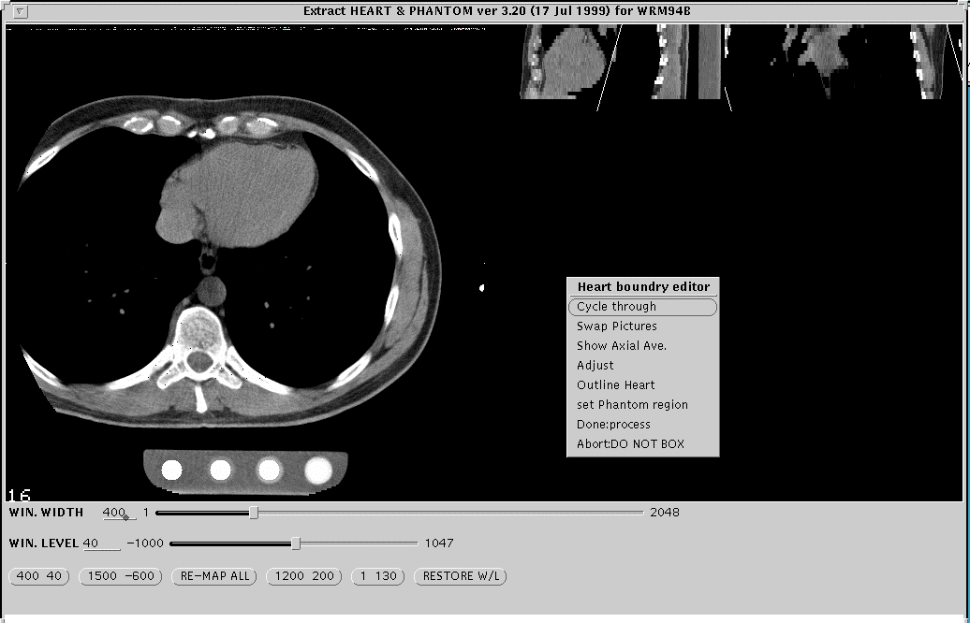
Once again you will have to check if all of the heart has been included in the boxed region. Do this by right clicking to bring up the menu and then choosing “Cycle Through”. Once you are sure the entire heart is boxed bring up the menu once again and click on “Done: process”. A small window will pop up on the top left corner of the screen, choose “begin tracing” to launch the second part of the Scoring process.
Phantom
Right-Click Menu
Fig 4.2

3. Identifying the Regions In The Phantom

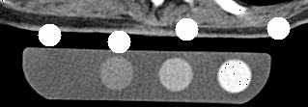
During the boxing stage you will be checking to see if the cylindrical regions of the calibration phantom have been properly identified. Figure 5.1 shows a phantom whose cylindrical regions have not yet been identified. And figure 5.2 shows a phantom with properly identified regions.
Fig 5.1
Cylindrical Hydroxy-apatite region

The purpose of identifying the hydroxy-apatite regions in the phantom is to let the scoring software have a way to
Fig 5.2
Properly centered regions

compare the known density of the hydroxy-apatite phantoms to that of calcification in the arteries.

When you do come upon a region which has not been properly identified, right-click the center of the nearest hydroxy-apatite region and choose “set Phantom Region” from the menu, Fig 5.3. The white circle nearest to the center of the hydroxy-apatite region you clicked will jump there. Do this with all the regions till the circles appear to be located within all regions. Figures 5.3 to 5.5 shows this process in order.
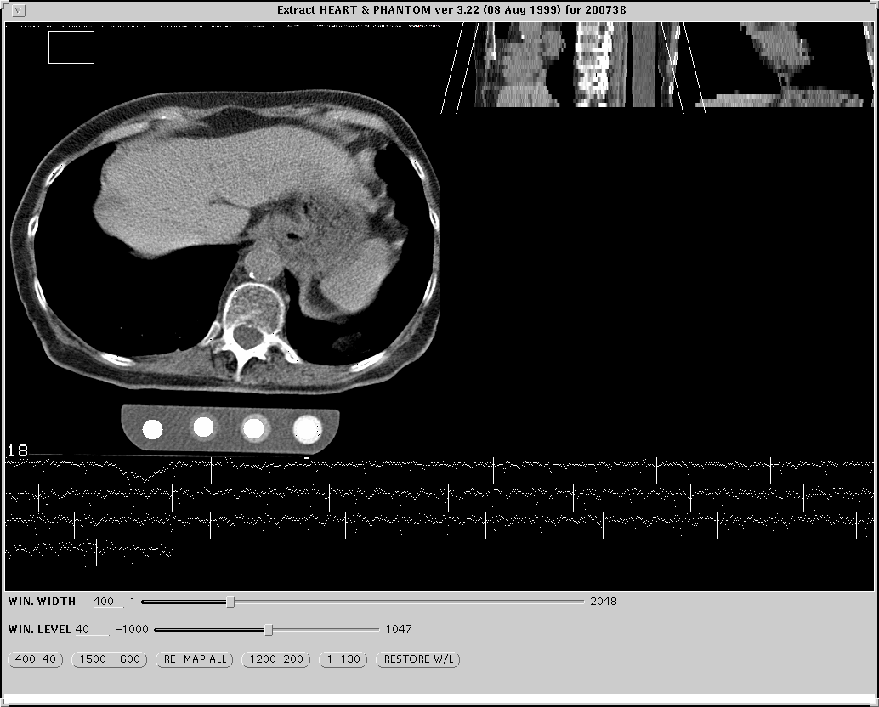
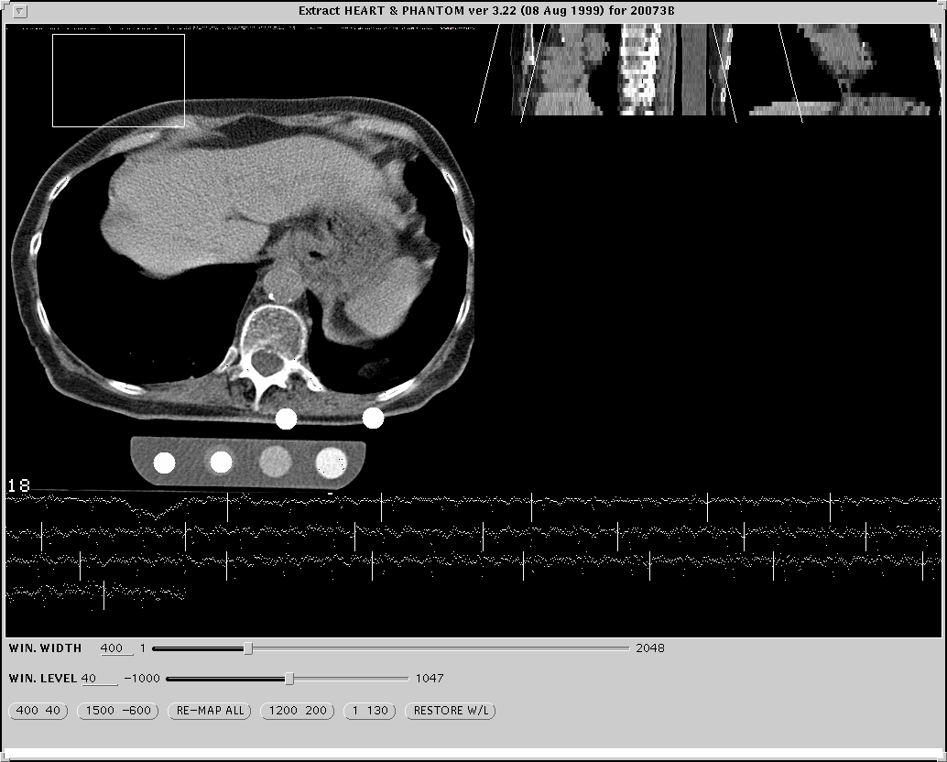
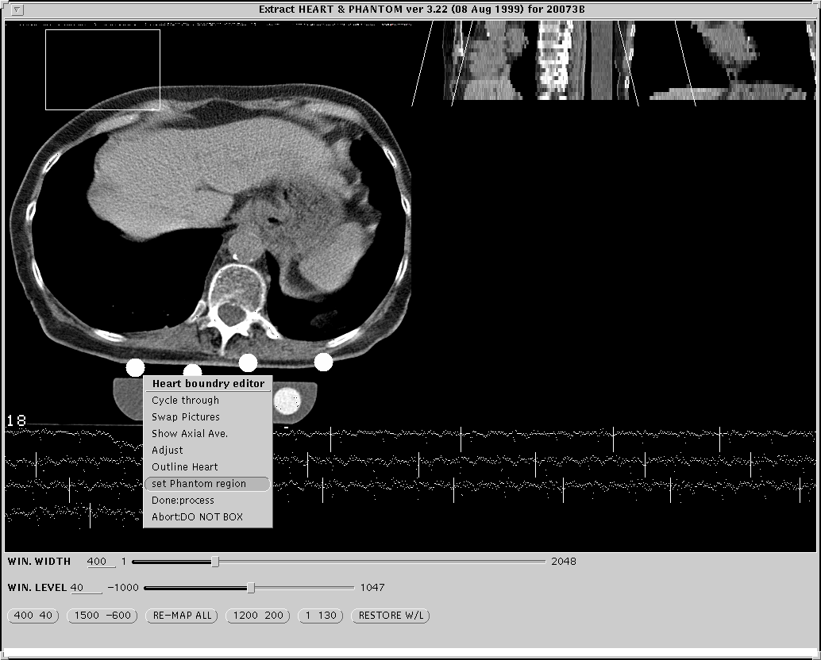
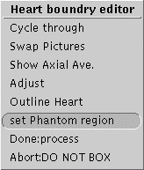
Fig 5.4
Fig 5.5
Right-click menu.
Fig 5.3

TRACING

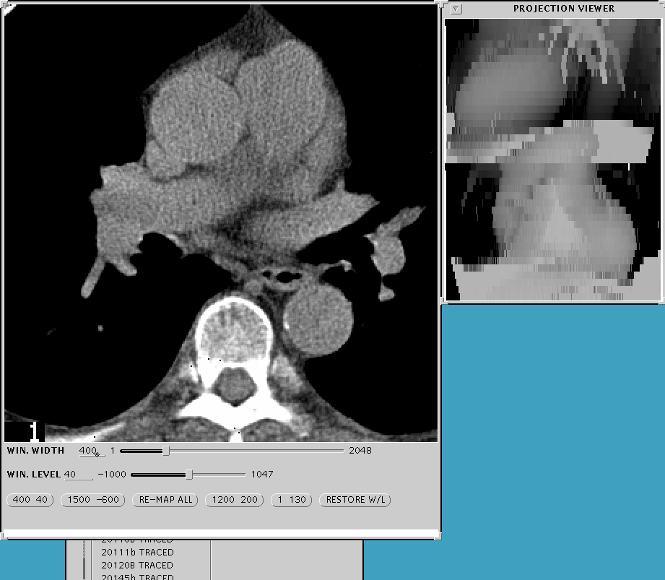
1. Launching the Tracing Program
Tracing Window
Projection Window
Fig 5.6
There are two ways to launch the Tracing program, by clicking on the Trace button (see Fig 2.2) or by finishing the Boxing process as described in the previous section. The purpose of the tracing program is to actually trace the path of the vessels through the heart, so that the Scoring software will know where to look for lesions. Basically you will scroll through all the slices and identify where the appropriate vessels are.

Navigating through the slices is simple. First you must left-click the tracing window. After, you may move forward through the slices by pushing the ‘down’ arrow key on the keyboard. To go in reverse, use the ‘up’ arrow key.

2. Labeling the Vessels
Now you will label the vessels. Follow through with the pictures at the bottom of the page, Fig 6.1 to Fig. 6.3. First scroll through the slices, using the arrow keys, till you see the first instance of the Left Main Artery, in this case it is on slice number six, Fig. 6.1. Now right click on the Left Main Artery and choose “L. Main” from the menu that pops up. A red “X” should hover over the vessel.

The computer will distinguish the vessels using colors, Red for Left Main, Green for the L.A.D., Yellow for the Circumflex, and Blue for the Right Coronary. Next look for any other identifiable vessels on the same frame, if there are any, identify them the same way, if not move on to the next frame. In our case, Fig. 6.1, the LAD is also present, so we label it by Right clicking on the vessel to bring up the pop-up menu and then choosing “L.A.D.”, a yellow arrow will now appear. On our next slice, Fig. 6.2, the L.A.D. is still present. To label a vessel in the following frame just Left click on the vessel and the program will label it accordingly. For example, in Fig. 6.2, we left click on the LAD to continuously mark it and we use the Right click pop-up menu to label the Circumflex and the LAD Branch.
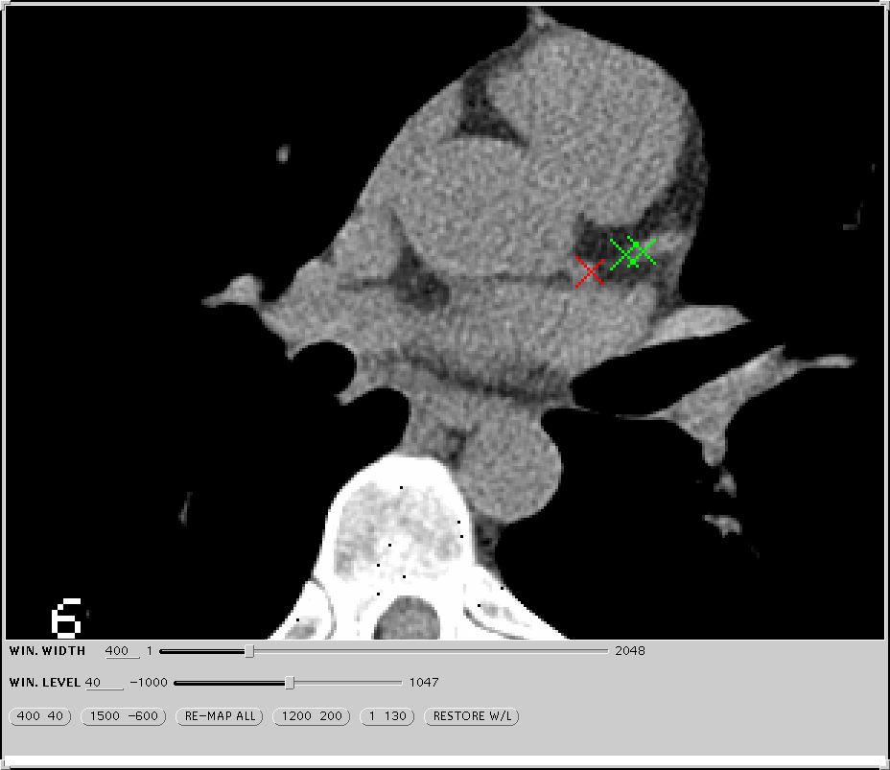
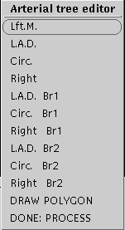
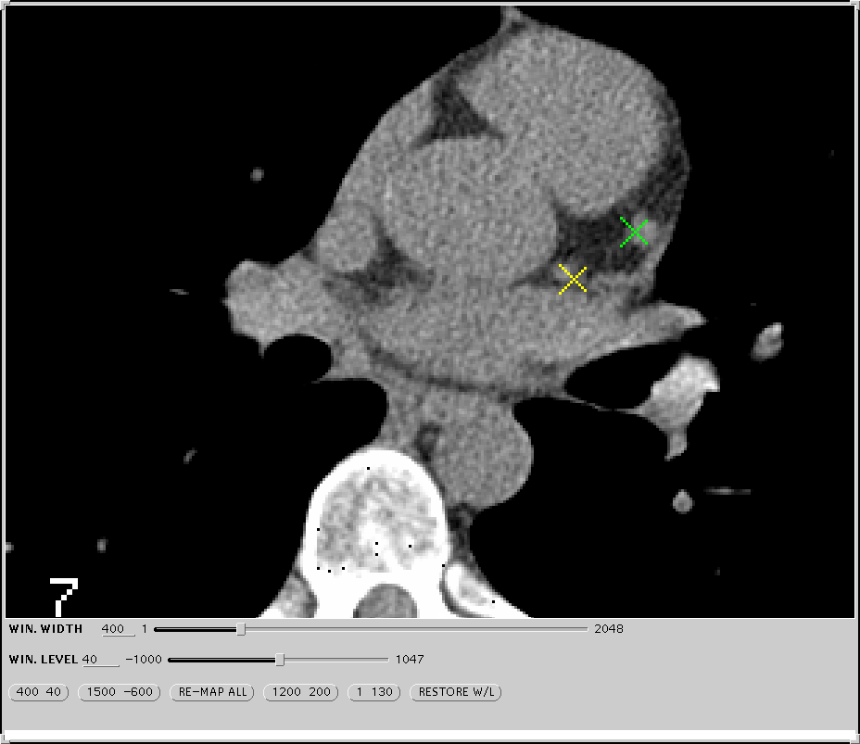
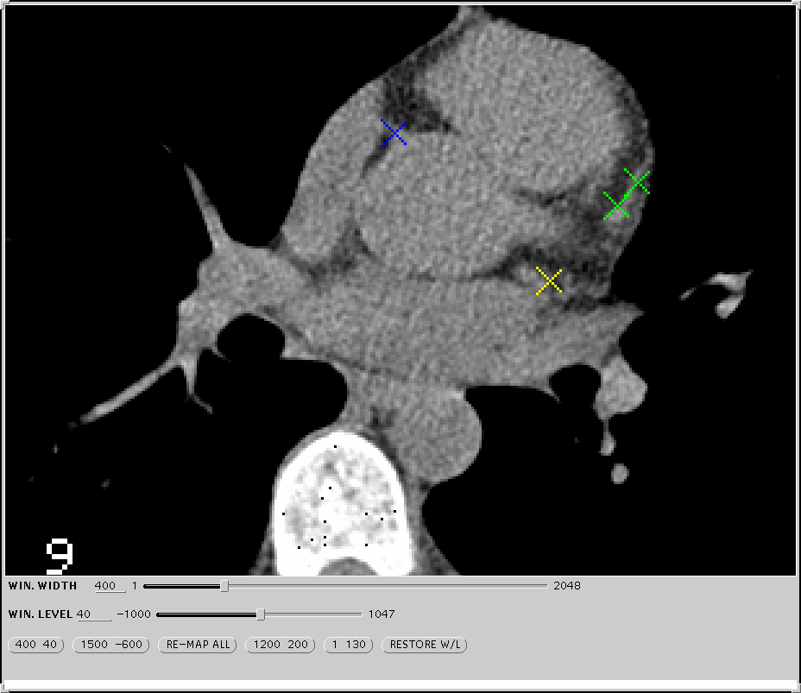
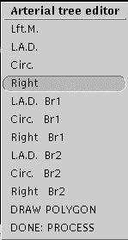
Right-Click Menu
Left Main
L.A.D
Fig 6.1
Circumflex
L.A.D.

Fig 6.2
Slice Number
Right Coronary
Fig 6.3

3. Checking the Tracings
After you have labeled all the vessels in the last slice where vessels appear, you should check your work by right clicking anywhere on the image and choosing “Done: process” from the pop up menu. When you do this you will see the images reappear consecutively with the circular regions surrounding the points, Fig 7.1, where you placed the X’s. Be sure that the entire coronary tree is included.

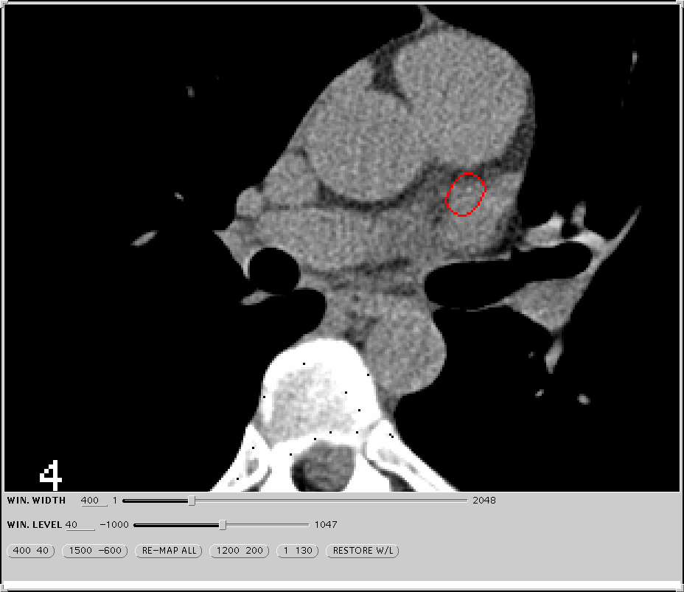
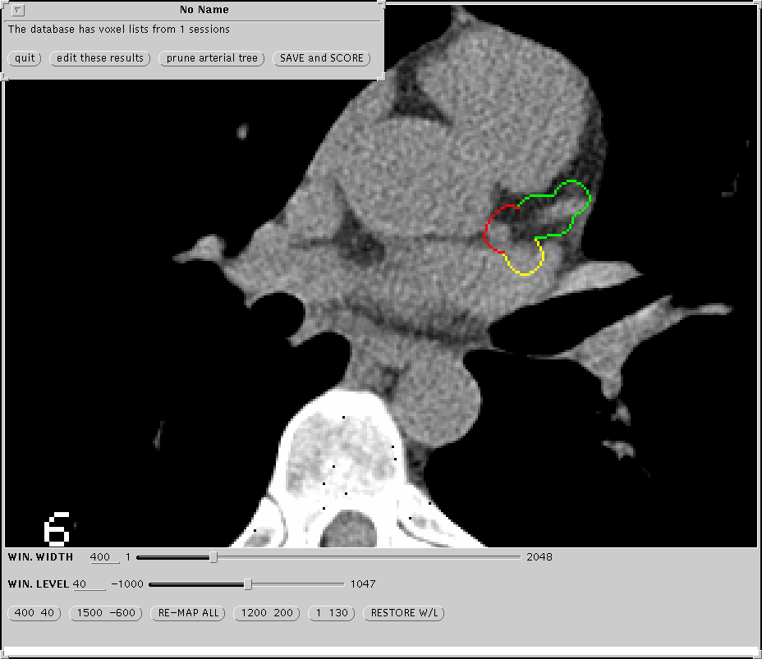
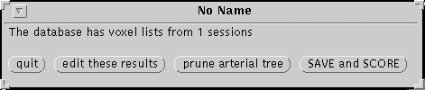
4. Editing the X’s
Fig 7.1
Circular region surrounding a vessel previously marked with an X.
7.2
If you note that the regions are not encircling the arteries in every image, you should then choose “Edit Points” from the little menu (Fig 7.2) you now see at the top of the screen. Then page through the images and delete the incorrect points by using ‘Shift’+Left-Clicking on the X’s. Then replace with a new X marker in the correct position. When you have finished editing the X’s, Right-Click again, and choose “Done:Process” from the pop-up menu and return to section 3 above.

5. Finish Tracing
If the regions are placed correctly, choose either “Save and Score” from the resulting options, Fig 7.2, to proceed to the Scoring program or “Exit” to end tracing and return to the Subject Chooser.

SCORING

1. Launching The Scoring Program
Launch the scoring program by either highlighting a ‘TRACED’ study in the Subject Chooser and clicking on the Scoring Icon, Fig 2.2, or by choosing “Save and Score” when finishing the Tracing program, see above.

2. Checking Lesions
If the scoring program cannot find calcium within the regions created during Tracing, image slice no. 1 will appear with no colored regions indicated. In this case, you will then have to Right-Click to bring up the pop up menu and choose “Quit”. The Quality Assurance Menu will then appear.

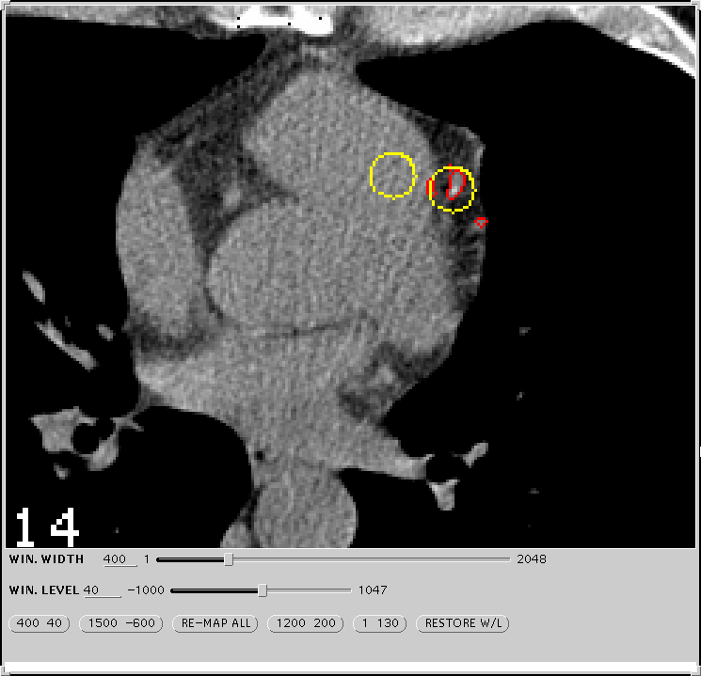
If the Program does find calcified lesions, you must decide whether or not these really represent coronary calcium. In this case, the program will take you directly to its choice for a lesion. These lesions, Fig 8.1, will be surrounded by a circle. A circle of the same color will appear somewhere else on the image. Move your mouse to drag the circle to a homogenous blood-pool near the lesion in question. Click the left button if you agree that this is coronary calcium. Otherwise click the middle button if you do not agree. Then repeat this same procedure for every “lesion” the program identifies in this image. The program will automatically jump to the next image with a calcified lesion after you have assessed all the lesions in this image.
Calcified lesion which program has identified.
Fig 8.1
Circle that follows the mouse. This must be in a homogenous blood pool when assessing a lesion

After you have assessed the last lesion in the last image, the QA menu will appear.

3. Quality Assessment Tool
The QA menu, Fig 8.2, has seven categories that you must assess. These are Motion Artifact, Streak, Phantom, Misreg, Noise, Arteries, and Coverage.

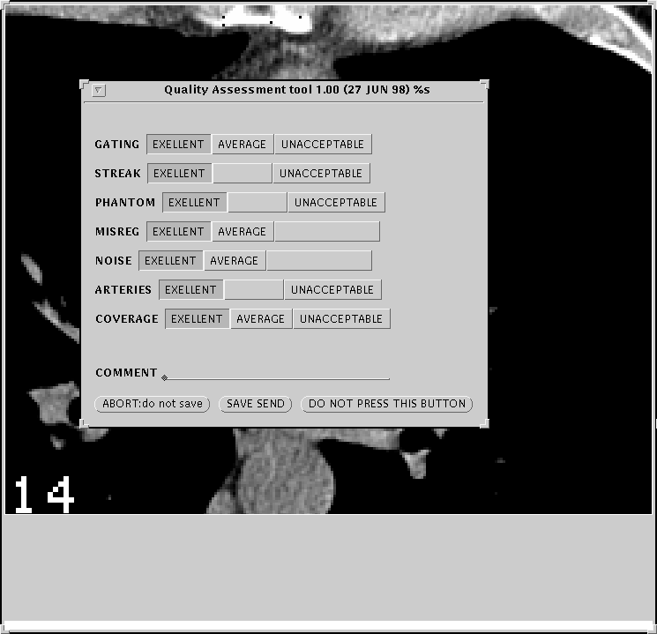
Choose your assessment by using the following guidelines:
Fig 8.2

Motion Artifact – Choose ‘Unacceptable’ if there is blurring of the distal RCA or other notable portion of the coronary arteries, otherwise choose ‘Excellent’

Streak- Choose ‘Unacceptable’ if streak artifact overlaps any calcified coronary lesion. Other wise choose Excellent’.

Phantom- Choose ‘Unacceptable’ if insufficient assessment of the phantom
occurs in any image. Otherwise choose ‘Excellent’.

Misreg- Choose ‘Average’ if the images in the projection window do not
show smooth epicardial borders. Otherwise choose ‘Excellent’.

Noise- Choose ‘Average’ if the image contains excessive noise such that
the program has mistaken noise for coronary calcium. Otherwise
choose ‘Excellent’.
Arteries- Choose ‘Unacceptable’ if part of a major coronary artery is cut by
the edge of an image. Otherwise choose ‘Excellent’.

Coverage- Choose ‘Unacceptable’ if the images do not
include the origin of the left main coronary artery or the
coronary sinus. Choose ‘Acceptable’ if ‘Unacceptable’ does
not apply but if any portion of the tree is excluded due to
insufficient coverage in the Z-direction. Otherwise choose
‘Excellent’.

Once finished click the “Save and Send” button.

4. Auto Archiving (Automatic CD Backup)

After scoring, immediately after you click the “Save and Send” button, the software automatically places a copy of the study you have just scored, including original images and all tracings, into a hidden archive folder.

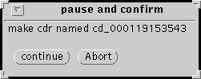
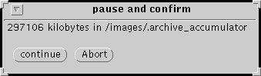
After each complete scoring a window will pop up, Fig 9.1, indicating the size of the archive. Once the size of the archive reaches over 600 megabytes another pop up window will appear asking if you would like to continue with the backup. It will then ask you to confirm the writing of the backed-up archive files to the CD Studio. Once you click continue in the window in Fig 9.2, you must then place your mouse over the “cmdtool” window of the CaTool software, Fig 9.3.
Fig 9.2
Fig 9.1

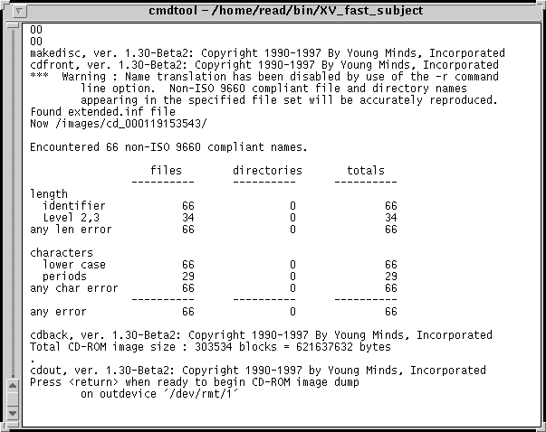
The software will then proceed to transfer the archive from the Sun Workstation onto the CD Studio. If you continually check on the “cmdtool” window it will show the progress of the transfer, it usually takes 15 minutes. Once it has transferred over the archive another window will pop-up asking if you would like to continue and write to the CD. After you click continue, the archive will be burned into the CD. This will take approximately 15 minutes, please note that you may open another CaTool window and continue scoring while you are backing up. Once the backup has completed the program will ask you to remove the CD and label it.
Fig 9.3

Test the CD to make sure all the files have been properly burned in.

APPENDIX A: Protocol for Inter-scan, Inter-reader, and Intra-reader Variability

This protocol is designed to serve as a guide to readers in preparing the necessary studies for scoring and transmission for the purposes of inter-scan, inter-reader, and intra-reader variability assessment, which will be done by the Coordinating Center.
Necessary log-in accounts will need to be created as follows:
For regular reading: MESA-SM, MESA-NZ
For inter-reader variability: MESA-RD, MESA-MB (senior readers)
For intra-reader variability: MESA-SM1, MESA-NZ1, *MESA-RD1, *MESA-MB1

*to be used for occasional checks of intra-reader variability on senior readers It is assumed that each account, subject chooser, and summary of scores file will be study-specific—e.g., only studies of one type (MESA or CARDIA, but not both) will be included in a given reader’s account.

1. Interscan Variability:
Since nearly all studies will be performed in duplicate (except for those where one of the studies is technically inadequate for transmission or reading), the coordinating center will select the appropriate sample of studies for examining inter-scan variability among each of the scanning sites. Transmitted summary of scores files will contain duplicate scans with the same identification number but slightly different scan times that the coordinating center will use to distinguish between first and second scans. This may require as much as 25-50% of the duplicate studies examined in order to obtain monthly inter-scan variability for each center and/or technician.

2. Inter-reader Variability:
A 5% sample of each reader’s read scans will be reread by a second, senior reader (RD or MB) on a monthly basis. Once the month’s scans have been read, with scores transmitted, the data manager will run a random number generator program that will determine which scans to select. The scored files that are selected will then be copied by the data manager to appear in the Subject Chooser and rolled back to “NAMED” status, and the reader responsible for reading such scans will then be notified to read them. After scoring, the reader will click on the indicator in the software menu designating this as a quality control study. Once read, the summary of scores file will be transmitted to the coordinating center, and since read by a different reader, it will be evaluated in determining inter-reader variability

3. Intra-reader Variability:
A 5% sample of each reader’s read scans will be reread by the same reader on a monthly basis. Once the month’s cans have been read, with scores transmitted, the data manager will run a random number generator program that will determine which scans to select. The scored files that are selected will then be copied by he data manager to appear in the Subject Chooser and rolled back to the “NAMED” status. The reader responsible for reading such scans will then be notified to read them. Once read, the summary of scores file will be transmitted to the coordinating center, and since read by the same reader, the study will be evaluated in determining intra-reader variability.

APPENDIX B: Description of Options In Scoring Defaults Menu

Introduction. The tracing program creates a tubular region of interest of radius R. These tubes define the “voxel list”. Only these tubes of diameter R are available for evaluation of calcified plaque. R has been set at 7mm. This value is a compromise between higher values which would necessitate a lot of pruning and lower ones which would necessitate an excessive amount of editing during tracing.

1. Source. This can have two values: Voxel List or Pixels. Always set this as Voxel List. Setting at Pixels will cause the tracing program to search outside of the voxel list.

2. Edits. This can have three values: Override, Show, or Ignore. These are important in rescoring a case and in batch scoring.

Override – causes the scoring program to override prior edits and thus to start “from scratch”. This should always be used in Interactive Scoring.

Show – causes the lesions which have been edited out or removed during a prior scoring to be listed but not to be counted in adding up the score. They are listed in an intermediary file (REG) as noise.

Ignore – causes the scoring program to include edits from pror scorings and therefore to ignore regions which were removed during prior scorings. Ignore should usually be used for batch scorings.

3. Extract. This allows the user to choose whethter he/she wants to use the actual pixel values (Brightness in Hounsfield Units) or to scale these to the phantom (Scale to Phantom).

4. Skip Selected Levels. Do not use this option.

5. Apply Proximity Limit. Possible values for this are Nearest, Farthest, Peak and Each.

Nearest – causes plaques which are on the border defined by the search radius, R, to be entirely included.

Farthest – causes such plaques to be entirely excluded.

Peak – causes these plaques to be included only if the peak value is inside of R.

Each – causes the plaque to be split so that only the part within the R is included.

In general, always use NEAREST.

6. Include calcium at base. This can be True or False. True causes ostial calcium to be included. False causes it to be excluded. Set this at TRUE.

7. Reference Region Filter. Set as Brighter Than Threshold.

8. Pad Region. This defines, in units of pixels diameters, the distance the scoring program will search from a calcified lesion defined by the Base Value and Minimum Lesion Size. This will affect the arterial summation calcium mass estimates but should never affect the other measures. Set this at 8 pixels for interactive scoring. Set this at maximum for batch scoring.

9. Growth Threshold. This defines in HU the included pixels in the arterial summation mass formula. All pixels of at least this value within the pad region will be included in the arterial summation mass formula. Set this at 101 HU for interactive scoring. Set this at maximum for batch scoring.

10. Vessels. This allows the user to exclude or include vessels in scoring. By blanking out a vessel, the reader causes a zero contribution from that vessel to be counted in the summary of scores file. The vessels allowed are: Aorta, Left, Main, LAD, CX, RCA, Noise, Other. In general only Left Main, LAD, CX, and RCA should be highlighted.

11. Search Radius [r]. This, in mm/10, defines the outer limit of the search for lesions and the outer limit for the extension of lesions for the arterial summation calcium mass algorithm. It is limited by the radius of the voxel list, R. Therefore, if r is greater than R, Then R defines the search limits. Set the search radius at 100 mm/10 for both interactive and batch scoring.

12. Base Value. This defines the definition of a calcified plaque. Set it at 131 HU for both interactive and batch scoring. Do no change the base value.

13. Minimum Lesion Size. This defines the minimum size of a calcified plaque. It is the minimum number of contigious pixels (sharing a side) that define a calcified lesion.

APPENDIX C: CD Backup Procedure (Manual)

1) Place blank CDR into Young Minds device.

2) Select studies to backup and place in separate folder.

3) Left click the folder, containing the files to be backed up, to select it.
Then right click “File” ➔ “Custom Commands” ➔ “How Big?” to determine the size of the folder. The value that is reported is in kilobytes and it should be less than 640,000.

4) When you are ready to backup,
Right-click “File” ➔ “Custom Commands” ➔”MakeDisc”.

5) The MakeDisc program window will appear.

First, Left-click the “Base Directory” button to specify the which folder contains the data to be backed-up. In the ‘selections’ space, type in the name of the folder to be backed-up (i.e. /home/rd/forbackup). Click “O.K.”

Second, Left-click “image” ➔ “Premaster”, to start the backup process.

Once dumping has been completed, you may then “Left-click” “Image” ➔ “Cut” to begin writing to the CDR.

6) Once the status bar has indicated that the disc is finished, eject the disc, label it, and close the MakeDisc program.

APPENDIX D: How To Make and Test A Test Case

The test case software has been created by Mr. Reed in order to allow us to “check up” on the software periodically to be sure that it is working correctly. All readers should know how to make and test a test case.

- First, delete the “testcase” already present by using the cmdtool
( command tool ).

%rm –ri /images/testcase

2) Select a good case ( one with a cal. Phantom and clear arteries ).

3) Box it using Reed Scoring software.

4) Copy its directory to the “testcase” directory using the cmdtool
( command tool ).

% cp –r /images/(name of study) /images/testcase

5) Click the “Update” button on the subject chooser and trace the “testcase” you just made. Place X’s only where you would like to “create” a known calcified lesion.

After Tracing, choose “DONE: Process” ➔ “Save and score”.
Then quit Scoring window.

6) Using the ‘File Manager’, rename the file “trajectory” with the name “phanplaque”.

Right-click desktop to bring up the “Workspace menu”
Right-click “Programs” ➔ “File Manager”
Use the “File Manager” to bring up the ‘/images/testcase’ directory.
Left-click the file ‘trajectory’ file ( it will be highlighted ).
Type in ‘phanplaque’ ➔ press “Enter”.

Now you are going to create calcified lesions. You can create one or more than one. For starters, try a simple case like the following:

150 | 140 | 131
90 | 240 | 156
140 | 100 | 166

Assume that the default Hounsfield number defining a lesion is greater than 130 and that the default minimal lesion size is 3 adjacent pixels (.8 mm² with a 30 cm F o V). Remember that adjacency is defined as sharing a side, not a corner. So the score for the above lesion would be (number of adjacent pixels over 130) X (weight determined by max HU in lesion) X (area of one pixel) For a 30 cm F o V and a minimum lesion size of 3 this gives a score of:

6 * 2 * (.52 * .52) or 3.24.

Now to make this lesion in the ‘phanplaque’ file, double-click the file in the “File Manager” and edit as follows.

The lesion making program only makes square lesions like the one above. Delete the first two numbers from the first line of the file.

Add a lesion size, in pixels,‘n’ at the end of the first line.

Press “enter” to go to next line.

Add matrix of ‘n’ lines and ‘n’ columns of densities of “HU” numbers. In above case, this would be 3 columns and 3 lines. Separate these entries by tabs.
Repeat this process for as many lines in the original file as you like.
Save by Right-clicking “File” ➔ “Save”
Record on a piece of paper the matrix for the lesion you have created. Score it by hand and record the score under your matrix.
Exit Text Editor by right clicking “File” ➔ “Quit”

**See examples on next page**

8) Run the program ‘fake_phan’ in the ‘testcase’ directory by using the cmdtool ( command tool ).

% cd /images/testcase
% fake_phan

9) Save results in ‘boxed’ image file.

% mv the_phantom the_heart.skw

- Trace and score the case called “testcase” in the subject chooser.

- Check the results and compare them with what you calculated in number 7 above.

- When you have created the test case correctly. Delete the ‘.img’ file from the test case directory by typing in the following:

% rm –i /images/testcase/*.img

Answer yes to the following question only if it is deleting the image file for the testcase (it should end in ‘.img’)
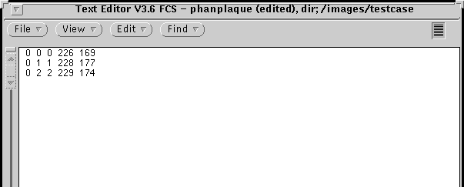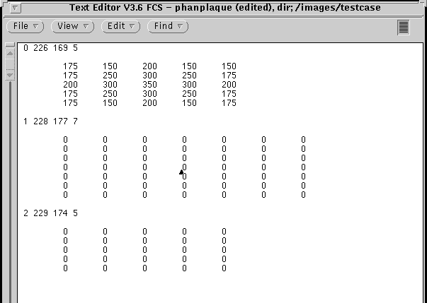
Numbers to be deleted from each row.
Number added to indicate size of lesion
Each row represents one vessel per slice which you identified during tracing

Edited ‘phanplaque’ file.

5 x 5 matrix of HU units.
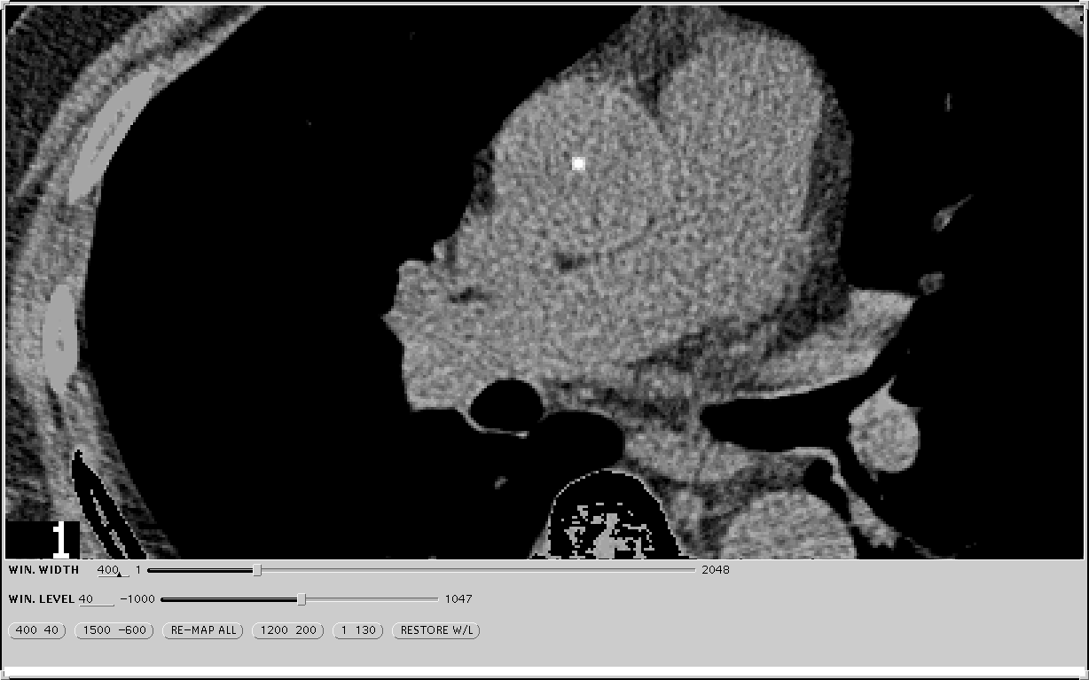
Lesion from first matrix of phanplaque file.
Unfinished matrices for two other lesions
Resulting image from first slice of testcase file..

XII. Attachments

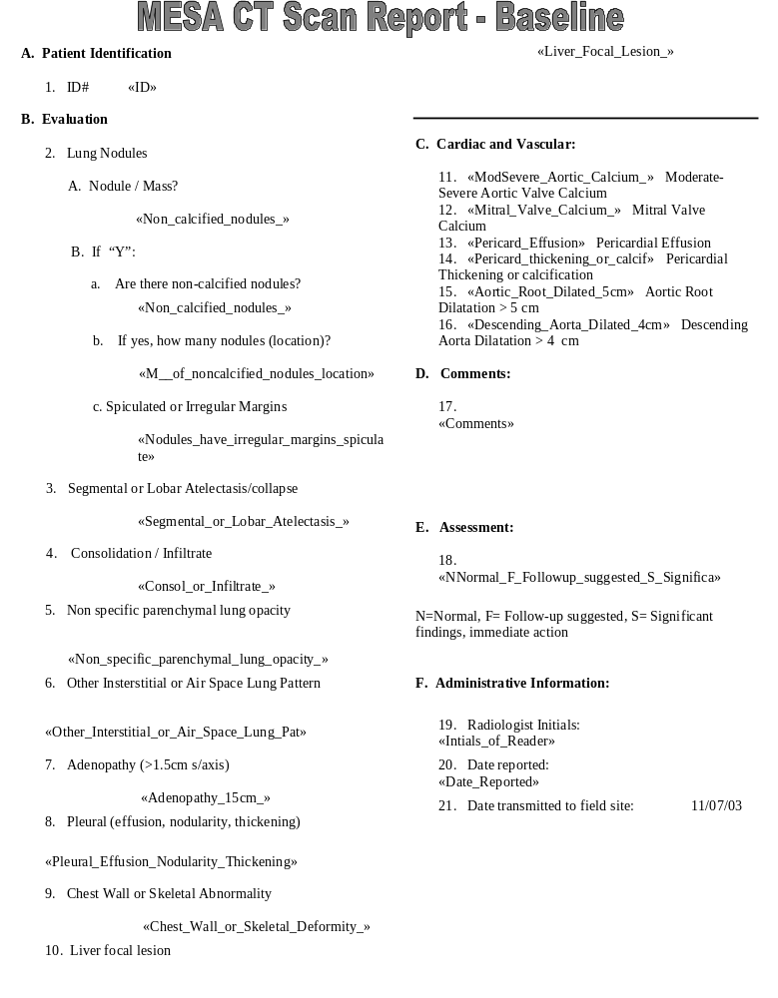

CT Study Transmission Sheet/ FAX to 310-533-1616

CT STUDY TRANSMISSION SHEET

STUDY (CIRCLE): MESA

Transmission Date ____/ ____ / __________
Transmission Time _______:_________

Scanning Center Location ______________________ ID ____________
Staff sending form: ___________________ Phone: _________________

Patient ID Number | Acrostic | Date Scanned | Archived  (Y/N) | Number of Slices | Comments

QA QCT Sheet - FAX to 310-533-1616

Quality Assurance QCT Data Sheet for MESA Study

Mesa Site ___________________________ CT Scanner Mfgr._____________________

CT Scanner Model______________________ Phantom Serial Number____________________

QA Date | Tech.  Initials | Kvp | MA | FOV | Slice Thickness | Table Height | Hounsfield Numbers
 |  |  |  |  |  |  | 0 | 50 | 100 | 200 | Torso PIN

MESA CT Reading Center Complete Scan Log
ID number | Scan Date | Scan Time | Send Date | Check  Sum | Send Time | Checked  for completeness | Phantom



