MESA 5 Protocol 03/30/10
Version 1.0

Cardiac Magnetic Resonance Imaging (MRI)

MESA Protocol

Johns Hopkins University - MRI Reading Center
Chia Liu, PhD
David A. Bluemke, MD, PhD
João A.C. Lima, MD, MBA
Erin P. Ricketts, MSPH

Abbreviations:
BH: Breath hold
CMRI: Cardiac magnetic resonance imaging
ECG: Electrocardiography
GRE: Gradient recalled echo
IR: Inversion recovery
NBH: Non breath hold
PSIR: Phase sensitive inversion recovery
SSFP: Steady state free precession
TSE: Turbo spin echo
VLA: Ventricular long axis
HLA: Horizontal long axis

Please name the sequences according to the guide-line below:
Please name the sequences on the scanner according to the left column, the right column is for your information.
Name Definition
_3_PLANE_SCOUT (three plane scout)
PVLA_SCOUT (vertical or pseudovertical long axis scout)
HLA_CINE (Horizontal long axis cine)
LT_HORIZONTAL (line tag horizontal)
LT_VERTICAL (line tag vertical)
T1_MAP_PRE (pre-contrast T1 map)
SA_CINE (short axis cine using SSFP sequence)
SA_CINE_FGRE (short axis cine using gradient echo sequence)
VLA_CINE (two-chamber cine)
T1_MAP_POST_1 (post-contrast T1 map at 12 minutes post Gd)
TI_SCOUT (TI scout on Siemens)
SA_SSFP_DE (delayed enhancement short axis single shot –SSFP)
SA_GRE_DE (delayed enhancement short axis gradient echo)
HLA_GRE_DE (delayed enhancement horizontal long axis gradient echo)
VLA_GRE_DE (delayed enhancement two-chamber gradient echo)
T1_MAP_POST_2 (post-contrast T1 map at 25 minutes post Gd)

General Overview
Different sections of this Protocol:
- Localizer images (scout images)
- Tagging imaging in two vertical and horizontal line tags these series of images are to assess the movement and strain of the myocardium.
- Pre-Contrast (baseline) T1 map imaging in mid-LV level, short axis view (one slice, the same location as the mid-level tagging images) to assess the pre-contrast T1 values
- Gadolinium injection: Relevant only to participants who are eligible for the delayed contrast enhancement portion of the study. In the current protocol gadolinium-based contrast agent (0.15 mmol/kg body weight, total dose, use Magnevist ONLY) is administered prior to short axis cine imaging.
- Cine images acquired in the short-axis plane from the base (atrium) to the apex, using the Steady State Free Precession (SSFP) technique. Long-axis SSFP cine series will also be acquired in the four-chamber view and two-chamber view.
- Post contrast T1 map imaging at 12 minutes post Gd in mid LV level, short axis view (one slice, the same location as the mid-level tagging images) to assess the post-contrast T1 values.
- TI time determination A TI (inversion time) scout (Siemens) will be performed on Siemens scanners to help select the optimal TI for viability imaging. For the GE scanner at Columbia, test TI sequences at TI 175, 200, and 225 msec will be performed.
- Single-shot delayed enhancement (Siemens MRI scanners only.). The same slice position as multiple shot, however all slices will be acquired in one breath-hold with SSFP sequence.
- Fast gradient echo (multiple-shot) delayed enhancement images must be acquired at 15 minutes after the contrast agent injection, in the same short-axis and long-axis planes as the cine series. A segmented inversion recovery (IR) spoiled gradient recalled echo (GRE) sequence is to be used. A phase sensitive acquisition sequence will be used on Siemens scanners. A standard sequence will be used on the GE scanner.

- Post contrast T1 map imaging at 25 minutes post Gd in mid level short axis view (one slice, the same location as the mid-level tagging images) to assess the post-contrast T1 values.
Technologists are required to complete an ‘MRI Completion Form’ for each participant. Steps for Image Acquisition and the MR sequence parameters for the protocol are given below. Vendor-specific implementations of the protocol are also provided.

Participant Preparation
- Complete the MRI safety screening form required at your institution. MESA participants are not screened for MRI safety/compatibility.
- Request participant use the rest room before the study.
- Breath-holding is done at resting lung volume for the entire MESA protocol.
Test breath-holding. The participant is required to be able to hold their breath for 15 seconds at resting lung volume twice in order to participate in the protocol.
Inform and train participant on breath-holding, example: “Breath in … Let your air out until you are comfortable, and stop breathing.”
- Make sure that the connectors for cardiac coils and ECG are in place.
- Thoroughly clean the ECG contact area with alcohol swabs. With participant supine on the table, attach ECG electrodes to his/her chest according to your MRI manufacturer suggestions.
- If selected and consented for gadolinium (circled ‘yes’ on MRI completion form), place a 22 G cannula in the right antecubital vein. Alternatively, gadolinium may be administered by butterfly needle under direct observation. Note that lack of venous access is not a protocol contraindication to MRI scanning.
- If selected and consented for gadolinium, prepare a dose of gadolinium-based contrast agent (0.15 mmol/kg, Magnevist) with 20 ml saline flush.

Image Acquisition
A. MRI completion form
Complete the MESA MRI completion form AT THE END OF THE SCAN for each required component.
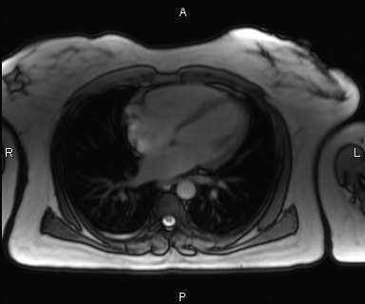
B. Multi-planar Scouts/Localizers:
Three slices in three orthogonal plane (axial, coronal and sagittal, 3 slices/view, 9 slices in total) SSFP breath hold scout images should be performed. Localize the heart at the isocenter. Perform the localizer AT RESTING LUNG
VOLUME.
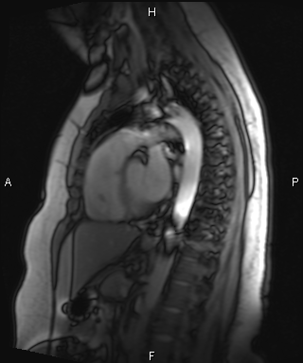

C. Pseudovertical Long Axis Scout:
Bright blood (SSFP), breath-hold, one slice (non-cine) image. Plan this on the axial scout view with the largest volume of heart, from the base (middle of the mitral valve) to apex of the left ventricle, on the axial scouts. Perform the localizer AT RESTING LUNG VOLUME.
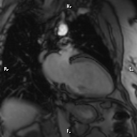

D. Short axis scouts:
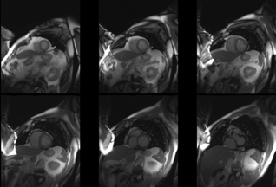
12 bright blood (SSFP) axial images covering the whole heart from great arteries to the apex. These images will be used for planning the four-chamber cine images. Data acquisition at the diastolic phase.

E. Cine Four-chamber (Horizontal long axis, 1 slice):
Bright blood (SSFP), BH method with retrospective gating, 40 phases. This slice should be planned on short axis scout images. The plane should pass through the middle of the ventricle to the apex, avoiding the aorta. The pseudovertical long axis view will be used as a reference for checking the slice position. The plane should pass through the middle of the mitral valve to the apex on the long axis view.
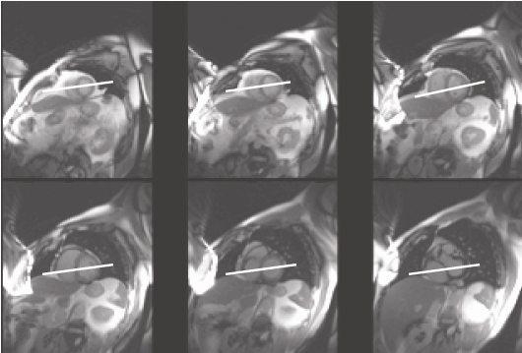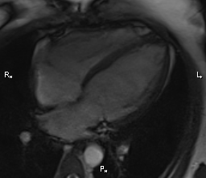

G. Line Tags, Horizontal and Vertical:
3 slices bright blood (FGRE) images. The upper slice should be placed 2 cm below the mitral valve with a slice thickness of 10 mm and distance factor of 50% (5 mm) between slices. Use Prospective gating. Typically 12-20 phases are achieved. Make sure that sharing view button is switched to ON on the Siemens scanner, to double the number of phases. This is automatic on the GE scanner. Images are acquired at RESTING LUNG VOLUME. Copy the exact same slices and parameters from the horizontal prescription and covert it to vertical tags (see protocol details).
GE Scanners: from the user CV card choose the “taggingangle” and set it to “0” degrees for horizontal tag lines and “90” degrees for the vertical tag lines. From the same CV card choose the “copyit” and set it to “0”. This is being done in order to prevent the scanner from increasing number of phases.
* Make sure that the tag lines are perpendicular to the Frequency encoding direction (FED). Frequency direction is shown as a small arrow at the side of the image in the “mini viewer”. The tag line direction is correct if it goes in the direction of the phase wrap seen at the edges of the image.
Siemens Scanners: Tag directions will automatically change when the user changes the phase encoding direction (note, this is already pre-built into the protocol that Hopkins will email to you). Therefore, by changing the phase encoding direction, the direction of the tag lines will correctly change by themselves.
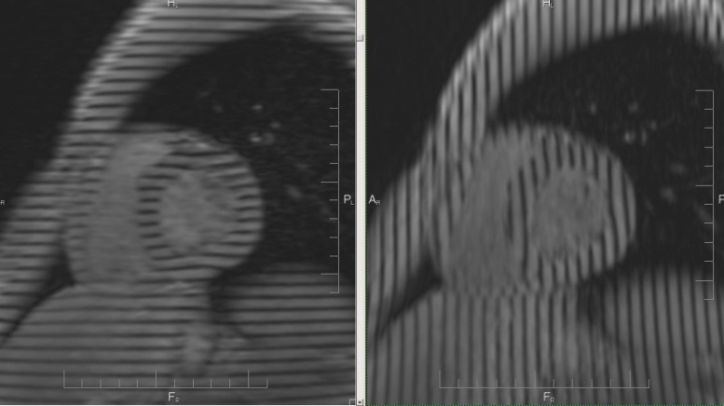
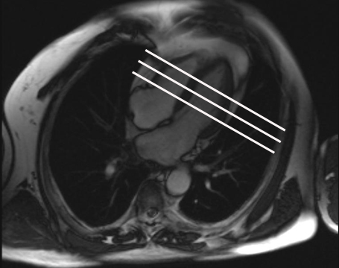

Line Tags | Recommended GENERAL Protocol | Vendor Specific Protocol
 |  | Siemens | GE
Sequence | Gradient Echo | FLASH | Fast GRE
Repetition Time (TR; ms) | minimize | 26.35 | Min
Echo Time (TE; ms) | minimize | 2.5 | Min full
Flip Angle (degrees) |  | 10 | 12
Views per segment/ segmentation factor |  | 9 | 8
Field of View (mm) | 360*360 | 360*360 | 360*360
Spatial Resolution (mm) |  | 1.4*2.8*10 | 1.4*5.6*10
Image Matrix |  | 256*128 | 256*64
Slice Thickness (mm) | 10 | 10 | 10
Slice Gap (Short Axis) (mm) | 5mm | 50% | 5 mm
Number of slices | 3 | 3 | 3
Bandwidth (Hz/pixel) |  | 283 | 62.50
Parallel Imaging | No | No | No
Partial Fourier (if any) | No | None | No
Gating | Prospective | Prospective | Prospective
Tag Spacing | 7 mm | 7 | 5 pixel (7mm)

H. T1 mapping: Pre-Contrast (MOLLI, for Siemens scanners ONLY)
Acquire this sequence in the short axis plane, mid-ventricular level of the LV (the same slice location as the mid tagging). MOLLI sequence is used with the following parameters: FOV = 360x360 mm², flip angle = 35 degrees, matrix: 256x192, slice thickness = 8 mm. All other parameters should be the default settings. The image sequence is acquired with breath-holding. 11 images should be displayed after the acquisition. MOLLI images should be acquired in all participants whether or not gadolinium contrast is injected.
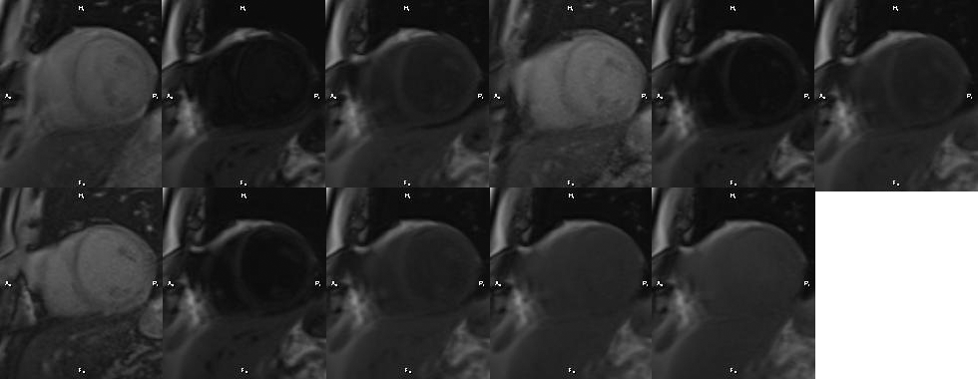

- Gadolinium Injection:
The gadolinium dose is 0.15 mmol/kg, using Magnevist only. This is infused at 1 ml/sec, followed by saline flush of 20 ml. If the IV gauge is small, the infusion rate may be decreased and is not critical (perfusion images are not obtained). A butterfly needle is acceptable if veins are small. Delayed enhancement images must be acquired starting at 15 minutes after gadolinium injection. Gadolinium should not be injected in participants who are excluded from the viability (contrast enhanced) section of the exam, for any reason. Please check the MRI completion form to verify if the participant should/should not receive gadolinium. If participant is eligible for gadolinium, record volume and time of each injection on the MRI completion form. The time of injection should be recorded from the clock time displayed on the scanner. Use the timer provided by the MRI Reading center for the precise timing of T1 mapping and SA gradient echo delayed enhancement imaging.
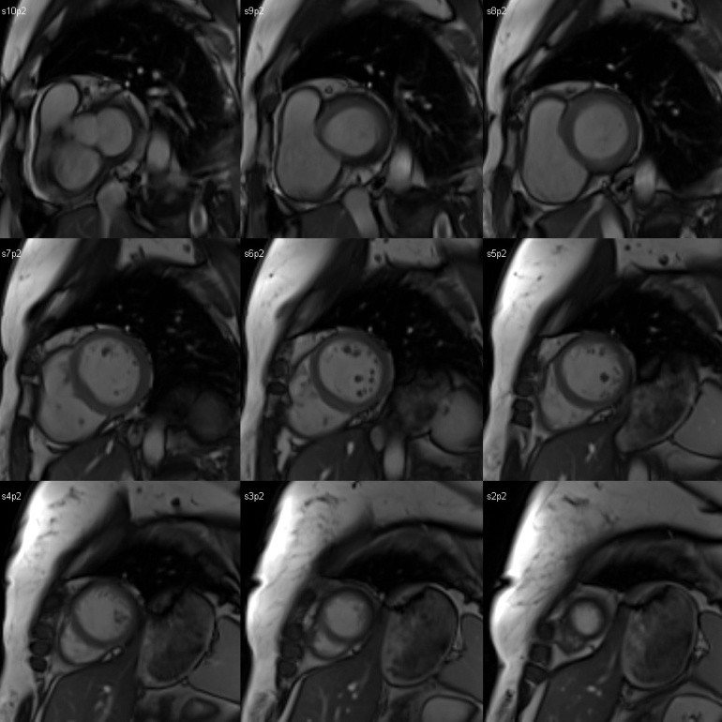
J. Cine Short Axis:
Cine short axis images should be obtained while waiting for gadolinium to wash-out from the myocardium. Bright blood (SSFP) sequence, breath-hold (resting lung volume), minimum of 12 slices, 40 phases, covering the whole heart from the atria to apex. Parallel imaging (e.g. ASSET, SENSE, or GRAPPA) with an acceleration factor of 2 to reduce acquisition time (optional).
Begin scanning 1 cm above the mitral valve plane.

Optional: concatenate two slices in one breath-hold (two slices in one breath-hold usually takes less than 15 seconds). Slices should be set in descending order from base to apex. The last apical slice should locate within the myocardium such that the entire 12 slices could cover left atrium as much as possible. Flip angle should be set at the largest possible (usually 45-70º).
- Two-chamber (Vertical long axis):
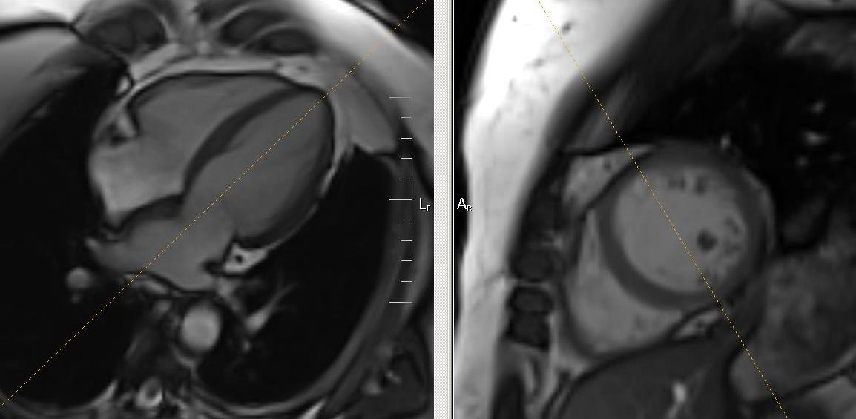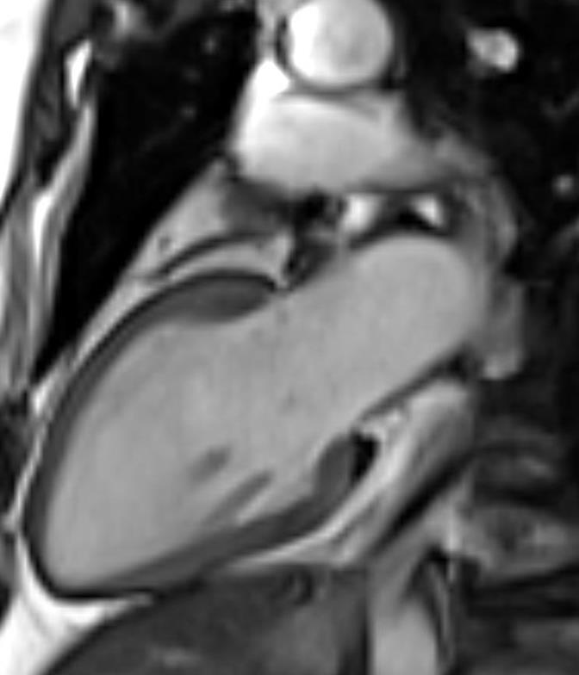One slice, BH, bright blood (SSFP) sequence. 40 phases in one slice. The slice position should be prescribed from a short axis view, and cross-referenced on the 4 chamber view and short axis slices to insure correct positioning.

CINE Imaging | Recommended GENERAL Protocol | Vendor Specific Protocol
 |  | Siemens | GE
Sequence | SSFP | True FISP | FIESTA
Repetition Time (TR; ms) | minimize ≤ 3.8 | ≤ 3.8 | Min
Echo Time (TE; ms) | minimize | minimized | Min Full
Flip Angle (degrees) | maximize | Maximum 70° | Maximum, 45°
Field of View (mm) | 360-400 frequency * 270-400 phase  (depending on participant size) | 360 * 360 | 360 * 360
Spatial Resolution (mm) | Better than 2.5 * 2.0 * 10.0 | 1.4*1.7*8 | 1.4 * 1.8 * 8
Image Matrix | 256*128 | 256*205 | 256 * 192
Slice Thickness (mm) | 8 mm | 8 | 8
Slice Gap (Short Axis) (mm) | 2 mm | 2 | 2
Number of phase | 40 | 40 | 40
Number of slices | Minimum of 12 short axis  1 vertical long axis  1 horizontal long axis | Minimum of 12 SA,  1 four-chamber, 1 VLA | Minimum of 12 SA,  1 four-chamber, 1 VLA
Bandwidth (Hz/pixel) | ≥ 900 | 1221 | 125kHz, 977 Hz/pixel
Parallel Imaging | (Optional) Acceleration factor: 2 | GRAPPA: 2 | ASSET
Partial Fourier (if any) | No | off | No
Gating | Retrospective | ECG/Retro | ECG/Retrospective
Number of segments | ≤ 20 | 18 | 16
Temporal Resolution (ms) | 30-50 msec | 49 | 48
Breath-hold time (s) | ≤ 15 | ≤ 15 | ≤ 15

L. T1 mapping: Post-Contrast (MOLLI, for Siemens) at 12 minutes post Gd
Copy and paste the same protocol as in section H. T1 mapping Pre-Contrast. Use a mid-ventricular SA (same location as the middle tagging images) view using MOLLI sequence with the following parameters: FOV = 360x360 mm², flip angle = 35 degree, matrix: 256x192, slice thickness = 8 mm. The remaining parameters are based on default setting. Image is acquired with breath-holding. 11 images should be displayed after acquisition.
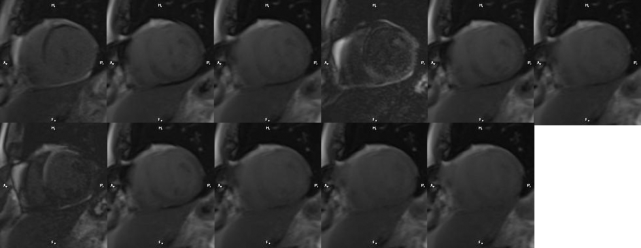
- TI Scout (Siemens, GE)
The purpose of these sets of images is to find the best inversion time so that the myocardium appears dark (arrow). This is a bright blood (SSFP), BH sequence; the slice position can be copied from the cine four-chamber views. If myocardium is not nulled, increase TI by 25 ms increments and check resulting images. Perform the TI scout in a mid-ventricular short axis view:
For GE images, use test TI times of 175, 200, 225 msec. Use the optimum TI where myocardium is nulled. In the example below, TI 300 is optimal. YOU ARE ALLOWED TO INCREASE THE TI DURING THE ACQUISITION.
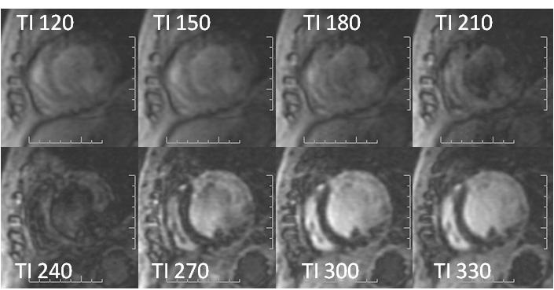
N. Short Axis SSFP Delayed Enhancement (Siemens only)
Single-shot inversion recovery (IR) steady state free precession (SSFP) sequence, use PSIR on Siemens scanners. Use parallel imaging (e.g. ASSET, SENSE, or GRAPPA) with an acceleration factor of 2. Select optimal TI and check for nulling of normal myocardium (as described above). Acquire in same short axis and long axis planes as cine images. Slice thickness: = 10 mm; Gap: none (contiguous slices).
DELAYED ENHANCEMENT
Single-shot | Recommended GENERAL Protocol | Siemens
Sequence | Single-shot Inversion Recovery SSFP | True FISP IR Single-Shot
Repetition Time (TR; ms) | minimize | ≤ 3.0
Echo Time (TE; ms) | minimize | minimized
Flip Angle (degrees) | maximize | 45
Field of View (mm) | 360-400 frequency * 270-400 phase  (depending on participant size) | 400 * 300
Spatial Resolution (mm) | Better than 3.0 * 3.0 * 10.0 | Better than 3.0 * 3.0 * 10.0
Image Matrix | At least 108 * 192 | 192*130
Slice Thickness (mm) | 8 | 8
Slice Gap (Short Axis) (mm) | none (contiguous slices) | 0
Number of slices | (same as for Cines:  short-axis slices to cover heart from valve plane to apex + 1 four-chamber, 1 VLA and 1 LVOT) | ~12 SA
 |  | 1 four-chamber; 1VLA
Magnetization Preparation | Inversion Recovery (IR) | non-sel. IR
Inversion time (TI; ms) | Optimize, using TI scout | Start with 300 if uncertain
Bandwidth (Hz/pixel) | ≥ 900 | 1532
Parallel Imaging | Acceleration factor: 2 | GRAPPA: 2
Partial Fourier (if any) | None | Off
Trigger | every heart beat | 1 trigger pulses
Number of segments | 1 | 1
Breath-hold time (s) | 10-15 | 13 (BH optional)

O. Short Axis Gradient Echo Delayed Enhancement:
Segmented inversion recovery (IR) spoiled gradient recalled echo (GRE), if available use PSIR, BH, Stack of short axis slices to cover the LV (use same geometry as short axis cine images, starting 1 cm above the mitral valve plane). Slice thickness 8 mm; Gap for short-axis slices: ≤ 2 mm. Use Phase Sensitive IR on Siemens scanners. Check for artifacts associated with arrhythmia. If present, proceed directly to single-shot viability (where available).
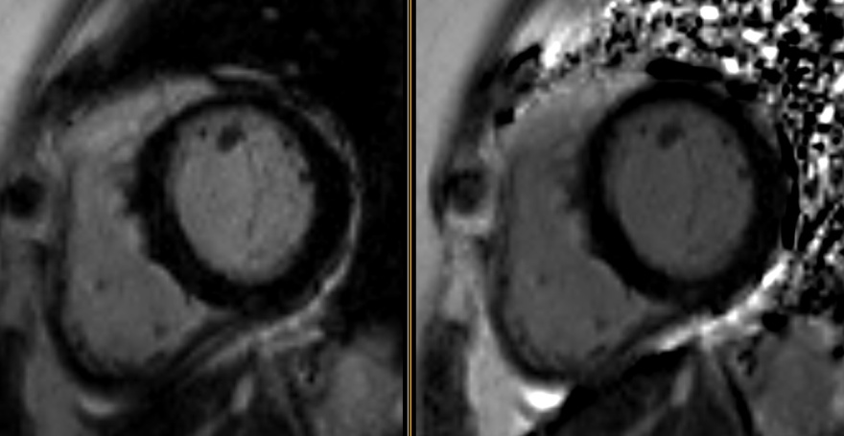

DELAYED ENHANCEMENT | Recommended GENERAL Protocol | Vendor Specific Protocol
Multi-Shot |  | Siemens | GE
Sequence | Inversion Recovery segmented, spoiled GRE | Turbo FLASH PSIR segmented | Fast GRE
Repetition Time (TR; ms) | ≤ 10 | ≤ 10 | Min
Echo Time (TE; ms) | ≤ 5.0 | 3.34 | Min Full
Flip Angle (degrees) | 20-30 | 25 | 20
Field of View (mm) | 360-400 frequency * 270-400 phase  (depending on participant size) | 360 * 360 | 360*360
Spatial Resolution (mm) | Better than 2.5 * 2.0 * 10.0 | 1.4 * 2.3 * 8 | 1.4 *2.25*8
Image Matrix | At least 128 * 256 | 256 * 154 | 256 * 160
Slice Thickness (mm) | ≤ 10 | 8 | 8
Slice Gap (Short Axis) (mm) | ≤ 2 | 2 | 2
Number of slices | (same as for Cines:  short-axis slices to cover heart from valve plane to apex + 1 four-chamber, 1 VLA) | minimum 12 SA | minimum 12 SA
 |  | 1 HLA; 1VLA | 1HLA; 1VLA
Magnetization Preparation | Inversion Recovery (IR) | non-sel. IR | IR
Inversion time (TI; ms) | Optimize, using TI scout or Look-Locker if available | Start at 300 if uncertain | 225 if uncertain
Bandwidth (Hz/pixel) | 100-150 | 130 | 31.25
Parallel Imaging | None | Off | No
Partial Fourier (if any) | No | Off | No
Trigger | every heart beat | 2 trigger pulses | 300 ms
Number of segments | ≤ 30 | 15 | 10
Breath-hold time (s) | ≤ 15 | ≤ 15 | 12-14

P. Four-chamber Gradient Echo Delayed Enhancement
Bright blood (FGRE) if available use PSIR, BH, four-chamber view. The position of the slice can be copied form the cine four-chamber view. TI should be set based on the optimum myocardial suppression in the TI scout (refer to section L).
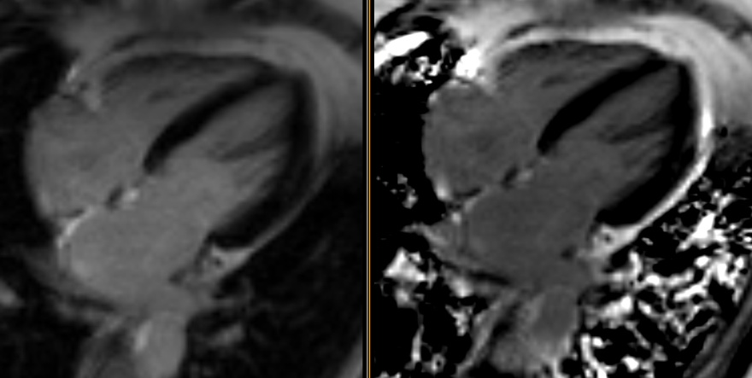
Q. Two-chamber Gradient Echo Delayed Enhancement
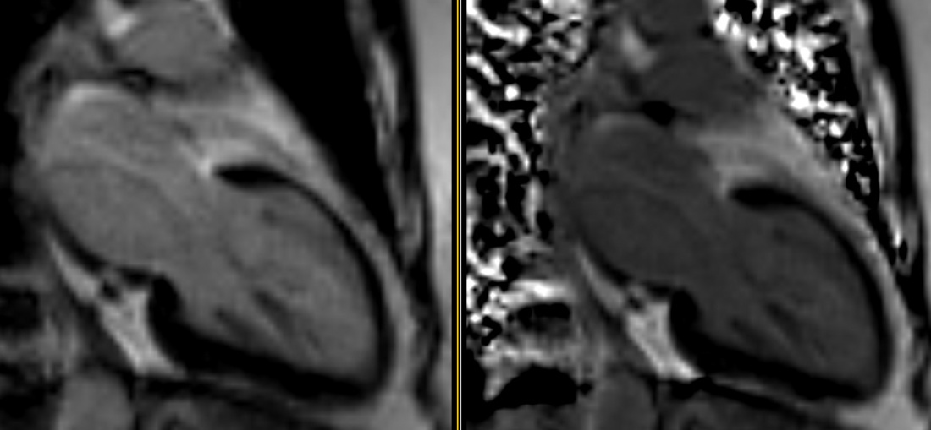
R. T1 mapping: Post-Contrast (MOLLI, for Siemens) at 25 minutes
Copy and paste the same protocol as in section L. T1 mapping Post-Contrast at 12 minutes. Use a mid-ventricular SA (same location as the middle tagging images) view using MOLLI sequence with the following parameters: FOV = 360x360 mm², flip angle = 35 degree, matrix: 256x192, slice thickness = 8 mm. The rest of parameters are based on default setting. Image is acquired with breath-holding. 11 images should be displayed after acquisition.
Study image and completion form transfer
Technologists should submit images to the MRI Reading Center at Johns Hopkins via the MIRC MESA node on the scanner. Additionally, they should burn a CD to give to the MESA Study Coordinator. Data should also be stored on the local PACS system. Techs should fill-out the MRI completion form and give to the MESA Study Coordinator for transmission to the MRI Reading Center.

