Multi-Ethic Study
Of Atherosclerosis -
Individual response to Vitamin D
(MESA INVITe)

EXAM 6

Field Center Procedures

Manual of Operations v1.4

February 28, 2018

Table of Contents
1. MESA INVITe STUDY OBJECTIVES 3
2. STUDY DESIGN 3
3. SELECTION OF PARTICIPANTS 3
4. STUDY PROCEDURES 3
4.1 MESA INVITe Exam 6 Visit. 3
4.1.1 MESA INVITe Exam 6 Clinic Flow 4
4.1.2 Medications Inventory Instructions 5
4.1.3 Screening Form Instructions 6
4.1.4 Dispensing Study Drug 8
4.1.5 2-Week Check in Phone Call 9
4.2 MESA Exam 6A. 10
4.2.1 Exam 6A MESA INVITe Clinic Flow 10
4.2.2 Phlebotomy and Urine Collection 10
4.2.3 Sunlight Questionnaire 13
4.2.4 Unused Study Medication Return 13
4.2.5 Adverse Events 14
4.3 MESA Exam 6 Plus 15
4.4 Study Drug Details 16
5. RESULTS LETTERS 17
Appendix A: MESA Classic INVITe Scheduling Script 18
Appendix A: MESA Family INVITe Scheduling Script 19
Appendix B: MESA Messenger Winter 2017 MESA INVITe article 20
Appendix C: Welcome Letter 21
Appendix D: Participant FAQs 22
Appendix E: Two-week phone call script 24
Appendix F: Exam 6A and 6 Plus Lab Processing Form 25
Appendix G: Participant Results Letter template 27
Appendix H: Contacts 28

MESA INVITe STUDY OBJECTIVES
The goal of the Individual Response to Vitamin D Ancillary Study (MESA INVITe) is to determine genetic and metabolic characteristics that modify the response to vitamin D supplementation. The results of this study will identify new genetic markers and biomarkers of vitamin D status that influence response to vitamin D treatment.
Vitamin D is a complex metabolic hormone that may reduce the risks of cardiovascular and other chronic diseases. Published studies have reported substantial differences in people’s response to vitamin D supplements. These differences may be caused by genes that affect vitamin D metabolism, race and ethnic differences, and/or heterogeneity in functional vitamin D status. Humans receive vitamin D through exposure to UV light from the sun, dietary supplements, and foods.

STUDY DESIGN
A total of 1,600 MESA participants will be recruited from five MESA field centers: Wake Forest University, Columbia University, Northwestern University, UCLA, and Johns Hopkins University during their Exam 6 visit. For MESA INVITe, participants will receive study drug that contains either 2,000 international units of vitamin D, or a placebo that contains only sunflower oil. Neither MESA participants nor Field Center staff will know whether a participant is assigned vitamin D supplements or placebo. The study drug and placebo softgels and their packaging look identical. Study drug and placebo will be randomly assigned in a 3:1 ratio with stratification by site. The duration of the study is 16 weeks, concluding with an additional in-person MESA study visit “6A.” The primary outcomes are changes in serum concentrations of parathyroid hormone (PTH) and 1,25-dihydroxyvitamin D (1,25(OH)₂D) and urinary calcium excretion.

SELECTION OF PARTICIPANTS
MESA participants from the five participating field centers will be selected for this ancillary study if if their Exam 1 (or other baseline exam) serum calcium was less than or equal to 11mg/dL. Participants may be enrolled from MESA Classic, MESA Air New Recruits, or MESA Family. These criteria are used to select participants for MESA INVITe in the Exam 6 data collection software. Additional exclusion criteria for MESA INVITe include:
Current use of >1,000 international units (IU) of vitamin D daily
Current use of any activated vitamin D product (calcitriol, paricalcitol, hectorol)
Known history of allergy or adverse reaction to vitamin D treatment or sunflower oil
Known clinical history of primary hyperparathyroidism
Known clinical history of kidney stones within the previous 5 years
Current or previous history of maintenance kidney dialysis or kidney transplantation
Current participation in another interventional or clinical trial study
Inability to provide written informed consent
Participants will complete a MESA INVITe Screening Question to eliminate those who are not eligible (see section 4.1.3).

STUDY PROCEDURES
Most participants will complete MESA INVITe procures at their Exam 6 visit and at a second “Exam 6A” visit approximately 16 weeks after Exam 6.

Participants who completed Exam 6 within 4 weeks of MESA INVITe screening and enrollment may be enrolled in MESA INVITe without repeating the baseline blood draw and urine collection (which is normally included in the core Exam 6 visit). These participants can complete the MESA INVITe Exam 6 Visit as listed in section 4.1.

Participants who completed Exam 6 more than 4 weeks prior to the start of MESA INVITe can join the study by completing a new baseline visit called “Exam 6 Plus.” Details of these exams are outlined in section 4.3.

MESA Air New Recruit and MESA Air Family participants will use the Exam 6 Plus protocol, since these cohorts do not participate in core Exam 6 visits.

Paper data collection forms, participant materials, and phone scripts are available on the MESA website at https://www.mesa-nhlbi.org/MesaInternal/ClinicFormsSection.aspx#exam6forms.

MESA INVITe Exam 6 Visit.
Most of the baseline data and biosamples for MESA INVITe will be obtained from existing Exam 6 procedures, including the Medical History Form, Core Exam 6 Phlebotomy, and Medications Inventory. No additional blood draw is required for the baseline MESA INVITe procedures at Exam 6 if MESA INVITe screening and enrollment are completed within 4 weeks of the Exam 6 visit. The following new forms and procedures will be added to Exam 6 for MESA INVITe:
- Daily Vitamin D dose calculation in the Exam 6 Medications Inventory)
- MESA INVITe Screening Form
- MESA INVITe Consent
- Study drug distribution and tracking

MESA INVITe Exam 6 Clinic Flow
Participants can be called prior to the Exam 6 visit to review eligibility (see MESA INVITe Scheduling Script in Appendix A and MESA INVITe Phone Screening Form) or they can be approached in the clinic. At the Exam 6 visit, Field Center staff will approach selected participants to confirm eligibility, explain the details of the trial, answer relevant questions, and perform the informed consent process. Eligible and willing participants will complete the MESA INVITe consent form and receive study medication.
Here is the suggested Exam 6 clinic flow with MESA INVITe components:
- Blood Pressure/Pulse Oximetry
- Anthropometry
- Phlebotomy and Urine Collection (note that no additional blood or urine are collected for MESA INVITe at the Exam 6 visit)
- Echo/Arterial Stiffness
- Medications Inventory (with vitamin D calculation)
- Interviews/Questionnaire (Medical and personal history, urinary symptoms, physical activity, Heart failure symptoms, cognitive function testing, lung questionnaire)
- MESA INVITe Screener
- MESA INVITe Consent Form (if eligible based on MESA INVITe Screener)
- Dispense MESA INVITe Study drug (if eligible and consented) and complete Study Completion Form (note: participants will receive the study medication here, but will not begin taking the medication until the following day)
- Spirometry
- Lung CT
- Heart Monitor Patch application
- 6 minute walk test
- Exit interview
The order of clinic procedures should be modified to meet the needs of each specific Field Center. The MESA INVITe Screening form requires that the Medications Inventory and Medical History forms be completed prior to the screener.
The screener form will be available for all participants selected for MESA INVITe. After the Medical History, Medications Inventory, and MESA INVITe screening form are complete, a note will display at the end of the screening form saying that the participant is either eligible or ineligible. If the participant is eligible, go to the Clinic Reception form and enter a consent (yes or no) for MESA INVITe/Vitamin D. If the participant refuses to participate, enter consent as “No.” For those who consent, (consent values is updated to “yes” for MESA INVITe/Vitamin D in the clinic reception form) the MESA INVITe Study Completion form will appear in the participant’s form list and the details of dispensing the study medication can be recorded. The screener form must be completed for all selected participants, and consent status must be entered for all eligible participants.
Please make use of the following materials to provide details of the MESA INVITe Ancillary Study to participants (see Appendices A-D or the MESA Exam 6 forms and documents webpage at https://www.mesa-nhlbi.org/MesaInternal/ClinicFormsSection.aspx#exam6forms):
MESA INVITe MOP
- MESA INVITe Recruitment Scheduling Phone Script
- Winter 2017 MESA Messenger article for MESA INVITe
- MESA INVITe Welcome Letter
- MESA INVITe Participant Frequently Asked Questions (FAQs)
Participants who consent to the study should receive a Welcome Letter and FAQ document which details the goals of the study and instructions for taking the study medication (see Appendices C and D).

Medications Inventory Instructions
The Exam 6 Medications Inventory forms has been updated to calculate a total daily dose of vitamin D reported by each participant. The vitamin D dose for all medications and supplements must be accurately recorded in the Medications Inventory to identify participants who take more than 1000IU of vitamin D daily. Be sure to remind participants to bring all vitamins and supplements to the exam during their appointment reminder call so that their daily vitamin D intake can be accurately recorded.

The Exam 6 Medications Inventory has been updated to calculate the daily vitamin D dose to determine eligibility for MESA INVITe. For each medication entered in the form, the amount of vitamin D contained in the prescription or supplement is prepopulated into the “Strength” column. See image below. The “Total Vitamin D Amount” is calculated at the top of the screen.

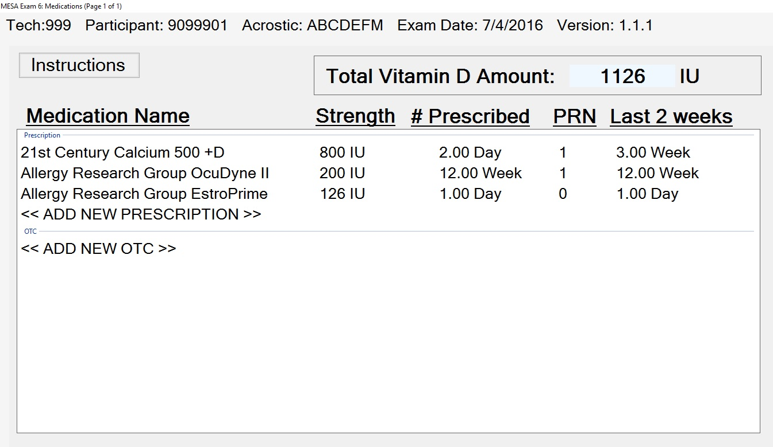
If the Medications database does not list a vitamin D dose, or reports an incorrect amount of vitamin D for any medication in the list, the amount of vitamin D can be entered manually by clicking on the medication and updating the “Strength” information (see image below). The Total Vitamin D Amount on the main medications page will be updated with this new information.

The Medications Inventory asks about medications taken in the past two weeks. If a participant takes a vitamin D containing medication less frequently than every two weeks, it should be reported in the Medications Inventory.

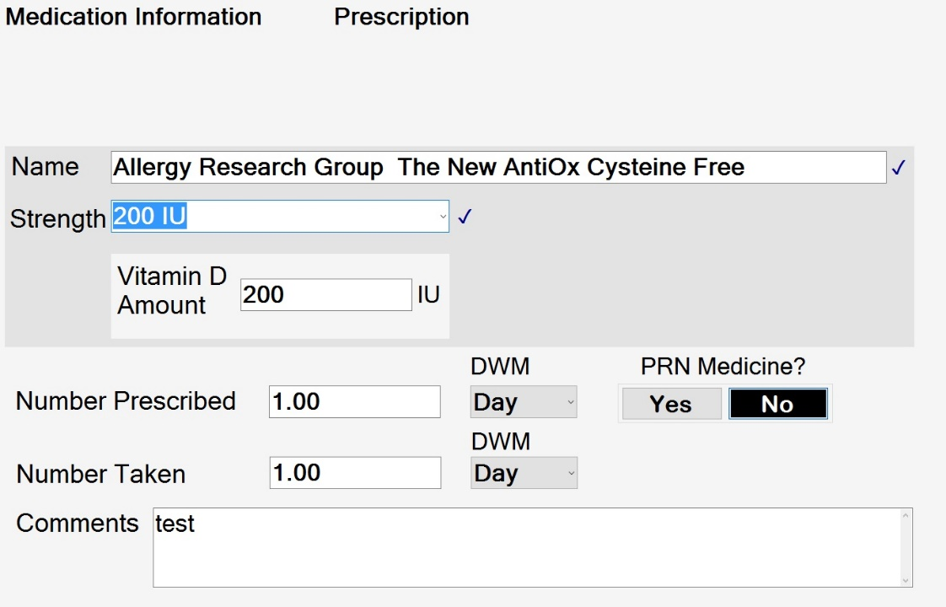
The total daily vitamin D dose will be used to pre-populate the answer to question 1 in the MESA INVITe Screening Form.
Participants who report using Paricalcitol, Zemplar, Hectorol, Doxercalciferol, Rocaltrol, Calcijex, or Calcitriol NovaPlus are not eligible for MESA INVITe. Use of these medications will be reflected in question 2 in the MESA INVITe Screening Form.

Screening Form Instructions
The Exam 6 data collection software is set up with checks and balances to ensure that only eligible participants receive study drug.
All participants who are selected for MESA INVITe will have the MESA INVITe Screening form included in their forms list in the EDC program. Once the Medications Inventory, Medical History Form and MESA INVITe Screener are complete, the participant’s eligibility is reported at the end of the screener form. The screener form must be completed for all selected participants to accurately track eligibility and refusal data.
Eleven questions ascertain eligibility for MESA INVITe. Questions 2 through 5 are populated in the MESA INVITe Screening form based on answers reported in the Exam 6 Medications Inventory and Medical History forms (Daily vitamin D dose, kidney dialysis or transplantation, recent history of kidney stones). The remaining 6 questions will be administered to the participant in the MESA INVITe Screening form (willingness to participate, Primary hyperparathyroidism, sarcoidosis, elevated serum calcium, allergies/adverse reactions, participation in other clinical trials).
Participants who take more than 1000 IU of vitamin D daily that are otherwise eligible for the study may choose to temporarily reduce their vitamin D supplementation and participate in MESA INVITe if their supplement usage is not recommended by or prescribed by a medical professional, or if their medical professional agrees that it is acceptable to reduce their vitamin D supplement dose to 1000IU or less for 28 weeks (12 weeks prior to the study and for the 16 weeks of the study). If they are willing, participants will be asked to reduce their vitamin D supplementation for 12 weeks and return for MESA INVITe using the 6 Plus protocol.

Question by Question Instructions for MESA INVITe Screening Form

- Has the participant refused to participate in MESA INVITe?
If YES, the participant is not eligible for the MESA INVITe Study. End Questionnaire.

- Was the participant not screened or enrolled for a reason other than the screening questions?
If YES, enter a description of the reason.

Questions 3-6 will be pre-populated based on answers reported in the Exam 6 Medications Inventory and Medication History forms. Confirm with the participant that the pre-filled responses are correct.

- Is the total daily dose of Vitamin D reported in the Medications form more than 1000IU?
The answer will be pre-populated based on the total Vitamin D Dose reported in the Exam 6 Medications Inventory.
If YES, ask:
2a. Would you be willing to temporarily reduce your vitamin D supplements in order to take part in the vitamin D study? Record response YES or NO. If YES, go on to question 4.
If NO: go to END.

- Did the participant report taking Paricalcitol, Zemplar, Hectorol, Doxercalciferol, Rocaltrol, Calcijex, or Calcitriol NovaPlus in the Medications form?
The answer will be pre-populated based on medications reported in the Exam 6 Medications Inventory.
If YES, the participant is not eligible for the MESA INVITe Study and questions 5-12 can be skipped.

- Did the participant report having kidney stones since their last MESA visit?
The answer will be pre-populated based on the answer to question 31 on the Exam 6 Medical History Questionnaire: Did you pass a kidney stone since your last MESA visit?
If YES, the participant is not eligible for the MESA INVITe Study and questions 6-12 can be skipped.

- Did the participant report kidney failure requiring dialysis or transplantation?
The answer will be pre-populated based on the answer to question 31 on the Exam 6 Medical History Questionnaire: Did you pass a kidney stone since your last MESA visit?
If YES, the participant is not eligible for the MESA INVITe Study and questions 7-12 can be skipped.

Questions 7-12 will be read to participants.

- Have you ever had condition called primary hyperparathyroidism, in which blood levels of calcium and parathyroid hormone are too high? Please note that hyperparathyroidism is diﬀerent from hyperthyroidism and hypothyroidism, which are common problems of a diﬀerent gland.
Record response YES or NO. If YES, the participant is not eligible for the MESA INVITe Study and questions 8-12 can be skipped.

Please note that hyperthyroidism and hypothyroidism are common diseases of the thyroid gland that participants may easily mistake for hyperparathyroidism, which is much less common. If participants respond yes to this question, please make sure they are distinguishing these similar-sounding disorders.

- Have you been diagnosed with sarcoidosis?
Record response YES or NO. If YES, the participant is not eligible for the MESA INVITe Study and questions 9-12 can be skipped.

- Have you ever been told by a heath care provider that you have elevated serum calcium levels?
Record response YES or NO. If YES, the participant is not eligible for the MESA INVITe Study and questions 10-12 can be skipped.

- Do you have an allergy or adverse reaction to sunﬂower oil or vitamin D?
Record response YES or NO. If YES, the participant is not eligible for the MESA INVITe Study and questions 11-12 can be skipped.

- Are you currently participating in another interventional research study or clinical trial? Record response YES or NO. If YES, the participant is not eligible for the MESA INVITe Study and questions 12 can be skipped.

- If question 3 and 3A are YES: Were your vitamin D supplements prescribed or recommended by your health care provider?

If YES: If you would like to take part in MESA INVITe, you will need to ask your health care provider if it is safe to temporarily reduce your vitamin D supplements to 1000 IU or less for 28 weeks (12 weeks prior to study, and for the 16 weeks of the study). Please call us back at XXX-XXX-XXXX after you talk with your health care provider to let us know if you will participate.

When the participant alerts the Field Center that their health care provider has approved reducing their vitamin D supplements, select Participant has approved temporary reduction with provider and will participate.

On what day will you reduce your vitamin D supplements?
Enter Date of start of 12-week temporary reduction period: MM/DD/YYYY
At the end of the 12-week temporary reduction period, call the participant to confirm that the temporary reduction was completed, enter the date of the end of the 12-week period, and re-administer the screening questionnaire.
Great! Your MESA INIVTE Exam can be scheduled any time after MM/DD/YYYY.

If NO: If you would like to participate in the MESA INIVTE study, you will need to temporarily reduce your vitamin D supplements for 12 weeks before starting the study drug, and you will need to return to the clinic after those 12 weeks to begin the study. Would you like to participate?
If NO: go to END.
If YES: On what day will you reduce your vitamin D supplements?
Enter Date of start of 12-week reduction period: MM/DD/YYYY
At the end of the 12-week reduction period, call the participant to confirm that the temporary reduction was completed, enter the date of the end of the 12-week reduction period, and re-administer the screening questionnaire.
Great! Your MESA INIVTE Exam can be scheduled any time after MM/DD/YYYY.

If a participant is unsure or does not know the answer to any of questions 7-12, record the response as NO.

Dispensing Study Drug
If a participant is eligible for MESA INVITe based on the Screening form, the consent status for the MESA INVITe option in the clinic reception form must be updated to Yes (willing to participant) or No (refused to participate). When the consent is updated to “Yes” for MESA INVITe, the MESA INVITe Study Completion form will be added to the participant’s form list. The Study Completion form will track the details of dispensing the study drug. In the form, indicate whether the study drug was dispensed, the date that it was dispensed, the bottle number, and whether it was dispensed in clinic or sent to the participant by mail.
Bottles should be dispensed in chronological, ascending order. The contents of these bottles (vitamin D or placebo) have been assigned by the MESA Coordinating Center and are known only to the Coordinating Center and the distributor of the study medications. Randomization was performed in blocks of variable size to mask participants, field center staff, and study investigators from each participant’s treatment assignment, until that participant completes the trial. Dispensing the bottles in chronological, ascending order will ensure that randomization and blinding are maintained throughout the trial.
A web report on the MESA Data Reports page at https://www.mesa-nhlbi.org/MesaInternal/MESAEx5/Ex6VitD_Bottle.aspx displays the bottle number assigned to each participant.
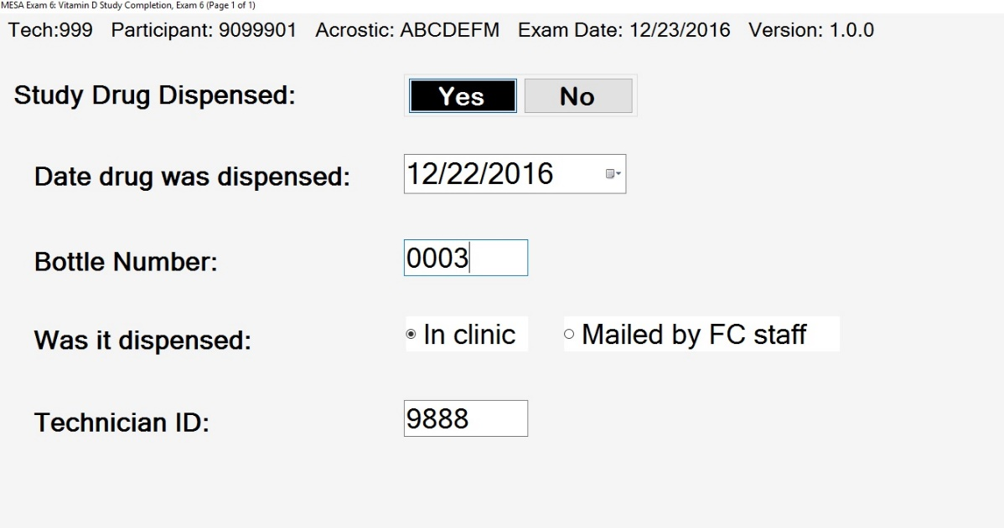

2-Week Check in Phone Call
Contact participants by telephone approximately two weeks after the start of study medication to address any questions regarding the study, encourage adherence to the study drug, inquire about adverse events, and confirm scheduling for MESA Exam 6a. A script for the phone call is provided in Appendix E. Use the Study Completion Form to document the following:
- Inquire if study drug is being taken per protocol and record deviations
- Record date participant began taking study drug
- Record any adverse events (in Adverse Events Form)
- Exam 6A visit date. If the participant refuses to return for the 6A study visit, select “Exam 6A Refused” where you would enter the Exam 6A date in the 2 week Study Completion form. If this option is selected, enter a brief description of the reason why the participant refused to complete the 6A visit.

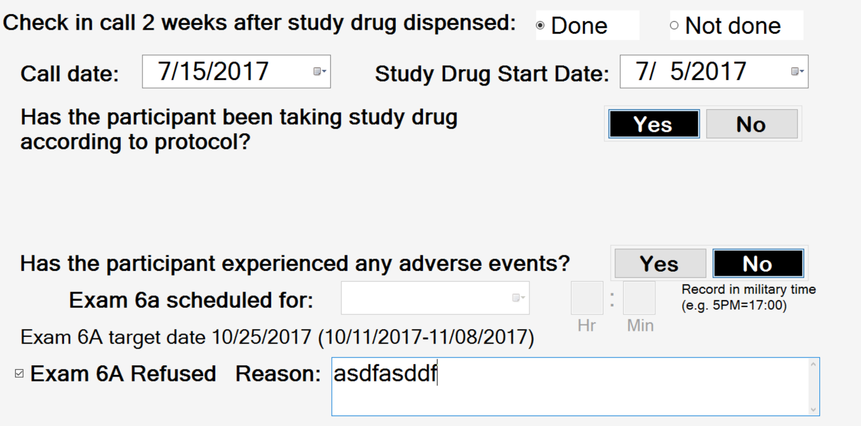
If adverse events have occurred, record them in the Adverse Events Form according to instructions in section 4.2.8.

MESA Exam 6A.
Participants will return to their respective MESA field centers for a specialized examination specific to this trial approximately 16-weeks after starting the study drug. This follow-up visit is denoted as “MESA Exam 6A.” Participants should return as close to their 16-week follow-up time as possible, within +/- 4 weeks. Study medication bottles include 20 weeks of medication and participants will be asked to continue to take their medication up until the time of their Exam 6A visit. There are no time limitations for the Exam 6A visit; it is better to bring a participant back for an Exam 6A visit after 30 weeks than not at all. Participants should also be brought back regardless of whether they are still taking the study medication, even if the participant has stopped taking the study medication altogether.
Participants should receive an exam 6A reminder phone call 2-3 days prior to the scheduled visit.

Exam 6A MESA INVITe Clinic Flow
The Exam 6A study visit includes the following components:
- Return of unused study medication to assess compliance
- Measurement of end-of-study systolic and diastolic blood pressures
- Completion of an end-of-study Medications Inventory Form, including the use of vitamin D-containing medications (both prescribed and over the counter)
- Completion of brief questionnaire to assess sunlight exposure during the trial
- Collection of end-of-study blood and spot urine specimens
- Collection of end-of-study DNA and RNA for future assessment of changes in gene expression with vitamin D treatment.
Systolic and diastolic blood pressures, Anthropometry, Medications, and collection of blood and spot urine specimens will be performed using identical procedures to those used for MESA Exam 6.

Phlebotomy and Urine Collection
The Exam 6A blood and urine samples must be drawn by a MESA Exam 6 certified phlebotomist follow the procedures outlined in the Exam 6 Laboratory Manual of Operations (available on the MESA website at https://www.mesa-nhlbi.org/MesaInternal/Manuals.aspx. Unlike the Exam 6 core blood draw, participants are not required to fast for the MESA INVITe Exam 6A blood draw.
The 6A includes drawing 2 blood tubes (one 7.5mL serum tube and one 2.5mL PAXgene RNA tube) and one 50mL urine collection. Labels for the 6A laboratory collection will be provided by the MESA Coordinating Center. The PAXgene tube is only collected if the participant has not refused to provide DNA/RNA for Exam 6 or MESA INVITe (as appropriate at each field center).
Unlike Exam 6, blood and urine samples collected at Exam 6A will be shipped directly to the University of Washington (see instructions below).

Supplies and Equipment
The following supplies will be provided by University of Washington:
- 1 – 2.5 mL PAXgene RNA tubes (BD# 762165)
Field Centers will supply (in addition to core Exam 6 equipment and supplies described in the Exam 6 Laboratory Manual of Operations):
- 1 – 7.5 mL Serum tubes (BD# 367987)
- Urine collection cup (Fisher Scientific #14-375-143)
- Cryovials (Fisher Scientific #02-681-338)
Rubber bands for freezer boxes
Ziplock plastic bags for freezer boxes
Absorbent material
Packaging tape
Dry ice (~10 - 15 pounds per shipping container)
Shipping labels (FedEx address labels)
Category B labels (UN3373 “BIOLOGICAL SUBSTANCE, CATEGORY B”)
Dry Ice labels (Dry Ice UN 1845, Class 9 - Miscellaneous
Styrofoam Shipping Containers (Polyfoam Packers or Thermosafe)

Exam 6A and 6 Plus Processing:
Refer to the Exam 6 Laboratory Manual of Operations for general collection, processing and centrifugation instructions including special circumstances.

After blood collection, time before centrifugation
Serum: store at room temperature for at least 60 minutes, but < 90 minutes prior to centrifuging.
After aliquoting, freeze ALL samples within 10 minutes or place immediately on dry ice.

Centrifugation
- Serum 7.5 mL tube. Keep at room temperature for at least 60 minutes, but no longer than 90 minutes, to allow them to clot. Record start time of centrifuging on the MESA 6A/6Plus Processing Form.
- PAXgene RNA tubes. Do NOT centrifuge these tubes. Filled tubes may remain at room temperature until as soon as able to freeze upright in a -80°C freezer.

Exam 6A and 6 Plus Aliquoting:

Collection Tube | Sample Type | Number of Aliquot vials | Color Code | Volume per Aliquot Vial
1 x 7.5 mL Serum draw tube | Serum | 3 (Cryos #1-3) | Red | 1.0 mL serum in 1.5 mL cryovials
1 x PAXgene RNA (#7) | (do NOT centrifuge) | (do NOT aliquot) |  | Remains in draw tube.

Refer to the Exam 6 Laboratory Manual of Operations for general aliquoting instructions, including special circumstances.

Serum Draw Tube → Keep draw tube, and cryovials cool on wet ice during processing. After centrifuging, gently invert the pooling tube containing the serum several times to ensure thoroughly mixed. Aliquot, by the volumes specified in the table above, into cryovials #1-3, and color-code with red caps. Double check the specified sample volume is being aliquoted into the correctly labeled cryovial. Freeze cryovials in an upright position at -80°C or colder within 10 minutes of aliquoting. After aliquoting is complete, discard the draw tube with the remaining coagulated in the appropriate biohazard waste container.

PAXgene RNA → #7. The PAXgene RNA tube is NOT aliquoted (and NOT centrifuged). Double check the draw tube is labeled with its correct MESA barcode label – the barcode label includes the 7-digit MESA participant ID + 1-digit visit year ‘6’ + the 2-digit repository identifier ‘07’. The sample remains in the draw tube, and is frozen upright in a -80°C freezer.

Collection | Sample Type | Number of Aliquot Vials | Color Code | Volume per Aliquot Vial
Urine | Urine (plain) | 3 (Cryos #4-6) | Yellow | 1.5 mL urine in 2.0 mL cryovial

- Keep urine refrigerated or on ice until processing.
- Gently swirl urine immediately prior to aliquoting to ensure sample is thoroughly mixed.
- Aliquot 1.5 mL urine into three pre-labeled 2.0 mLs cryovials, Cryovials #4-6. Keep cryovials on ice. These cryovials will be color-coded with yellow caps.
- Do NOT overfill the cryovials. There must be space for the urine to expand when frozen. These should all be 2.0 mL size cryovials.
- Double-check urine aliquots have the correct participant ID labels and caps are securely tightened on filled cryos.
- Discard any extra urine.
- Check off on the MESA INVITe Processing Form the number of urine aliquots made (Cryovial #s 4-6), see Appendix F.
- Freeze cryovials in an upright position at -80°C or colder, within 10 minutes of aliquoting.
Exam 6A Quality Control Procedures:
- Participants selected for serum QC will have 0.5 mL serum aliquoted into a 0.5 mL cryovial labeled with the participant’s serum blind duplicate label.
- After filling serum cryovials #1-3, aliquot 0.5 mL serum into a 0.5 mL cryovial labeled with the participant’s appropriate blind duplicate label.
- Freeze filled blind duplicate cryovials immediately (within 10 minutes of aliquoting), and be sure they are frozen in the upright position.
- Place blind duplicate samples (from multiple participants) in a 2” freezer box (preferably use a 9x9 box grid). Complete the Blind Duplicate Shipping Form listing the cryovials in the order they are loaded in the freezer box and include the freezer box in the frozen shipment of MESA INVITe 6A samples to University of Washington.

Exam 6A and 6 Plus Shipping:

In MESA Exam 6A or 6 Plus, sites ship frozen MESA Exam 6A/6 Plus samples to the University of Washington every second Tuesday of the month, or on the same day as their central lab shipment. Please notify Ashveena Dighe of your preference. Frozen samples are to be shipped by an overnight carrier. Follow the packaging and shipping protocol in the Exam 6 Laboratory Manual of Operations. Include in the shipment a shipping manifest and box map of samples.

E-mail notification of the shipment, including the FedEX airbill number(s), number of participant sample sets shipped, and the shipping manifest, the day samples are packaged to: Ashveena Dighe (ashveena@uw.edu)

Mailing Address:
John Ruzinski
NJB Bldg (room 3NJ.317.W)
908 Jefferson St
Seattle WA, 98104

The shipping manifest should include the following information: Study ID number, date of study visit, type of study visit (Exam 6, Exam 6A, Exam 6Plus), and box number (for multiple box shipments only). The box map should include location of each tube, indicated by study ID and tube type.

Sunlight Questionnaire
Participants will complete a Sunlight Questionnaire to report on the amount of time spent outdoors and the amount of body surface that was exposed to sunlight during the previous week, as well as travel to sunny locations.

Question by Question Instructions for MESA INVITe Sunlight Questionnaire

- Please estimate the amount of time that you spent outdoors in sun exposed areas during the past week:

For each day, Sunday through Saturday, answer About how many minutes did you spend outdoors?
Choose the appropriate response.

Which areas were exposed to the sun?
Check all that apply.

- Since Exam 6, have you travelled to a sunny location?
Select YES or No. If the participant started taking the study drug at a time other than their Exam 6 visit, the question should refer to when the participant started taking the study drug.

If YES:
2a. Where did you travel? (Choose all that apply)
Select all that apply.

2b. For how many days (total) did you spend traveling in a sunny location(s)?
Enter the number of days.

Unused Study Medication Return
Count and record all unused study medication in the Study Completion Form.
- Number of pills returned includes that are brought to the clinic at Exam 6A
- If any pills were lost, provide an estimate of the number of pills lost.
- Answer YES or NO for “Has the participant been taking study drug according to protocol and describe any deviations.

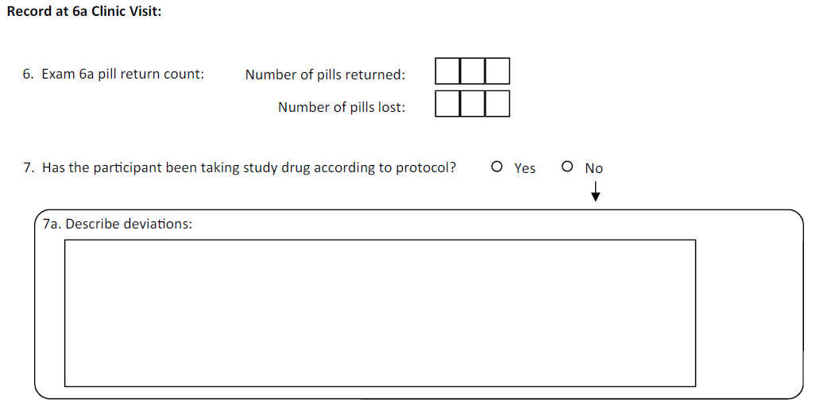

Adverse Events
Vitamin D (Cholecalciferol) is a commonly used over-the-counter supplement that has been evaluated in many published clinical trials using identical dosing strategies to that used in this trial, similar average doses to that used in this trial (eg, 50,000 IU monthly or 2400 IU daily), or even much larger doses than those used in this trial (e.g. 5000 IU daily or 50,000 IU weekly). Previous trials have found no differences in the frequency of adverse events comparing vitamin D to placebo. Some studies have noted a small increase in serum and urine calcium concentrations, prompting the measurement of these characteristics in this study. One study found a small increase in the frequency of nephrolithiasis, presumably due to urinary calcium excretion, prompting the decision to exclude MESA participants who have a history of kidney stones. Based on the generally safe profile of vitamin D and the exclusion criteria applied for eligibility, it is expected that adverse events related to study drug will be rare. However, unusual adverse events related to the study medication or other adverse unrelated to the study medication can always occur.
The Adverse Events Form will be completed during the Exam 6A visit, but adverse events may also be reported during the 2-week follow-up phone call or by phone calls to field center staff initiated by participants.
Definitions
Adverse Event (AE): any untoward medical occurrence in a patient or clinical investigation subject taking a study medication. The event does not necessarily have a causal relationship with the study treatment.
Serious Adverse Event (SAE): any untoward medical occurrence that at any dose results in death, is life-threatening, requires hospitalization, or results in significant disability/incapacity.
Important medical events that do not fall into the above categories may also be considered an SAE when, based on medical judgment, such events may jeopardize the patient’s safety and require medical/surgical intervention to prevent one of the outcomes listed in the SAE definition. The term SAE is not intended as a measure of severity or intensity. All AE’s/SAE’s that occur after the time of informed consent will be reported.
Adverse Events Reporting
All AEs will be reported on the Adverse Events Form as soon as they are reported by a participant. Pre-existing conditions (any condition that was known to be present prior to signing of informed consent or identified during the screening procedures) will not be considered or recorded as AEs unless the condition worsens in intensity or frequency.
Assessment of Causality and Severity
The seriousness of adverse events will be ascertained by the study staff and the need for further evaluation, follow-up, or referral. The relationship between study participation and AEs will be determined according to standard criteria:
- Not related – temporal relationship of the onset of the event, relative to study participation, is not reasonable or another cause can by itself explain the occurrence of the event.
- Possibly related – temporal relationship of the onset of the event, relative to study participation, is reasonable but the event could have been due to another, equally likely cause.
- Probably related – temporal relationship of the onset of the event, relative to study participation, is reasonable and the event is more likely explained by the study treatment than by another cause.
- Definitely related – temporal relationship of the onset of the event, relative to study participation, is reasonable and there is no other cause to explain the event.
Reporting Adverse Events
Report serious AE or AE related to drug to site PI (or designee) within 24 hours and to study PIs (Dr. de Boer and Kestenbaum, see contact information in appendix H) within 72 hours. The Data Safety Monitoring Board (DSMB & NHLBI) will be notified of SAEs within 7 days.
Report other AE to site PI (or designee) and study PIs (Drs. De Boer and Kestenbaum) within 1 week. DSMB reviews other AEs every 6 months and forwards a summary to NHLBI.

Adverse effects potentially related to study medications
Vitamin D3 (cholecalciferol) is Generally Recognized As Safe (GRAS) by the US FDA, indicating that it has been adequately shown to be safe under the conditions of its intended use.
Rare side effects of vitamin D3 can include gastrointestinal upset, nausea, constipation, and diarrhea.
Very rare side effects of vitamin D3 can include hypercalcemia (high calcium in the blood) and kidney stones, which may manifest as flank pain, pain with urination, or blood in the urine and can be diagnosed using imaging procedures. The MESA INVITe study is testing blood calcium levels at the beginning and end of each participant’s treatment period.
Both vitamin D3 and placebo are packaged in softgels, the contents of which may rarely lead to allergic reactions including skin rash.
MESA INVITe Adverse Event Form
All adverse events must be reported in the MESA INVITe Adverse Events Form. Of no adverse events are reported, indicate “none” in the Adverse Events form at Exam 6A. The form records the following information:
- Description of the AE
- Start and stop date of the AE
- Outcome (Unresolved, resolved, resolved with sequelae, or death)
- Treatment requirement (None, concomitant medications, non-drug therapies, concomitant medications and non-drug therapies, hospitalization).
- Study Drug Action (none, discontinued, stopped and restarted).
- Severity (mild, moderate, severe).
- Relation to study drug (unlikely, possible, or probable).
- Seriousness of event (AE or SAE).

MESA Exam 6 Plus
As of January 2017, 405 of the 2653 MESA participants selected for MESA INVITe had already completed their Exam 6 visit. Some of these participants may return to complete the MESA INVITe screener and study drug distribution within 4 weeks of Exam 6, but others will fall outside the 4-week window, requiring a new baseline exam for MESA INVITe. This new baseline exam is noted as “Exam 6 Plus.” Exam 6 Plus may be used to complete other ancillary study components as well, especially the carotid ultrasound from the newly funded Epigenetics of Atherosclerosis Ancillary Study.
The Coordinating Center will provide lists of participants selected for MESA INVITe that have already completed Exam 6.
Participants will also require the 6 Plus visit if they temporarily reduce their vitamin D supplements in order to meet the study eligibility criteria. If a participant is eligible for the study for all criteria except that they take more than 1000IU of vitamin D per day, they can choose to temporarily reduce their supplements for 12 weeks prior to the starting study drug and during the 16-week study drug period in order to participate.
In addition, MESA Air New Recruit and Family participants will complete Exam 6 Plus as their baseline MESA INVITe visit. MESA Air New Recruit and Family participants were originally recruited for MESA ancillary studies in 2004-2007, and many will be contacted for Follow-up 19 phone calls starting in February 2018. Sites are encouraged to phone screen these participants for INVITe Eligibility during their Follow-up 19 phone calls, but they can also be contacted during a second non-follow-up related phone call.
Participants who require a new baseline MESA INVITe 6 Plus visit will complete the following procedures:
- Anthropometry
- Blood pressure
- Review of Medications Inventory with total daily vitamin dose calculation
- MESA INVITeINVITe Screening Form
- Blood and Urine collection (following the Exam 6A protocol: non-fasting collection of 1-7.5mL serum and 1-2.5 mL PAXgene RNA tube, plus urine sample), all sent directly to the University of Washington Kidney Research Institute Lab (see section 4.2.2).
A second set of Exam 6 Plus lab labels will be printed for all selected MESA INVITe participants who have already completed Exam 6. The Medical History form will not be repeated at the Exam 6 Plus visit.
Some Field Centers plan to bring appropriate participants back for Exam 6 Plus right away, and others may wait until the end of Exam 6 to start Exam 6 Plus visits. All sites should take advantage of participants who are returning to field centers to complete procedures for other ancillary studies (for example, MESA Lung/Lung Non-Smokers Ancillary Study Lung CTs, Atrial Fibrillation or MESA Memory Ancillary Study brain MRI, Tissue Sodium Ancillary Study leg MRI, Heart Failure Ancillary Study cardiopulmonary exercise testing, Epigenetics of Atherosclerosis carotid ultrasounds, or MESA PET Ancillary Study visits) to complete Exam 6 Plus with minimal participant burden and cost.
Blood and urine aliquoting, processing and shipping instructions are noted above in section 4.2.2.

Participants selected for MESA INVITe who completed Exam 6 prior to the start of MESA INVITe have Exam 6 Plus forms added to the Forms section of the Exam 6 software.

Study Drug Details
Each bottle of study drug contains 140 softgels that will be dispensed (by either the Research Pharmacy or MESA clinic staff) in the order of the number printed on the bottle label. The unique bottle number is coded to allow the Coordinating Center to track whether it contains vitamin D or a placebo. 75% of the study drug bottles contain vitamin D and 25% contain placebo. Distributing the bottles in the order of the number on the bottle label will ensure that the vitamin D and placebo are distributed in a 3:1 ratio. The vitamin D and placebo softgels and their packaging look identical.
Study drug should be stored in a secure, climate-controlled environment at room temperature.
Each field center will receive 500 bottles of study medications in one shipment at the start of the study. Bottles will be numbered sequentially and should be distributed to participants in numerical order according to the bottle number on the study drug label. The study drug does not require repackaging before dispensing to participants.
For sites using research pharmacies, returned study drug will be collected and destroyed according to their standard operating procedures.
Instructions to participants for taking study medication
- Take one pill every day during the entire 16 weeks of the study. The pill will contain either vitamin D or a placebo (a substance that looks the same but contains no vitamin D)
- If one day of treatment is missed, participants may take two pills the following day. The vitamin D dosages in this study are safe for this purpose.
- If more than one day of treatment is missed, participants should go back to taking the study pills once per day as soon as possible.
- All leftover pills must be kept and returned to the MESA study coordinator at the time of the 6A study visit.
MESA INVITe Study Drug Label:
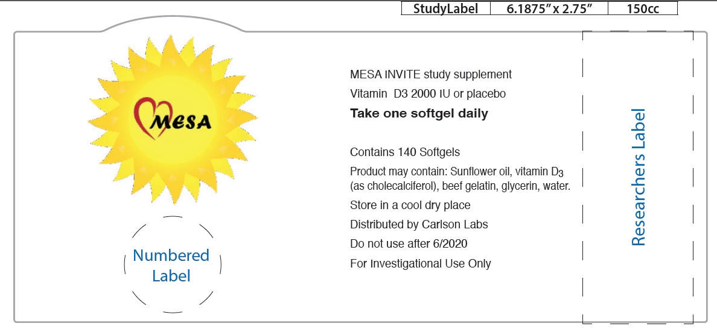

RESULTS LETTERS
Participants will receive their pre and post study vitamin D and calcium levels by mail 1-2 months after Exam 6A, as well as their study treatment assignment (either vitamin D or placebo). The University of Washington laboratory is certified for measuring vitamin D and calcium levels.
The MESA Coordinating Center will provide results letters to field centers to be mailed to participants.
See Appendix G for the results letter template.

Appendix A: MESA Classic INVITe Scheduling Script
We are looking forward to seeing your for your MESA Exam 6 clinic visit on [DATE: _ _ /_ _/_ _ _ _ TIME: _ _:_ _ am/pm]!
I wanted to check in with you before your exam to let you know about a new study that has been recently added to MESA Exam 6 that will help researchers understand differences in how people respond to vitamin D supplements.
To give you a little background on this new study; we know that Vitamin D is important for good bone and general health. And we know that your body can get vitamin D from sunlight, some foods, and treatment with supplements. Interestingly, people respond differently to vitamin D treatment. While some people experience large changes in their vitamin D levels, other people experience only small changes or no change at all. The purpose of this study is to figure out why people respond differently to vitamin D. We will test whether genes, hormones, or other biological factors might explain the variation in individual responses to vitamin D treatment.
As a MESA participant, you are eligible for this study if you are not currently taking more than 1,000 units of vitamin D supplements per day, and if you do not have a recent history of kidney stones or kidney failure. If you choose to participate, we will ask you to take a single softgel pill every day for 16 weeks. The pills will contain either vitamin D or a placebo (a substance that looks the same but contains no vitamin D). You may continue to take your other medications and supplements, including low doses of vitamin D, throughout the study. We will ask you to return to the MESA examination center 16 weeks after Exam 6 to give a blood and urine sample, complete a short questionnaire, and return any extra study medication.
Would you like to go through the screening questions for this study now to see if you are eligible to participate?
If no, That’s OK. We can talk about it more when you come in for your Exam 6 visit. Please bring all of your medications and supplements, including your vitamins, to your Exam 6 visit. Thank you so much for talking with me today. We greatly appreciate your participation in MESA. If you have any questions, please feel free to call us at the clinic at (clinic telephone number)
If yes, administer MESA INVITe Phone Screener Form
If eligible, as determined by screener form:
It looks like you may be eligible for the vitamin D study in MESA. We will have a few more questions during your Exam 6 visit to determine your eligibility.
If you would like to participate in this part of the MESA Study, it will be very important for you to bring all of your medications and supplements, including your vitamins, to your Exam 6 visit. We would especially like to look at the vitamins and supplements you currently take to make sure that you are not already taking large amounts of vitamin D. Thank you so much for talking with me today. We greatly appreciate your participation in MESA. If you have any questions, please feel free to call us at the clinic at (clinic telephone number)
If not eligible, as determined by screener form:
I am sorry, but it looks like you will not be eligible for the vitamin D study. We still look forward to seeing you for Exam 6. Thank you so much for talking with me today. We greatly appreciate your participation in MESA. If you have any questions, please feel free to call us at the clinic at (clinic telephone number)

Appendix A: MESA Family INVITe Scheduling Script
I wanted to check in with you to let you know about a new study that has been recently added to MESA that will help researchers understand differences in how people respond to vitamin D supplements.
To give you a little background on this new study; we know that Vitamin D is important for good bone and general health. And we know that your body can get vitamin D from sunlight, some foods, and treatment with supplements. Interestingly, people respond differently to vitamin D treatment. While some people experience large changes in their vitamin D levels, other people experience only small changes or no change at all. The purpose of this study is to figure out why people respond differently to vitamin D. We will test whether genes, hormones, or other biological factors might explain the variation in individual responses to vitamin D treatment.
As a MESA participant, you are eligible for this study if you are not currently taking more than 1,000 units of vitamin D supplements per day, and if you do not have a recent history of kidney stones or kidney failure. If you choose to participate, we will ask you to take a single softgel pill every day for 16 weeks. The pills will contain either vitamin D or a placebo (a substance that looks the same but contains no vitamin D). You may continue to take your other medications and supplements, including low doses of vitamin D, throughout the study. We will ask you to return to the MESA examination center 16 weeks after Exam 6 to give a blood and urine sample, complete a short questionnaire, and return any extra study medication.
Would you like to go through the screening questions for this study now to see if you are eligible to participate?
If no, That’s OK. Thank you for your consideration. If you have any questions, please feel free to call us at the clinic at (clinic telephone number)
If yes, administer MESA INVITe Phone Screener Form
If eligible, as determined by screener form:
It looks like you may be eligible for the vitamin D study in MESA. Would you be willing to come to the [field center] clinic to take part in the study?
If yes, go on…
If you would like to participate in this part of the MESA Study, it will be very important for you to bring all of your medications and supplements, including your vitamins, to your clinic visit. We would especially like to look at the vitamins and supplements you currently take to make sure that you are not already taking large amounts of vitamin D. Thank you so much for talking with me today. We greatly appreciate your participation in MESA. If you have any questions, please feel free to call us at the clinic at (clinic telephone number)
If not eligible, as determined by screener form:
I am sorry, but it looks like you will not be eligible for the vitamin D study. We greatly appreciate your participation in MESA. If you have any questions, please feel free to call us at the clinic at (clinic telephone number)

Appendix B: MESA Messenger Winter 2017 MESA INVITe article
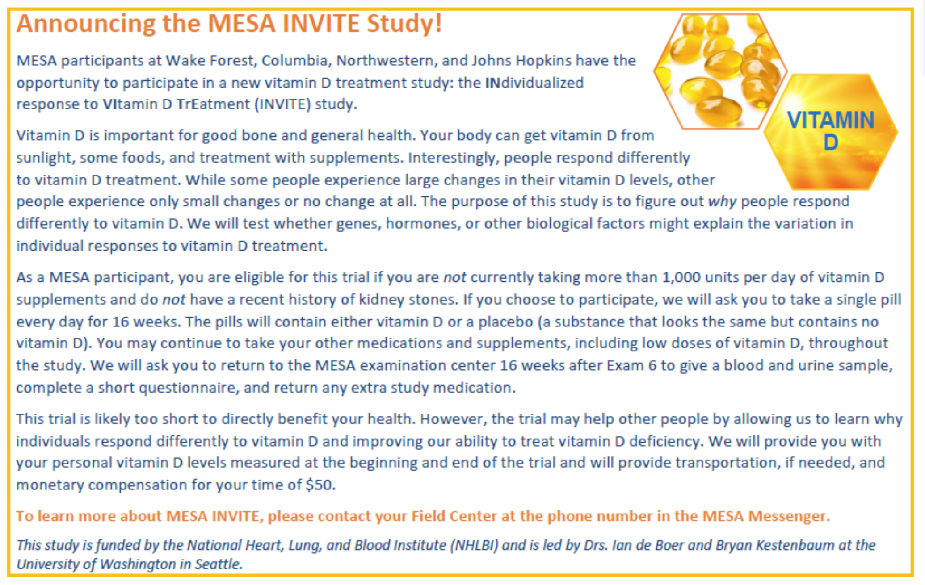

Appendix C: Welcome Letter

The MESA INVITe (Individualized response to vitamin D treatment) Study

Thank you for agreeing to participate in the MESA INVITe Study. Your participation will help us better understand why people respond differently to vitamin D treatment. To help us most effectively conduct this study we ask that you follow these instructions:
- Take one pill every day during the entire 16 weeks of the study. The pill will contain either vitamin D or a placebo (a substance that looks the same but contains no vitamin D)
- If you miss one day of treatment you may take two pills the following day. The vitamin D dosages in this study are safe for this purpose.
- If you miss more than one day of treatment, please go back to taking the study pills once per day as soon as you can.
- Please keep all of your leftover pills and return them to the MESA study coordinator at the time of your checkout visit.
- Please return for your checkout visit so that we can determine your individualized response to vitamin D! A MESA representative will call you to schedule the visit.
- Please call your MESA field center with any questions or concerns about the study: (insert contact information here).
After you have completed your checkout visit, our laboratory will measure your vitamin D levels and send you a letter that includes your levels at the beginning and end of the study and whether you received vitamin D or placebo during the study.
Again, thank you for your participation in this study and in MESA.

Sincerely,

Bryan Kestenbaum, MD MS Ian de Boer, MD MS

Appendix D: Participant FAQs

- How long will I be in this study?
This study will last 16 weeks.
2. For how long should I take the study medication?
We ask that you take your study medication once per day during the entire 16 weeks of the study.
3. When do I start and stop my study medication?
You should take your first pill on the day that you receive them at the start of the study. You should take your last pill on the day that you go to your 16-week checkout study visit.
4. Could I receive a placebo?
Yes. One out of every four people in this study will receive an inactive capsule called a placebo. This will look just like the vitamin D capsules, but will contains no actual vitamin D. It is important that some people in this study take a placebo so that we can determine the actual effects of vitamin D, as opposed to just being in the study. The placebo will not cause any harm.
5. What do I do if I get the placebo?
This study is double-blind, which means that neither you nor the study team will know whether the study medication contains vitamin D or placebo. Regardless of whether you are receiving vitamin D or placebo you should take the study medication every day during the study.
6. Should I have pills left over?
Yes. We provide slightly more pills than needed so that people do not run out.
7. Should I take my study medication in the morning or evening?
You can take the study medication at any time of the day. Whenever you choose, a consistent time is useful for helping you remember to take the medication.
8. Should I take my study medication with food?
It is best to take the study medication with food for best absorption.
9. Can I put my study medication in a medication set with my other pills?
Yes.
10. Will the study medication interact with my other pills?
No. Vitamin D does not interact with other prescription medications.
11. What do I do if I miss a dose?
If you miss a dose of study medication, it is OK to take two pills the next day. The dosage of vitamin D in this study is safe for this purpose. If you miss more than one day of treatment, please go back to just taking the study medication once per day as soon as you can.
12. Should I avoid spending time outside in the sun?
No. Feel free to continue your usual daily activities, including going outside as you normally do.
13. Should I stop using sunscreen?
No. Please continue to use sunscreen the way you usually do.
14. Should I keep taking my usual vitamins and supplements?
Yes. Please continue taking your regular vitamins and supplements as you were at the beginning of this study. We will ask you about which vitamins and supplements you take at the beginning and end of the study.
15. Should I change my diet?
No. Please continue to follow your regular diet.
16. Will I experience any side effects from the study medication?
We do not expect side effects from taking either vitamin D or the placebo. However, if you do experience any new symptoms that you think might be related to your study medication, please call the MESA field representative to let us know. The MESA phone number is on the pill bottle.
17. What should I do if I can’t make the checkout examination?
For this study to work effectively, it is important that each participant return for their 16-week checkout visit so that we can determine their response to vitamin D treatment. It is important for all participants to return for this visit even if they have stopped taking your study medication. Please call your MESA field center to discuss alternate scheduling for the checkout visit if needed.
18. Will I be told about the study’s results?
Yes. We will measure your vitamin D and calcium levels at the beginning and end of this study. We will send you these results by mail, along with information on whether you received vitamin D or the placebo. You can share these results with your healthcare provider to choose whether you should take vitamin D supplements in the future.
19. What should I do after the study?
This study will end after the 16-week period. There are no further study requirements. You are free to take vitamin D supplements after the study is completed as you decide. Your participation in MESA will continue according to the usual study procedures.

Appendix E: Two-week phone call script

Two-week check in phone call for consented participants

MESA INVITe

Introduction:
This script describes “talking points” for checking in with participants who have consented to be in the MESA INVITe study. This phone call will occur approximately two weeks after the participant has begun taking study medication. A research coordinator at the site who is familiar with the participant will make the phone call.

1. Hello my name is (research coordinator name) calling for (participant name). Is this a good time to talk?
Check for better time to talk if appropriate: ____________________________________
If YES to 1, then:
I am calling to check in with you regarding the MESA INVITe study you started a couple of weeks ago, for which you agreed to take a study drug to help us study vitamin D.
Go to 2.

2. On what date did you start taking the study medication?
Record the date in the Study Completion Form.

3. Have you been taking the study drug every day?
If Yes to 2, then:
Great. Please continue to take the study drug every day until you have completed 16 week in the study. Do you have any questions regarding the study or the study drug?
If NO to 2, then:
It is important to take the study drug every day as prescribed. Do you have any concerns about taking the study drug?

4. Thank you for your time. As a reminder, your Exam 6A is scheduled for (date and time of participant’s Exam 6A appointment). If you have any questions regarding the study or taking the study drug please feel free to call me at (research coordinator phone number).

Appendix F: Exam 6A and 6 Plus Lab Processing Form
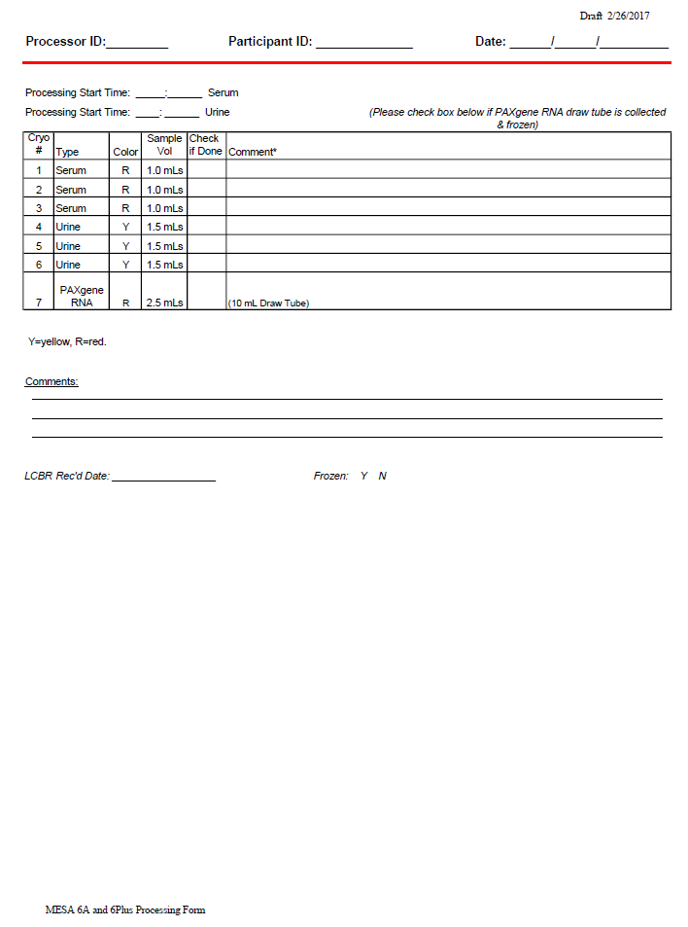

Appendix G: Participant Results Letter template
MESA Field Center
Address
Participant name
Address

Date

Dear ___________________,

Thank you very much for your participation in the MESA INVITe study. Your participation in this research is important for helping us better understand why people respond differently to vitamin D treatments and may lead to future improvements in the diagnosis and treatment of vitamin D deficiency. As part of the study we are providing you with your treatment assignment and the results of your blood tests for vitamin D and calcium.

Your treatment assignment was ___________________ (vitamin D or placebo)

Your blood test results are shown below

Beginning of study End of study

Serum 25-hydoxyvitamin D ______ ng/mL Serum 25-hydoxyvitamin D ______ ng/mL

Serum calcium ______ mg/dL Serum calcium ______ mg/dL

The Institute of Medicine defines 25-hydoxyvitamin D levels less than 20 ng/mL as potentially deficient and levels less than 10 ng/mL as deficient. These values were determined in Caucasian individuals and might not apply to other race/ethnicities.

As yet, there is no evidence that taking vitamin D supplements will improve your health. Several large studies are now underway to answer this question. Therefore, there is nothing that you need to do about your vitamin D test results. We encourage you to discuss your results with your doctor if you have questions about vitamin D.

Serum calcium levels are considered to be elevated if they are greater than 10.2 mg/mL. If your serum calcium level was >10.2 mg/dL at the end of the study, we encourage you to visit your doctor for further evaluation. If you have any questions about these results, please call ________. Thank you again for your participation in this study and in the Multi-Ethnic Study of Atherosclerosis.

Sincerely,

MESA PI

Appendix H: Contacts

Principal Investigators
Bryan R. Kestenbaum, MD, MS
Professor
Department of Medicine / Division of Nephrology
University of Washington Kidney Research Institute
Box 359606
325 9th Ave
Seattle, WA 98104
Phone: (206) 685-7343
Fax: (206) 685-9399
brk@uw.edu

Ian de Boer, MD MS
Associate Professor
Department of Medicine / Division of Nephrology
University of Washington Kidney Research Institute
Box 359606
325 9th Ave
Seattle, WA 98104
Phone: (206) 616-5403
Fax: (206) 685-8661
deboer@u.washington.edu

Coordinating Center Project Director

Kayleen Williams, MPH
Director of Clinical Operations
Collaborative Health Studies Coordination Center
University of Washington Dept of Biostatistics
Bldg 29, Suite 210
6200 NE 74th Street
Seattle, WA 98115
Phone: (206) 897-1916
kmfw@uw.edu

Kidney Research Institute Project Manager

Ashveena Dighe, MS, MPH
Project Manager, Kidney Research Institute
326 9th Ave, Box 359606
Seattle, WA 98104
Phone: (206) 744-4029
ashveena@nephrology.washington.edu

